**CREATION DE TABLES BASE DE DONNEES**

* **TABLE CLIENTS**

|  |  |  |  |  |
| --- | --- | --- | --- | --- |
| **Id_client** | **nom** | **adresse** | **telephone** | **email** |
| int | varchar | varchar | varchar | varchae |
|  |  |  |  |  |

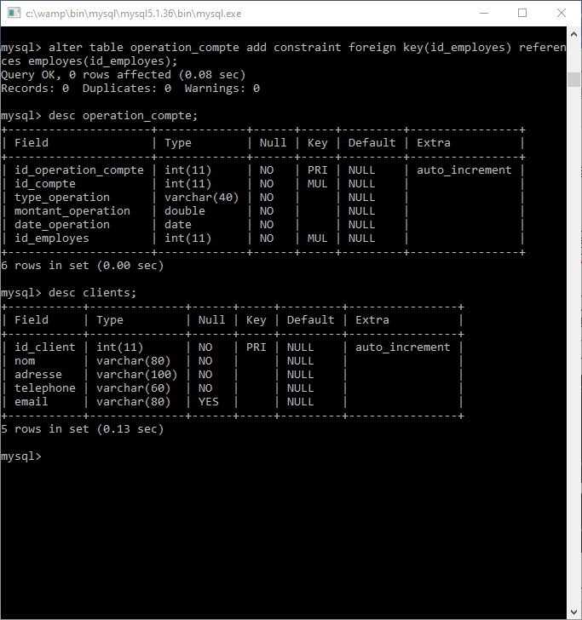

* **TABLE CLIENT SALARIE**

|  |  |  |  |  |  |  |  |  |
| --- | --- | --- | --- | --- | --- | --- | --- | --- |
| **Id_client_salarie** | **prenom** | **profession** | **salaire** | **Nom_entreprise** | **Adresses_entreprise** | **Id_entreprise** | **cin** | **Id_client** |
| int | varchar | varchar | double | varchar | varchar | varchar | varchar | MUL |

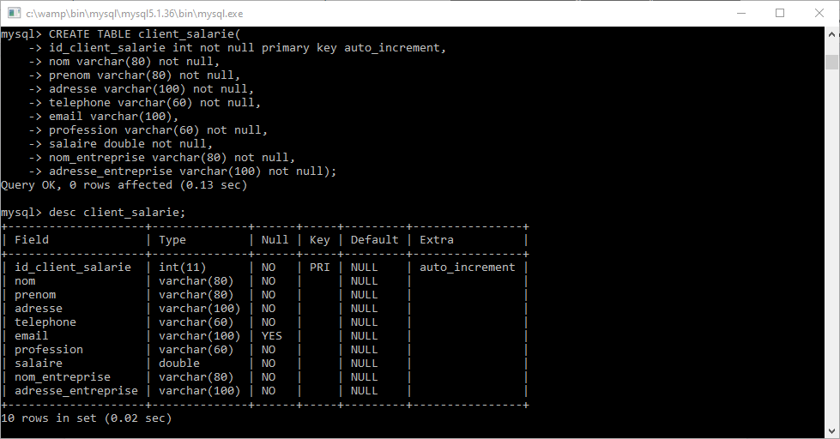

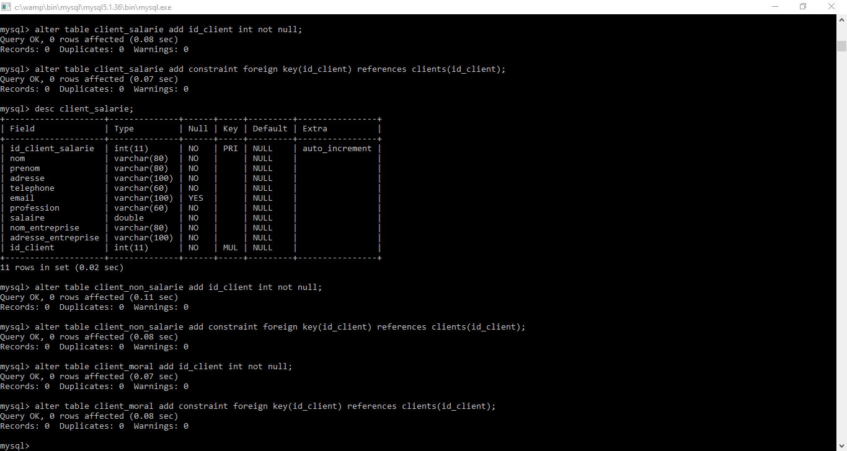

* **TABLE CLIENT NON SALARIE**

|  |  |  |  |  |
| --- | --- | --- | --- | --- |
| **Id_client_non_salarie** | **prenom** | **activite** | **cin** | **Id_client** |
| int | varchar | varchar | varchar | MUL |

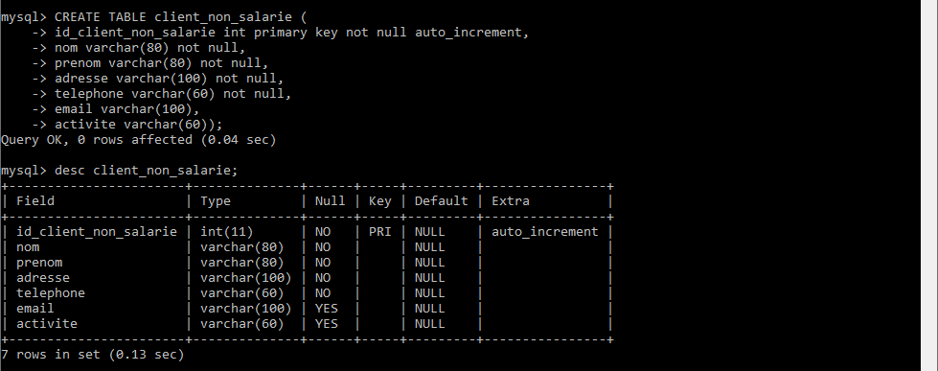



* **TABLES CLIENT MORAL**

|  |  |  |  |
| --- | --- | --- | --- |
| **Id_client_moral** | **Type_entreprise** | **Domaine_activite** | **Id_client** |
| int | varchar | varchar | MUL |

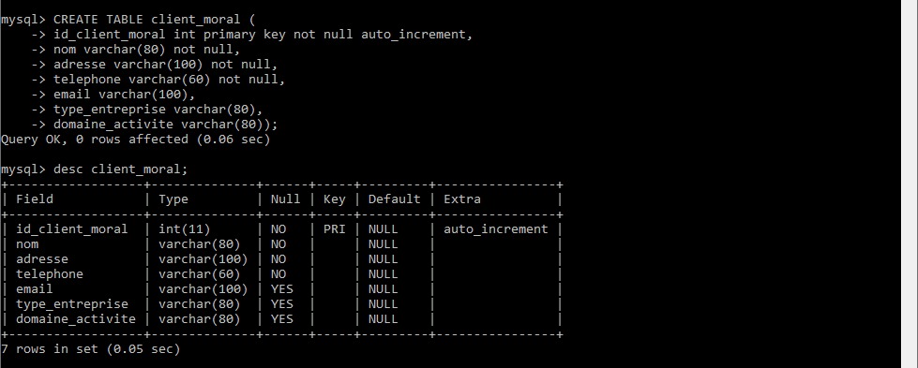



* **TABLE AGENCE**

|  |  |  |  |
| --- | --- | --- | --- |
| **Id_agence** | **Numero_agence** | **Adresse_agence** | **Id_administrateur** |
| int | varchar | varchar | MUL |

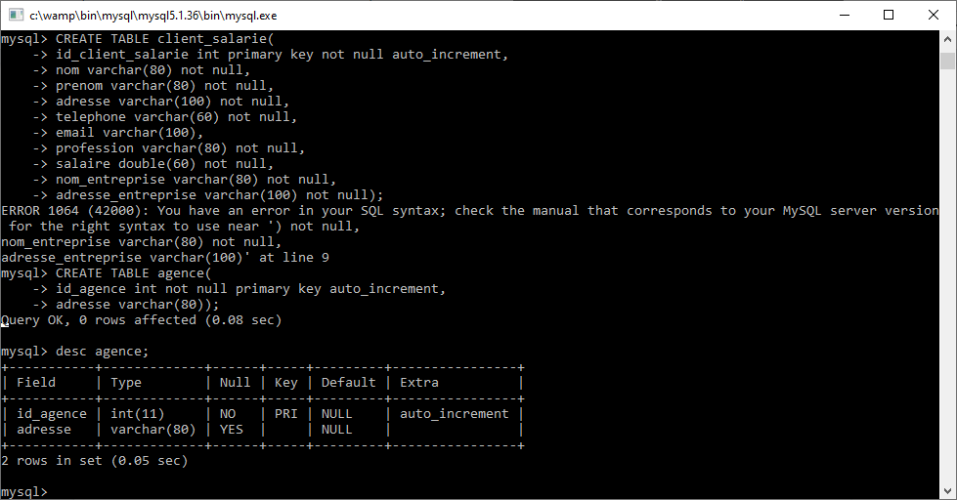

* **TABLE EMPLOYES**

|  |  |  |  |  |  |  |
| --- | --- | --- | --- | --- | --- | --- |
| **Id_employes** | **nom** | **prenom** | **adresse** | **telephone** | **email** | **Id_agence** |
| int | varchar | varchar | varchar | varchar | varchar | MUL |

* **TABLE ADMINISTRATEUR**

|  |  |  |  |  |
| --- | --- | --- | --- | --- |
| **Id_administrateur** | **login_administrateur** | **mot_de_passe_admin** | **Matricule_admin** | **Id_employes** |
| int | varchar | varchar | varchar | MUL |

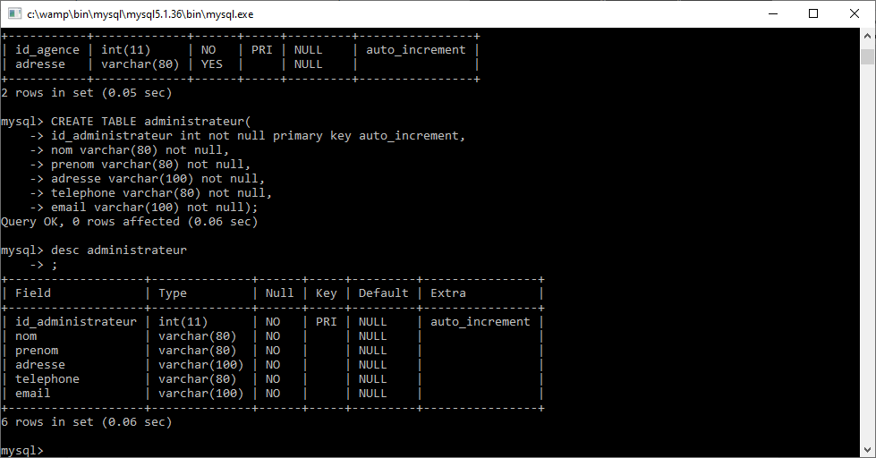

* **TABLE RESPONSABLE COMPTE**

|  |  |  |  |  |
| --- | --- | --- | --- | --- |
| **Id_responsable_compte** | **login_responsable** | **mot_de_passe_resp** | **Matricule_resp_compte** | **Id_employes** |
| int | varchar | varchar | varchar | MUL |

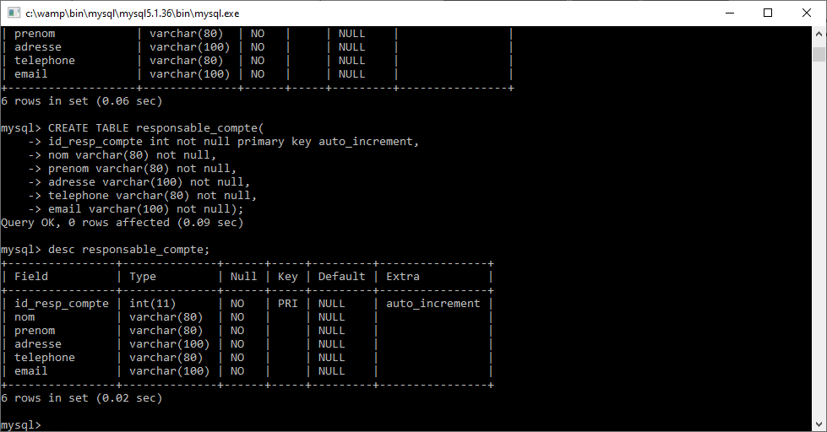

* **TABLE CAISSIERE**

|  |  |  |  |  |
| --- | --- | --- | --- | --- |
| **Id_caissiere** | **login_caissiere** | **mot_de_passe_caissiere** | **Matricule_caissiere** | **Id_employes** |
| int | varchar | varchar | Varchar | MUL |

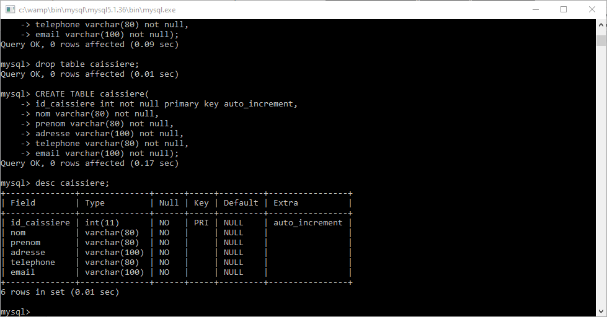

* **TABLE COMPTES**

|  |  |  |  |  |  |  |
| --- | --- | --- | --- | --- | --- | --- |
| **Id_compte** | **Numero_compte** | **cle_rib** | **solde** | **Id_client** | **Numero_agence** | **Date_ouverture** |
| int | int | int | double | int | varchar | date |
|  |  |  |  |  |  |  |

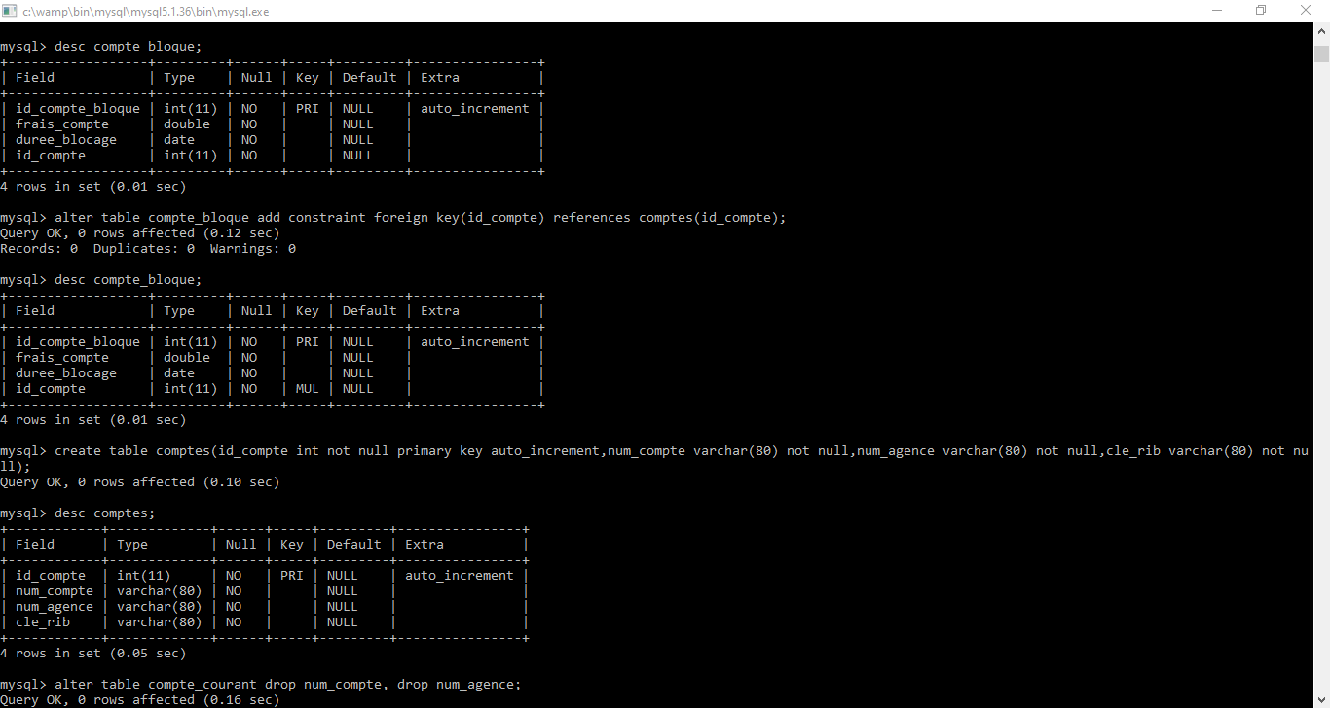

* **TABLE COMPTE EPARGNE**

|  |  |  |  |
| --- | --- | --- | --- |
| **Id_compte_epargne** | **Frais_ouverture** | **Montant_renumeration** | **Id_compte** |
| int | double | double | MUL |

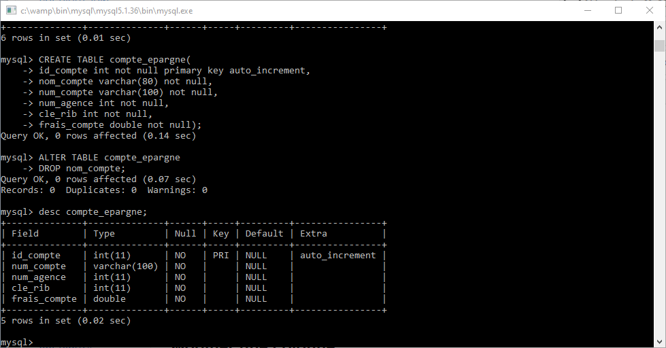

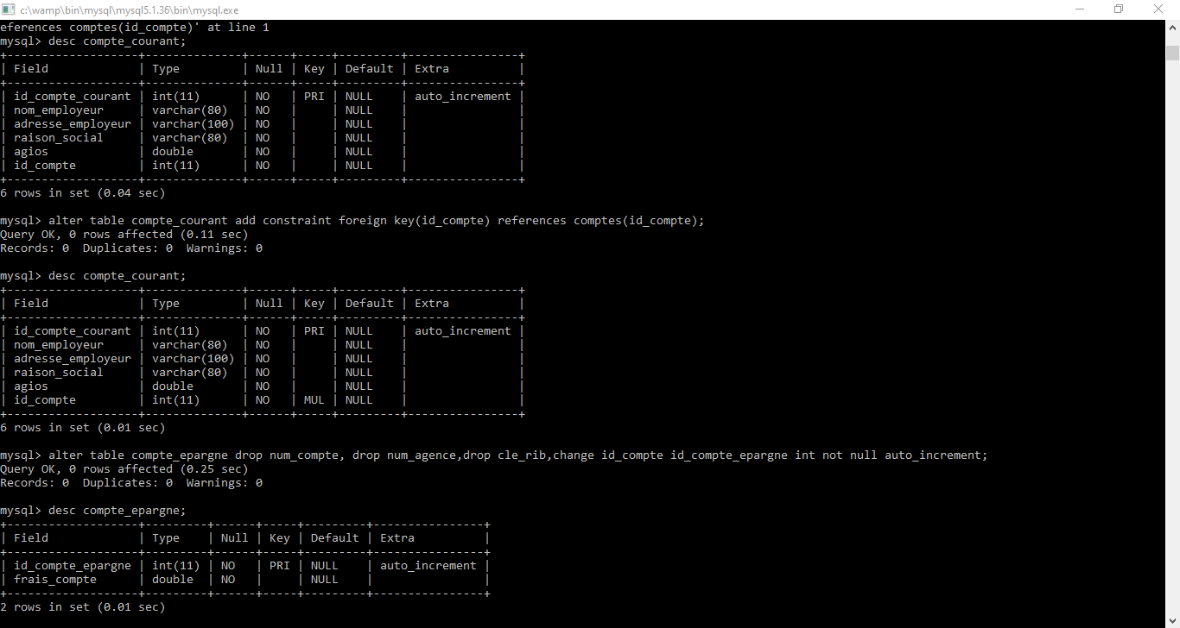

* **TABLE COMPTE COURANT**

|  |  |  |  |  |  |
| --- | --- | --- | --- | --- | --- |
| **Id_compte_courant** | **Nom_employeur** | **Adresse_employeur** | **Raison_socila** | **Id_agios** | **Id_compte** |
| int | varchar | varchar | varchar | MUL | MUL |

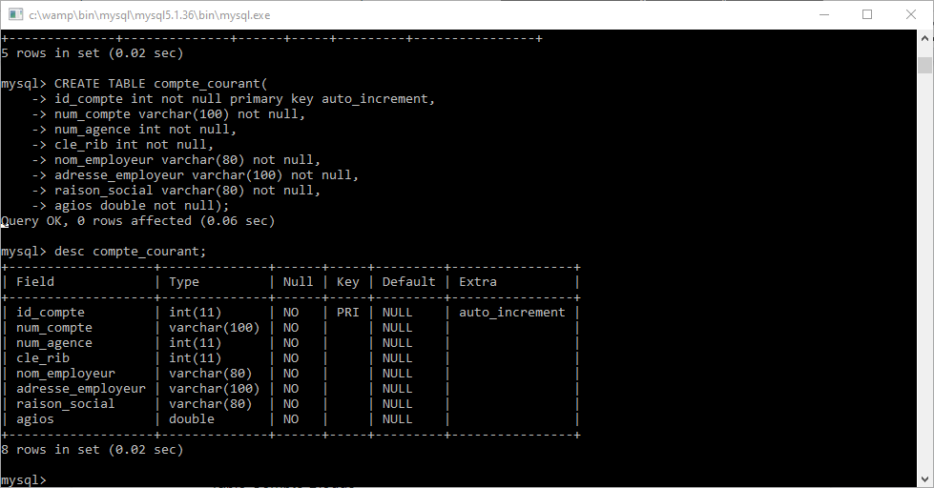

* **TABLE COMPTE BLOQUE**

|  |  |  |  |  |
| --- | --- | --- | --- | --- |
| **Id_compte_bloque** | **Frais_ouverture** | **Delais_blocage** | **Montant_renumeration** | **Id_compte** |
| int | double | date | double | MUL |

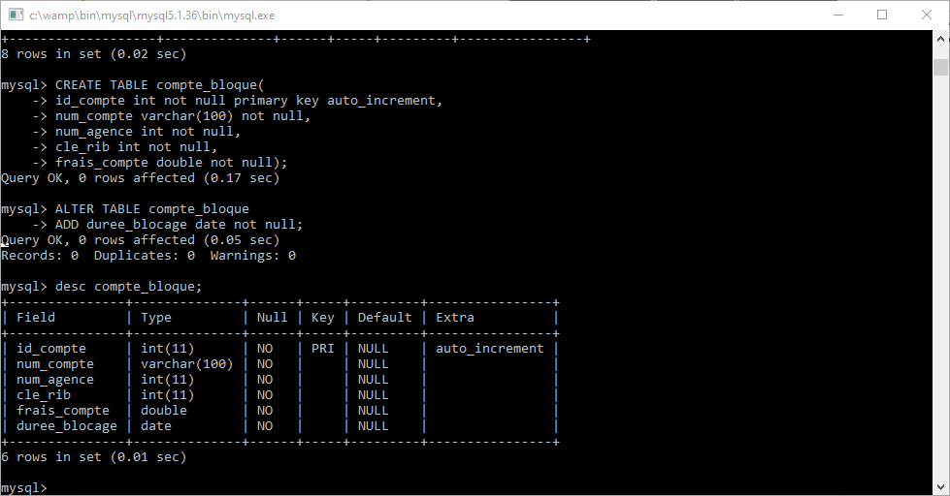

* **TABLE ETAT COMPTE**

|  |  |  |  |
| --- | --- | --- | --- |
| **Id_etat_compte** | **Etat_compte** | **Date_changement_etat** | **Id_compte** |
| int | varchar | date | MUL |

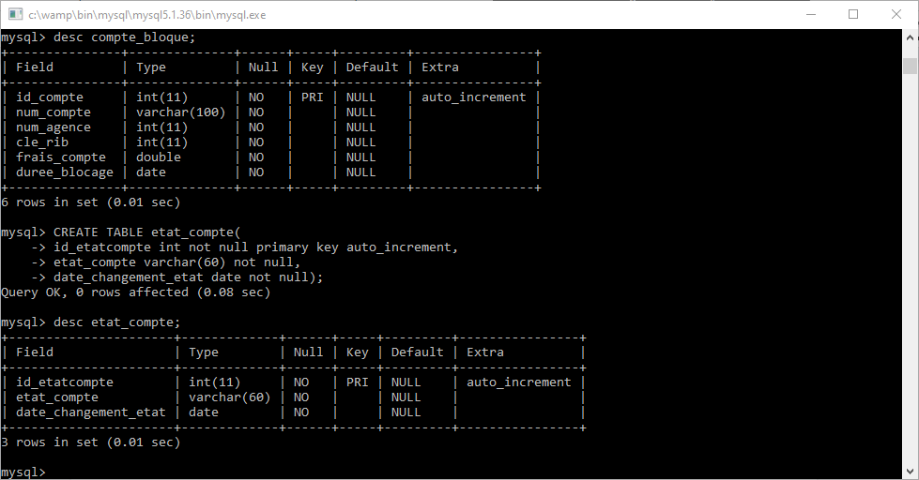

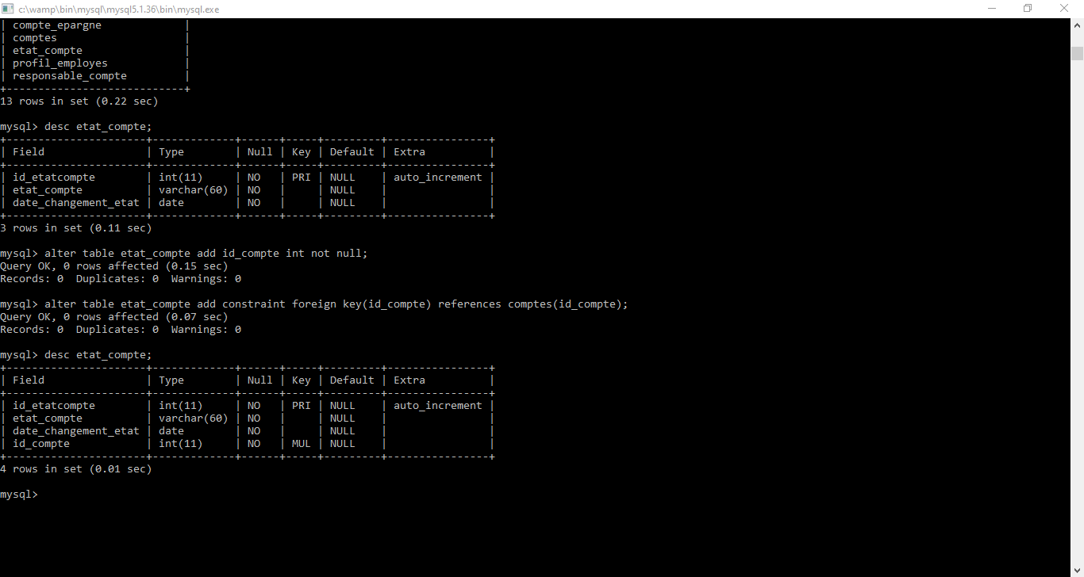

* **TABLE PROFIL EMPLOYES**

|  |  |  |  |
| --- | --- | --- | --- |
| **Id_profil_employes** | **Id_employes** | **Nom_fonction** | **Date_debut_fonction** |
| int | MUL | varchar | date |

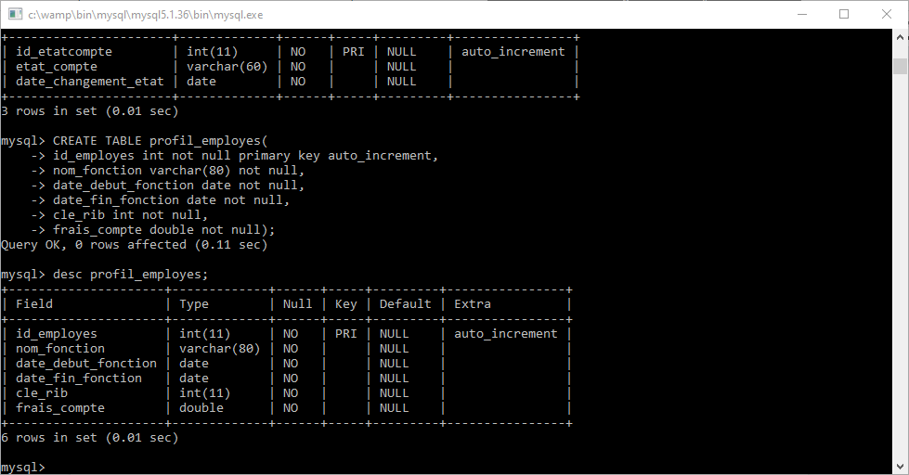

* **TABLE OPERATION COMPTE**

|  |  |  |  |  |  |  |
| --- | --- | --- | --- | --- | --- | --- |
| **Id_operation** | **Id_employe** | **Id_compte** | **Type_operation** | **Montant_operation** | **Id_compte_destinataire** | **Date_operation** |
| int | MUL | MUL | varchar | double | int | date |

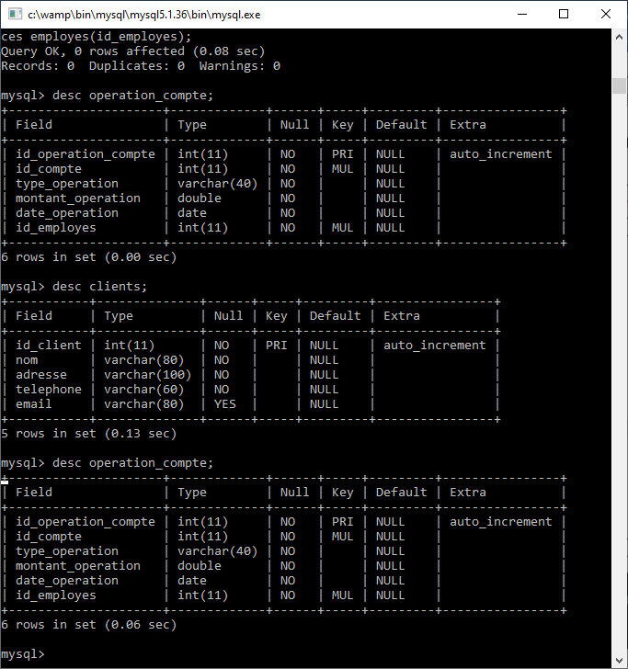

* **TABLE AGIOS**

|  |  |  |
| --- | --- | --- |
| **Id_agios** | **montant** | **taux** |
| int | double | int |

