Handout PiPossible

|  |  |  |
| --- | --- | --- |
| Name: | Rolle: | E-Mail: |
| Pascal Kunkel | Deployment, Design, Configuration | Kunkel.Pascal@student.dhbw-karlsruhe.de |
| Niklas Rajsp | Softwaredeveloper, Testmanager | Rajsp.Niklas@student.dhbw-karlsruhe.de |
| Adrian Schmidt | Produktmanager, Projektmanager | Schmidt.Adrian@student.dhbw-karlsruhe.de |

# Projektvorstellung:

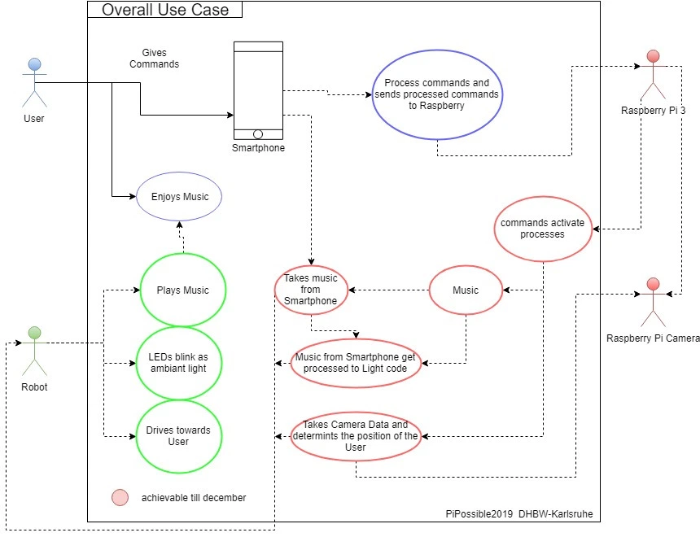

# Projektmanagement:

