**vlsimaster@JAI-SHRI-RAM:~$** cd PI_RISCV_Chip_Tapeout_2025/

**vlsimaster@JAI-SHRI-RAM:~/PI_RISCV_Chip_Tapeout_2025$** ls

Week0 Week1

**vlsimaster@JAI-SHRI-RAM:~/PI_RISCV_Chip_Tapeout_2025$** cd Week1

**vlsimaster@JAI-SHRI-RAM:~/PI_RISCV_Chip_Tapeout_2025/Week1$** ls

good_mux good_mux_synth.v log1.txt sky130_fd_sc_hd__tt_025C_1v80.lib tb_multiple_modules.v

good_mux.v good_mux_synth_.v multiple_modules.v tb_good_mux.v

**vlsimaster@JAI-SHRI-RAM:~/PI_RISCV_Chip_Tapeout_2025/Week1$** iverilog good_mux.v tb_good_mux.v -o good_mux

**vlsimaster@JAI-SHRI-RAM:~/PI_RISCV_Chip_Tapeout_2025/Week1$** ./good_mux

VCD info: dumpfile tb_good_mux.vcd opened for output.

**vlsimaster@JAI-SHRI-RAM:~/PI_RISCV_Chip_Tapeout_2025/Week1$** gtkwave tb_good_mux.vcd

GTKWave Analyzer v3.3.104 (w)1999-2020 BSI

[0] start time.

[300000] end time.

WM Destroy

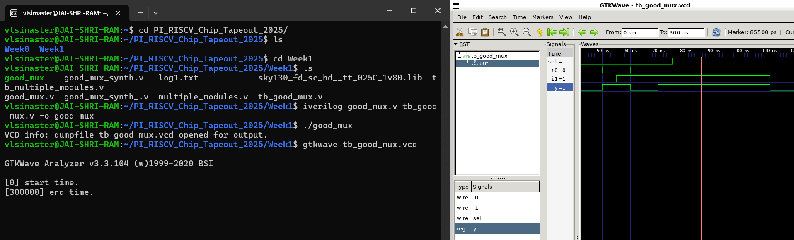

**vlsimaster@JAI-SHRI-RAM:~/PI_RISCV_Chip_Tapeout_2025/Week1$ yosys**

/----------------------------------------------------------------------------\

| yosys -- Yosys Open SYnthesis Suite |

| Copyright (C) 2012 - 2025 Claire Xenia Wolf <claire@yosyshq.com> |

| Distributed under an ISC-like license, type "license" to see terms |

\----------------------------------------------------------------------------/

Yosys 0.55+46 (git sha1 5b8b5292e, g++ 11.4.0-1ubuntu1~22.04 -fPIC -O3)

**yosys> read_liberty -lib sky130_fd_sc_hd__tt_025C_1v80.lib**

1. Executing Liberty frontend: sky130_fd_sc_hd__tt_025C_1v80.lib

Imported 418 cell types from liberty file.

**yosys> read_verilog good_mux.v**

2. Executing Verilog-2005 frontend: good_mux.v

Parsing Verilog input from `good_mux.v' to AST representation.

Generating RTLIL representation for module `\good_mux'.

Successfully finished Verilog frontend.

**yosys> synth -top good_mux**

3.22.1.1. Executing ABC.

Running ABC command: "<yosys-exe-dir>/yosys-abc" -s -f <abc-temp-dir>/abc.script 2>&1

ABC: ABC command line: "source <abc-temp-dir>/abc.script".

ABC:

ABC: + read_blif <abc-temp-dir>/input.blif

ABC: + read_library <abc-temp-dir>/stdcells.genlib

ABC: + strash

ABC: + dretime

ABC: + map

ABC: + write_blif <abc-temp-dir>/output.blif

3.22.1.2. Re-integrating ABC results.

ABC RESULTS: MUX cells: 1

ABC RESULTS: internal signals: 0

ABC RESULTS: input signals: 3

ABC RESULTS: output signals: 1

Removing temp directory.

3.24. Executing HIERARCHY pass (managing design hierarchy).

Attribute `top' found on module `good_mux'. Setting top module to good_mux.

3.24.1. Analyzing design hierarchy..

Top module: \good_mux

3.24.2. Analyzing design hierarchy..

Top module: \good_mux

Removed 0 unused modules.

3.25. Printing statistics.

=== good_mux ===

Number of wires: 4

Number of wire bits: 4

Number of public wires: 4

Number of public wire bits: 4

Number of ports: 4

Number of port bits: 4

Number of memories: 0

Number of memory bits: 0

Number of processes: 0

Number of cells: 1

$_MUX_ 1

3.26. Executing CHECK pass (checking for obvious problems).

Checking module good_mux...

Found and reported 0 problems.

**yosys> abc -liberty sky130_fd_sc_hd__tt_025C_1v80.lib**

**yosys> show**

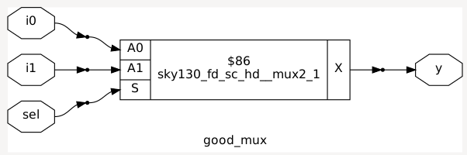

**yosys> write_verilog good_mux_synth1.v**

*(without -noattr)*

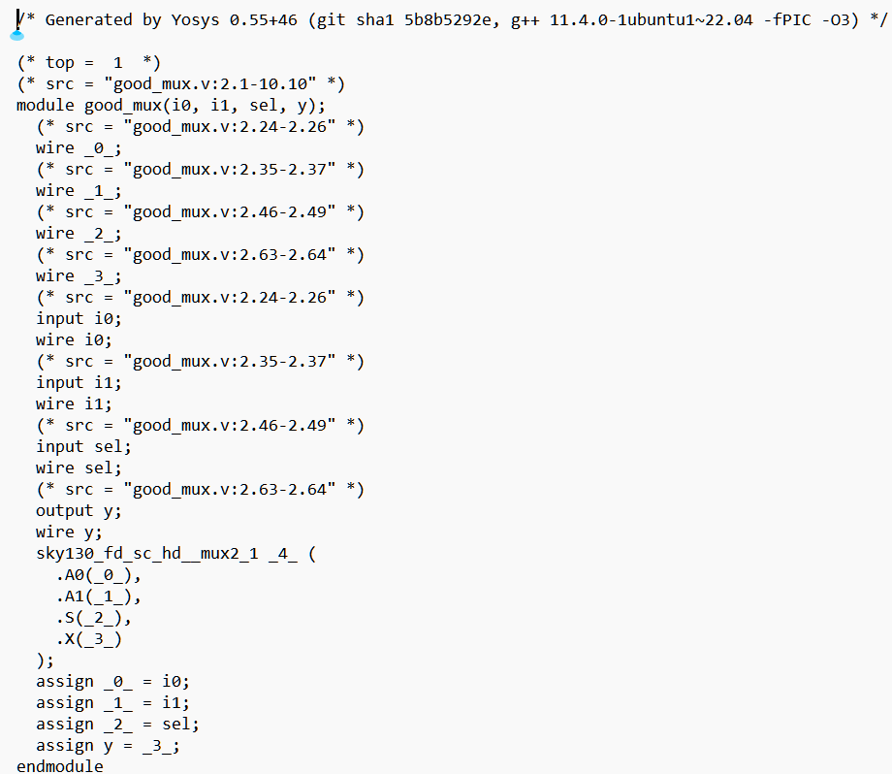

**yosys> write_verilog -noattr good_mux_synth2.v**

*(with -noattr)*

vlsimaster@JAI-SHRI-RAM:~/PI_RISCV_Chip_Tapeout_2025/Week1$ yosys

/----------------------------------------------------------------------------\

| yosys -- Yosys Open SYnthesis Suite |

| Copyright (C) 2012 - 2025 Claire Xenia Wolf <claire@yosyshq.com> |

| Distributed under an ISC-like license, type "license" to see terms |

\----------------------------------------------------------------------------/

Yosys 0.55+46 (git sha1 5b8b5292e, g++ 11.4.0-1ubuntu1~22.04 -fPIC -O3)

yosys> read_liberty -lib sky130_fd_sc_hd__tt_025C_1v80.lib

1. Executing Liberty frontend: sky130_fd_sc_hd__tt_025C_1v80.lib

Imported 418 cell types from liberty file.

yosys> read_verilog multiple_modules.v

2. Executing Verilog-2005 frontend: multiple_modules.v

Parsing Verilog input from `multiple_modules.v' to AST representation.

Generating RTLIL representation for module `\sub_module2'.

Generating RTLIL representation for module `\sub_module1'.

Generating RTLIL representation for module `\multiple_modules'.

Successfully finished Verilog frontend.

yosys> synth -top multiple_modules

3.25. Printing statistics.

=== multiple_modules ===

Number of wires: 5

Number of wire bits: 5

Number of public wires: 5

Number of public wire bits: 5

Number of ports: 4

Number of port bits: 4

Number of memories: 0

Number of memory bits: 0

Number of processes: 0

Number of cells: 2

sub_module1 1

sub_module2 1

=== sub_module1 ===

Number of wires: 3

Number of wire bits: 3

Number of public wires: 3

Number of public wire bits: 3

Number of ports: 3

Number of port bits: 3

Number of memories: 0

Number of memory bits: 0

Number of processes: 0

Number of cells: 1

$_AND_ 1

=== sub_module2 ===

Number of wires: 3

Number of wire bits: 3

Number of public wires: 3

Number of public wire bits: 3

Number of ports: 3

Number of port bits: 3

Number of memories: 0

Number of memory bits: 0

Number of processes: 0

Number of cells: 1

$_OR_ 1

=== design hierarchy ===

multiple_modules 1

sub_module1 1

sub_module2 1

Number of wires: 11

Number of wire bits: 11

Number of public wires: 11

Number of public wire bits: 11

Number of ports: 10

Number of port bits: 10

Number of memories: 0

Number of memory bits: 0

Number of processes: 0

Number of cells: 2

$_AND_ 1

$_OR_ 1

yosys> abc -liberty sky130_fd_sc_hd__tt_025C_1v80.lib

yosys> show

5. Generating Graphviz representation of design.

ERROR: For formats different than 'ps' or 'dot' only one module must be selected.

yosys> show multiple_modules

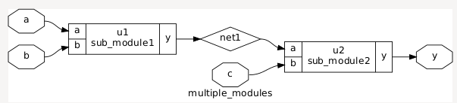

yosys> flatten

7. Executing FLATTEN pass (flatten design).

Deleting now unused module sub_module1.

Deleting now unused module sub_module2.

yosys> show multiple_modules

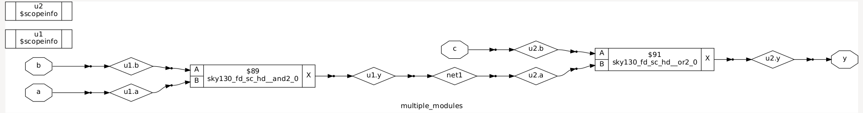

yosys> synth -top sub_module2d

yosys> show sub_module2

