PORTABLE WATER FILTER AND SAFETY MONITORING SYSTEM

EMBEDDED SYSTEMS: COEPRO15

Submitted by:
Alon, Angel Andrein L.
Amaba, Ariel John A.
Barcelona, Leo Jay B. De
Jesus, Christian Garcia, Llyod Andrei D.
Ilao, Kyle Andrei James Z.
Jovelo, Robie R.
Macabangon, Pia Nicole B.
Ortenero, Mel Paolo

Bachelor of Science in Computer Engineering
Submitted in the College of Engineering and Digital Technology
Department of Computer Engineering

Sir. Meiko Rios

Objectives
- To develop a system that detects water quality using pH, turbidity, TDS, and temperature sensors.
- To provide real-time safety feedback through display, LED indicators, and buzzer alerts.
- To ensure portability with rechargeable battery power management.
- To design a compact and user-friendly embedded system for quick water safety checks.
- To integrate a basic water filtration mechanism that improves water quality after detection.

System Functions
- Water Quality Monitoring System: Uses pH, turbidity, TDS, and temperature sensors to analyze water samples.
- Threshold Detection: Categorizes readings into Safe, Warning, Unsafe based on WHO standards.
- Alert System: Activates LED indicators and buzzer for real-time notification.
- Display System: Shows sensor readings and safety status on OLED/LCD.
- Power Management: Provides portable, rechargeable energy via Li-ion battery and TP4056 module.
- Water Filtration Control System: Enables the system to initiate a filtration process when water quality is classified as unsafe or at a warning level, using a pump and filter setup to improve water condition before conducting another analysis.
Technical Components
Category | Component | Quantity | Purpose
Microcontroller | Arduino Nano/Uno | 1 | Processes sensor signals and  controls display
Sensor | pH Sensor Module | 1 | Detects acidity/alkalinity
Sensor | Turbidity Sensor Module | 1 | Measures water clarity
Sensor | TDS Sensor Module | 1 | Measures dissolved solids
Sensor | TemperatureSensor (DS18B20) | 1 | Measures water temperature
Display | OLED/LCD Displa | 1 | Shows readings and safety status
Output | LED Indicartors (Green, Yellow, Red) | 3 | Displays water safety status
Output | Active Piezo Buzzer | 1 | Produces alert sound
Power | V9 Battery | 2 | Portable power source
Interconnects | Wires | 1 | Conductive paths for electricity.
Actuator | Mini water pump activated water filter | 1 | Moves water through filtration  system
Filter | Sendiment Filter | 1 | Removes impurities and odor
Control | Relay Control | 1 | Controls pump ON/OF
Tubin | Tubing | 1 Set | Water flow connection

Prototype Visualization:
Prototype Description: The proposed prototype is a compact embedded device with sensors immersed in water samples. The system includes:
- Sensor probes for pH, turbidity, TDS, and temperature
- OLED/LCD display for real-time readings
- LED indicators and buzzer for alerts
- Rechargeable battery with TP4056 charging module
- Breadboard/PCB for connections
- 3-stage water filtration module (sediment, carbon, and UF/CB filter)
- Relay-controlled water pump for automated filtration process
Filtration and Water Flow Mechanism: The system is enhanced with a filtration module that activates when water quality is detected as unsafe or at a warning level. A relaycontrolled water pump directs the water through a multi-stage filtration system to remove impurities such as suspended particles, odor, and some microorganisms. After filtration, the water is re-tested by the sensors to verify improvement in quality.
Closed-Loop Feedback System: The prototype operates in a feedback loop where water is continuously monitored, filtered when necessary, and re-evaluated. This ensures more reliable and accurate water quality assessment.
Instant Safety Status Indicator: Simplifies interpretation with clear categories.
- Non-Invasive Measurement: Uses sensor-based technology for easy sampling.
- Portable and Lightweight Design: Compact, battery-powered, and easy to carry.
- User-Friendly Interface: Clear OLED/LCD display for accessibility.
- Low-Cost Implementation: Affordable components make it accessible to communities.
- Automated Threshold-Based Detection: Provides immediate safety classification.
- Energy-Efficient Operation: Optimized power management for extended use.
- Integrated Filtration System: Automatically filters water when unsafe levels are detected.
- Automated Water Flow Control: Utilizes a pump and relay module to regulate the filtration process.

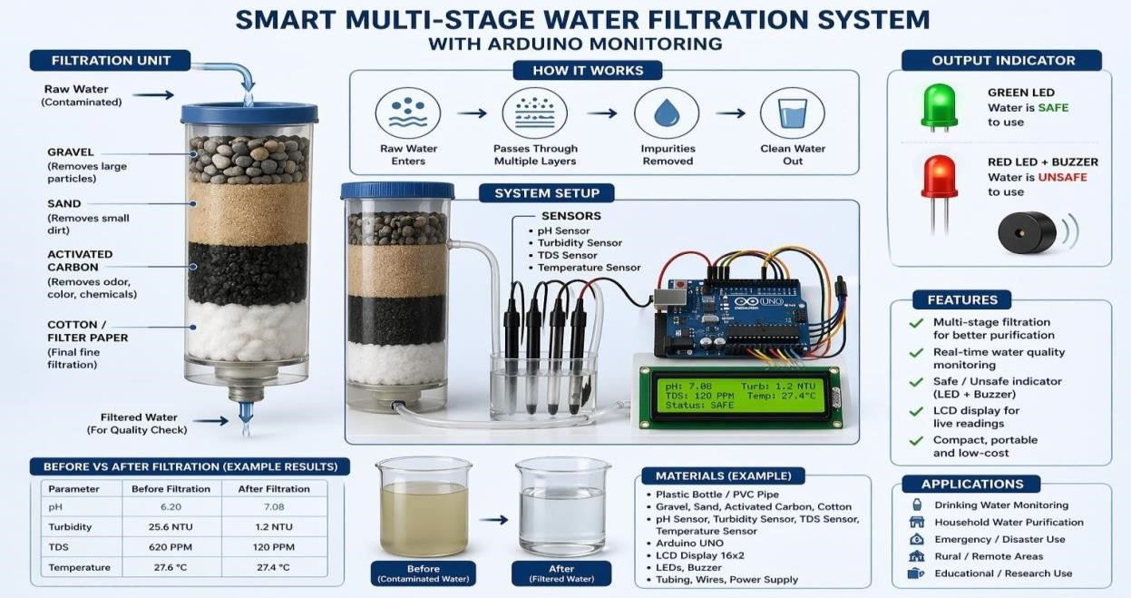

Schematic Connections:
Component | Arduino Pin | Connection Type
pH Sensor | A0 | Analog Input
Turbidity Sensor | A1 | Analog Input
TDS Sensor | A2 | Analog Input
Temperature Sensor | D2 | Digital Input
OLED (SDA) | A4 | I2C Data Line
OLED (SCL) | A5 | I2C Clock Line
Green LED | D8 | Digital Output
Yellow LED | D9 | Digital Output
Red LED | D10 | Digital Output
Buzzer | D11 | Digital Output
V9 Battery | VIN/GND | Power Supply
Relay Module | D7 | Digital Output
Water Pump | External Power | Controlled by Relay

Estimated Cost (PHP):
Item | Estimated Price
Arduino Nano/Uno | ₱287.00
OLED Display | ₱230.00
pH Sensor | ₱582.00
Turbidity Sensor | ₱290.00
TDS Sensor | ₱516.00
Temperature Sensor | ₱167.00
9V Energizer Battery | ₱100.00
LEDs Indicators, Wires | ₱102.00
Active Passive Buzzer | ₱105.00
Mini Water Pump/filter | ₱116.00
Relay Module | ₱128.00
TOTAL: ₱2,623.00

COMPONENTS:
ARDUINO UNO
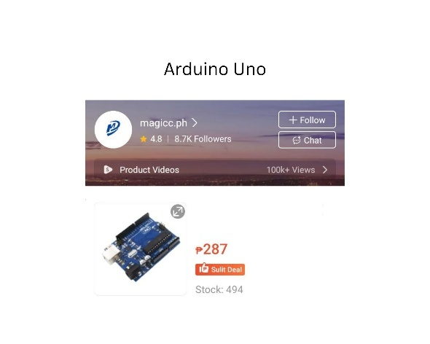

SHOP NAME | PRICE
Magicc.ph | ₱ 287.00

TURBIDITY SENSOR MODULE
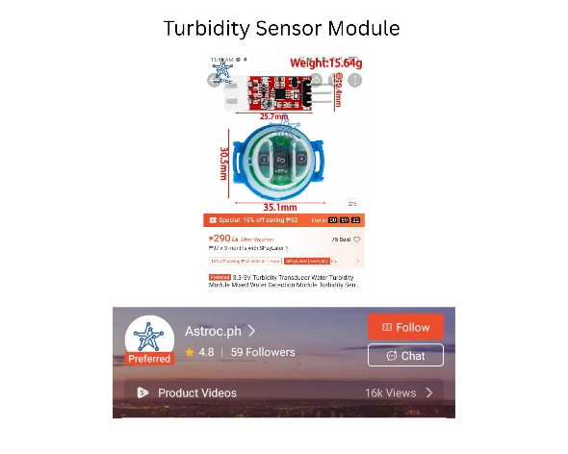
SHOP NAME | PRICE
Astroc.ph | ₱ 290.00

TDS SENSOR MODULE
SHOP NAME | PRICE
MakerLab | ₱ 561.00
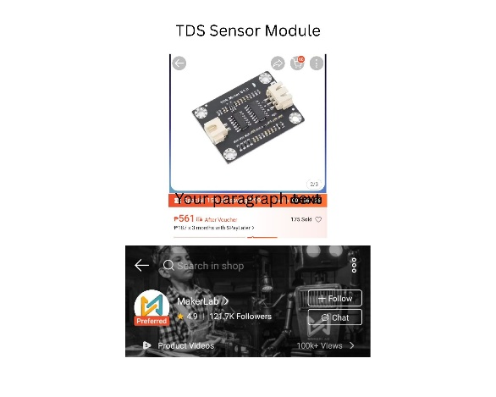

TEMPERATURE SENSOR MODULE (DS18B20)
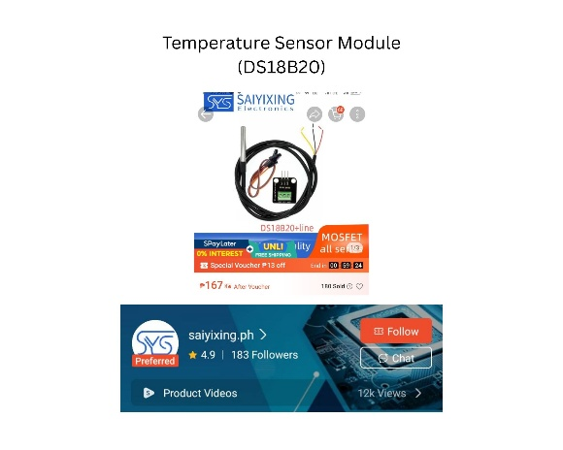

SHOP NAME | PRICE
Saiyixing.ph | ₱ 167.00

OLED/LCD DISPLAY
SHOP NAME | PRICE
Kingzizi.ph | ₱ 230.00
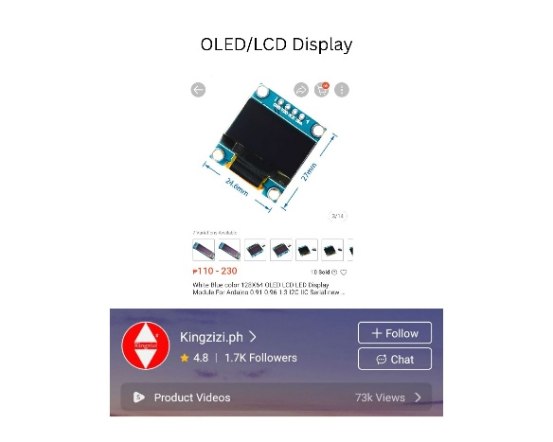

LED INDICATORS (YELLOW, GREEN, RED)
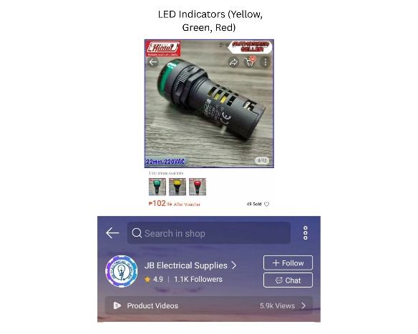
SHOP NAME | PRICE
JB Electrical Supplies | ₱ 102.00

ACTIVE PASSIVE BUZZER
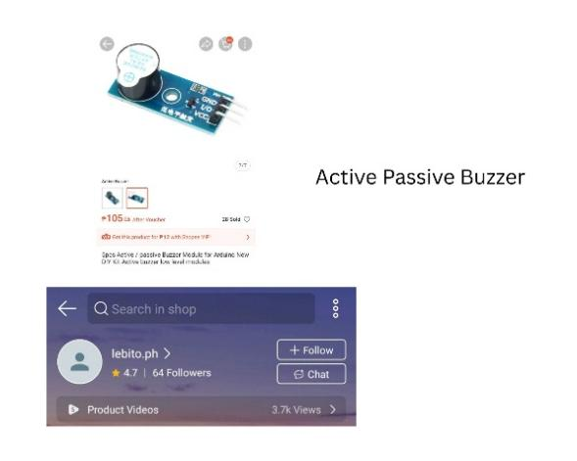
SHOP NAME | PRICE
Lebito.ph | ₱ 105.00

9V BATTERY
SHOP NAME | PRICE
Pandayan Plus | ₱ 107.00
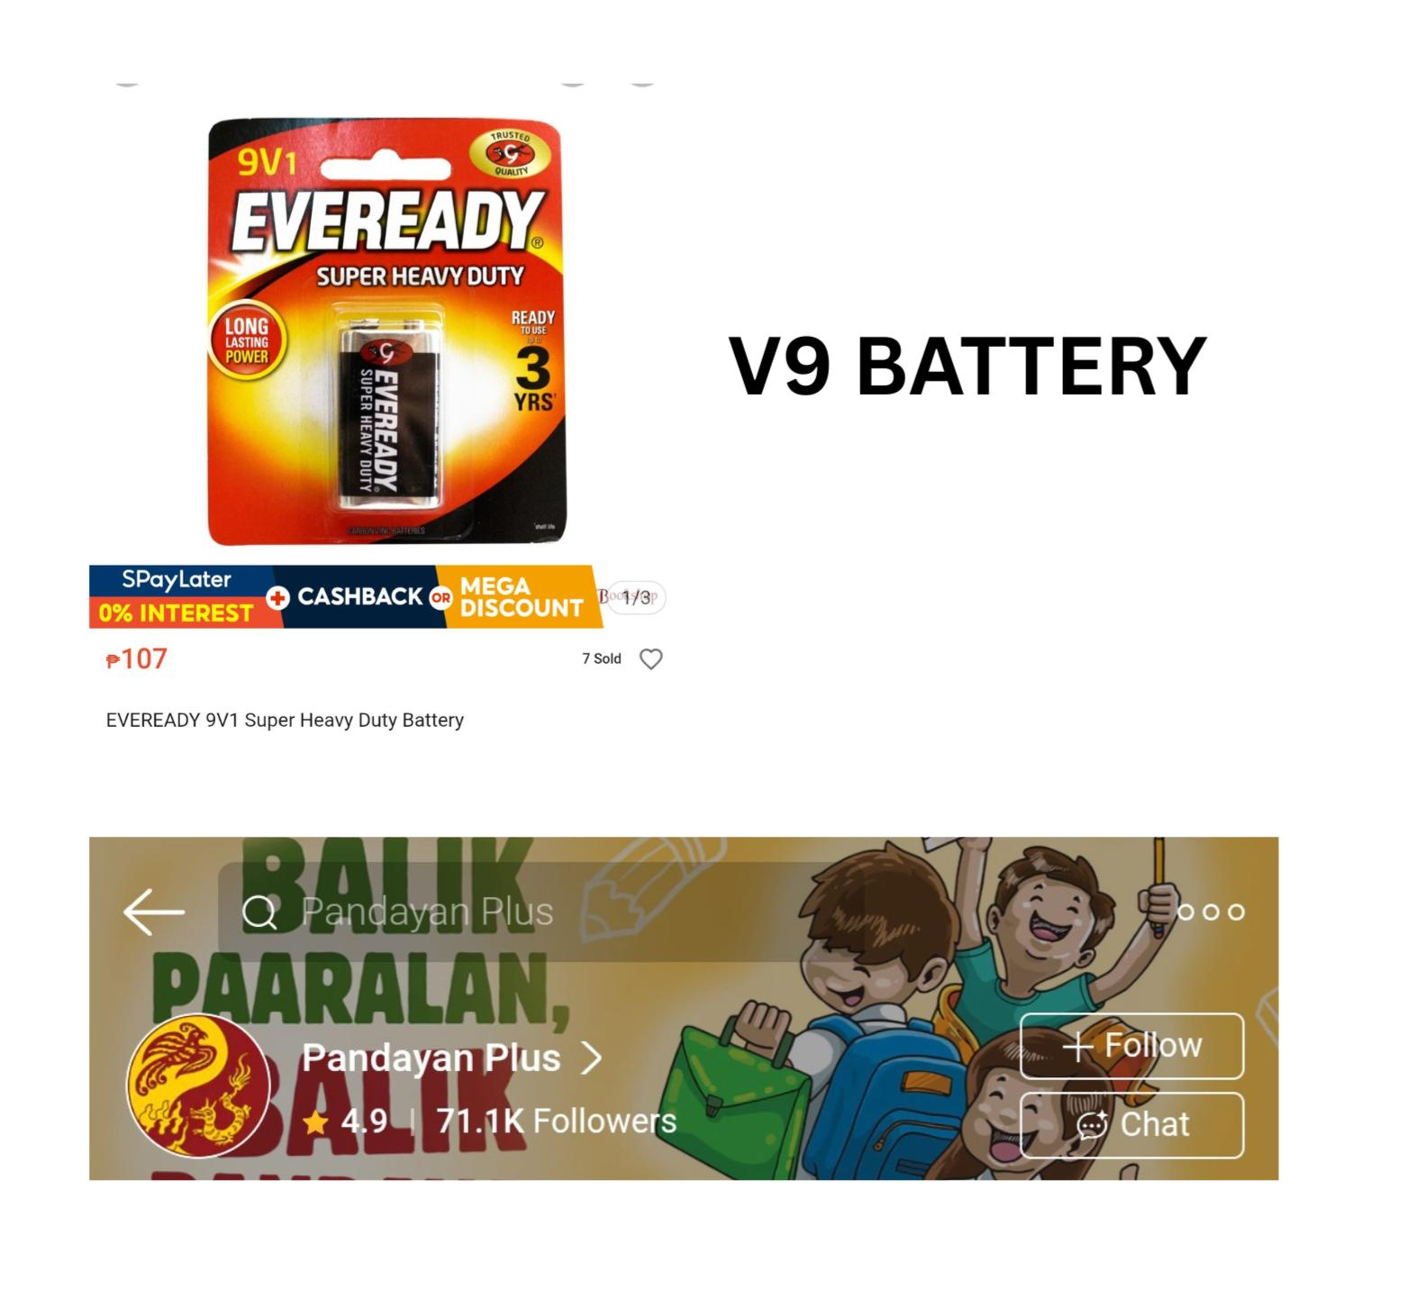

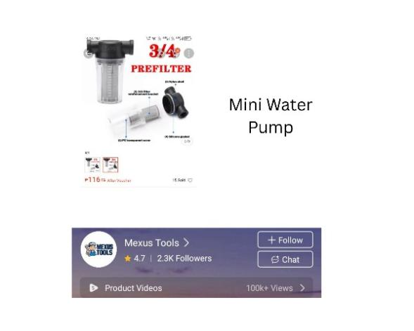
MINI WATER PUMP
SHOP NAME | PRICE
Mexus Tools | ₱ 116.00

RELAY MODULE
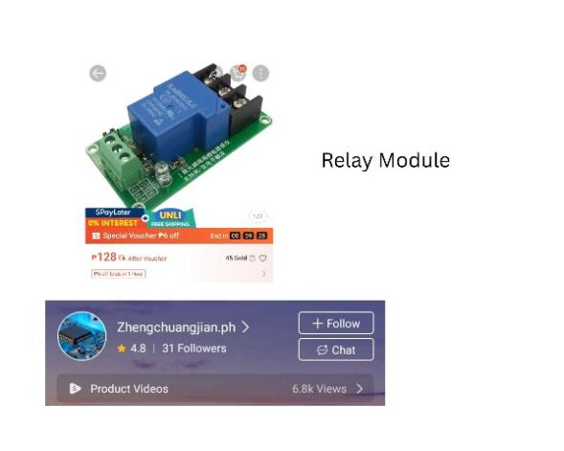
SHOP NAME | PRICE
Zengchuangjian.ph | ₱ 128.00

PH SENSOR
SHOP NAME | PRICE
Reland2.ph | ₱ 582.00
