Pia M. Arak BSIT-II B

James Atacador Computer Programming II

**Introduction:**

Teachers have found difficulties in computing the final average grade of students when using Calculators and Excel App. It is somehow inconvenience for them use calculators since they manually put the numbers on the calculators without any label on them so it may cause uncertainties of the values. Also, they calculate the final average grade of the students on a step-by-step basis since isn’t programmed to directly calculate for the average value of the values that has been inputted. While when using Excel App it is also inconvenient for the teachers because, though it was already programmed to calculate the average value of the grades of students, they would still move the cursor at the end of the display to find the final average grade or value.

The beauty of this application “Grading System” is that teachers will just put the values/grades of every subject on their desired places on the application and then with just one click, the final average grade is already been calculated by the application. This application is very convenient for the teachers to use since it is not like the calculators that should be operated manually just to get the average. Also, unlike the excel app, you don’t need to move the cursor of this app just to find out the average value of grades.

The main goal of this application is to help High School teachers to calculate the final grades of the students in the easiest way. This application is very fit for teachers to use where they can easily calculate the final average grade of their students with just one click. There will be no inconvenience to them since the display of this application is very clear and understandable. Other than they can easily compute the said values, teachers can also save time and energy than using any other application or devices.

Inside the said application there are eight boxes corresponding the subject (common) a high school student is taking up (English, Math, Science, Filipino, Araling Panlipunan Computer, Vocational Arts, MAPEH). The teacher should fill in all the eight boxes in order to get the student’s final average and just but one click, they can also add its record for future reference. This application is separate from any other documents of the students record. It only consists of the final grades of a student for every subject and the average value of their grades.

**Technologies:**

There were three technologies that has been used to develop the Grading System Application namely the Netbeans, Wamp server, and MySql.

**Screenshots:**

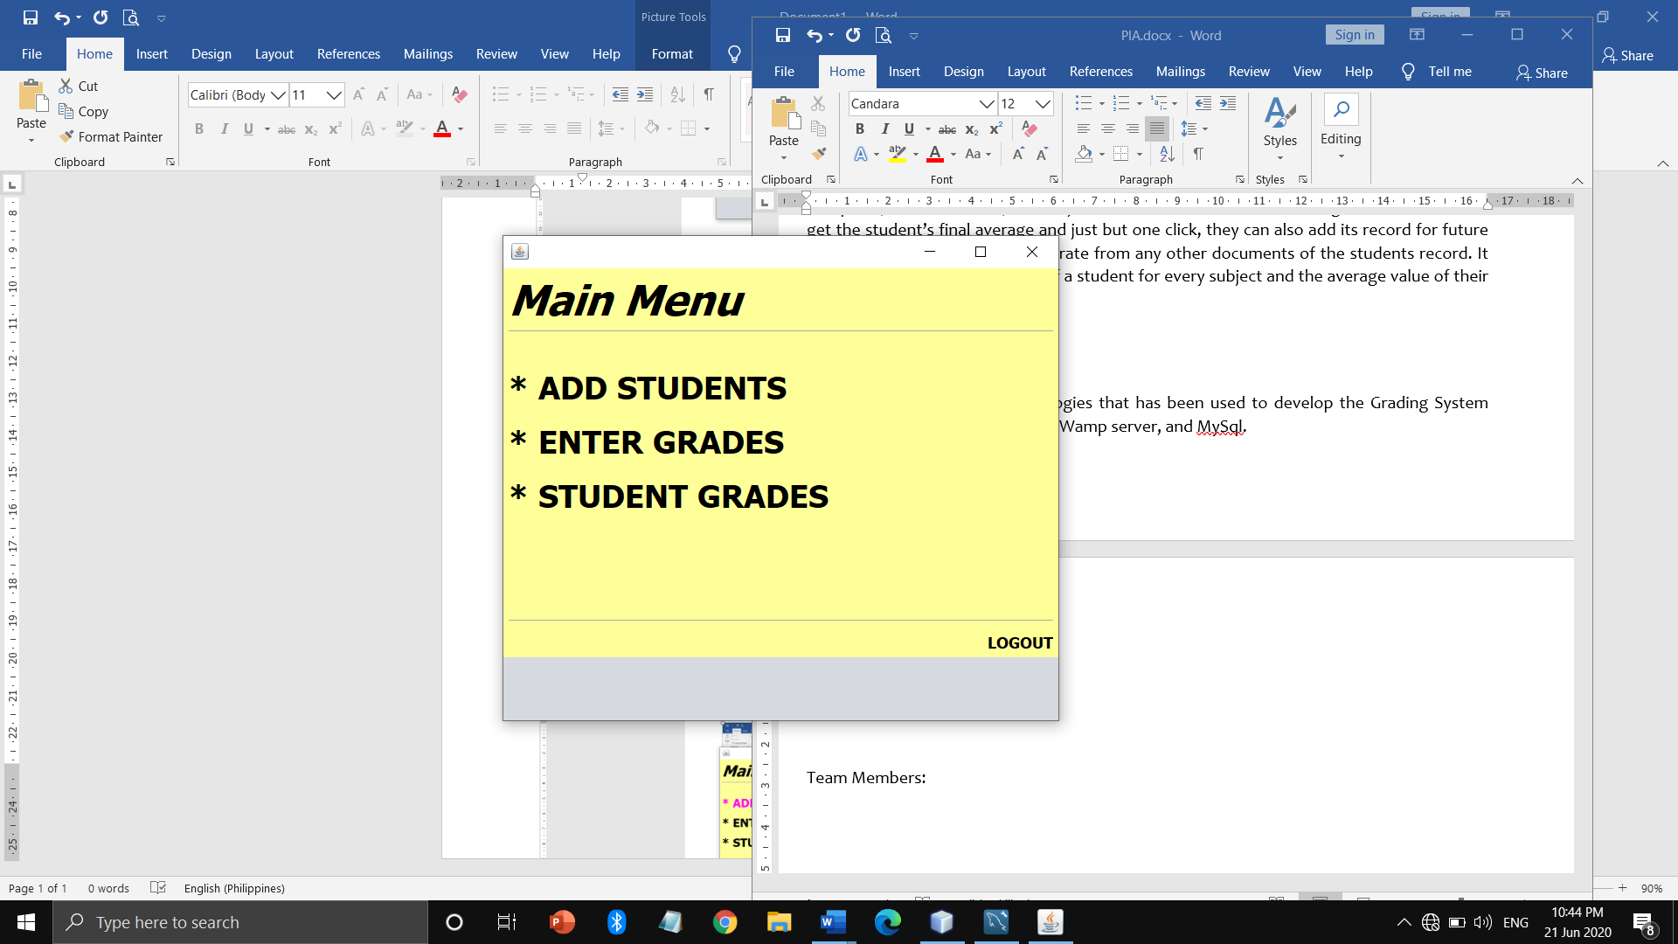

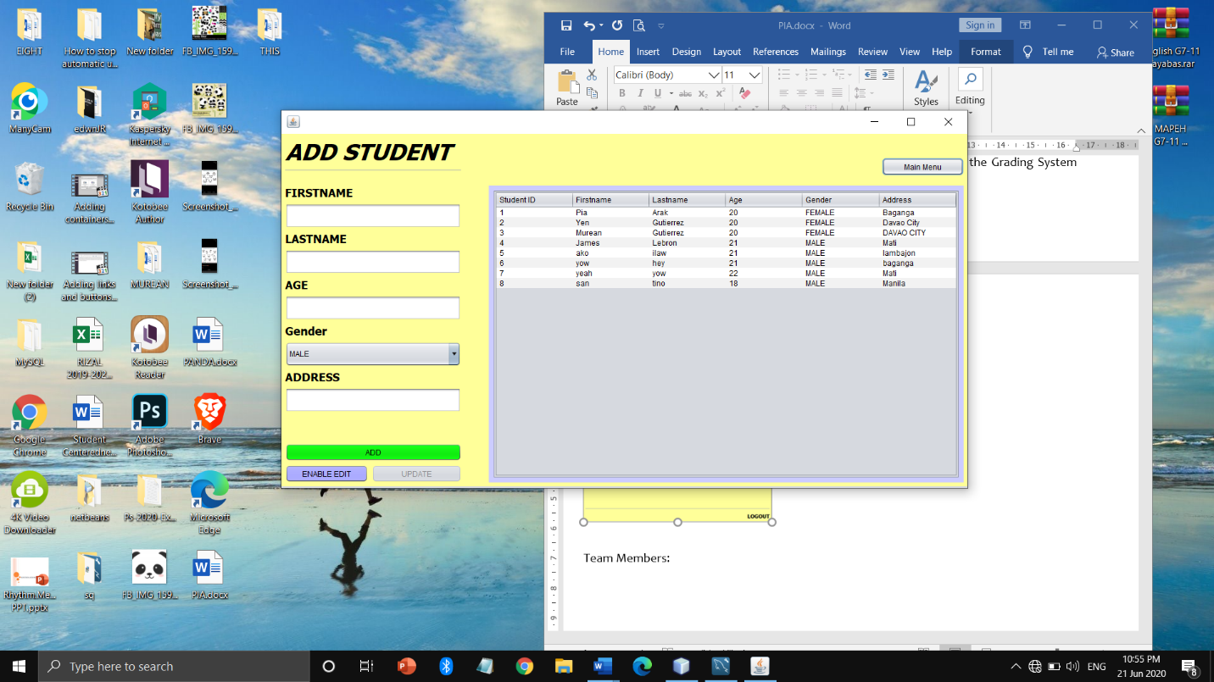

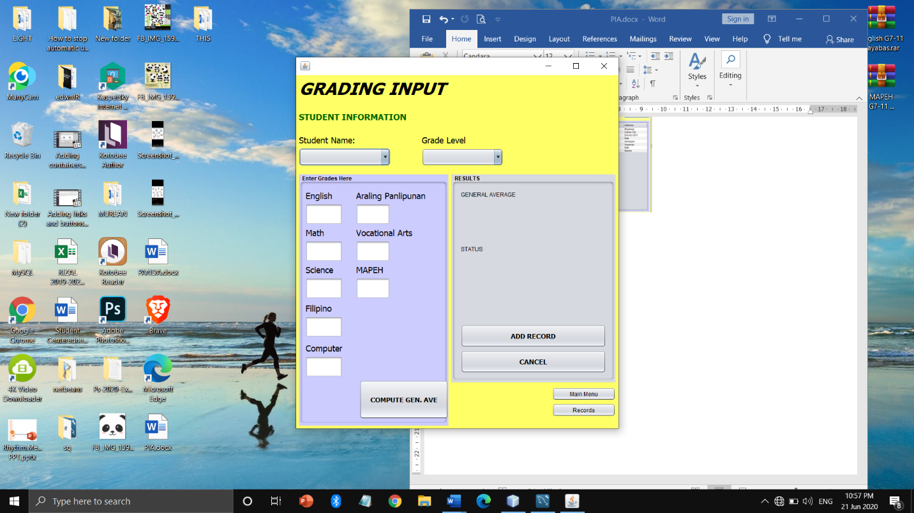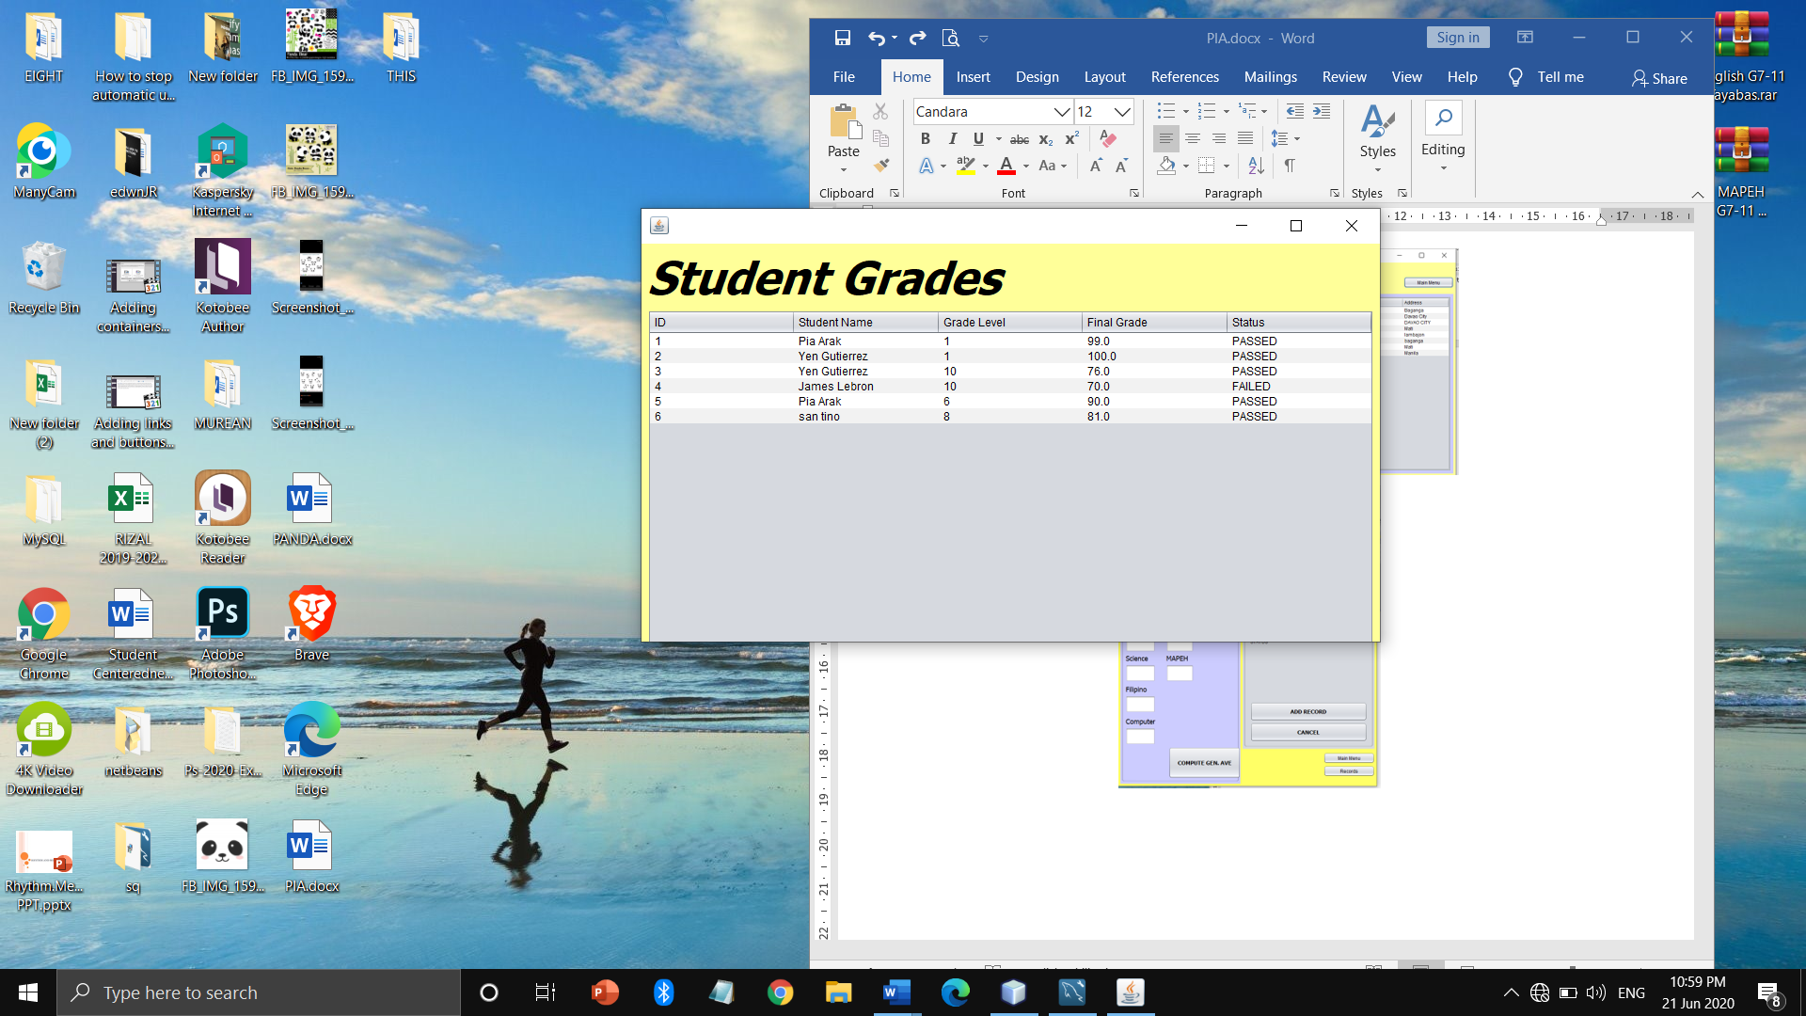

**Team Members:**

**Pia M. Arak**

* **App designer**



**James Atacador**

* **Encoder**