http://127.0.0.1:8888/JSON/ascan/action/scan/?url=https%3A%2F%2Ftodoist.com%2F&recurse=&inScopeOnly=&scanPolicyName=&method=&postData=&contextId=

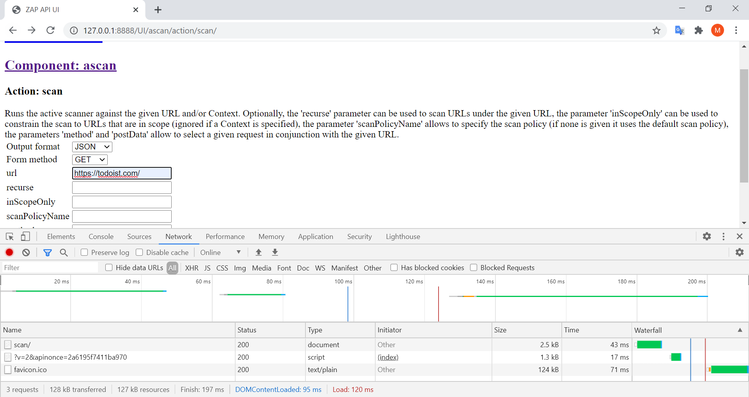
asasa

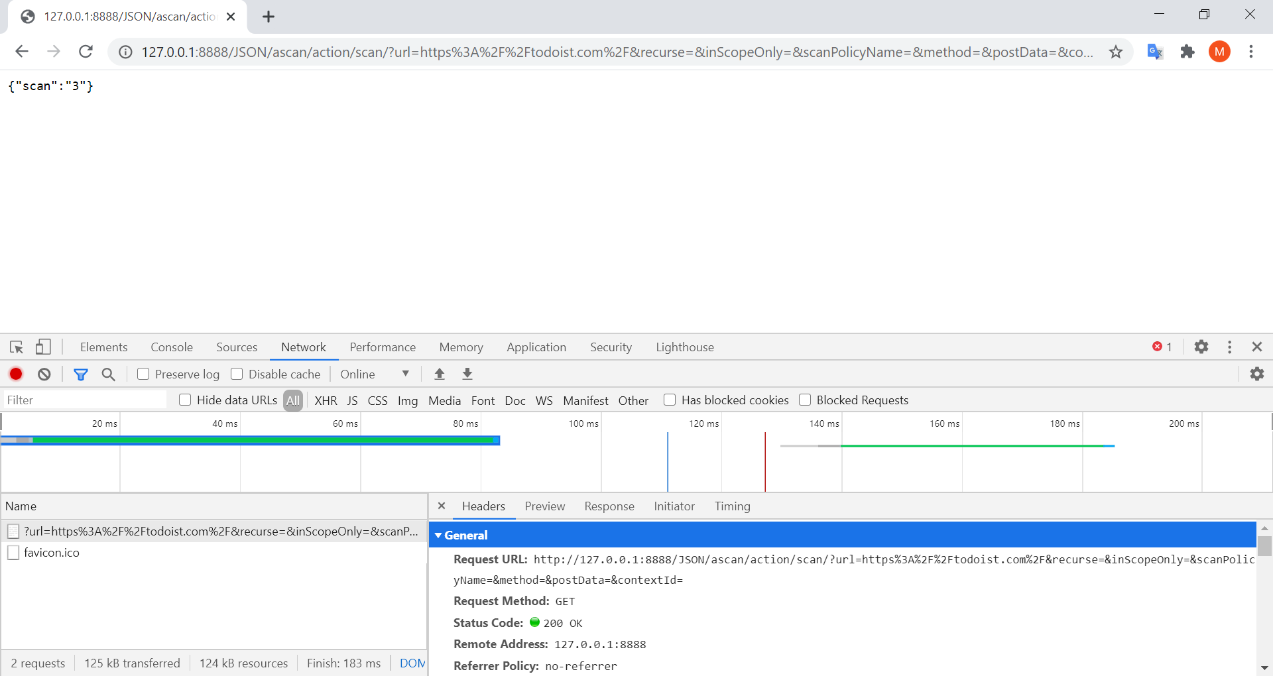
ScanID
http://127.0.0.1:8888/JSON/ascan/view/scanProgress/?scanId=4
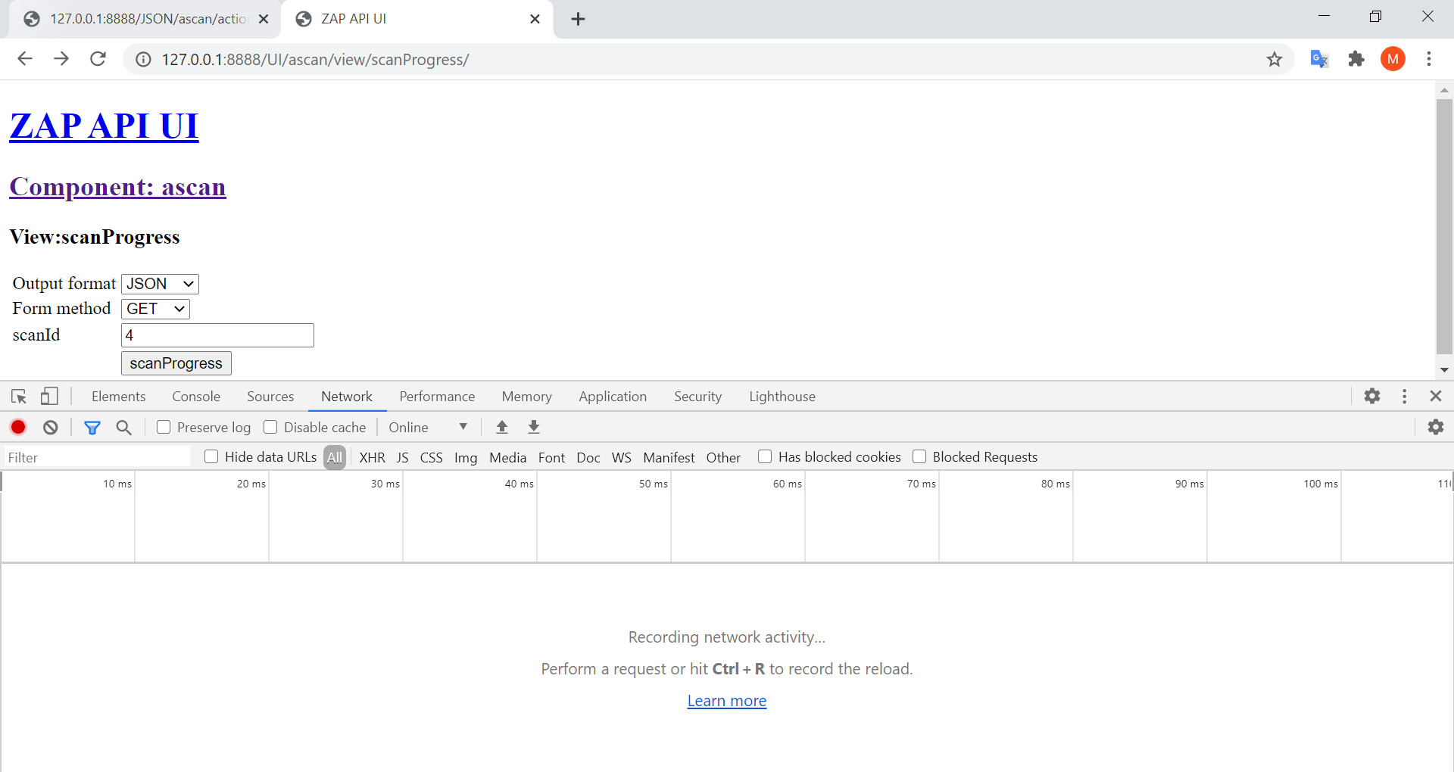

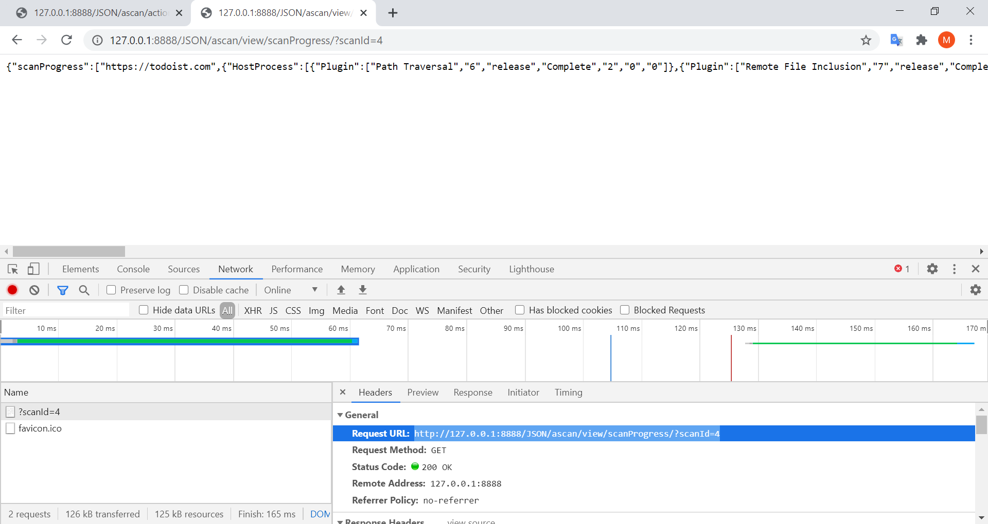
Status
http://127.0.0.1:8888/JSON/ascan/view/status/?scanId=4

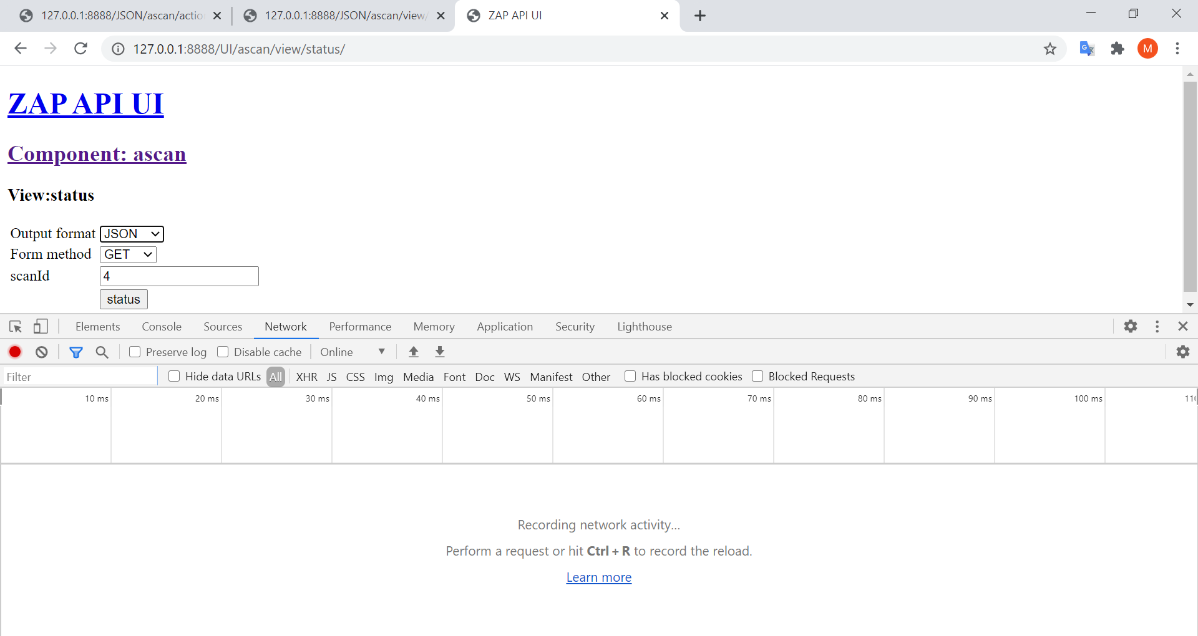
sd

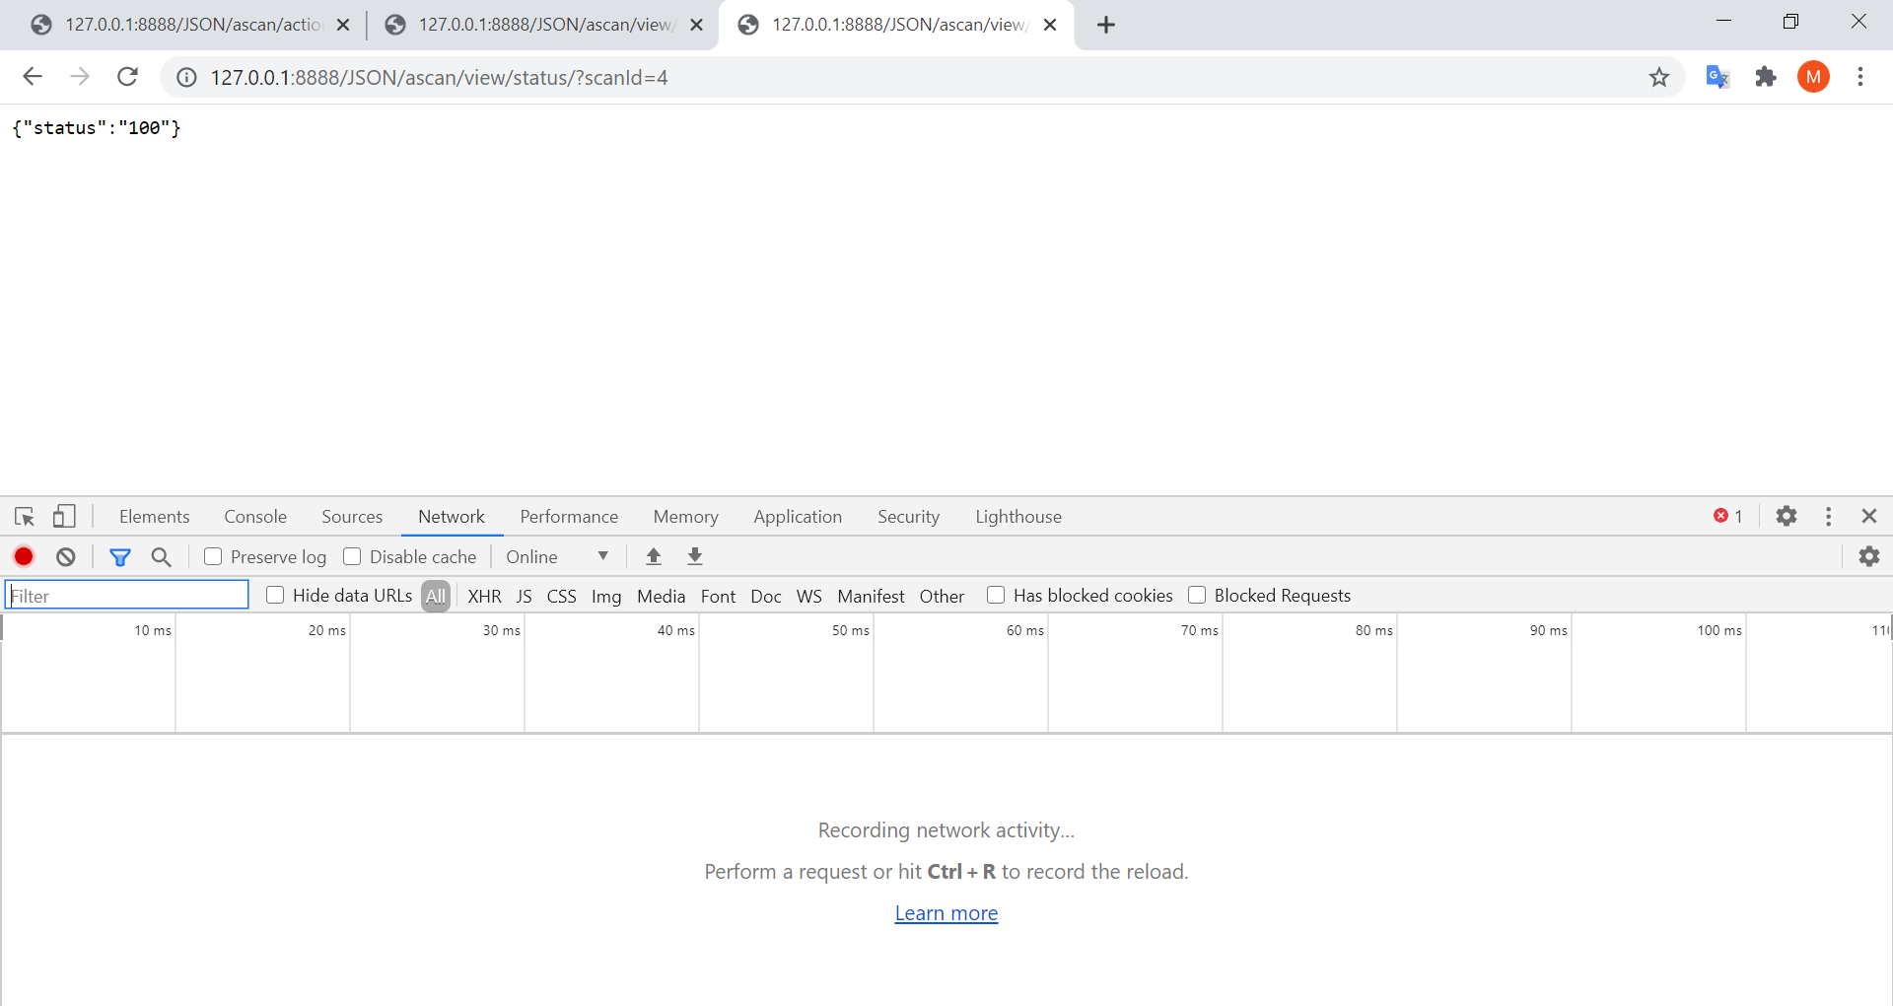
html report
http://127.0.0.1:8888/OTHER/core/other/htmlreport/?

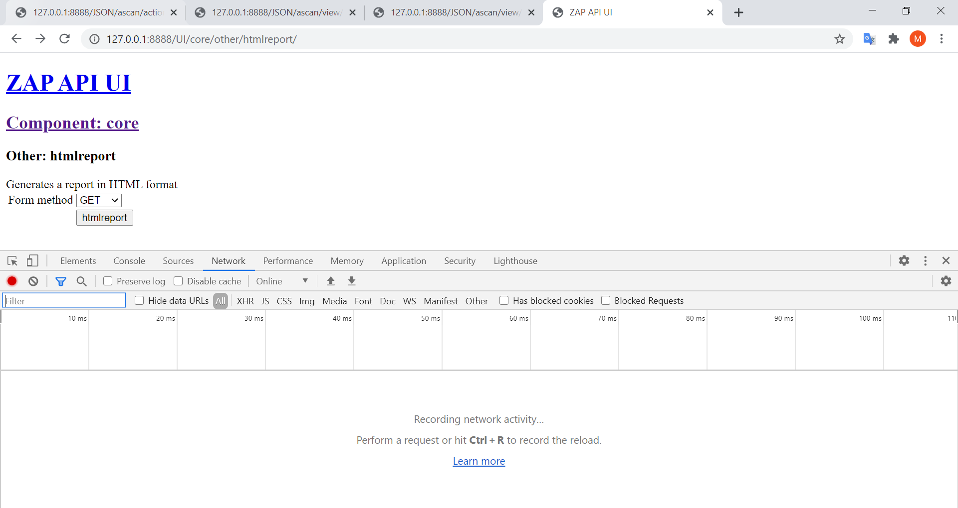
asa
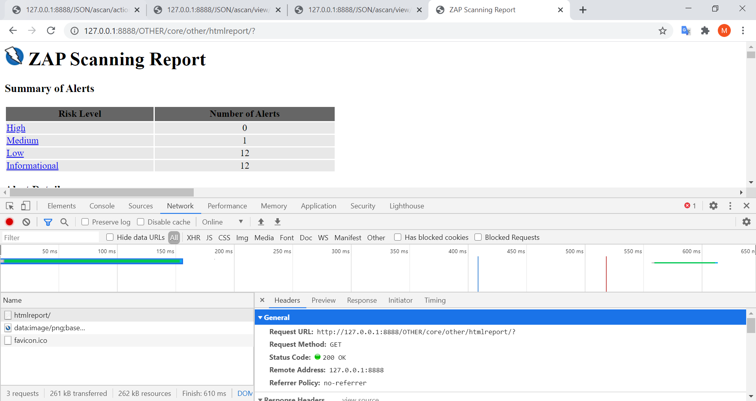
ScanProgress con html
http://127.0.0.1:8888/HTML/ascan/view/scanProgress/?scanId=4
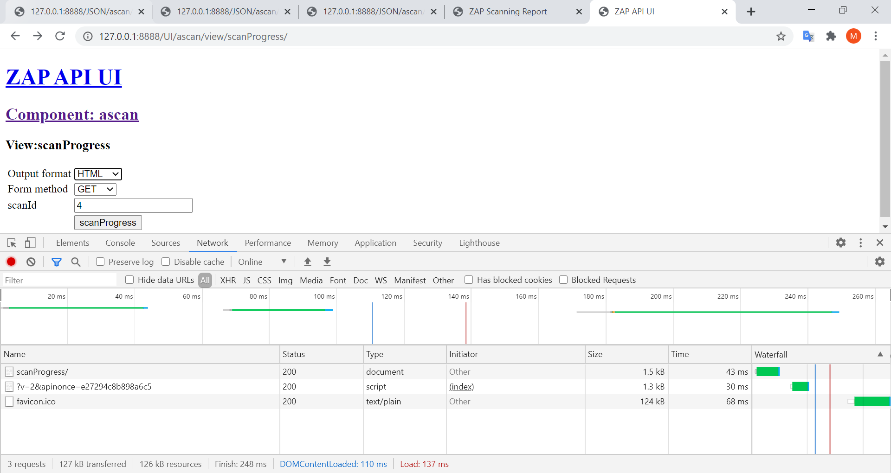
dsd

