Experimental Module

The experiments/ directory contains scripts for analyzing and visualizing the behavior of the user fatigue model.

Each file represents a separate experiment exploring how different parameters affect attention dynamics and error probability.

attention_animation.py


Generates an animation showing how user attention changes over time.
The first phase simulates continuous alert exposure (attention decay).
The second phase simulates recovery (attention restoration).
The result is saved as a GIF to visualize fatigue dynamics.

attention_animation2.py


An extended version of the attention animation.
May include comparisons between multiple fatigue rates or alternative load scenarios.
Used to demonstrate differences between behavioral regimes.

dashboard.py

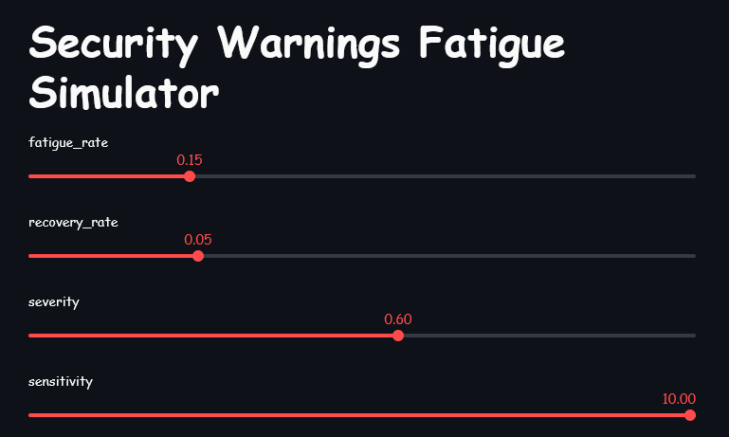
Interactive Streamlit dashboard.
Allows real-time adjustment of key model parameters:
- fatigue_rate
- recovery_rate
- severity
The attention curve updates instantly, enabling interactive exploration of the model.

error_attention.py

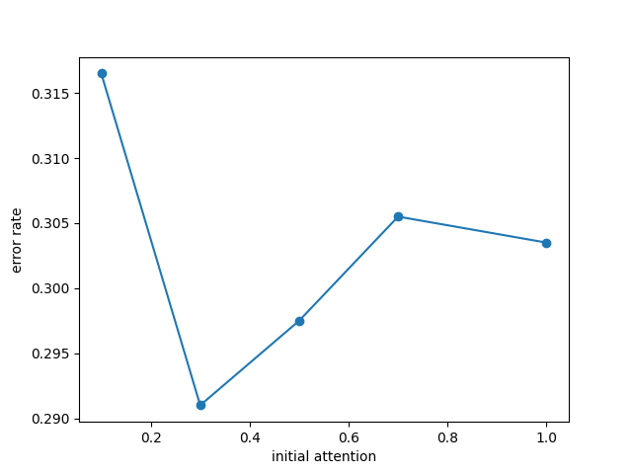
Analyzes the relationship between initial attention and error probability.
For different attention levels, the script computes the error rate and plots the dependency.
Demonstrates that lower attention leads to higher error probability.

error_heatmap.py

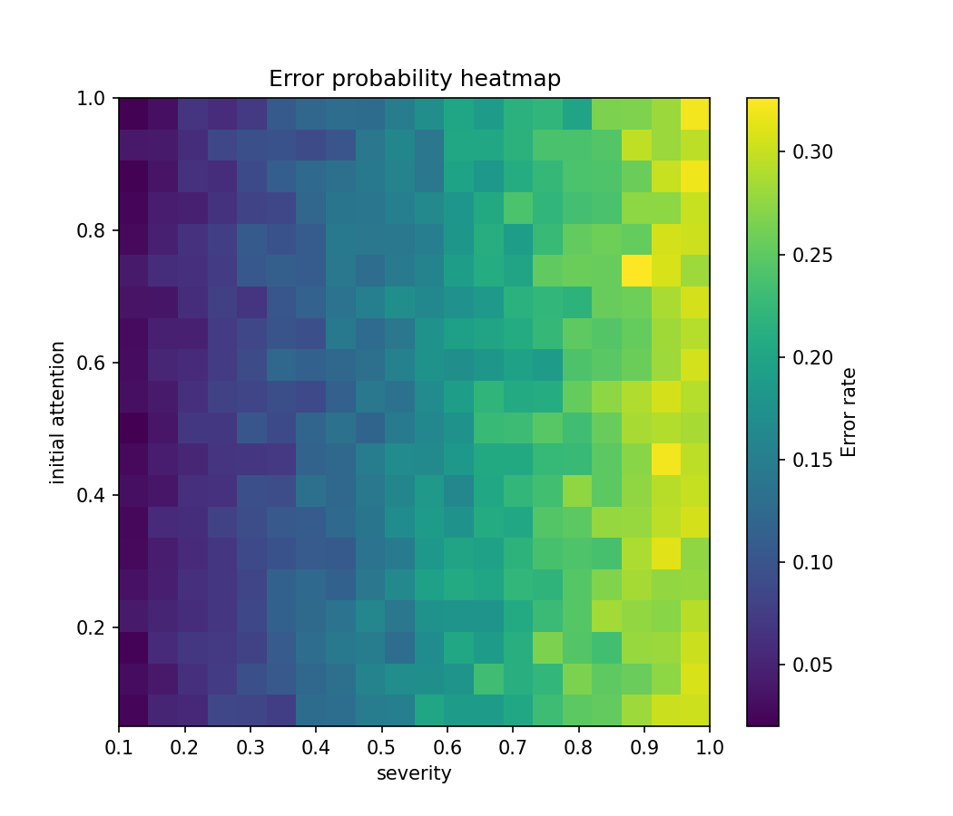
Builds a 2D heatmap showing error probability as a function of:
- initial attention
- alert severity
Highlights high-risk regions in the parameter space.

error_surface_3d.py

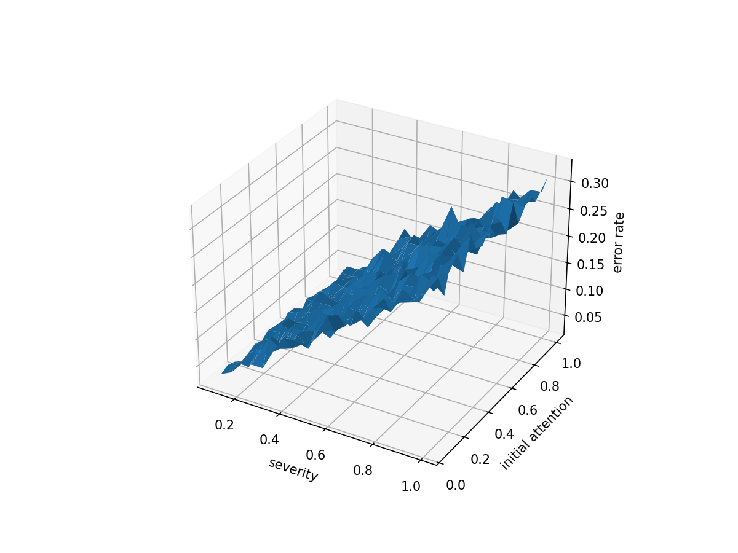
Creates a 3D surface plot of error probability depending on:
- severity
- initial attention
Provides a spatial visualization of the same relationship shown in the heatmap.

fatigue_recovery_plot.py

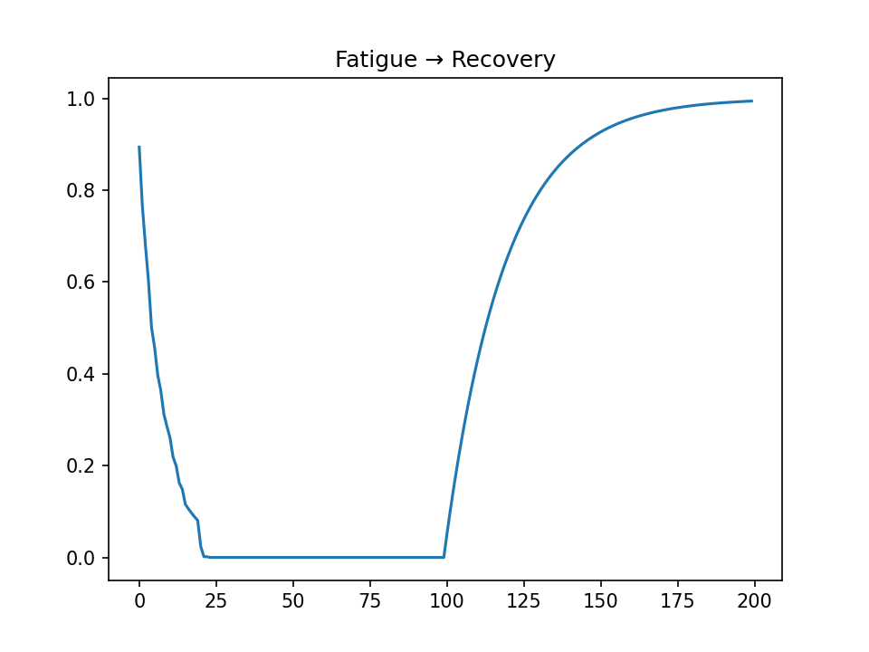
Simulates two stages:
- Continuous alert load (attention decay)
- Recovery period (attention restoration)
Plots attention dynamics across both phases.

fatigue_sweep.py

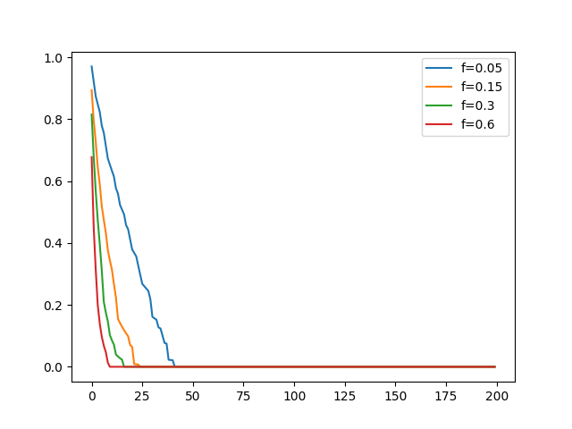
Compares multiple values of fatigue_rate.
Displays several attention decay curves on a single graph to show how fatigue speed affects degradation.

recovery_sweep.py
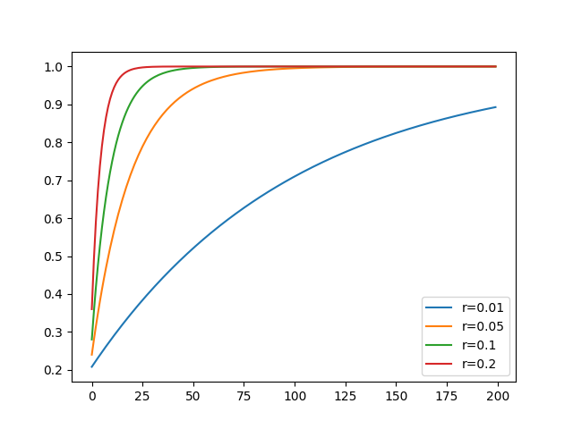
Analogous to fatigue_sweep, but for recovery_rate.
Demonstrates how different recovery speeds influence attention restoration.

monte_carlo_attention.py

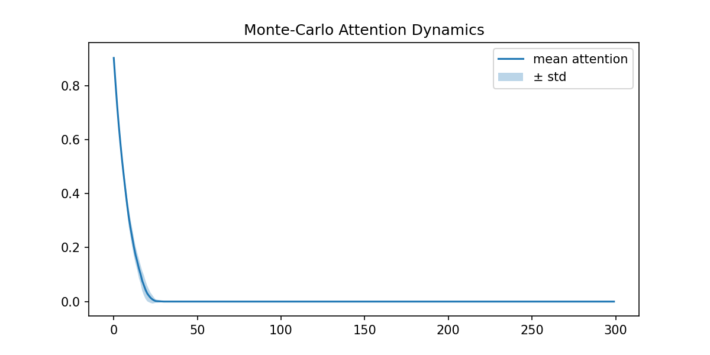
Performs multiple simulation runs (Monte Carlo analysis).
Plots:
- mean attention trajectory
- standard deviation band
Used to evaluate model stability and variability.

reaction_histogram.py

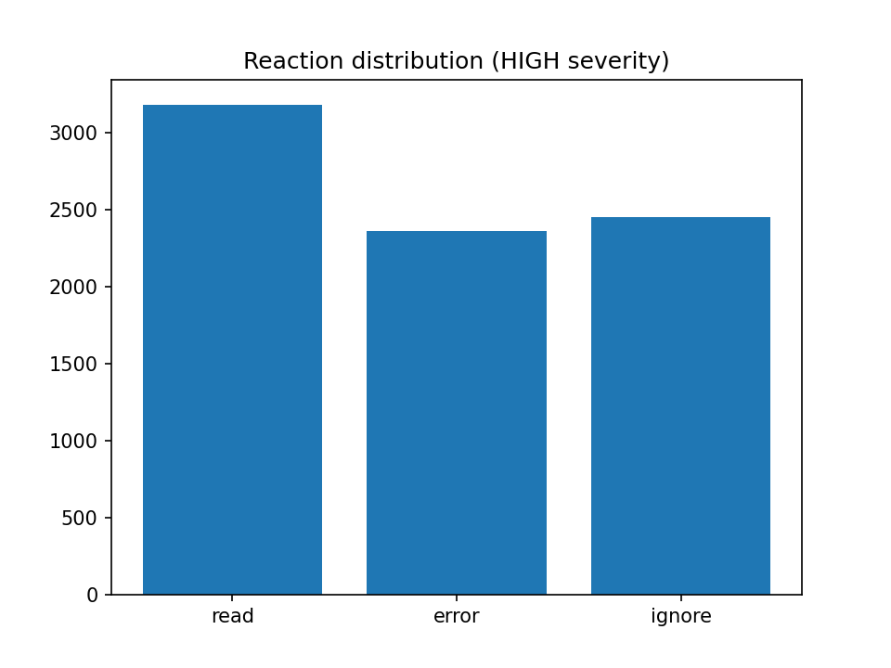
Displays the distribution of user reactions:
- READ
- IGNORE
- ERROR
Provides a quantitative overview of behavior under fixed parameters.

severity_comparision.py / severity_plot.py

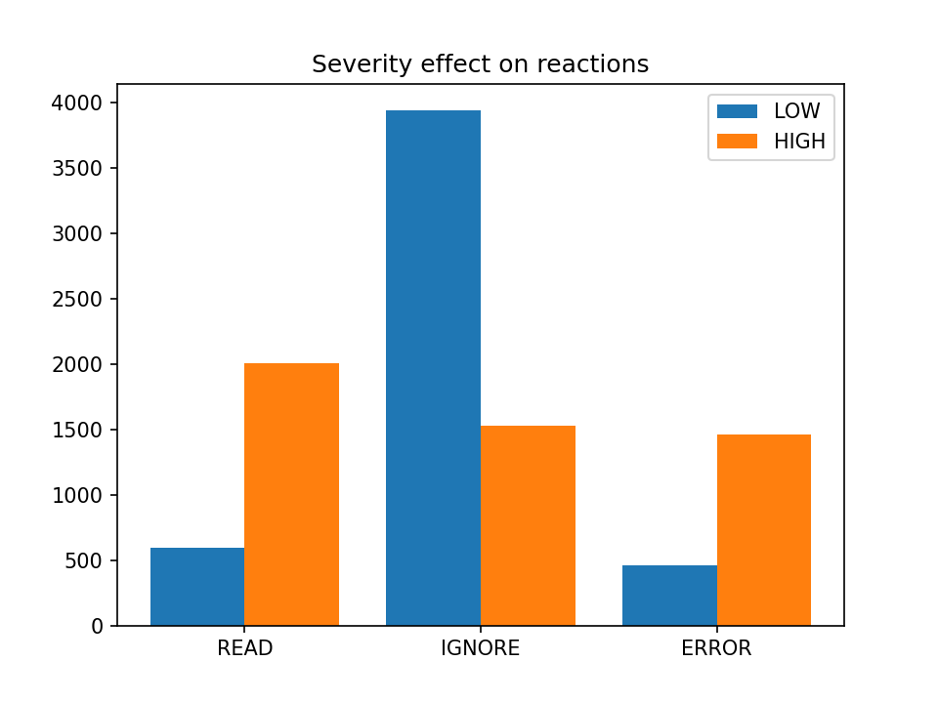

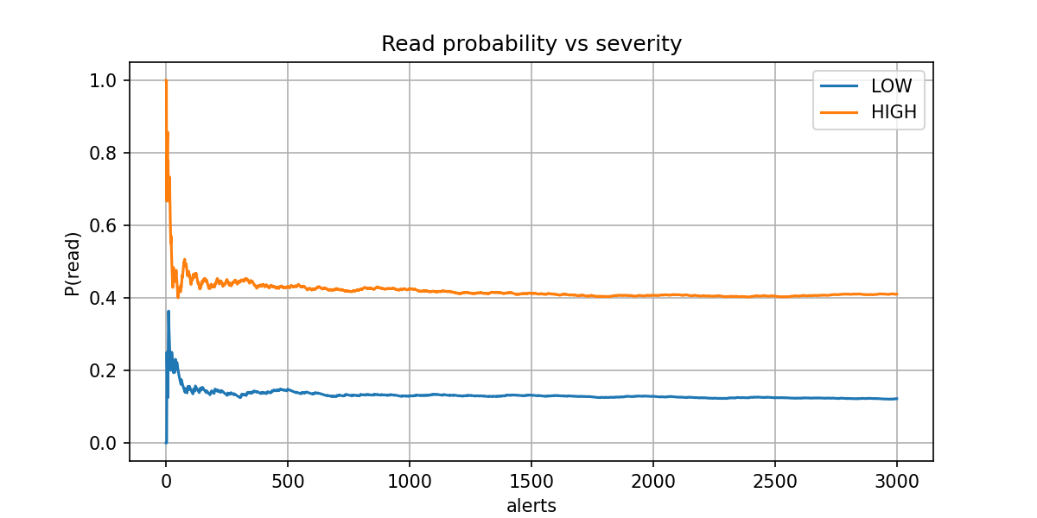
Compares different alert severity levels (LOW, MEDIUM, HIGH).
Shows that higher severity alerts are more likely to be read, while lower severity alerts are more likely to be ignored

sanity_experiment.py

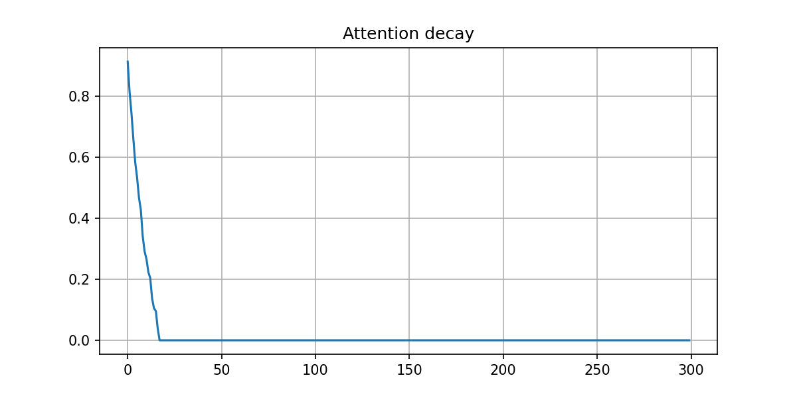
Basic validation experiment.
Used to confirm expected model behavior:
attention decreases under load and increases during recovery.

utils.py
Utility module.
Contains shared helpers (e.g., output directory handling) to avoid code duplication across experiments.

