1_Welcome_Expectations_Conduct

The Piacentino Lab Manual

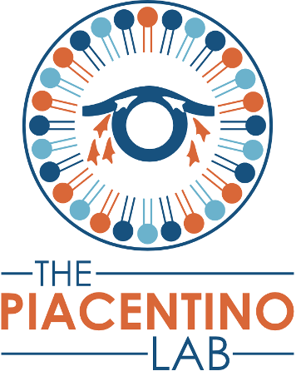

A guide to lab expectations, safety, and policies

Welcome to The Piacentino Lab!

We’re excited to have you on our team! Our group is committed to maintaining an exciting, supportive, educational, and productive environment, and we expect you to play your part in keeping this atmosphere thriving. We hope you will learn a lot about cell and developmental biology, build new skills at the bench and at the computer, and contribute new knowledge in these areas to the greater scientific community. Along the way, we hope you will have fun with your research projects and form new friendships and colleague networks that will serve you long after you have left the lab.

This lab manual will forever be a work in progress which is designed to help Piacentino lab members at all stages by providing information on what we expect of one another, how we conduct ourselves, how the lab runs, how to get help, and more. Please help us maintain this resource: let Mike know if you have any additions, clarifications, or corrections to suggest!

To make sure everyone is on the same page when they join our group, new lab members are expected to read and understand this manual, and discuss concerns with Mike. In addition, we hope that this manual will come in handy later, so if you’re wondering about something, check this document out for answers or pointers to new resources! And if you have a question about something NOT in the manual, ask Mike, and we can work together to add it for the future.

This lab manual was inspired by the lab manuals of many great labs, most notably the Aly, Barber, Blind, and Gilbert labs. We want to thank these groups for generously sharing, and for leading our community in building supportive research groups dedicated to clear communication. This lab manual is licensed under a Creative Commons Attribution-NonCommercial 4.0 International License (CC NC 4.0). If you’re writing your own lab manual, we welcome you to take inspiration from ours (with appropriate citations).

Lab Address:

The Piacentino Lab, 104 WBSB
Johns Hopkins University SOM
725 N Wolfe Street
Baltimore, MD 21205

Lab Phone:
(410) 955-1809

Values and Expectations

Mission Statement

We in the Piacentino lab aim to empower one another to grow as scientists and as human beings while seeking to understand how the developing embryo constructs our adult form. Specific projects combine chicken embryology with rigorous live imaging, molecular biology, and biochemistry to determine how cellular lipids drive cell migration in development and disease. We foster a community built on curiosity, compassion, inclusivity, and determination.

Why do our work?

- Increased understanding of normal development helps recognize, prevent, and treat congenital anomalies
- Conserved mechanisms from development impact homeostasis, aging, and disease
- Training in interdisciplinary science unlocks future innovation

Our Lab Values:

- Integrity - be honest, truthful, and reliable
- Curiosity, enthusiasm, and engagement
- Producing high-quality results through hard work, patience, and determination
- Empowering one another to reach new heights and maintain a growth mindset
- Being inclusive and respectful of one another’s experiences

Science is hard, but it’s also fun. We want to make sure that everyone experiences a positive, engaging, hostility-free, challenging, and rewarding lab environment. To maintain that environment, we all seek to embody these values and operate under the following expectations of ourselves and one another:

Everyone

- Always strive for your best – today’s best might look different from yesterday or tomorrow, and it is the same for everyone else around
- Behave professionally, responsibly, reliably, and with integrity
- Put in the time and effort needed to move your project forward – a strong PhD typically takes at least 50 hours of effort per week, though this varies at different phase of the project
- Take ownership of your project – find the question that interests you, build/draw a mechanistic model to explain your data, identify the assumptions it makes, and design experiments to test those assumptions
- Take ownership of your own experience and education – keep up to date with the literature, with your training, and with developing new skillsets
- Work with urgency, but work carefully and ask for help
- Support your fellow lab mates when they need help
- We expect you to make mistakes, we also expect you to admit and learn from them
- Keep honest and detailed records of your experiments, their analyses, and results
- Respect your fellow lab mates – their strengths and weaknesses, their passions and motivations, respect their desire for quiet if they need it, and for support and a kind ear when they need it. Respect their culture, their values, their beliefs, and their identities.
- Report areas where you may be struggling or if you witness tension or hostility in the lab
- Attend and participate in relevant meetings
- Give feedback candidly and with the intention to help, not to hurt
- Receive feedback with gratitude and appreciation – it’s a gift to be shown how to improve
- Challenge me (Mike) when I’m wrong or when your opinion is different, and treat the rest of the lab to your unique expertise
- Be a good lab citizen – work safely, be tidy, do your lab chores, lock the doors and turn off the lights at the end of the day, etc.

Principal Investigator – Mike

“Everyone” above, and I promise to also…
- Support you and your research (scientifically, financially, emotionally)
- Help you develop your paper and grant writing skills
- Provide constructive feedback in a timely manner
- Be available in person and via email/Slack on a regular basis
- Share my perspective on where the lab is going, where the field is going, and tips on surviving and thriving in academia
- Support your career development by introducing you to other researchers in the field, promoting your work at talks, writing recommendation letters, and letting you attend conferences as often as schedules/finances permit
- Help you prepare for the next step of your career, wherever it may be
- Care for and prioritize your physical and emotional well-being
- Adhere to the JHU policies on mentorship across all career stages

Postdocs

“Everyone” above, and you will be also expected to…
- Develop your own independent line of research
- Work to build a distinguishing research identity that is yours and recognized from outside
- Don’t wait for opportunities/ideas, but rather actively seek them out and nourish them
- Help train and mentor students in the lab when they need it
- Present your work at departmental events, at other labs (if invited), and at conferences
- Apply for grants (e.g. NIH F32, NIH K99). Though I will only hire you if I can support you for at least one year, it’s in your best interest to get experience writing grants.
- Apply for jobs (academic or otherwise) when you’re ready, and discuss with Mike the steps you plan to take toward identifying these jobs and developing the necessary skillset

Graduate Students

“Everyone” above, and you will be also expected to…
- Develop your thesis research – this should represent a significant contribution to our scientific knowledge. You will work closely with Mike in developing this research project and overseeing its progress, but ultimately you are expected to take ownership of this body of work and its execution.
- Help mentor undergraduate students and more junior graduate students when they need it
- Present your work at departmental, regional, and national events
- Apply for grants (e.g. NSF GRFP, NIH F31, NIH F99/K00). It’s in your best interest to get experience writing grants.
- Think about what you want for your career (research or teaching in academia, industry, scientific writing, something else), and talk to Mike about it to make sure we both identify the right training you’ll need to prepare for that career
- Make sure you meet all departmental and program deadlines (exams, thesis, committee meetings) – and make sure Mike is aware of them!
- After completing your core curriculum, prioritize your research – coursework is important, but ultimately your research project is what earns your PhD and prepares you for your next career stage.
- Adhere to the JHU Mentorship Commitments of Faculty Advisors and PhD Students (more about JHU policies for PhD trainees and their mentors here: https://provost.jhu.edu/education/graduate-and-professional-education-resources/phd-mentoring-policies-and-resources/)

Lab Staff

“Everyone” above, and you will be also expected to…
- Work on your own part-time research project (developed with Mike’s help)
- Help new lab members adjust to the lab by answering whatever questions you can
- Help with onboarding and getting new members familiar with our systems
- Organize and maintain databases for common lab protocols, image storage, and analyses
- Maintain laboratory stocks – monitor inventory levels; prepare solutions and reagents when running low; order new reagents, consumables, and equipment as needed; maintain laboratory equipment and train new users
- Maintain lab safety protocols for the lab (writing, renewal), archives of old paperwork and forms related to lab SOPs, orders, shipments, etc.
- Be in the lab on a regular basis – your presence is needed in the lab, so you are expected to hold a predictable schedule

Undergraduate and High School Students

“Everyone” above, and you will be also expected to…
- Develop a weekly schedule by talking to your lab mentor – you should be coming in every week and scheduling enough time to get your work done
- Help your mentor perform experiments, or work on your independent project if relevant
- Always ask if you are unsure of something
- Commit to at least: one full academic year plus one full time summer, or two full academic years
- Show up and be engaged – read the literature, think about our science, participate in lab meetings, etc

Code of Conduct

Harassment and Discrimination

Our lab, and Johns Hopkins, are environments that must be free of harassment and discrimination. Every lab member must abide by the Johns Hopkins University policies on harassment and discrimination, found at the Office of Institutional Equity (https://oie.jhu.edu/). You can also learn about JHU’s Sexual Misconduct Policies and Procedures (https://sexualmisconduct.jhu.edu/policies-laws/). Please read these policies now.

Mike is committed to ensuring the lab is a safe, friendly, and accepting environment for everyone. We will not tolerate any verbal or physical harassment or discrimination on the basis of gender, gender identity and expression, sexual orientation, ability/disability, physical appearance, body size, race, or religion. We will not tolerate intimidation, stalking, following, unwanted photography or video recording, sustained disruption of talks or other events, inappropriate physical contact, and unwelcome sexual attention. Finally, it should go without saying that lewd language and behavior have no place in the lab, including any lab outings.

If you feel you are being harassed or discriminated against or notice someone else being harassed, please alert Mike immediately. If Mike is the cause of your concern, please reach out to the Cell Biology department director (Andrew Ewald) or another trusted faculty member of Cell Biology or your graduate program.

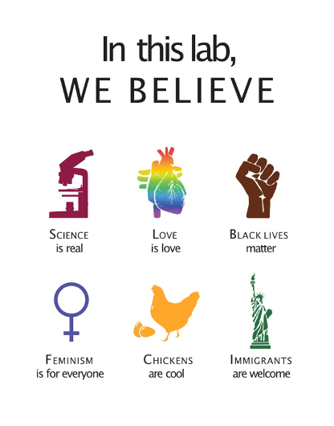

Diversity, Equity, Inclusion and Belonging (DEIB) Statement

As a researcher, a mentor, and a member of the LGBTQ+ community, Mike is dedicated to fighting for diversity, equity, inclusion and belonging. Race, ethnicity, gender, age, religion, language, abilities/disabilities, sexual orientation, gender identity, political affiliation, and socioeconomic status should not be barriers to the STEM community or grounds for discrimination. As such, the Piacentino lab welcomes people and viewpoints from all backgrounds. Only when everyone feels a sense of belonging and support from their community can our scientific and human endeavors reach their peak ingenuity and excellence.

Scientific Integrity and Research Ethics

The lab and Johns Hopkins University are committed to ensuring research integrity and take a hard line on research misconduct. Fabrication, falsification, and plagiarism are not tolerated. Any allegations of misconduct will be handled swiftly. The JHU Research Integrity Policies are posted on the Office of Research Integrity website (https://ori.sites.jhu.edu/policies-and-procedures/). In addition, you will be required to participate in institutional training on the responsible conduct of research as an undergraduate, graduate student or postdoc; the precise training will depend on funding source and career stage, please see the Responsible Conduct of Research (“RCR”) program information here (https://ori.sites.jhu.edu/responsible-conduct-of-research-program/).

The deeper problem is that some people feel pressured to commit research misconduct in the first place. If you are feeling like your work doesn’t measure up to others around you or need to publish more, publish faster, or publish in higher impact journals, reach out and talk to Mike. These feelings are normal, and something everyone experiences at various stages in their career – but it is NEVER an excuse to fabricate, falsify, or plagiarize. You joined the lab because you’re curious about the world and you want to find out how things really work. Science is about uncovering and sharing the truth, or as close as we can get to it with the available methods. Engaging in research misconduct is a disservice to you and to the field. It risks your career and the careers of your colleagues. It is not worth it. Don’t do it.

