Causal Phase Recognition for Wall-Normal Shared Control in Remote Robotic Painting

Introduction
- Motivation
  - Observation from the preceding remote-painting experiment
    - Persistent difficulty maintaining detailed EOAT–wall contact during teleoperation
    - Concurrent operator demand: tangential path control and wall-normal contact correction
  - Shared-control opportunity
    - Operator authority over tangential painting motion
    - Robot assistance for the wall-normal component and contact regulation
- Need for causal phase recognition
  - Phase-dependent assistance logic
    - FREE MOTION: assistance disengagement
    - APPROACH: safe convergence without premature contact locking
    - PAINTING: wall-normal regulation during surface interaction
    - RETRACT: prompt assistance release without resisting withdrawal
  - No fixed phase order; no imposed minimum phase duration
  - Operational risk from delayed, missed, or spurious phase transitions
- Research problem
  - Rule-based logic versus data-driven causal classifiers under a common input and replay protocol
  - Dominant PAINTING class versus brief APPROACH and RETRACT intervals
  - Generalization across training-set composition, trials, and participants
- Study aim
  - Comparative evaluation of deterministic, framewise, probabilistic sequential, and recurrent models
  - Effect of training-data structure and scale on model ranking
  - Learned spatial memory as a surface-relative cue without an explicit wall rule
- Research questions
  - RQ1. Which causal model offers the most useful trade-off among phase F1, transition behavior, and interpretability?
  - RQ2. How do training-set composition and scale alter held-out performance?
  - RQ3. Does a learned position-memory gate improve minority-phase and transition recognition?

Study Data and Phase Definition
- Source dataset
  - Preceding remote robotic painting experiment
  - Six participants; four visual-interface conditions; 22 trials; 61 continuous sequences
  - 208,430 labeled frames; 207,488 frames with valid causal features; 115.8 min
- Causal input representation
  - 12 dimensions per frame
    - TCP force: x, y, z
    - Position relative to trial start: x, y, z
    - Backward-difference velocity: x, y, z
    - Backward-difference acceleration: x, y, z
  - Training-set standardization only; no future-frame features
- Manual phase labels
  - FREE MOTION, APPROACH, PAINTING, RETRACT
  - Dataset distribution
    - FREE MOTION: 29.6%; APPROACH: 5.0%; PAINTING: 62.7%; RETRACT: 2.8%
  - Minority-phase emphasis: APPROACH and RETRACT

Causal Phase-Recognition Methods
- Causal FSM
  - Training-calibrated force and motion thresholds; deterministic online state logic
- Random Forest
  - Nonlinear framewise tree ensemble; independent prediction per observation
- Gaussian Mixture Model
  - Phase-conditional mixture likelihoods; framewise maximum-posterior prediction
- Gaussian HMM
  - Single-Gaussian state emissions; causal forward filtering
- GMM-HMM
  - Mixture emissions with learned state transitions; causal forward filtering
- Causal LSTM
  - One-layer recurrent classifier; 64 hidden units
  - 120-frame training chunks; batch size 32; 20 epochs; learning rate 0.001
  - Unweighted cross-entropy; persistent hidden state during one-frame online replay
- Causal LSTM with learned spatial memory
  - Original 12D observation xₜ retained
  - Learned scalar gate gₜ: 0 = retain memory; 1 = write current position
  - Position memory: mₜ = (1 − gₜ)mₜ₋₁ + gₜpₜ
  - Internal relative position: rₜ = pₜ − mₜ
  - LSTM input: [xₜ, rₜ, gₜ]
  - Phase cross-entropy only; no wall coordinates, gate labels, or gate regularizer

Evaluation Protocol
- Training-structure comparison; common held-out trial 08_01
  - Participant-specific: 10_01–10_04; four trials
  - Single-interface: 06_01, 07_01, 10_01, 11_01; four trials
  - Diversity-balanced: 06_03, 09_04, 10_01, 11_02; four trials
  - All available training data: 21 trials; 08_01 excluded
- Participant-independent evaluation
  - Leave-one-participant-out; six held-out participant folds
- Online replay
  - One observation per model step; temporal state reset only at sequence boundaries
  - No future frames; no test-trial scaler fitting; no test-trial model fitting
- Metrics
  - Frame classification: accuracy, balanced accuracy, Macro F1, per-phase F1
  - Transition detection: matched recall and F1 within ±2.0 s
  - Operational stability: false transitions, absolute transition delay, inference time
  - Transition recall: proportion of true phase changes matched by a prediction; not overall frame accuracy
- Spatial-memory effect verification
  - Baseline 12D LSTM, DSA 13D representation, and full learned-memory model
  - Existing diagnostics: capacity-matched plain LSTM, masked inputs, and retrained partial-input variants

Results
- Training-data structure and scale (Table 1; Figures 1–5)
  - With four training trials, model ranking depended on how the trials were selected; no four-trial structure dominated every model.
  - Using all 21 training trials improved Macro F1 for every learned model and moved the Causal LSTM to the strongest overall held-out result.
  - Random Forest remained highly competitive in low-data settings, indicating a lower sample requirement than the recurrent model.
Table 1
Held-Out Classification Performance by Training-Set Structure
Model | P10-4 | I01-4 | DIV-4 | ALL-21
Causal FSM | 61.8 / 25.1 | 42.3 / 26.2 | 49.9 / 23.6 | 54.9 / 24.5
Random Forest | 83.5 / 48.0 | 84.2 / 54.5 | 81.9 / 41.8 | 87.9 / 61.7
GMM | 76.6 / 39.7 | 80.1 / 46.8 | 79.4 / 48.6 | 82.3 / 54.2
Gaussian HMM | 79.0 / 42.6 | 81.1 / 48.5 | 75.8 / 42.4 | 77.3 / 51.7
GMM-HMM | 75.5 / 39.8 | 74.8 / 45.1 | 76.4 / 46.3 | 80.4 / 50.9
Causal LSTM | 78.2 / 50.1 | 82.0 / 54.7 | 75.9 / 46.0 | 89.3 / 64.1
Note. Values are Accuracy / Macro F1 in percentages. All models were evaluated on the same unseen trial, 08_01. P10-4 = four trials from participant 10; I01-4 = four trials from interface condition 01; DIV-4 = four condition-diverse trials; ALL-21 = all remaining 21 trials.
Figure 1
Macro F1 Across Four Training-Set Structures
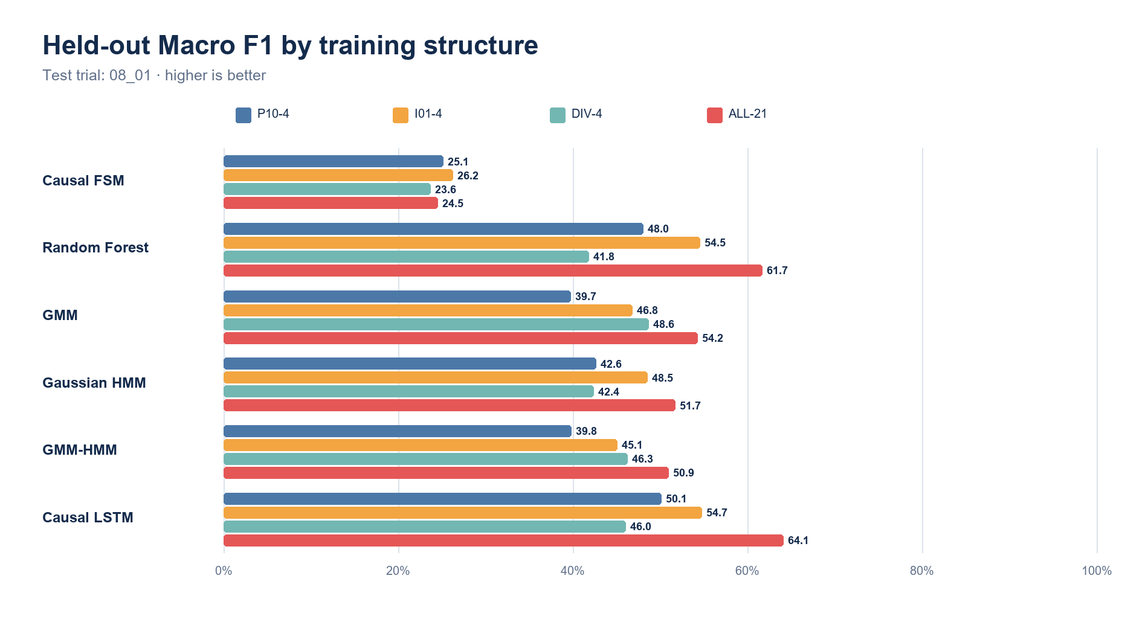
Note. The 21-trial condition yielded the highest Macro F1 for each learned model. The rule-based FSM did not show the same scale-related gain.
Figure 2
Whole-Trial Phase Labels for Participant-specific, 4 trials
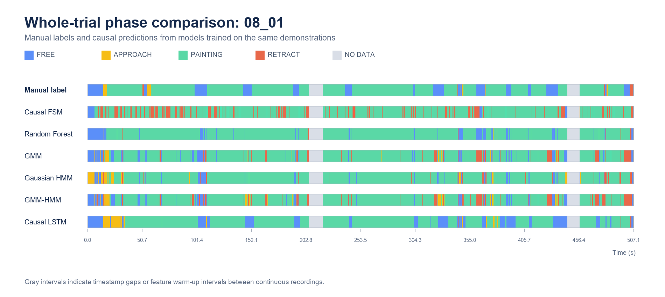
Note. Ground truth and one-frame causal predictions on 08_01. Training set: 10_01–10_04; 27,813 training frames. Gray intervals indicate timestamp gaps or feature warm-up intervals.
Figure 3
Whole-Trial Phase Labels for Single-interface, 4 trials
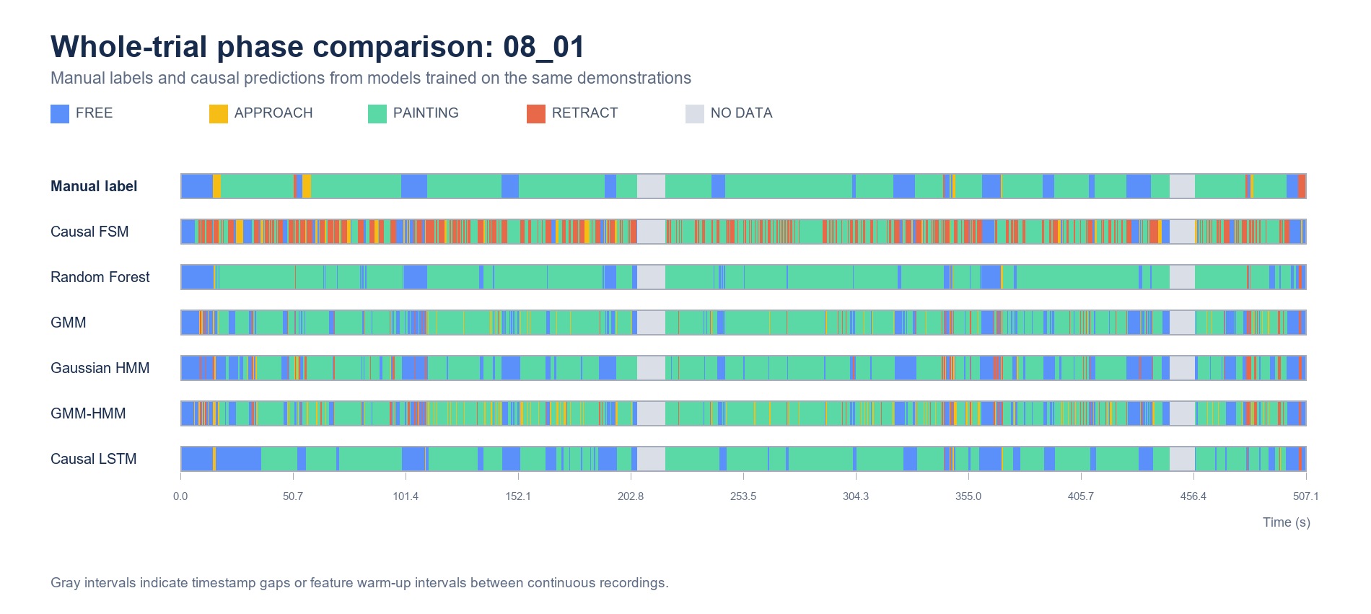
Note. Ground truth and one-frame causal predictions on 08_01. Training set: 06_01, 07_01, 10_01, 11_01; 33,251 training frames. Gray intervals indicate timestamp gaps or feature warm-up intervals.
Figure 4
Whole-Trial Phase Labels for Diversity-balanced, 4 trials
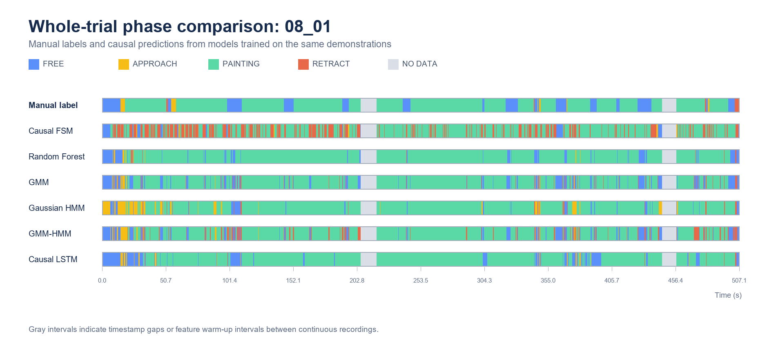
Note. Ground truth and one-frame causal predictions on 08_01. Training set: 06_03, 09_04, 10_01, 11_02; 27,451 training frames. Gray intervals indicate timestamp gaps or feature warm-up intervals.
Figure 5
Whole-Trial Phase Labels for All available training data, 21 trials
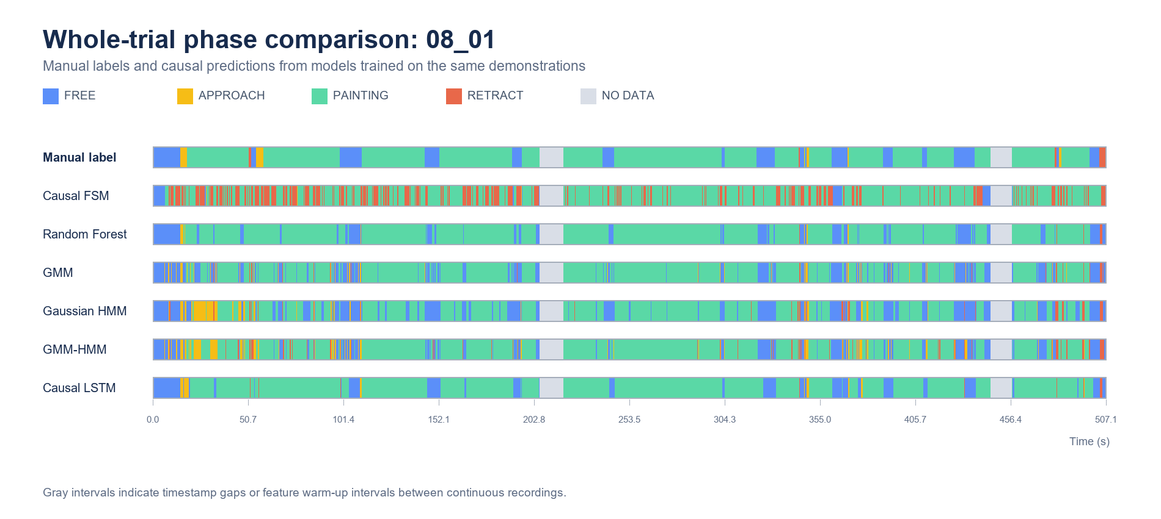
Note. Ground truth and one-frame causal predictions on 08_01. Training set: all trials except 08_01; 193,014 training frames. Gray intervals indicate timestamp gaps or feature warm-up intervals.
- Detailed 21-trial model comparison (Tables 2–3)
  - Causal LSTM provided the strongest joint classification result and the fewest spurious transitions, while Random Forest retained the highest RETRACT F1.
  - GMM detected the greatest proportion of true transitions but produced many additional false transitions; transition sensitivity alone did not indicate reliable phase tracking.

Table 2
Per-Phase Performance After Training on 21 Trials
Model | Accuracy | Macro F1 | FREE F1 | APP. F1 | PAINT. F1 | RET. F1
Causal FSM | 54.9 | 24.5 | 21.0 | 0.0 | 72.4 | 4.5
Random Forest | 87.9 | 61.7 | 73.2 | 39.8 | 92.9 | 40.8
GMM | 82.3 | 54.2 | 67.0 | 25.6 | 90.0 | 34.4
Gaussian HMM | 77.3 | 51.7 | 68.9 | 20.5 | 85.4 | 32.2
GMM-HMM | 80.4 | 50.9 | 68.2 | 21.5 | 89.8 | 24.2
Causal LSTM | 89.3 | 64.1 | 76.8 | 49.7 | 94.0 | 35.8
Note. Values are percentages on unseen trial 08_01. APP. = APPROACH; PAINT. = PAINTING; RET. = RETRACT. Test distribution: FREE 2,861 frames; APPROACH 336; PAINTING 11,078; RETRACT 199.
Table 3
Transition Behavior After Training on 21 Trials
Model | Transition recall | Transition F1 | False transitions | |Delay|, ms
Causal FSM | 9.8 | 1.6 | 468 | 458
Random Forest | 68.3 | 15.9 | 283 | 303
GMM | 82.9 | 9.5 | 644 | 377
Gaussian HMM | 68.3 | 20.8 | 200 | 360
GMM-HMM | 63.4 | 13.2 | 326 | 401
Causal LSTM | 58.5 | 40.3 | 54 | 401
Note. Transitions were matched by phase-pair identity and nearest unused prediction within ±2.0 s. Transition recall is the proportion of 41 true transitions matched; false transitions are unmatched predicted changes.
- Participant-independent generalization (Table 4; Figure 6)
  - Across unseen participants, the Causal LSTM retained the strongest mean accuracy and Macro F1, but participant-level variance remained substantial.
  - Probabilistic sequence models showed temporal smoothing benefits without matching the recurrent model's aggregate classification performance.
Table 4
Leave-One-Participant-Out Performance
Model | Accuracy | Macro F1 | APP. F1 | RET. F1 | Transition recall
Causal FSM | 60.5 (11.6) | 32.3 (5.1) | 9.5 (9.7) | 8.9 (4.7) | 13.6 (5.4)
Random Forest | 78.7 (8.3) | 52.1 (10.4) | 31.7 (18.9) | 22.4 (12.7) | 60.2 (13.0)
GMM | 74.2 (9.2) | 51.1 (6.9) | 32.3 (14.3) | 21.1 (9.7) | 74.7 (3.9)
Gaussian HMM | 69.5 (9.7) | 48.9 (4.3) | 28.8 (7.1) | 24.4 (9.6) | 56.4 (7.8)
GMM-HMM | 69.4 (10.8) | 49.2 (5.9) | 32.8 (14.0) | 18.0 (6.8) | 58.4 (8.9)
Causal LSTM | 80.3 (7.3) | 59.7 (8.4) | 49.4 (14.8) | 31.8 (12.6) | 61.7 (16.0)
Note. Values are mean (SD) percentages across six participant folds. Each fold trained on all other participants and replayed the held-out participant causally, one frame at a time.
Figure 6
Participant-Independent Macro F1
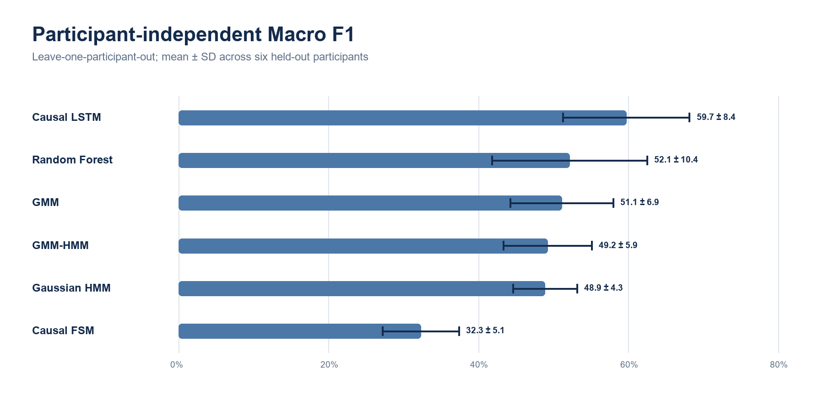
Note. Bars show fold means; error bars show one standard deviation across held-out participants.
- Spatial-memory extension (Tables 5–6; Figures 7–8)
  - The full spatial-memory LSTM improved balanced accuracy, Macro F1, RETRACT F1, and transition recall over the baseline LSTM, while preserving the strong PAINTING result.
  - The learned gate was generally high during PAINTING and lower during FREE MOTION and APPROACH, consistent with continual updating of a local surface memory rather than storing only the first contact point.
  - Capacity control and partial-input diagnostics indicated that the gain was not explained by parameter count alone and that the full interaction among xₜ, rₜ, and gₜ was important.
Table 5
LSTM Input and Spatial-Memory Comparison
Model | Accuracy | Balanced | Macro F1 | APP. F1 | RET. F1 | Trans. recall | Trans. F1
Baseline LSTM (12D) | 89.3 | 59.7 | 64.1 | 49.7 | 35.8 | 58.5 | 40.3
DSA LSTM (13D) | 88.0 | 61.5 | 62.8 | 46.0 | 34.3 | 58.5 | 35.8
Spatial-memory LSTM | 90.1 | 63.3 | 66.1 | 50.0 | 38.9 | 70.7 | 43.6
Note. Values are percentages on unseen trial 08_01. Baseline = original 12D input; DSA = distance, speed, and acceleration representation; spatial memory = original 12D input plus learned rₜ and gₜ.
Table 6
Component-Effect Verification for the Spatial-Memory LSTM
Condition | Accuracy | Balanced | Macro F1 | APP. F1 | RET. F1 | Trans. F1 | Parameters
Baseline LSTM, h=64 | 89.3 | 59.7 | 64.1 | 49.7 | 35.8 | 40.3 | 20,228
Capacity-matched LSTM, h=74 | 89.7 | 56.7 | 60.8 | 37.6 | 32.6 | 38.5 | 26,348
Full spatial model, x+r+g | 90.1 | 63.3 | 66.1 | 50.0 | 38.9 | 43.6 | 26,437
Full weights; r masked | 89.6 | 57.6 | 61.0 | 31.0 | 38.9 | 41.5 | 26,437
Full weights; g masked | 81.7 | 62.3 | 59.3 | 50.0 | 29.0 | 25.7 | 26,437
Retrained x+r | 88.9 | 59.3 | 63.4 | 45.1 | 37.8 | 35.1 | 26,181
Retrained x+g | 88.6 | 59.9 | 63.1 | 47.9 | 33.5 | 39.7 | 25,669
Note. Values are percentages except Parameters. Input masking used the trained full-model weights and is diagnostic rather than a separately optimized model. Retrained partial-input variants used the same held-out trial. h = hidden units.
Figure 7
Performance of the Baseline, DSA, and Learned Spatial-Memory LSTMs
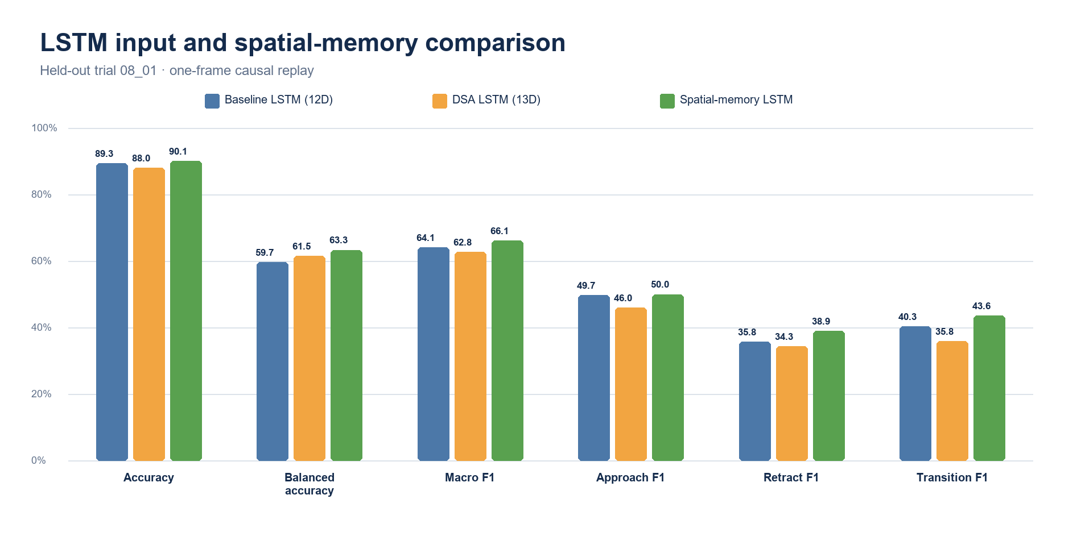
Note. The full spatial-memory model produced the strongest balanced, Macro F1, RETRACT F1, and transition F1 values among the three LSTM representations.
Figure 8
Learned Gate and Relative-Position Memory During Causal Replay
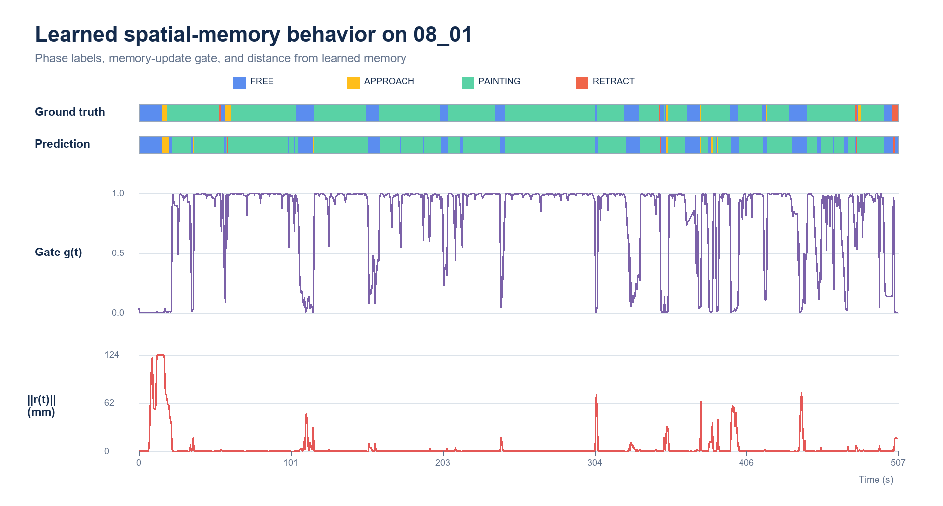
Note. The gate controls memory writing, not the PAINTING label directly. A high gate repeatedly moves memory toward the current position; the resulting rₜ measures local displacement from that learned reference. The trace supports functional use but does not establish a geometrically exact wall model.

Discussion
- Model trade-offs
  - Causal FSM
    - Strength: transparent logic, negligible training demand, direct safety review
    - Weakness: brittle thresholds, poor transient-phase recognition, heavy calibration dependence
  - Random Forest
    - Strength: strong low-data baseline, nonlinear decision boundaries, simple fitting
    - Weakness: no temporal memory, greater susceptibility to framewise chattering and false transitions
  - GMM
    - Strength: high transition sensitivity, compact probabilistic phase representation
    - Weakness: phase-overlap ambiguity and many spurious transitions without temporal state
  - Gaussian HMM
    - Strength: causal temporal smoothing and interpretable state transitions
    - Weakness: rigid single-Gaussian emissions and delayed or weakened brief-phase responses
  - GMM-HMM
    - Strength: multimodal emissions with temporal continuity
    - Weakness: added complexity without top-ranked performance; dependence on learned transition statistics
  - Causal LSTM
    - Strength: strongest data-rich and participant-independent aggregate performance; few false transitions
    - Weakness: greater data requirement, weaker interpretability, remaining transition-recall and delay trade-off
  - Spatial-memory LSTM
    - Strength: improved minority-phase balance and transition detection through a learned local spatial reference
    - Weakness: modest single-trial gain, indirect gate semantics, possible memory drift across unfamiliar geometry
- Interpretation of training-scale effects
  - Tree ensemble advantage under limited trials: strong framewise pattern fitting with low sequence-data demand
  - LSTM advantage under expanded trials: improved learning of temporal variability and participant-specific motion patterns
  - Implication: model ranking inseparable from available sequence diversity and evaluation split
- Meaning of learned spatial memory
  - End-to-end emergence of a task-useful surface-relative latent cue from phase labels alone
  - Continuous PAINTING-period updates consistent with a local wall manifold, not a single memorized contact point
  - Gate value as memory-write strength; not an independent PAINTING detector
  - Evidence for integrating structured inductive bias without explicit wall coordinates or phase-order rules
- Limitations
  - Single wall geometry, EOAT, task family, and laboratory context
  - Only six participants; one common held-out trial for training-structure and spatial-memory comparisons
  - Severe class imbalance and short APPROACH/RETRACT intervals
  - Transition metric dependence on a ±2.0-s matching window
  - No closed-loop user evaluation of phase-triggered wall-normal shared control
  - No geometric ground truth proving that mₜ equals the physical wall surface
- Next validation
  - Closed-loop shared-control experiment: safety, contact stability, operator workload, and task quality
  - Cross-geometry and cross-tool validation; uncertainty-aware assistance release
  - Gate and memory diagnostics against measured surface geometry

Contributions
- Application-driven formulation of causal phase recognition for wall-normal shared control in remote robotic painting
- Common one-frame causal benchmark spanning rules, framewise learning, probabilistic sequence models, and recurrent learning
- Empirical evidence that training-set scale and composition can change the preferred model
- Learned spatial-memory LSTM requiring neither explicit wall coordinates nor fixed phase-order and duration constraints
- Evaluation emphasis on minority-phase F1, transition matching, false transitions, and delay beyond overall accuracy

