Causal Phase Recognition for Wall-Normal Shared Control in Remote Robotic Painting

Introduction
- Motivation
  - Observation from the preceding remote-painting experiment
    - Persistent difficulty maintaining detailed EOAT–wall contact during teleoperation
    - Concurrent operator demand: tangential path control and wall-normal contact correction
  - Shared-control opportunity
    - Operator authority over tangential painting motion
    - Robot assistance for the wall-normal component and contact regulation
- Need for causal phase recognition
  - Phase-dependent assistance logic
    - FREE MOTION: assistance disengagement
    - APPROACH: safe convergence without premature contact locking
    - PAINTING: wall-normal regulation during surface interaction
    - RETRACT: prompt assistance release without resisting withdrawal
  - No fixed phase order; no imposed minimum phase duration
  - Operational risk from delayed, missed, or spurious phase transitions
- Research problem
  - Rule-based logic versus data-driven causal classifiers under a common input and replay protocol
  - Dominant PAINTING class versus brief APPROACH and RETRACT intervals
  - Generalization across training-set composition, trials, and participants
- Study aim
  - Comparative evaluation of deterministic, framewise, probabilistic sequential, and recurrent models
  - Effect of four-trial training-set composition and participant-independent generalization
- Research questions
  - RQ1. Which causal model offers the most useful trade-off among phase F1, transition behavior, and interpretability?
  - RQ2. How do four-trial composition and participant holdout alter causal classification performance?

Study Data and Phase Definition
- Source dataset
  - Preceding remote robotic painting experiment
  - Six participants; four visual-interface conditions; 22 trials; 61 continuous sequences
  - 208,430 labeled frames; 207,488 frames with valid causal features; 115.8 min
- Causal input representation
  - 12 dimensions per frame
    - TCP force: x, y, z
    - Position relative to trial start: x, y, z
    - Backward-difference velocity: x, y, z
    - Backward-difference acceleration: x, y, z
  - Training-set standardization only; no future-frame features
- Manual phase labels
  - FREE MOTION, APPROACH, PAINTING, RETRACT
  - Dataset distribution
    - FREE MOTION: 29.6%; APPROACH: 5.0%; PAINTING: 62.7%; RETRACT: 2.8%
  - Minority-phase emphasis: APPROACH and RETRACT

Causal Phase-Recognition Methods
- Causal FSM
  - Training-calibrated force and motion thresholds; deterministic online state logic
- Random Forest
  - Nonlinear framewise tree ensemble; independent prediction per observation
- Gaussian Mixture Model
  - Phase-conditional mixture likelihoods; framewise maximum-posterior prediction
- Gaussian HMM
  - Single-Gaussian state emissions; causal forward filtering
- GMM-HMM
  - Mixture emissions with learned state transitions; causal forward filtering
- Causal LSTM
  - One-layer recurrent classifier; 64 hidden units
  - 120-frame training chunks; batch size 32; 20 epochs; learning rate 0.001
  - Unweighted cross-entropy; persistent hidden state during one-frame online replay

Evaluation Protocol
- Training-structure comparison; common held-out trial 08_01
  - Participant-specific: 10_01–10_04; four trials
  - Single-interface: 06_01, 07_01, 10_01, 11_01; four trials
  - Diversity-balanced: 06_03, 09_04, 10_01, 11_02; four trials
- Participant-independent evaluation
  - Leave-one-participant-out; six held-out participant folds
- Online replay
  - One observation per model step; temporal state reset only at sequence boundaries
  - No future frames; no test-trial scaler fitting; no test-trial model fitting
- Metrics
  - Frame classification: ±1.0-s temporal-tolerance accuracy; strict full-sequence Macro F1 and per-phase F1
  - Transition detection: precision, recall, and F1 for the same from-to phase event matched one-to-one within ±1.0 s
  - Operational stability: false transitions, absolute transition delay, inference time
  - Tolerance rule: a phase prediction is accepted by tolerant accuracy when the same manual phase occurs within ±1.0 s in the same contiguous sequence; full-sequence F1 remains exact frame-by-frame

Results
- Four-trial training-set composition (Tables 1–4; Figures 1–4)
  - With four training trials, model ranking depended on how the trials were selected; no four-trial structure dominated every model.
  - Random Forest remained highly competitive in low-data settings, indicating a lower sample requirement than the recurrent model.
Table 1
Held-Out Classification Performance by Training-Set Structure
Model | P10-4 | I01-4 | DIV-4
Causal FSM | 67.1 / 25.1 | 45.8 / 26.2 | 54.4 / 23.6
Random Forest | 88.3 / 48.0 | 88.9 / 54.5 | 87.5 / 41.8
GMM | 80.3 / 39.7 | 83.4 / 46.8 | 82.7 / 48.6
Gaussian HMM | 84.1 / 42.6 | 83.9 / 48.5 | 81.1 / 42.4
GMM-HMM | 78.8 / 39.8 | 78.0 / 45.1 | 79.5 / 46.3
Causal LSTM | 83.6 / 50.1 | 86.2 / 54.7 | 81.1 / 46.0
Note. Values are ±1-s tolerant accuracy / strict full-sequence Macro F1 in percentages. All models were evaluated on the same unseen trial, 08_01. P10-4 = four trials from participant 10; I01-4 = four trials from interface condition 01; DIV-4 = four condition-diverse trials.
Figure 1
Macro F1 Across Three Four-Trial Training Sets
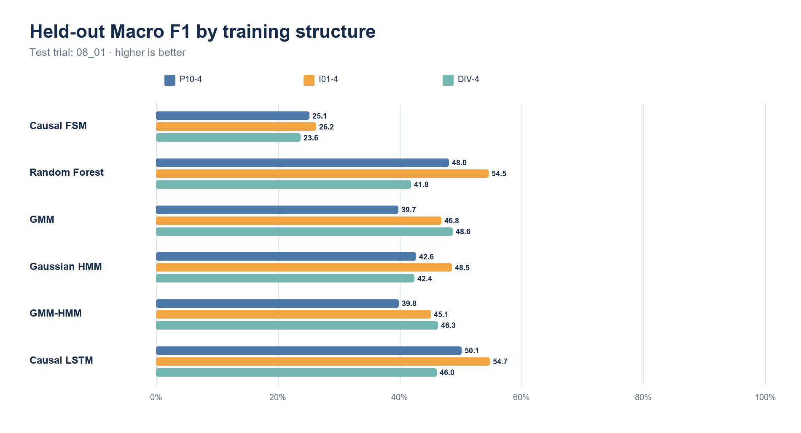
Note. Model ranking changed with participant and interface composition even though each training set contained four trials.
.
Figure 2
Whole-Trial Phase Labels for Participant-specific, 4 trials
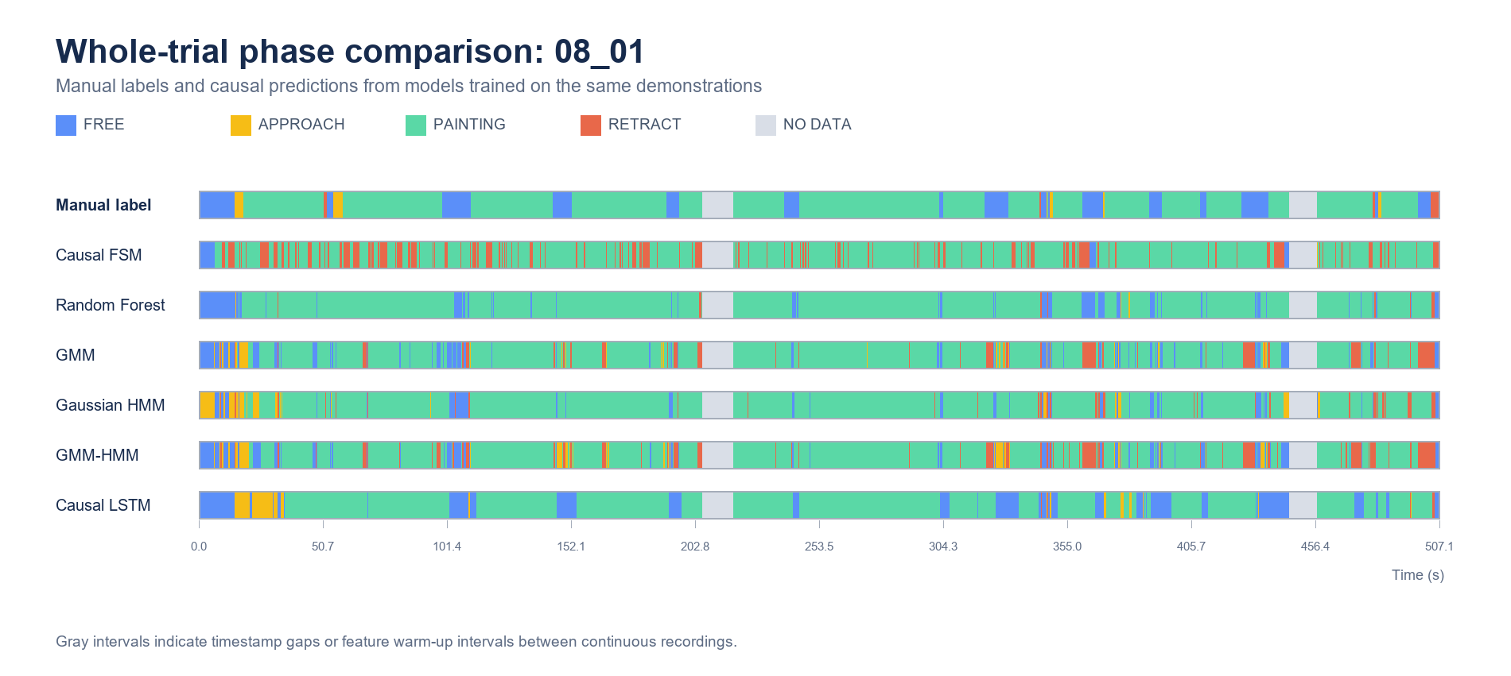
Note. Ground truth and one-frame causal predictions on 08_01. Training set: 10_01–10_04; 27,813 training frames. Gray intervals indicate timestamp gaps or feature warm-up intervals.
Table 2
Detailed Performance for Participant-Specific Four-Trial Training
Model | ±1 s  Tol. Acc. | Full-seq.  Macro F1 | FREE  F1 | APP.  F1 | PAINT.  F1 | RET.  F1 | Trans. F1  (±1 s) | Trans.  recall | False  trans. | |Delay|  ms
Causal FSM | 67.1 | 25.1 | 16.9 | 0.0 | 77.3 | 6.2 | 1.1 | 4.9 | 318 | 272
Random Forest | 88.3 | 48.0 | 53.4 | 11.4 | 90.9 | 36.4 | 11.9 | 48.8 | 276 | 326
GMM | 80.3 | 39.7 | 43.1 | 16.7 | 90.0 | 9.1 | 5.6 | 39.0 | 510 | 321
Gaussian HMM | 84.1 | 42.6 | 43.0 | 14.0 | 89.7 | 23.8 | 13.3 | 39.0 | 183 | 444
GMM-HMM | 78.8 | 39.8 | 44.7 | 14.5 | 90.6 | 9.4 | 6.5 | 26.8 | 287 | 470
Causal LSTM | 83.6 | 50.1 | 60.3 | 25.0 | 86.3 | 28.9 | 19.4 | 29.3 | 71 | 512
Note. Results on unseen trial 08_01 after participant-specific four-trial training. Tolerant accuracy accepts phase timing differences within ±1 s; Macro and phase F1 use strict matching over all valid frames. Transition F1 matches the same from-to event within ±1 s. False transitions are unmatched predicted events; delay is in milliseconds. Training set: 10_01-10_04; 27,813 training frames.
.
Figure 3
Whole-Trial Phase Labels for Single-interface, 4 trials
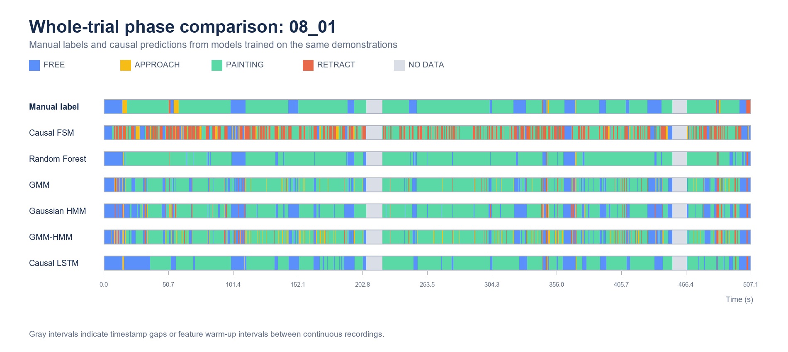
Note. Ground truth and one-frame causal predictions on 08_01. Training set: 06_01, 07_01, 10_01, 11_01; 33,251 training frames. Gray intervals indicate timestamp gaps or feature warm-up intervals.
Table 3
Detailed Performance for Single-Interface Four-Trial Training
Model | ±1 s  Tol. Acc. | Full-seq.  Macro F1 | FREE  F1 | APP.  F1 | PAINT.  F1 | RET.  F1 | Trans. F1  (±1 s) | Trans.  recall | False  trans. | |Delay|  ms
Causal FSM | 45.8 | 26.2 | 39.3 | 3.8 | 60.2 | 1.6 | 2.3 | 17.1 | 560 | 260
Random Forest | 88.9 | 54.5 | 60.7 | 28.4 | 90.8 | 38.1 | 17.0 | 58.5 | 218 | 329
GMM | 83.4 | 46.8 | 64.5 | 15.1 | 88.6 | 18.8 | 7.4 | 75.6 | 771 | 231
Gaussian HMM | 83.9 | 48.5 | 69.2 | 13.5 | 89.3 | 22.0 | 15.2 | 51.2 | 215 | 260
GMM-HMM | 78.0 | 45.1 | 64.5 | 16.9 | 85.2 | 13.7 | 8.2 | 61.0 | 547 | 276
Causal LSTM | 86.2 | 54.7 | 66.0 | 30.9 | 89.0 | 33.1 | 32.6 | 53.7 | 72 | 415
Note. Results on unseen trial 08_01 after single-interface four-trial training. Tolerant accuracy accepts phase timing differences within ±1 s; Macro and phase F1 use strict matching over all valid frames. Transition F1 matches the same from-to event within ±1 s. False transitions are unmatched predicted events; delay is in milliseconds. Training set: 06_01, 07_01, 10_01, 11_01; 33,251 training frames.
.
Figure 4
Whole-Trial Phase Labels for Diversity-balanced, 4 trials
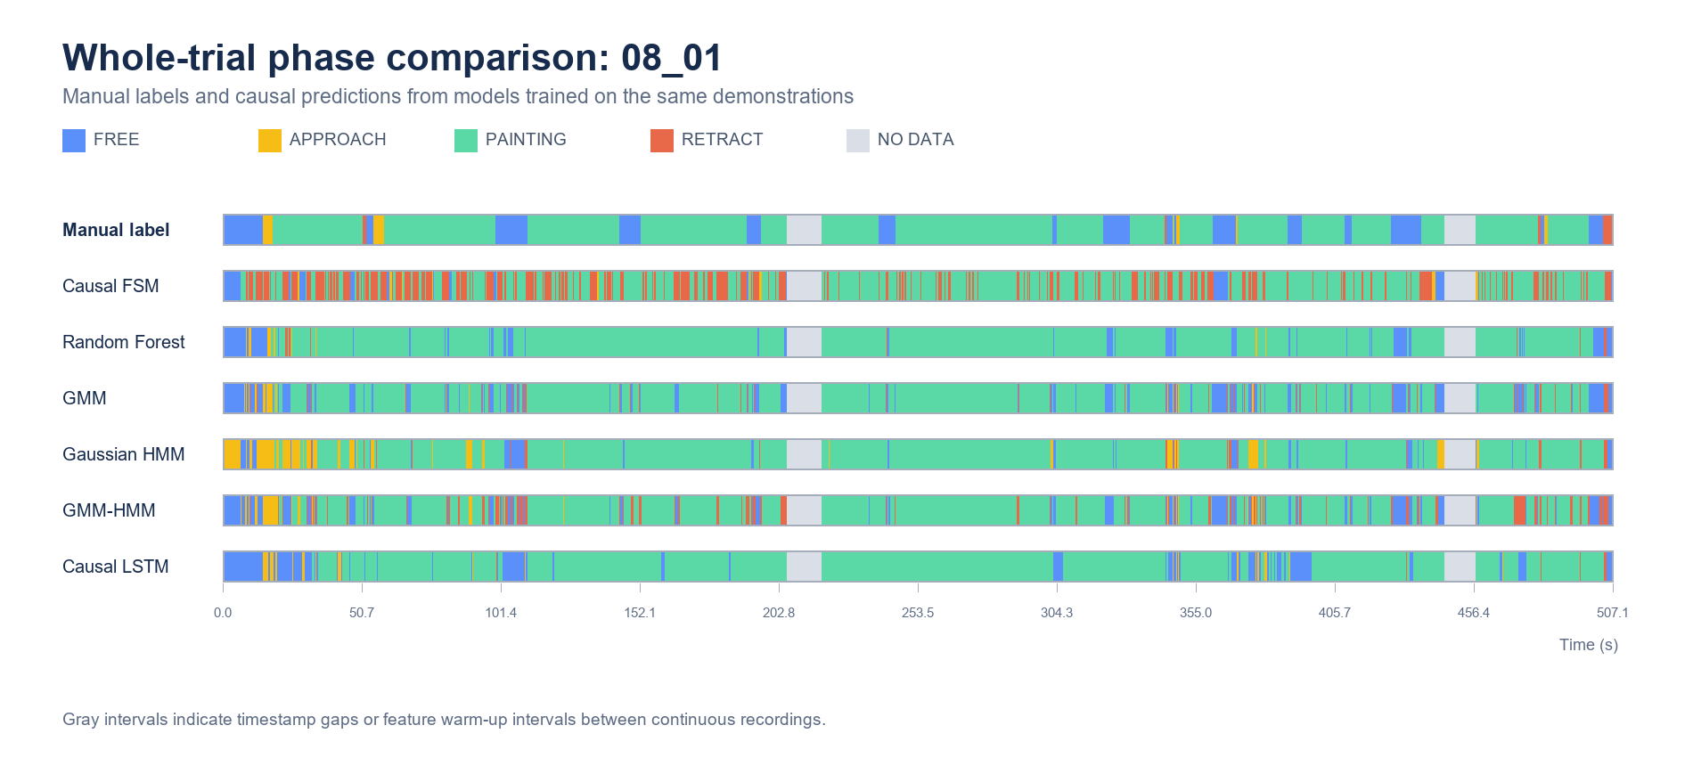
Note. Ground truth and one-frame causal predictions on 08_01. Training set: 06_03, 09_04, 10_01, 11_02; 27,451 training frames. Gray intervals indicate timestamp gaps or feature warm-up intervals.
Table 4
Detailed Performance for Diversity-Balanced Four-Trial Training
Model | ±1 s  Tol. Acc. | Full-seq.  Macro F1 | FREE  F1 | APP.  F1 | PAINT.  F1 | RET.  F1 | Trans. F1  (±1 s) | Trans.  recall | False  trans. | |Delay|  ms
Causal FSM | 54.4 | 23.6 | 20.5 | 1.6 | 68.2 | 4.3 | 0.7 | 4.9 | 527 | 146
Random Forest | 87.5 | 41.8 | 50.3 | 10.8 | 89.9 | 16.3 | 9.7 | 36.6 | 252 | 588
GMM | 82.7 | 48.6 | 55.0 | 35.3 | 88.6 | 15.6 | 8.2 | 58.5 | 522 | 312
Gaussian HMM | 81.1 | 42.4 | 35.2 | 16.7 | 87.6 | 30.0 | 13.8 | 34.1 | 148 | 438
GMM-HMM | 79.5 | 46.3 | 56.0 | 32.7 | 88.1 | 8.3 | 9.3 | 43.9 | 330 | 260
Causal LSTM | 81.1 | 46.0 | 40.7 | 33.1 | 85.6 | 24.6 | 11.5 | 22.0 | 107 | 360
Note. Results on unseen trial 08_01 after diversity-balanced four-trial training. Tolerant accuracy accepts phase timing differences within ±1 s; Macro and phase F1 use strict matching over all valid frames. Transition F1 matches the same from-to event within ±1 s. False transitions are unmatched predicted events; delay is in milliseconds. Training set: 06_03, 09_04, 10_01, 11_02; 27,451 training frames.
.
- Participant-independent generalization (Table 5; Figure 5)
  - Across unseen participants, the Causal LSTM retained the strongest mean accuracy and Macro F1, but participant-level variance remained substantial.
  - Probabilistic sequence models showed temporal smoothing benefits without matching the recurrent model's aggregate classification performance.
Table 5
Leave-One-Participant-Out Performance
Model | ±1 s  Tol. Acc. | Full-seq.  Macro F1 | FREE  F1 | APP.  F1 | PAINT.  F1 | RET.  F1 | Trans. F1  (±1 s)
Causal FSM | 67.2 (11.3) | 32.3 (5.1) | 35.9 (12.3) | 9.5 (9.7) | 74.9 (9.0) | 8.9 (4.7) | 4.2 (1.3)
Random Forest | 84.4 (6.6) | 52.1 (10.4) | 68.9 (8.0) | 31.7 (18.9) | 85.6 (9.7) | 22.4 (12.7) | 15.4 (5.6)
GMM | 79.0 (7.7) | 51.1 (6.9) | 67.7 (7.9) | 32.3 (14.3) | 83.4 (8.5) | 21.1 (9.7) | 8.8 (3.3)
Gaussian HMM | 74.2 (8.6) | 48.9 (4.3) | 64.8 (9.0) | 28.8 (7.1) | 77.5 (11.7) | 24.4 (9.6) | 15.2 (2.0)
GMM-HMM | 73.9 (9.8) | 49.2 (5.9) | 65.8 (8.4) | 32.8 (14.0) | 80.2 (11.5) | 18.0 (6.8) | 12.0 (5.2)
Causal LSTM | 85.9 (5.5) | 59.7 (8.4) | 70.7 (8.1) | 49.4 (14.8) | 87.0 (7.4) | 31.8 (12.6) | 32.7 (12.8)
Note. Values are mean (SD) percentages across six participant folds. Tolerant accuracy permits ±1-s phase timing differences. Full-sequence Macro and phase F1 use strict framewise matching over every valid held-out frame. Transition F1 uses one-to-one matching of the same from-to event within ±1 s.
.
Figure 5
Participant-Independent Strict Full-Sequence Macro F1
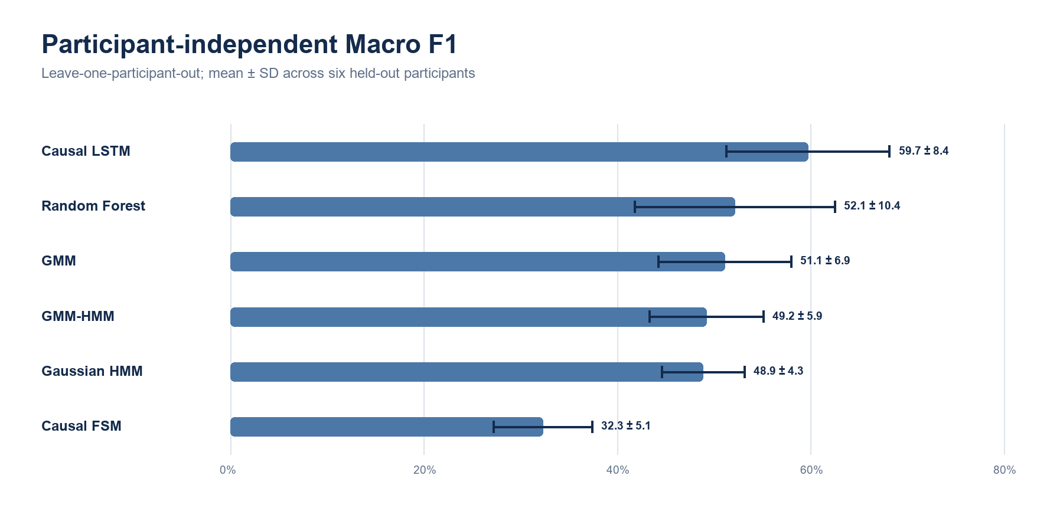
Note. Bars show strict full-sequence Macro F1 means; error bars show one standard deviation across held-out participants.

Discussion
- Model trade-offs
  - Causal FSM
    - Strength: transparent logic, negligible training demand, direct safety review
    - Weakness: brittle thresholds, poor transient-phase recognition, heavy calibration dependence
  - Random Forest
    - Strength: strong low-data baseline, nonlinear decision boundaries, simple fitting
    - Weakness: no temporal memory, greater susceptibility to framewise chattering and false transitions
  - GMM
    - Strength: high transition sensitivity, compact probabilistic phase representation
    - Weakness: phase-overlap ambiguity and many spurious transitions without temporal state
  - Gaussian HMM
    - Strength: causal temporal smoothing and interpretable state transitions
    - Weakness: rigid single-Gaussian emissions and delayed or weakened brief-phase responses
  - GMM-HMM
    - Strength: multimodal emissions with temporal continuity
    - Weakness: added complexity without top-ranked performance; dependence on learned transition statistics
  - Causal LSTM
    - Strength: strongest participant-independent aggregate performance; few false transitions
    - Weakness: greater data requirement, weaker interpretability, remaining transition-recall and delay trade-off
- Interpretation of training-structure and participant effects
  - Four-trial model ranking changed with participant and interface composition
  - Participant-level variance exceeded a simple single-trial comparison
  - Implication: model selection requires participant-independent evaluation rather than one held-out trial
- Limitations
  - Single wall geometry, EOAT, task family, and laboratory context
  - Only six participants; one common held-out trial for the training-structure comparisons
  - Severe class imbalance and short APPROACH/RETRACT intervals
  - Metric dependence on the selected ±1.0-s timing tolerance; tolerant accuracy and transition-event F1 must be interpreted alongside strict full-sequence F1
  - No closed-loop user evaluation of phase-triggered wall-normal shared control
- Next validation
  - Closed-loop shared-control experiment: safety, contact stability, operator workload, and task quality
  - Cross-geometry and cross-tool validation; uncertainty-aware assistance release

Contributions
- Application-driven formulation of causal phase recognition for wall-normal shared control in remote robotic painting
- Common one-frame causal benchmark spanning rules, framewise learning, probabilistic sequence models, and recurrent learning
- Empirical evidence that four-trial composition changes model ranking and that participant-independent evaluation is required
- Evaluation emphasis on minority-phase F1, transition matching, false transitions, and delay beyond overall accuracy

