LOPO Results
Leave-one-participant-out performance across six held-out participants.
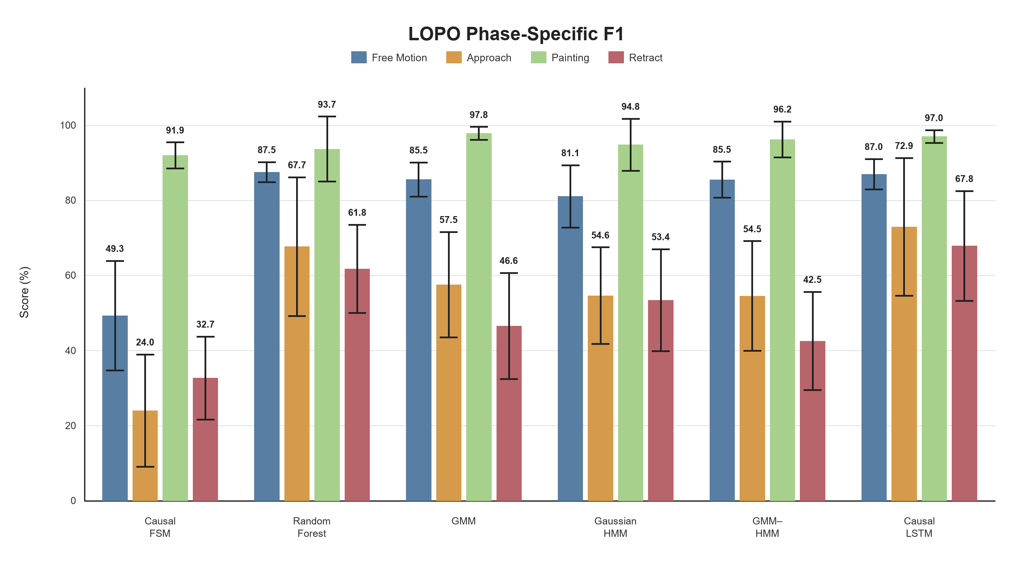
Figure 1. Phase-specific F1 scores. Bars represent means and error bars represent ±1 SD across six LOPO folds.

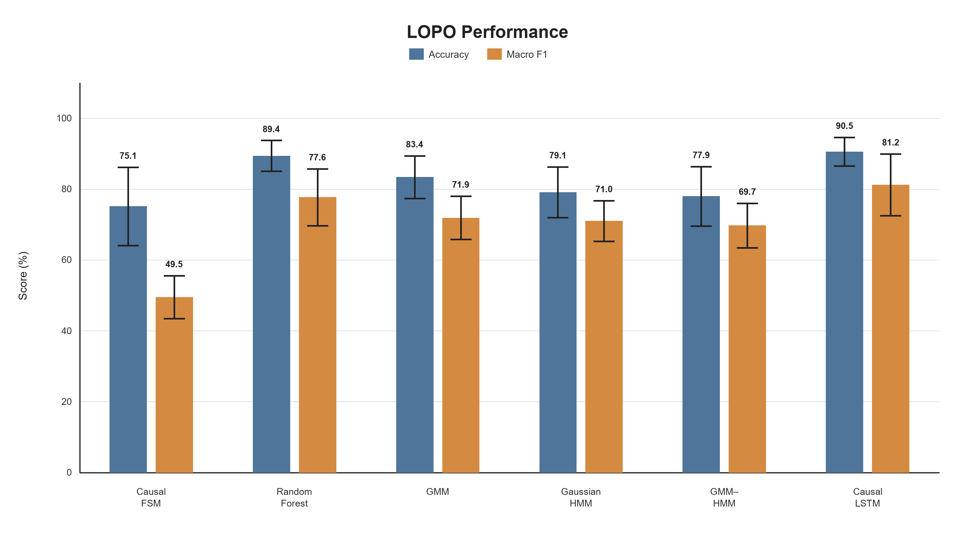
Figure 2. Overall LOPO performance. Bars represent means and error bars represent ±1 SD across six LOPO folds.

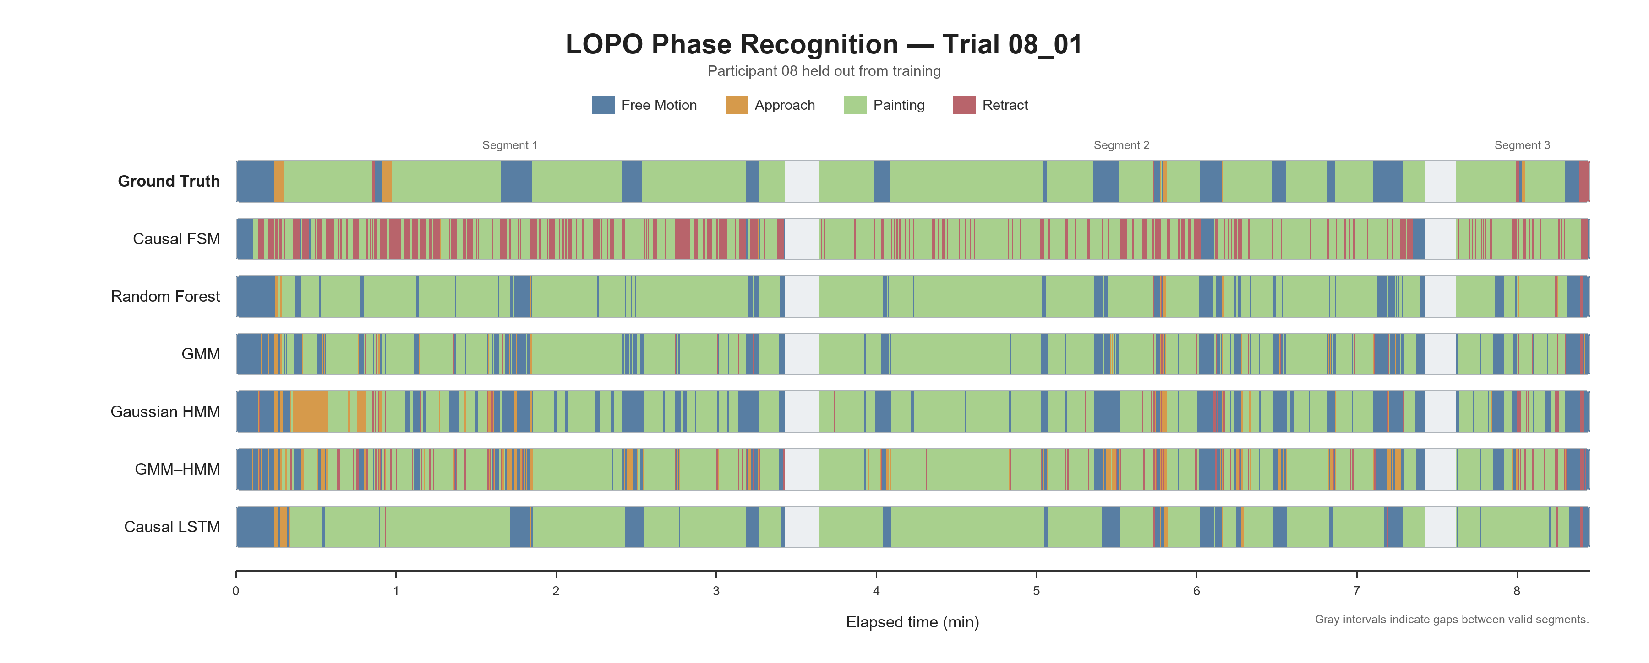
Figure 3. Framewise causal phase predictions for trial 08_01. Participant 08 was excluded from training; gray intervals indicate gaps between valid segments.

Table 1
LOPO Classification and Transition Results Within a ±3-s Tolerance
Model | Overall |  | Phase-specific F1 |  |  |  | Transition
Model | Accuracy | Macro F1 | Free Motion | Approach | Painting | Retract | F1
Causal FSM | 75.1 (11.0) | 49.5 (6.1) | 49.3 (14.6) | 24.0 (15.0) | 91.9 (3.5) | 32.7 (11.0) | 6.6 (2.3)
Random Forest | 89.4 (4.3) | 77.6 (8.0) | 87.5 (2.7) | 67.7 (18.5) | 93.7 (8.6) | 61.8 (11.7) | 18.3 (5.9)
GMM | 83.4 (6.0) | 71.9 (6.1) | 85.5 (4.5) | 57.5 (14.1) | 97.8 (1.7) | 46.6 (14.1) | 10.9 (3.6)
Gaussian HMM | 79.1 (7.2) | 71.0 (5.7) | 81.1 (8.3) | 54.6 (12.9) | 94.8 (6.9) | 53.4 (13.6) | 19.4 (1.8)
GMM–HMM | 77.9 (8.4) | 69.7 (6.3) | 85.5 (4.8) | 54.5 (14.6) | 96.2 (4.8) | 42.5 (13.1) | 15.6 (6.1)
Causal LSTM | 90.5 (4.0) | 81.2 (8.7) | 87.0 (4.0) | 72.9 (18.4) | 97.0 (1.7) | 67.8 (14.6) | 38.9 (10.5)
Note. Values are percentages and are reported as M (SD) across six held-out participants. Classification and transition scores were calculated using a ±3-s tolerance. LOPO = leave-one-participant-out; M = mean; SD = standard deviation.

