Causal Phase Recognition Results with a 3 Second Tolerance
Tables and figures only
Table 1 Four-trial comparison values are tolerant accuracy / tolerant Macro F1 percent
Model | P10-4 | I01-4 | DIV-4
Causal FSM | 75.1 / 35.4 | 51.0 / 48.3 | 61.7 / 43.6
Random Forest | 95.1 / 78.0 | 94.5 / 86.9 | 94.6 / 67.1
GMM | 85.9 / 61.5 | 88.2 / 62.9 | 88.8 / 66.1
Gaussian HMM | 90.5 / 69.2 | 86.9 / 71.5 | 88.3 / 70.1
GMM-HMM | 82.7 / 57.9 | 82.1 / 61.9 | 84.5 / 64.3
Causal LSTM | 90.5 / 76.1 | 89.7 / 80.6 | 89.3 / 67.4

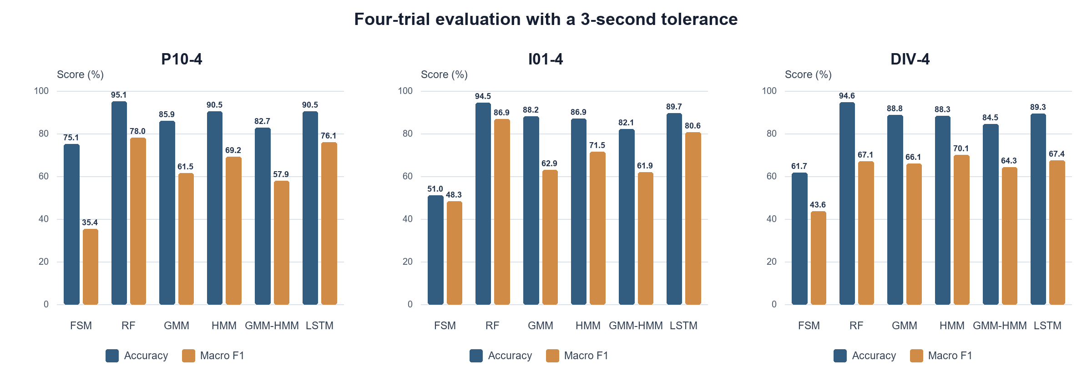
Figure 1 Four-trial tolerant accuracy and Macro F1 at +/-3 s
Table 2 Participant-specific four-trial training at +/-3 s percent
Model | Accuracy | Macro F1 | FREE F1 | APP F1 | PAINT F1 | RET F1 | Trans Recall | Trans F1
Causal FSM | 75.1 | 35.4 | 30.4 | 0.0 | 96.0 | 15.0 | 7.3 | 1.7
Random Forest | 95.1 | 78.0 | 90.7 | 49.8 | 98.1 | 73.6 | 53.7 | 13.1
GMM | 85.9 | 61.5 | 79.0 | 41.6 | 99.2 | 26.1 | 53.7 | 7.8
Gaussian HMM | 90.5 | 69.2 | 89.5 | 40.1 | 98.3 | 48.9 | 53.7 | 18.3
GMM-HMM | 82.7 | 57.9 | 78.2 | 27.5 | 99.7 | 26.5 | 41.5 | 10.0
Causal LSTM | 90.5 | 76.1 | 84.2 | 41.1 | 95.1 | 83.8 | 46.3 | 30.6

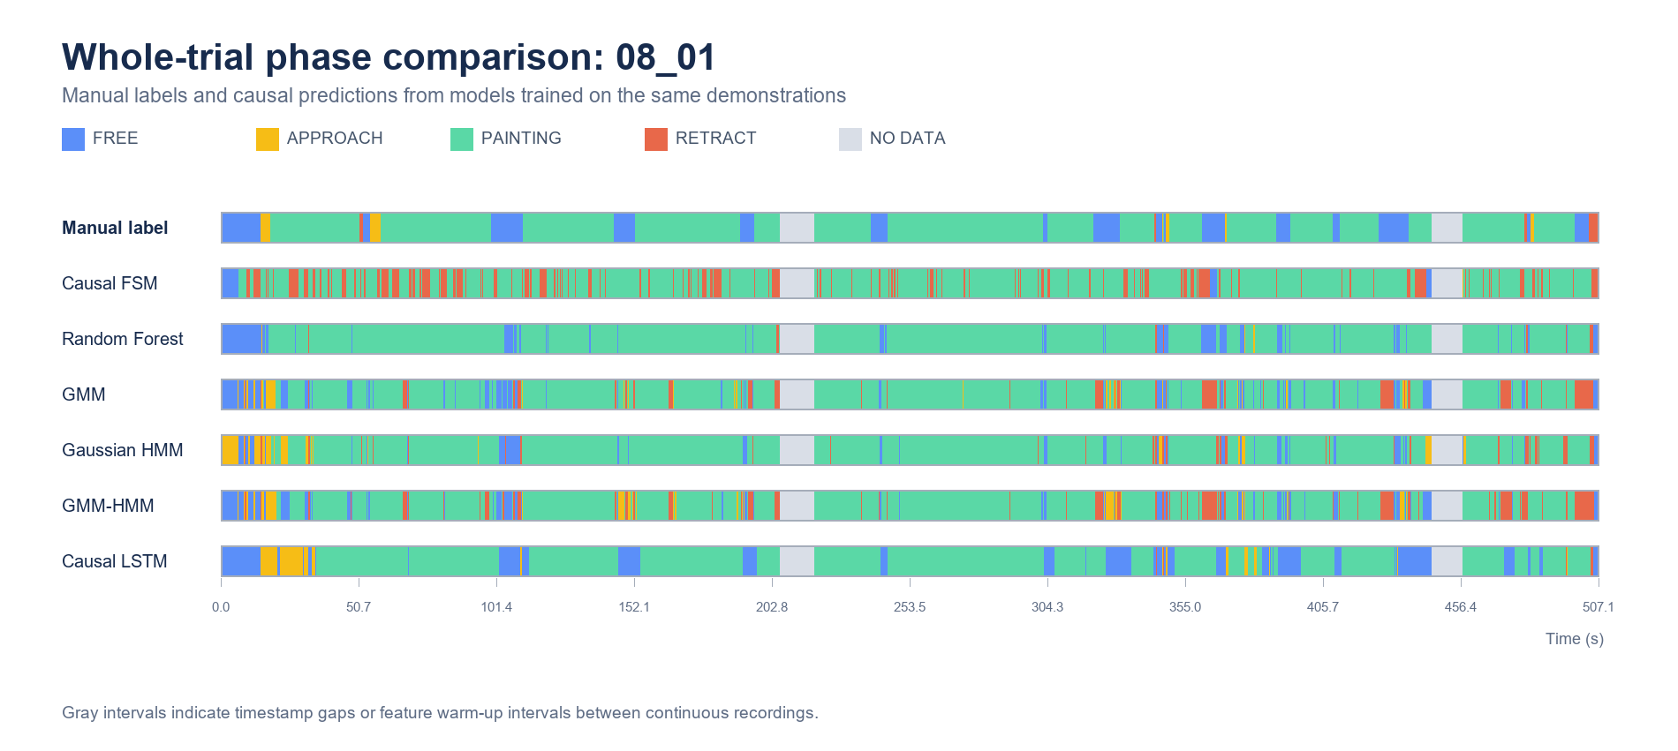
Figure 2 Ground truth and causal predictions on held-out trial 08_01 for P10-4
Table 3 Single-interface four-trial training at +/-3 s percent
Model | Accuracy | Macro F1 | FREE F1 | APP F1 | PAINT F1 | RET F1 | Trans Recall | Trans F1
Causal FSM | 51.0 | 48.3 | 65.9 | 18.7 | 96.6 | 11.8 | 24.4 | 3.3
Random Forest | 94.5 | 86.9 | 81.3 | 78.9 | 98.5 | 88.7 | 68.3 | 19.8
GMM | 88.2 | 62.9 | 84.0 | 26.6 | 99.2 | 41.7 | 85.4 | 8.3
Gaussian HMM | 86.9 | 71.5 | 81.0 | 57.5 | 99.9 | 47.7 | 61.0 | 18.1
GMM-HMM | 82.1 | 61.9 | 83.8 | 31.5 | 99.4 | 32.8 | 82.9 | 11.1
Causal LSTM | 89.7 | 80.6 | 79.4 | 64.7 | 97.3 | 81.2 | 56.1 | 34.1

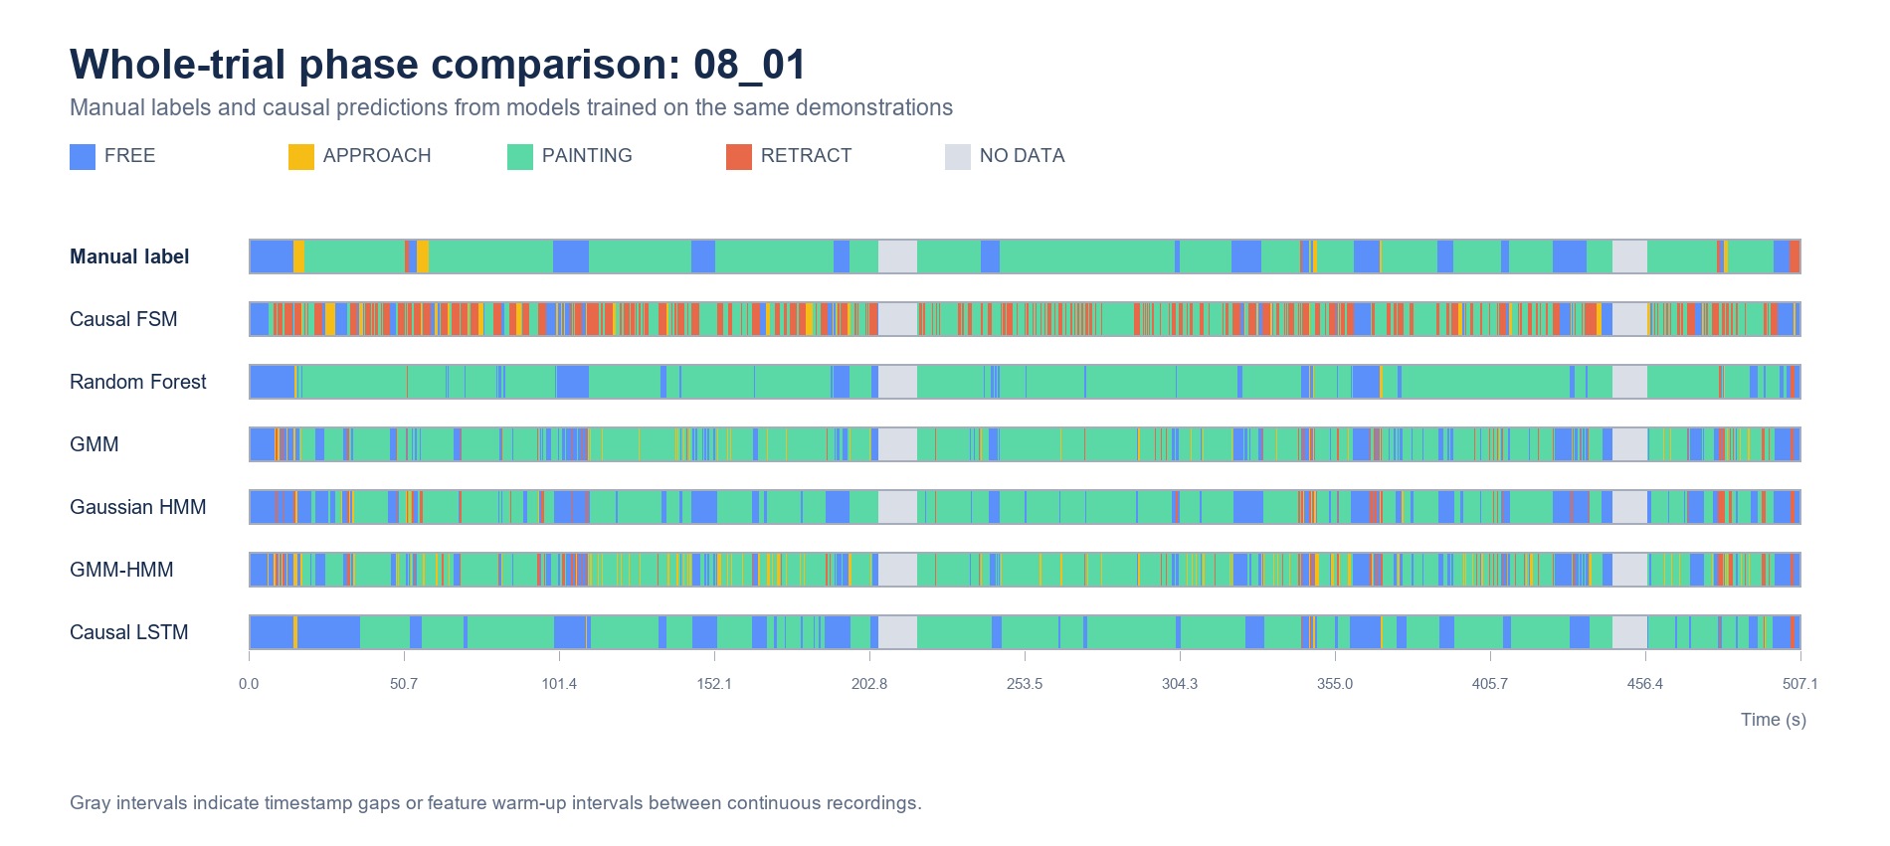
Figure 3 Ground truth and causal predictions on held-out trial 08_01 for I01-4
Table 4 Diversity-balanced four-trial training at +/-3 s percent
Model | Accuracy | Macro F1 | FREE F1 | APP F1 | PAINT F1 | RET F1 | Trans Recall | Trans F1
Causal FSM | 61.7 | 43.6 | 35.0 | 28.1 | 95.9 | 15.4 | 9.8 | 1.4
Random Forest | 94.6 | 67.1 | 87.0 | 42.5 | 98.2 | 40.6 | 51.2 | 13.6
GMM | 88.8 | 66.1 | 81.1 | 54.7 | 98.7 | 29.8 | 73.2 | 10.2
Gaussian HMM | 88.3 | 70.1 | 86.4 | 39.1 | 98.2 | 56.6 | 48.8 | 19.7
GMM-HMM | 84.5 | 64.3 | 86.4 | 48.4 | 98.9 | 23.5 | 53.7 | 11.3
Causal LSTM | 89.3 | 67.4 | 59.5 | 49.0 | 96.3 | 65.0 | 29.3 | 15.3

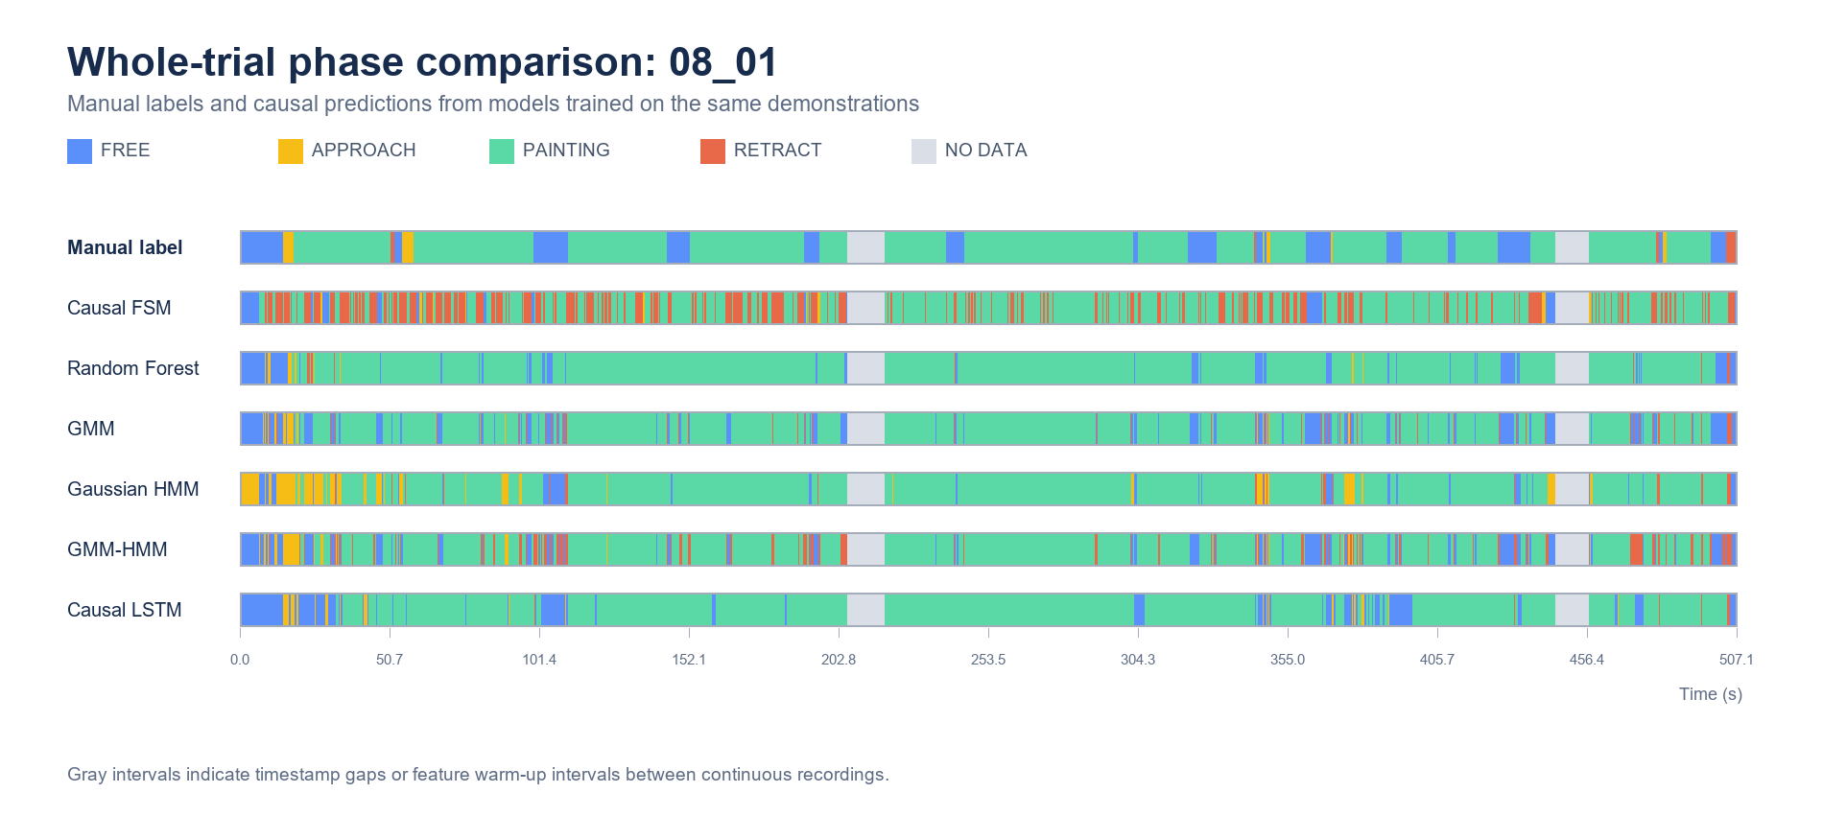
Figure 4 Ground truth and causal predictions on held-out trial 08_01 for DIV-4
Table 5 Six-fold LOPO results at +/-3 s mean SD percent
Model | Accuracy | Macro F1 | FREE F1 | APP F1 | PAINT F1 | RET F1 | Trans F1
Causal FSM | 75.1 (11.0) | 49.5 (6.1) | 49.3 (14.6) | 24.0 (15.0) | 91.9 (3.5) | 32.7 (11.0) | 6.6 (2.3)
Random Forest | 89.4 (4.3) | 77.6 (8.0) | 87.5 (2.7) | 67.7 (18.5) | 93.7 (8.6) | 61.8 (11.7) | 18.3 (5.9)
GMM | 83.4 (6.0) | 71.9 (6.1) | 85.5 (4.5) | 57.5 (14.1) | 97.8 (1.7) | 46.6 (14.1) | 10.9 (3.6)
Gaussian HMM | 79.1 (7.2) | 71.0 (5.7) | 81.1 (8.3) | 54.6 (12.9) | 94.8 (6.9) | 53.4 (13.6) | 19.4 (1.8)
GMM-HMM | 77.9 (8.4) | 69.7 (6.3) | 85.5 (4.8) | 54.5 (14.6) | 96.2 (4.8) | 42.5 (13.1) | 15.6 (6.1)
Causal LSTM | 90.5 (4.0) | 81.2 (8.7) | 87.0 (4.0) | 72.9 (18.4) | 97.0 (1.7) | 67.8 (14.6) | 38.9 (10.5)

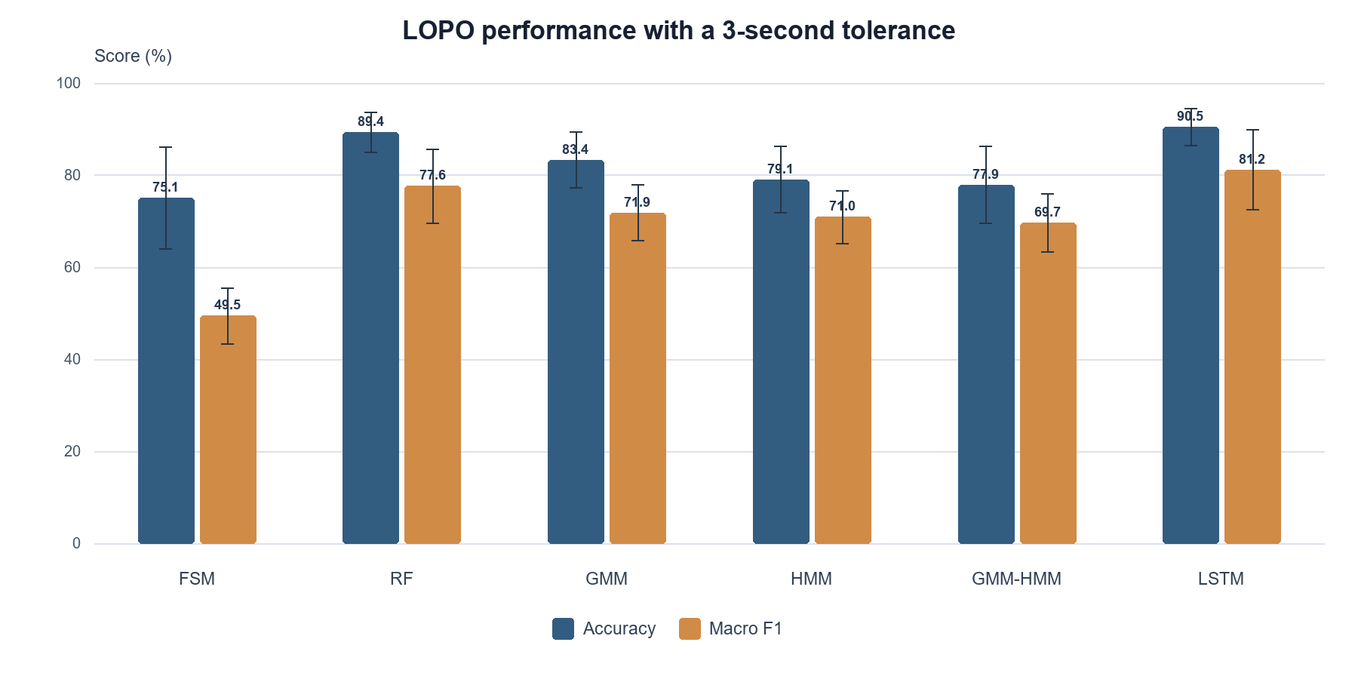
Figure 5 LOPO tolerant accuracy and Macro F1 at +/-3 s error bars show SD
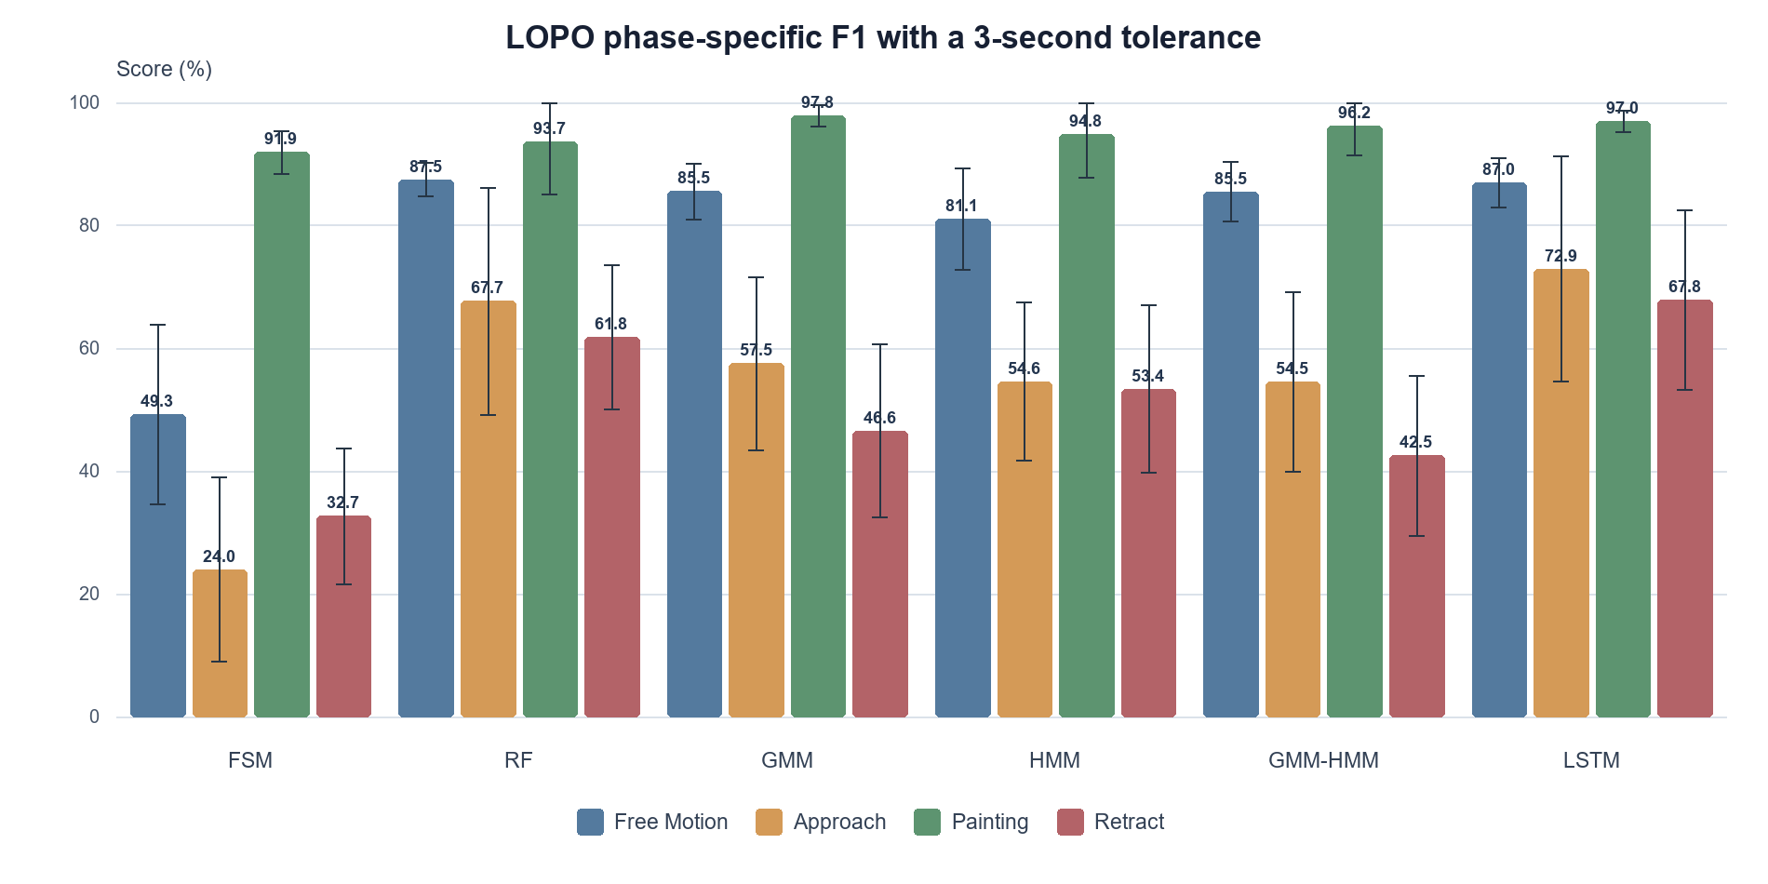
Figure 6 LOPO phase-specific F1 at +/-3 s error bars show SD
Table 6 LOPO transition-event results within +/-3 s mean SD
Model | Precision % | Recall % | F1 % | False transitions | Abs delay ms
Causal FSM | 4.8 (2.6) | 15.9 (5.9) | 6.6 (2.3) | 616.3 (422.2) | 931.2 (149.5)
Random Forest | 11.0 (4.7) | 64.8 (13.4) | 18.3 (5.9) | 827.8 (598.5) | 539.8 (138.2)
GMM | 5.9 (2.2) | 80.6 (5.1) | 10.9 (3.6) | 1947.2 (1195.2) | 591.8 (82.9)
Gaussian HMM | 11.6 (1.6) | 61.8 (9.6) | 19.4 (1.8) | 659.2 (383.3) | 659.4 (101.6)
GMM-HMM | 9.0 (4.1) | 65.2 (8.8) | 15.6 (6.1) | 1027.8 (616.4) | 728.8 (93.2)
Causal LSTM | 29.3 (10.6) | 65.1 (16.4) | 38.9 (10.5) | 262.3 (197.3) | 594.0 (167.3)

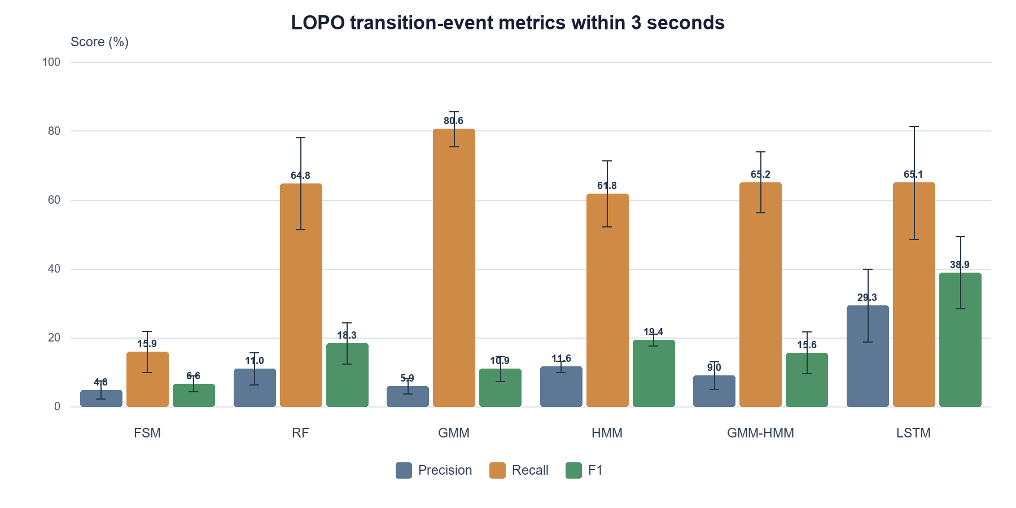
Figure 7 LOPO transition precision recall and F1 within +/-3 s error bars show SD

