Cover Page

**Attendance Taker**

https://github.com/PiaoYuGeXia/ObjectOrientedProgrammingFP

Group Members:

Jason Zhang

Ricky Pong

Rajan Bhahraj

8/14/2022

**Table of Work**

|  | Jason Zhang | Ricky Pong | Rajan Bharaj |
| --- | --- | --- | --- |
| Project Description |  | X |  |
| Uses Cases Diagram(s) | X |  |  |
| Sequence Diagrams |  |  | X |
| Class diagram(s) | X |  | X |
| Implementation | X |  | X |
| Conclusion |  | X |  |

**Table of Contents**

* Terminology Glossary (If needed)
* System Analysis
  + Project Description (One Page)
    - General Description, Goals and Benefits
    - System input(s) and output(s)
    - Special requirements (Performance, Interfaces, Constraints, Reliability, if any)
  + Uses Cases Diagram(s) and use cases description.
* System Design
  + Sequence Diagrams
  + Class diagram(s)
* Conclusion
* Appendix (any related reports, questionnaires, docs.. If any).

Product Description

Our product is an attendance system where the user, a teacher or an employer, interacts with various GUIs in order to a variety of tasks for their class or their employees respectively.

At first, the user will login to the system and that will then determine if they are a teacher or an employer based on their login credentials. If the user is a teacher, some of these tasks that the system can help with include adding a student, taking attendance of the student, and removing a student. However, if the user is an employer, some of these tasks that the system can help with include adding an employee, taking attendance of the employee, changing the salary of the employee, and laying off the employee.

The goal of this system is to make taking attendance, whether it’d be in a school environment or a workplace environment, to be as easy as possible.

System Inputs and Outputs

The only inputs in our system are text fields and buttons as the text fields are used for storing the information that the user enters and the buttons will be used for letting the system know what the user wants to do next. The system doesn’t output anything as it moreso just updates the information based on what the user has inputted.

Sequence Diagram

* Insert sequence Diagram here

Class Diagram

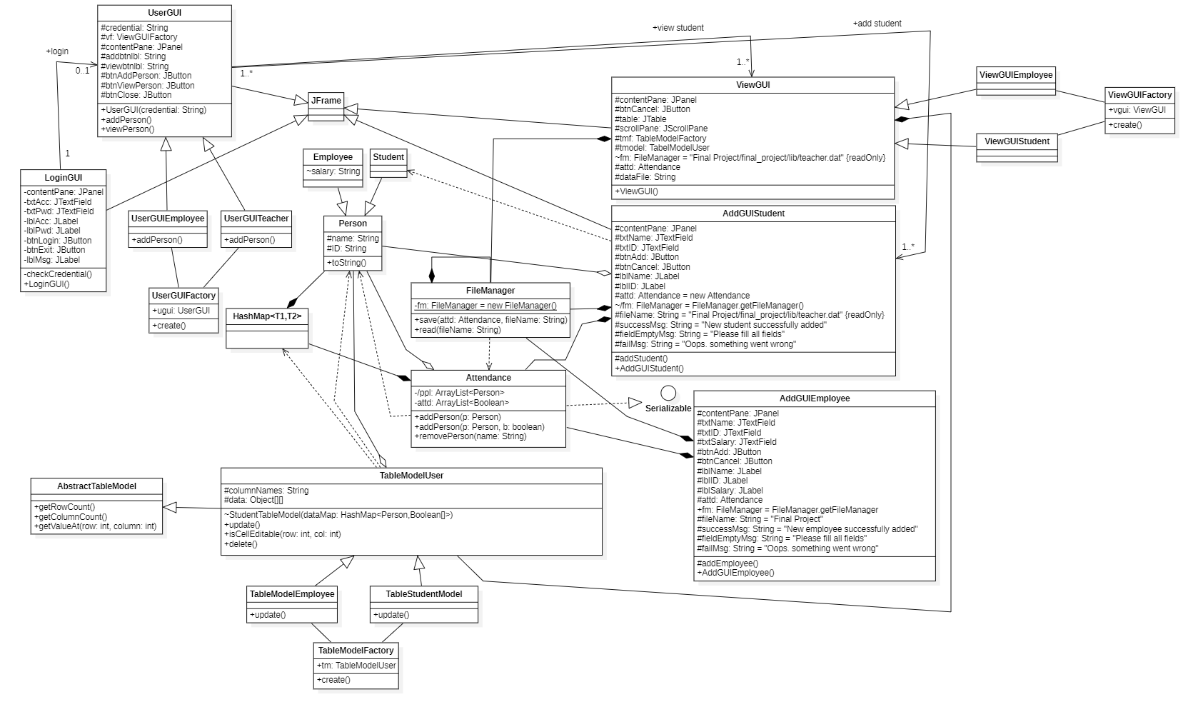

Conclusion

In conclusion, our system is designed to make taking attendance in general to be as seamless as possible using a combination of various GUIs to make it as easy as possible for the user to interact with. Having the system work for both employers and teachers makes our system more versatile as it can be used by a wider range of people.

In the future, this system can be expanded to incorporate groups of people with little monthly turnover like the armed forces, sports teams, and others.