Bartosz Piątek, Gabriel Malanowski

Lab 5

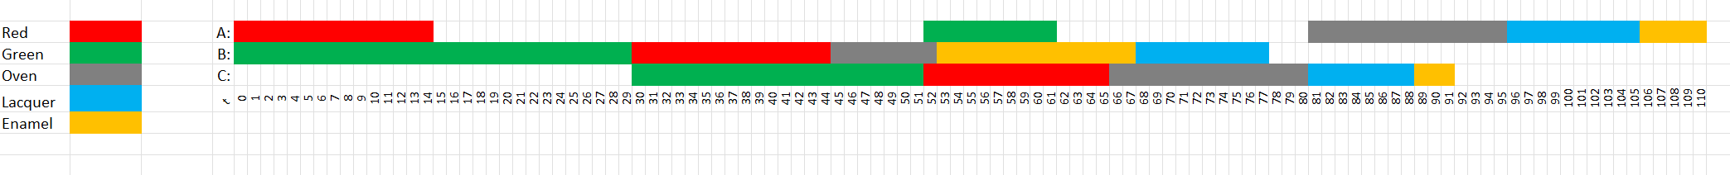

**Wyniki:**

Scheduling search.

Labeling has finished with return value of true

DFS1: DFS([B[4] = 53, B[0] = 30, B[1] = 0, B[2] = 45, C[0] = 52, C[1] = 30, A[0] = 0, A[1] = 52, C[2] = 66, A[3] = 96, A[2] = 81, A[4] = 106, C[3] = 81, B[3] = 68, C[4] = 89], SimpleSelect(org.jacop.search.SmallestDomain@484b61fc, org.jacop.search.MostConstrainedStatic@45fe3ee3, org.jacop.search.IndomainMin@4cdf35a9))

Search result is: true

A: A[0] = 0

A: A[1] = 52

A: A[2] = 81

A: A[3] = 96

A: A[4] = 106

B: B[0] = 30

B: B[1] = 0

B: B[2] = 45

B: B[3] = 68

B: B[4] = 53

C: C[0] = 52

C: C[1] = 30

C: C[2] = 66

C: C[3] = 81

C: C[4] = 89

BUILD SUCCESSFUL (total time: 0 seconds)