Лабораторна робота №2
Перевантаження операторів в С++/C#
Мета. Одержати практичні навички створення абстрактних типів даних і перевантаження операцій у мові С++, C#
Задача 1
- В клас Money додати:
  - Перевантаження:
    - операції ++ (--): одночасно збільшує (зменшує) значення полів first і second;
    - операції !: повертає значення true, якщо поле second не нульове, інакше false;
    - операції бінарний +: додає до значення поля second значення скаляра;
    - перетворення типу Money в string (і навпаки).

Лістинг програми

Money.h
#pragma once
#include <string>

void inputInfo(int& s, int& f);

class Money {
private:
int first_ = 0;
int second_ = 0;
public:
Money() = default;
Money(int first, int second);

int get_first() const noexcept { return first_; }
int get_second() const noexcept { return second_; }

void set_first(int first);
void set_second(int second);

void print() const;

Money& operator++();
Money operator++(int);
Money& operator--();
Money operator--(int);

bool operator!() const;

Money operator+(int scalar) const;

operator std::string() const;

static Money fromString(const std::string& str);
};

Money.css
#include "Money.h"
#include <iostream>
#include <stdexcept>
#include <sstream>

Money::Money(int first, int second) {
set_first(first);
set_second(second);
}

void Money::set_first(int first) {
if (first != 1 && first != 2 && first != 5 && first != 10 && first != 20 && first != 50 && first != 100) {
throw std::invalid_argument("the denomination of banknotes isn't real");
}
first_ = first;
}

void Money::set_second(int second) {
if (second < 0) {
throw std::invalid_argument("the number of bills cannot be less than zero");
}
second_ = second;
}

void Money::print() const {
std::cout << "denomination of bills: " << first_
<< ", count of bills: " << second_ << "\n";
}

void inputInfo(int& s, int& f) {
bool valid = false;
while (!valid) {
std::cout << "Hello\nEnter denomination of bills: ";
std::cin >> f;
std::cout << "Enter count of bills: ";
std::cin >> s;

try {
Money tmp;
tmp.set_first(f);
tmp.set_second(s);
valid = true;
}
catch (const std::invalid_argument& e) {
std::cout << "Error: " << e.what() << "\nTry again!\n";
}
}
}

Money& Money::operator++() {
++second_;
switch (first_) {
case 1: {
first_ = 2;
break;
}
case 2: {
first_ = 5;
break;
}
case 5: {
first_ = 10;
break;
}
case 10: {
first_ = 20;
break;
}
case 20: {
first_ = 50;
break;
}
case 50: {
first_ = 100;
break;
}
case 100: {
std::cout << "100 = max value for first";
break;
}
default: {
std::cout << "Eror, incorrect first";
}
}
return *this;
}

Money Money::operator++(int) {
Money temp = *this;
++(*this);
return temp;
}

Money& Money::operator--() {
--second_;
switch (first_) {
case 1: {
std::cout << "1 = min value for first";
break;
}
case 2: {
first_ = 1;
break;
}
case 5: {
first_ = 2;
break;
}
case 10: {
first_ = 5;
break;
}
case 20: {
first_ = 10;
break;
}
case 50: {
first_ = 20;
break;
}
case 100: {
first_ = 50;
break;
}
default: {
std::cout << "Eror, incorrect first";
}
}
return *this;
}

Money Money::operator--(int) {
Money temp = *this;
--(*this);
return temp;
}

bool Money::operator!() const {
return second_ != 0;
}

Money Money::operator+(int scalar) const {
return Money(first_, second_ + scalar);
}

Money::operator std::string() const {
std::ostringstream oss;
oss << first_ << " " << second_;
return oss.str();
}

Money Money::fromString(const std::string& str) {
std::istringstream iss(str);
int f, s;
iss >> f >> s;
return Money(f, s);
}

OOPLR02.01.css
#include <iostream>
#include <string>
#include "Money.h"

int main()
{
const int laptopPrice = 700, pcPrice = 1200, mousePrice = 150;
int product = 0;
int f = 0, s = 0;

try {
Money m1;
bool running = true;

while (running) {
int menu = 0;
std::cout << "\nSelect a menu item:\n"
<< "1. Update information\n"
<< "2. Current information\n"
<< "3. Has enough money\n"
<< "4. Items can buy\n"
<< "5. LW2\n"
<< "0. Exit\n";
std::cin >> menu;

switch (menu) {
case 1: {
inputInfo(s, f);
m1.set_first(f);
m1.set_second(s);
m1.print();
break;
}
case 2: {
m1.print();
break;
}
case 3: {
std::cout << "Select a product:\n"
<< "1. Laptop (" << laptopPrice << ")\n"
<< "2. PC (" << pcPrice << ")\n"
<< "3. Mouse (" << mousePrice << ")\n";
std::cin >> product;

int total = f * s;

switch (product) {
case 1:
if (total >= laptopPrice)
std::cout << "You have enough money for laptop\n";
else
std::cout << "You don't have enough money for a laptop\n";
break;
case 2:
if (total >= pcPrice)
std::cout << "You have enough money for PC\n";
else
std::cout << "You don't have enough money for a PC\n";
break;
case 3:
if (total >= mousePrice)
std::cout << "You have enough money for mouse\n";
else
std::cout << "You don't have enough money for a mouse\n";
break;
default:
std::cout << "Incorrect input\n";
break;
}
break;
}
case 4: {
int sum = f * s;
int ICBCount = 0;
std::cout << "Select a product:\n"
<< "1. Laptop (" << laptopPrice << ")\n"
<< "2. PC (" << pcPrice << ")\n"
<< "3. Mouse (" << mousePrice << ")\n";
std::cin >> product;

switch (product) {
case 1:
if (sum >= laptopPrice) {
while (sum >= laptopPrice) {
ICBCount++;
sum -= laptopPrice;
}
}
else
std::cout << "You don't have enough money for a laptop\n";
break;
case 2:
if (sum >= pcPrice) {
while (sum >= pcPrice) {
ICBCount++;
sum -= pcPrice;
}
}
else
std::cout << "You don't have enough money for a PC\n";
break;
case 3:
if (sum >= mousePrice) {
while (sum >= mousePrice) {
ICBCount++;
sum -= mousePrice;
}
}
else
std::cout << "You don't have enough money for a mouse\n";
break;
default:
std::cout << "Incorrect input\n";
break;
}

std::cout << "You can buy " << ICBCount << "\n";
break;
}
case 5: {
++m1;
std::cout << "After ++: ";
m1.print();

m1--;
std::cout << "After --: ";
m1.print();

if (!m1)
std::cout << "second is not zero\n";
else
std::cout << "Second is zero\n";

int scalar = 0;
std::cout << "Enter Scalar: ";
std::cin >> scalar;
Money m3 = m1 + scalar;
m3.print();

std::string str = (std::string)m3;
std::cout << "As string: " << str << "\n";

Money m4 = Money::fromString("50 7");
std::cout << "From string: ";
m4.print();
break;
}
case 0: {
running = false;
break;
}
default: {
std::cout << "Incorrect input\n";
break;
}
}
}

Money m2(f, s);
std::cout << "denomination of bills: " << m2.get_first()
<< ", count of bills: " << m2.get_second() << "\n";
}
catch (const std::exception& ex) {
std::cerr << "Error: " << ex.what() << "\n";
}

return 0;
}

Задача 2 у C# Windows Forms. Тема «Компютерні комплектуючі»
Лістинг програми
ClassParts.cs
using System;
using System.Collections.Generic;
using System.Linq;
using System.Text;
using System.Threading.Tasks;

namespace LW1._03
{
public class ComputerPart
{
public string Type { get; set; }
public string Brand { get; set; }
public string Model { get; set; }
public string ReleaseYear { get; set; }
public string Price { get; set; }
public string AdditionalInfo { get; set; }

public ComputerPart() { }

public ComputerPart(string type, string brand, string model, string releaseYear, string price, string additionalIndo)
{
Type = type;
Brand = brand;
Model = model;
ReleaseYear = releaseYear;
Price = price;
AdditionalInfo = additionalIndo;
}

public static void SortByPrice(List<ComputerPart> parts, bool ascending = true)
{
parts.Sort((x, y) =>
{
if (x > y) return ascending ? -1 : 1;
if (x < y) return ascending ? 1 : -1;
return 0;
});
}

public string[] ToRow()
{
return new string[] { Type, Brand, Model, ReleaseYear, Price, AdditionalInfo };
}

public static implicit operator string[](ComputerPart part)
{
return part.ToRow();
}

public static bool operator >(ComputerPart a, ComputerPart b)
{
return decimal.Parse(a.Price) > decimal.Parse(b.Price);
}

public static bool operator <(ComputerPart a, ComputerPart b)
{
return decimal.Parse(a.Price) < decimal.Parse(b.Price);
}

public static bool operator >=(ComputerPart a, ComputerPart b)
{
return int.Parse(a.ReleaseYear) >= int.Parse(b.ReleaseYear);
}

public static bool operator <=(ComputerPart a, ComputerPart b)
{
return int.Parse(a.ReleaseYear) <= int.Parse(b.ReleaseYear);
}
}
}
Form1.cs
using System.IO;
using System.Text.Json;

namespace LW1._03
{
public partial class LW1 : Form
{
private List<ComputerPart> parts = new List<ComputerPart>();
private List<ComputerPart> compareList = new List<ComputerPart>();

public LW1()
{
InitializeComponent();
btnEnter.Enabled = false;
cmbSelectType.Items.AddRange(new string[] {"Mother Board", "CPU",
"GPU", "RAM", "HDD", "SSD", "PSU", "Tower", "CPU Air Cooler", "Liquid Cooler",
"Case Fans", "Thermal Paste"});

txtAddInfo.MaxLength = 50;
txtBrand.MaxLength = 50;
txtModel.MaxLength = 50;
txtPrice.MaxLength = 50;
txtRelYear.MaxLength = 4;
}

private void btnEnter_Click(object sender, EventArgs e)
{
var part = new ComputerPart(
cmbSelectType.Text,
txtBrand.Text,
txtModel.Text,
txtRelYear.Text,
txtPrice.Text,
txtAddInfo.Text
);

parts.Add(part);
dgv1.Rows.Add(part);

cmbSelectType.SelectedIndex = -1;
txtBrand.Clear();
txtModel.Clear();
txtRelYear.Clear();
txtPrice.Clear();
txtAddInfo.Clear();

btnEnter.Enabled = false;
}

private void CheckFields()
{
btnEnter.Enabled =
!string.IsNullOrWhiteSpace(cmbSelectType.Text) &&
!string.IsNullOrWhiteSpace(txtBrand.Text) &&
!string.IsNullOrWhiteSpace(txtModel.Text) &&
!string.IsNullOrWhiteSpace(txtRelYear.Text) &&
!string.IsNullOrWhiteSpace(txtPrice.Text) &&
!string.IsNullOrWhiteSpace(txtAddInfo.Text);
}

private void cmbSelectType_SelectedIndexChanged(object sender, EventArgs e) => CheckFields();
private void txtBrand_TextChanged(object sender, EventArgs e) => CheckFields();
private void txtModel_TextChanged(object sender, EventArgs e) => CheckFields();
private void txtRelYear_TextChanged(object sender, EventArgs e) => CheckFields();
private void txtPrice_TextChanged(object sender, EventArgs e) => CheckFields();
private void txtAddInfo_TextChanged(object sender, EventArgs e) => CheckFields();

//==================+MenuStrip+==================\\
//==================+Json+==================\\

private void saveTSMI_Click(object sender, EventArgs e)
{
using (SaveFileDialog saveFileDialog = new SaveFileDialog())
{
saveFileDialog.Filter = "JSON files (*.json)|*.json|All files (*.*)|*.*";
if (saveFileDialog.ShowDialog() == DialogResult.OK)
{
string json = JsonSerializer.Serialize(parts, new JsonSerializerOptions { WriteIndented = true });
File.WriteAllText(saveFileDialog.FileName, json);
MessageBox.Show("File saved!", "Saving", MessageBoxButtons.OK, MessageBoxIcon.Information);
}
}
}

private void loadTSMI_Click(object sender, EventArgs e)
{
using (OpenFileDialog openFileDialog = new OpenFileDialog())
{
openFileDialog.Filter = "JSON files (*.json)|*.json|All files (*.*)|*.*";
if (openFileDialog.ShowDialog() == DialogResult.OK)
{
try
{
string json = File.ReadAllText(openFileDialog.FileName);
parts = JsonSerializer.Deserialize<List<ComputerPart>>(json) ?? new List<ComputerPart>();
dgv1.Rows.Clear();
foreach (var part in parts)
{
dgv1.Rows.Add(part);
}

MessageBox.Show("Data uploaded successfully!", "Uploading", MessageBoxButtons.OK, MessageBoxIcon.Information);
}
catch (Exception ex)
{
MessageBox.Show("Error opening file: " + ex.Message);
}
}
}
}

//==================-Json-==================\\

private void clearToolStripMenuItem_Click(object sender, EventArgs e)
{
dgv1.Rows.Clear();

parts.Clear();
}

private void tSMIOpenComp_Click(object sender, EventArgs e)
{
if (compareList.Count < 2)
{
MessageBox.Show("You must select at least 2 items for comparison.");
return;
}

ComparisonForm form = new ComparisonForm(compareList);
form.Show();
}

private void tSMIClear_Click(object sender, EventArgs e)
{
compareList.Clear();
MessageBox.Show("Comparison list cleared.");
}

private void sortByPriceToolStripMenuItem1_Click(object sender, EventArgs e)
{
ComputerPart.SortByPrice(parts, ascending: true);
dgv1.Rows.Clear();
foreach (var part in parts)
{
dgv1.Rows.Add(part.Type, part.Brand, part.Model, part.ReleaseYear, part.Price, part.AdditionalInfo);
}
}
private void sortByYearToolStripMenuItem_Click(object sender, EventArgs e)
{
parts.Sort((x, y) =>
{
if (x >= y) return -1;
if (x <= y) return 1;
return 0;
});
dgv1.Rows.Clear();
foreach (var part in parts)
{
dgv1.Rows.Add(part.Type, part.Brand, part.Model, part.ReleaseYear, part.Price, part.AdditionalInfo);
}
}

//==================-MenuStrip-==================\\

//==================+ContextMenuStrip+==================\\

private void deleteToolStripMenuItem_Click(object sender, EventArgs e)
{
if (dgv1.CurrentRow != null && dgv1.CurrentRow.Index >= 0)
{
int index = dgv1.CurrentRow.Index;

if (index < parts.Count)
parts.RemoveAt(index);

dgv1.Rows.RemoveAt(index);
}
}
private void clearToolStripMenuItem1_Click(object sender, EventArgs e)
{
dgv1.Rows.Clear();

parts.Clear();
}

private void dgv1_MouseDown(object sender, MouseEventArgs e)
{
if (e.Button == MouseButtons.Right)
{
var hitTest = dgv1.HitTest(e.X, e.Y);
if (hitTest.RowIndex >= 0)
{
dgv1.ClearSelection();
dgv1.Rows[hitTest.RowIndex].Selected = true;
dgv1.CurrentCell = dgv1.Rows[hitTest.RowIndex].Cells[0];
}
}
}

private void addToComparisonToolStripMenuItem_Click(object sender, EventArgs e)
{
if (dgv1.CurrentRow != null && dgv1.CurrentRow.Index >= 0)
{
int index = dgv1.CurrentRow.Index;
if (index < parts.Count)
{
var partToCompare = parts[index];

if (!compareList.Contains(partToCompare))
{
compareList.Add(partToCompare);
MessageBox.Show($"{partToCompare.Model} added to comparison!", "Comparison");
}
else
{
MessageBox.Show("This item is already in the comparison list.");
}
}
}
}

private void sortByPriceToolStripMenuItem_Click(object sender, EventArgs e)
{
ComputerPart.SortByPrice(parts, ascending: true);
dgv1.Rows.Clear();
foreach (var part in parts)
{
dgv1.Rows.Add(part.Type, part.Brand, part.Model, part.ReleaseYear, part.Price, part.AdditionalInfo);
}
}

private void sortByYearToolStripMenuItem1_Click(object sender, EventArgs e)
{
parts.Sort((x, y) =>
{
if (x >= y) return -1;
if (x <= y) return 1;
return 0;
});
dgv1.Rows.Clear();
foreach (var part in parts)
{
dgv1.Rows.Add(part.Type, part.Brand, part.Model, part.ReleaseYear, part.Price, part.AdditionalInfo);
}
}

//==================-ContextMenuStrip-==================\\
//==================+Methods+==================\\
//==================-Methods-==================\\
}
}
ComparisonForm.cs
using System;
using System.Collections.Generic;
using System.ComponentModel;
using System.Data;
using System.Drawing;
using System.Drawing.Text;
using System.Linq;
using System.Text;
using System.Threading.Tasks;
using System.Windows.Forms;

namespace LW1._03
{
public partial class ComparisonForm : Form
{
public ComparisonForm(List<ComputerPart> partsToCompare)
{
InitializeComponent();

dgvCompare.Columns.Add("Property", "Property");

for (int i = 0; i < partsToCompare.Count; i++)
{
dgvCompare.Columns.Add($"Part{i}", partsToCompare[i].Model);
}

AddRow("Type", partsToCompare.Select(p => p.Type).ToArray());
AddRow("Brand", partsToCompare.Select(p => p.Brand).ToArray());
AddRow("Model", partsToCompare.Select(p => p.Model).ToArray());
AddRow("Release Year", partsToCompare.Select(p => p.ReleaseYear).ToArray());
AddRow("Price", partsToCompare.Select(p => p.Price).ToArray());
AddRow("Additional Info", partsToCompare.Select(p => p.AdditionalInfo).ToArray());
}

private void AddRow(string property, string[] values)
{
var row = new List<string> { property };
row.AddRange(values);
dgvCompare.Rows.Add(row.ToArray());
}
}
}
Результати виконання програми

Одразу після завантаження форми:

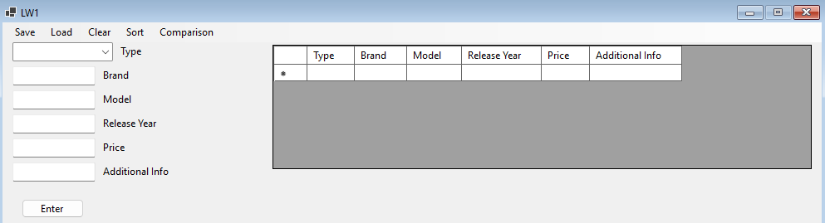
Після натискання кнопки «Load»:

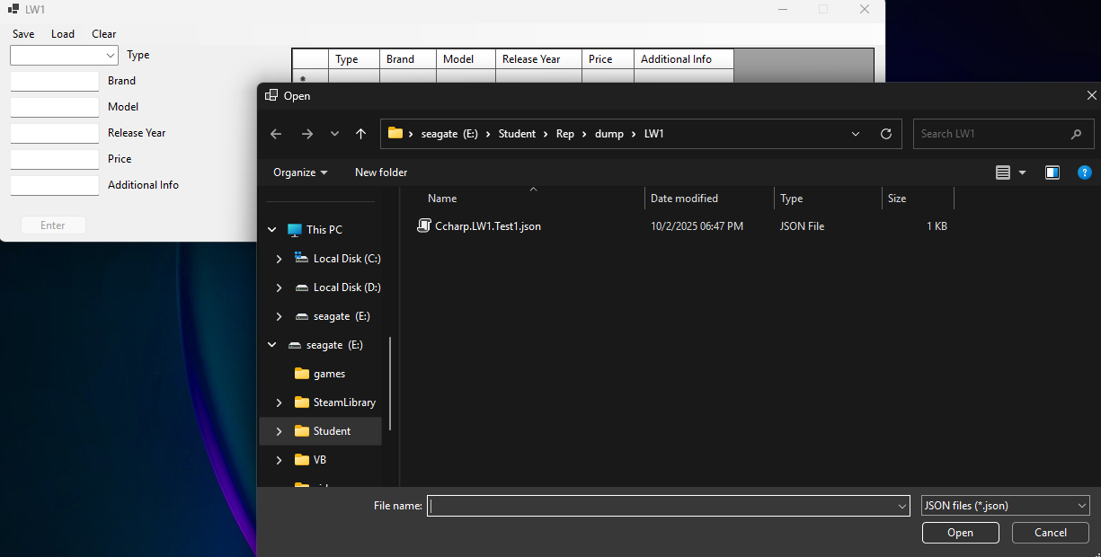

Вибравши JSON файл “Ccharp.LW1.Test1.json” відкриваємо список та виводимо у таблицю:
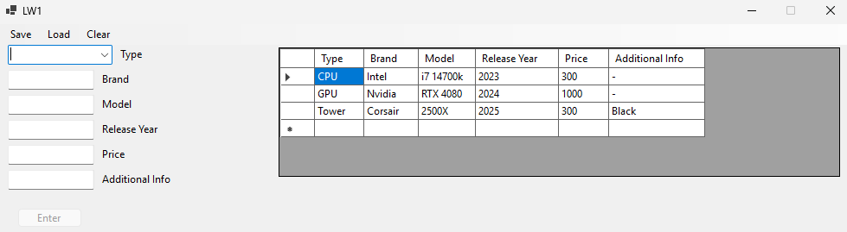
Додавання нового елементу (подія btnEnter_Click/кнопка “Enter”):
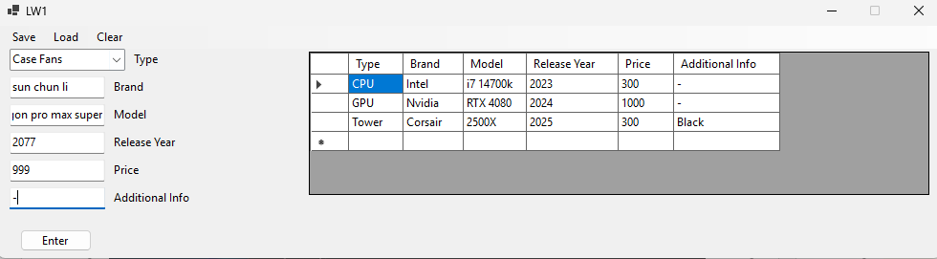
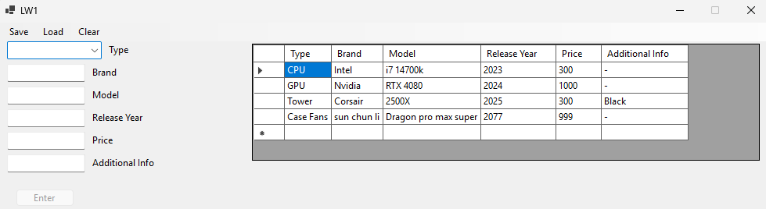

Після натискання «Зберегти»:
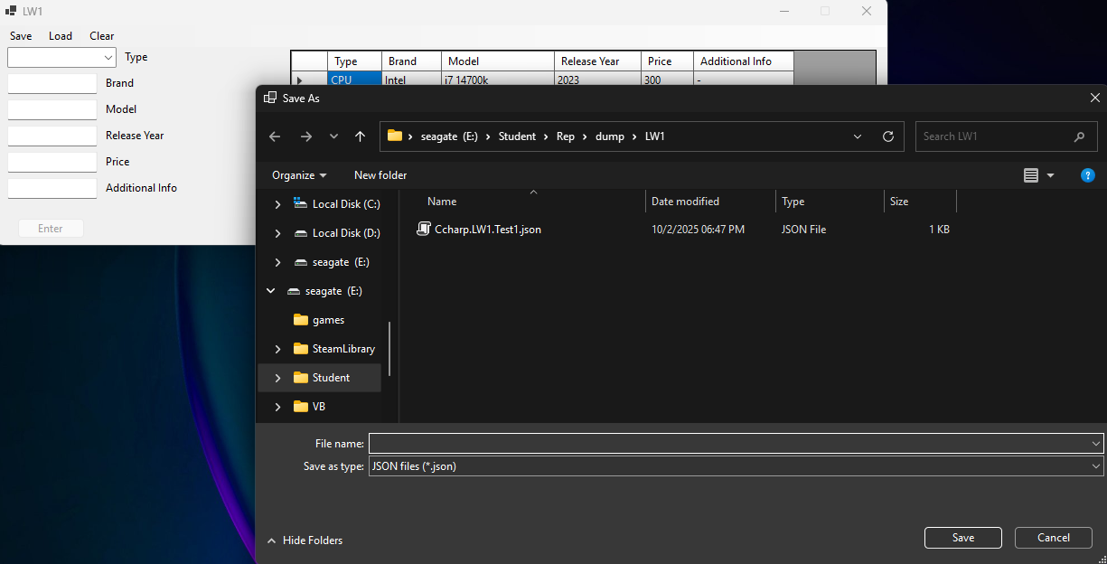
Після натискання «Очистити»:
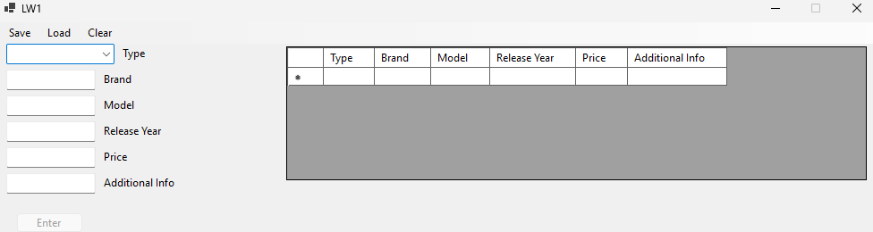

Після натискання «Sort by price»:

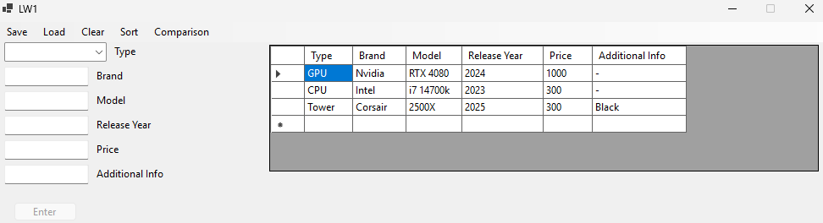
Після натискання «Sort by year»:
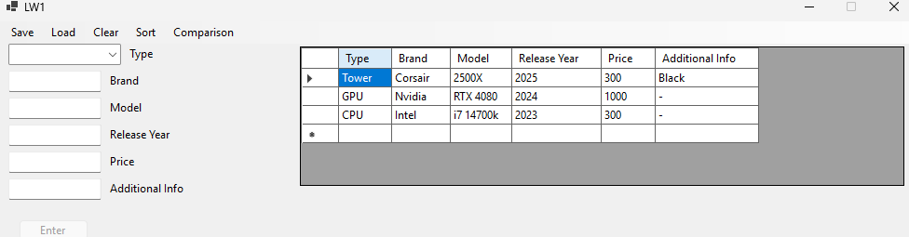

Висновок: Одержано практичні навички перевантаження операторів на С++ та C# Windows Forms.

