Pitas, Paul Bennedict F. || 2-ECE-B

EXP 9 Screenshots

* Problem Assignment 1

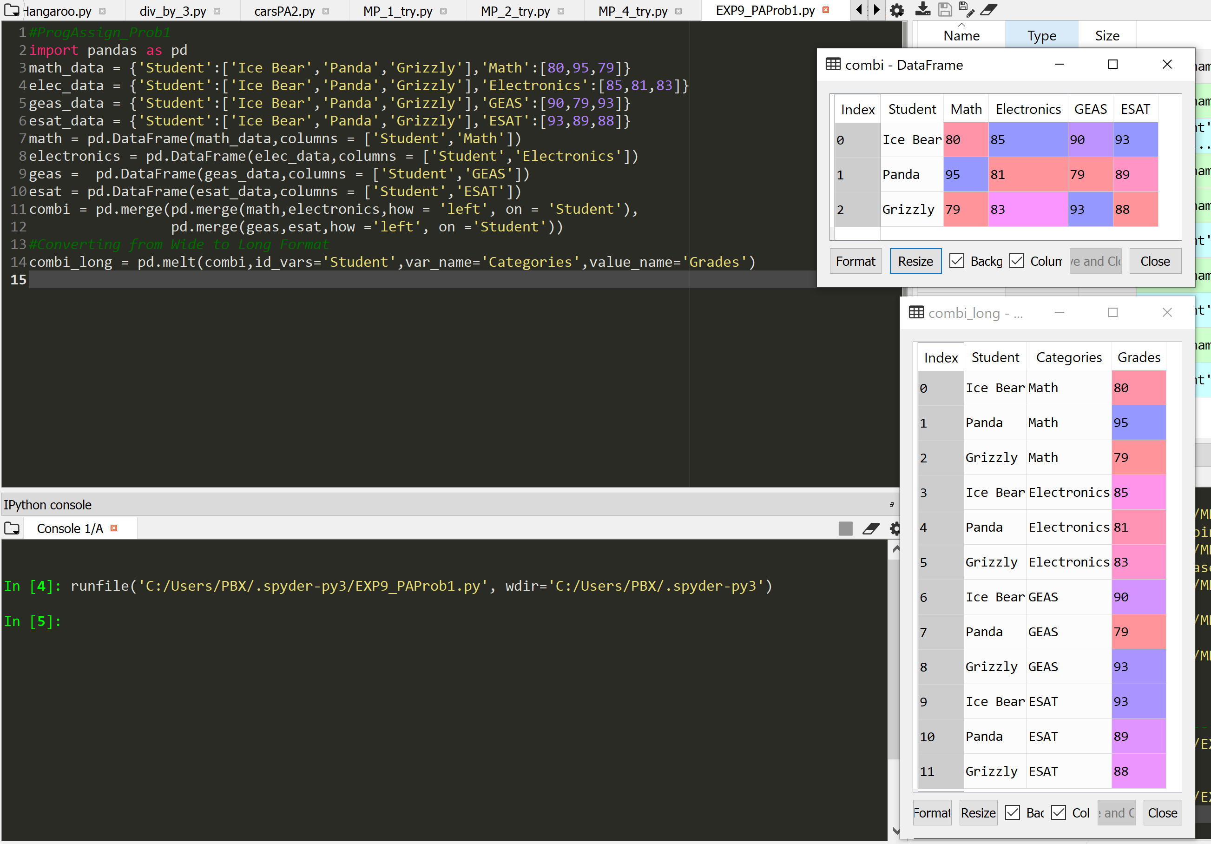

* Problem Assignment 2
  + Without Volume

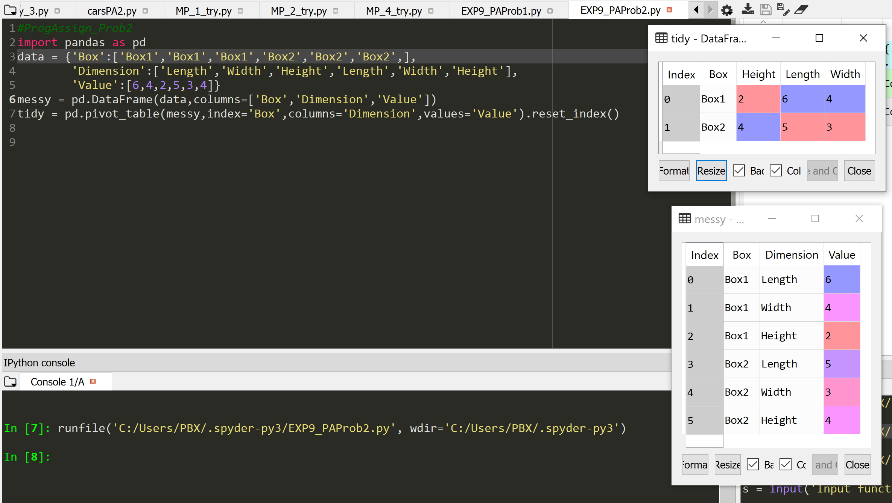

* + With Volume

