Pitas, Paul Bennedict F. || 2-ECE-B

EXPERIMENT 7 – CODE SCREENSHOTS AND TESTING

1. X_normalized

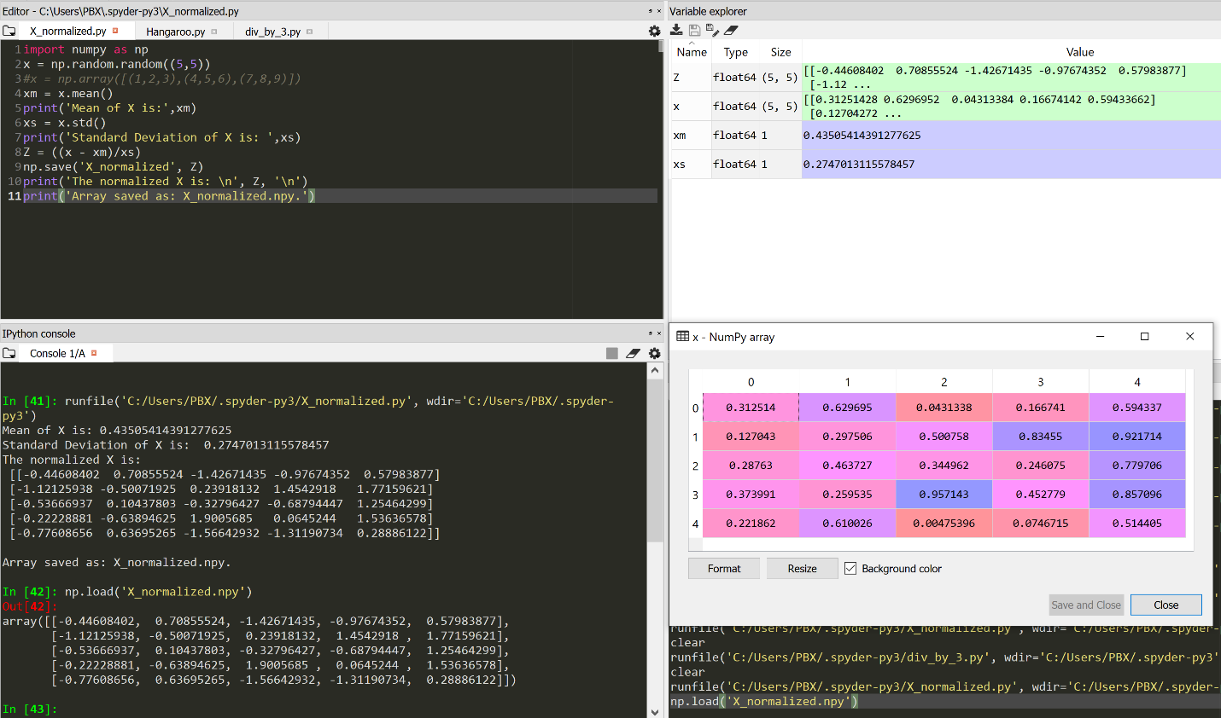

1. div_by_3

