Pitas, Paul Bennedict F. | 2-ECE-B

Experiment 8 Screenshots and Tests

* Problem Assignment 1

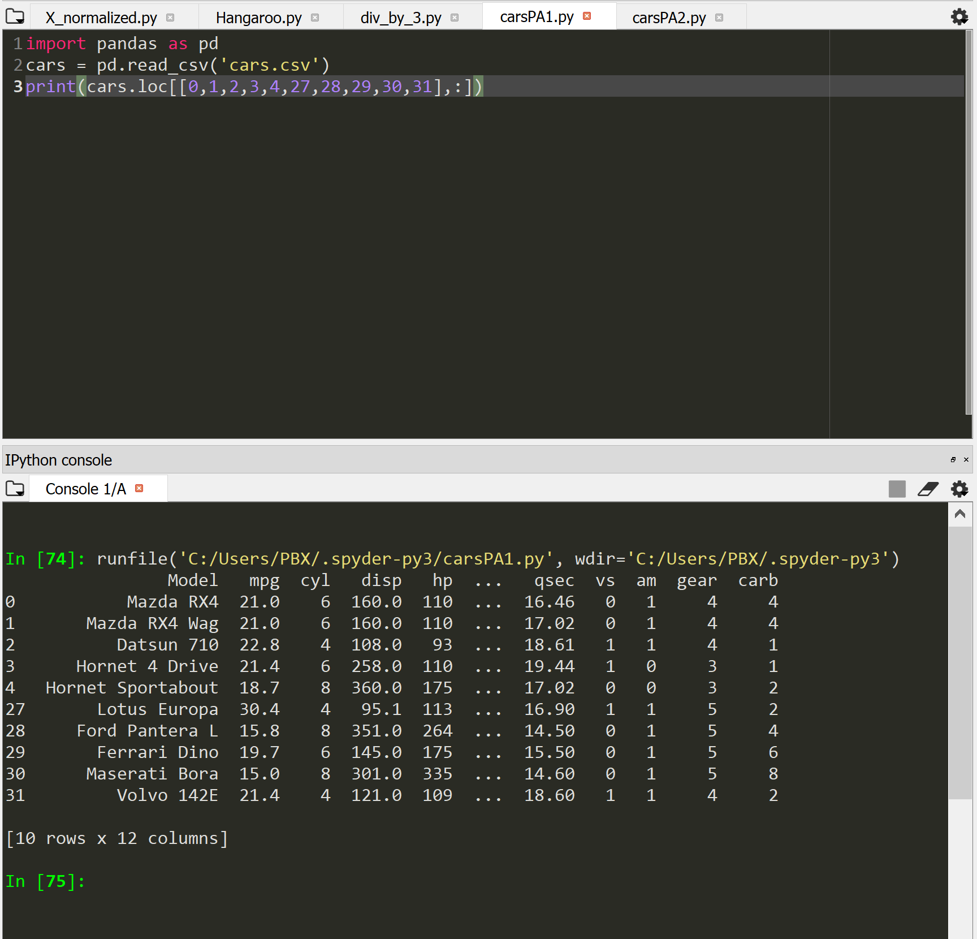

* Problem Assignment 2

