**Senior Design**

ENG EC 463

**Autonomous Legged Guide Robot**

**Team 2**

Yihe Bi

Bowen Ma

Yichen Wang

Xiteng Yao

Shun Zhang

**Required Materials:**

Hardware:

1. TOF Lidar
2. Raspberry Pi
3. Puppypi robot dog
4. Bluetooth Speaker

Software:

1. VNC Viewer

**Setup:**

QR Code Navigation Test:

The LiDAR module needs to be installed on top of the robot dog, and a destination target code must be initialized in the script. When the script is run, the robot dog should perform the line tracking module and choose the correct direction of turn at the "Y"-shaped intersection.

QR Code Destination Test:

The preliminary setup procedure should be the same as the navigation test, except for the addition of a connection to the Bluetooth speaker for voice feedback. This time, when the script is run, the robot should stop and provide mp3 voice feedback to the Bluetooth module when a QR code is present at the end of the track.

Pipeline Test:

This test requires all modules to be set up: the LiDAR, Bluetooth speaker, and a Y-shaped track with obstacles on it, as shown in the picture below. When the script is run, the robot dog should be able to reach one of the destinations without colliding with any obstacles.

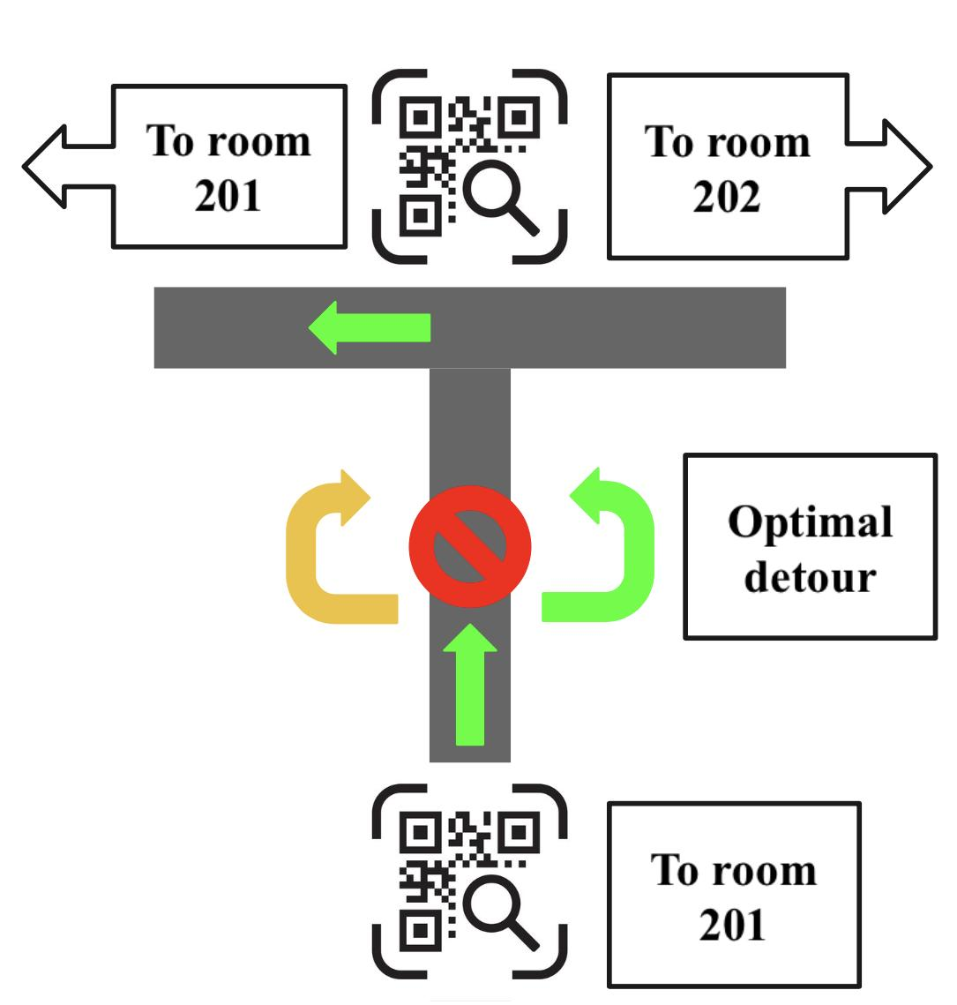

**Pre-testing Setup Procedure:**

Robot Dog test:

The robot dog should be turned on. A WLAN hotspot with SSID starting with “HW-1a” should be detectable. The computer needs to connect to the hotspot. Then, use the VNC software to connect to the onboard Raspberry Pi. The IP address should be 192.168.149.1, the username should be “pi”, and the password should be “raspberry”. After connection, a graphical desktop should be visible. For file transfer, WinSCP is needed. It can log in using the exact same credentials. Once these are done, the setup is complete.

**Testing Procedure:**

QR Code Navigation test:

1. Set up the environment, boot up the robot dog, and tape the Y-shape track on the ground with red tape.
2. Start running the script for the navigation test.
3. Record the robot and examine if the robot is on the line properly and reach the desired destination with the right turn.

QR Code Destination test:

1. Set up the environment, boot up the robot dog, connect the Bluetooth speaker to the robot dog for voice output.
2. Start running the script.
3. Record the interactions between the dog, the track, and whether the dog correctly recognizes the QR code and provides proper voice feedback to the speaker.

Pipeline test:

1. Set up the environment, boot up the robot dog, connect the Bluetooth speaker to the robot dog for voice output.
2. Set up the track for the dog with red tapes and add obstacles as shown in the schematics above.
3. Start running the “AllInOne.py” script.
4. Record if the dog can reach the destination while meeting the criteria listed below.

**Measurable Criteria:**

QR Code Navigation test:

1. The robot dog should be able to recognize the QR code on the intersection.
2. The robot dog should be able to perform the correct turn on the intersection while keeping track of the line.

QR Code Destination test:

1. The dog should be able to follow the line properly and recognize the QR code on the destination.
2. The dog should be able to stop when QR code is detected and provide proper voice feedback to the speaker with correct information about the destination.

Pipeline test:

1. For the final pipeline test, the criteria to determine if the robot dog is successful in performing the final tasks is as follows:
   1. Following the track properly
   2. Avoiding the obstacle with optimal detour
   3. Choosing the correct path when recognizing the QR code on the intersection
   4. Reaching the final destination and providing voice feedback to the user with the information of the destination.

**Score Sheet:**

|  |  |
| --- | --- |
| Objective | Correct? |
| In the QR code navigation test, the robot dog should be correct in choosing the path with absolutely no errors. | Y |
| The robot dog should provide voice feedback within 2 seconds of recognizing the final QR tag and the information should be correct. | Y |
| In the final pipeline test, the robot dog should be on the line more than 90% of time, excluding when performing obstacles avoidance. | Y |
| The robot dog should be avoiding the obstacle on the path with a detour which is the most optimal path, and with absolutely no collision with the obstacle. | Y |
| The robot dog should be reaching the final destination on the pipeline with voice feedback signaling the end of the test. | Y |

**Conclusion:**

During the test, the robot demonstrates the ability to navigate using line tracking, QR code recognition, and obstacle avoidance. It can choose correct path to the preset destination using the information form the QR code. It can also actively avoid obstacle along the path using the RGB camera, and it provides voice feedback along the way when seeing junctions or destinations marked by QR codes. Its behavior also shows that the control logic is functional. This shows that the robot has the basic ability to guide visually impaired people to an indoor location. It meets the function requirement for the project. What we can improve is to test on more lighting conditions, flooring materials, and obstacle positions. We can also add functions like voice control or demo function for better user experience. In a word, this test shows that the robot meets the functional requirements of the project, and we can also furthermore improve the overall usability of the robot.