Logo%20Main%20200

**Boston University**

**Electrical & Computer Engineering**

**EC464 Capstone Senior Design Project**

User's Manual

**Autonomous Legged Robot**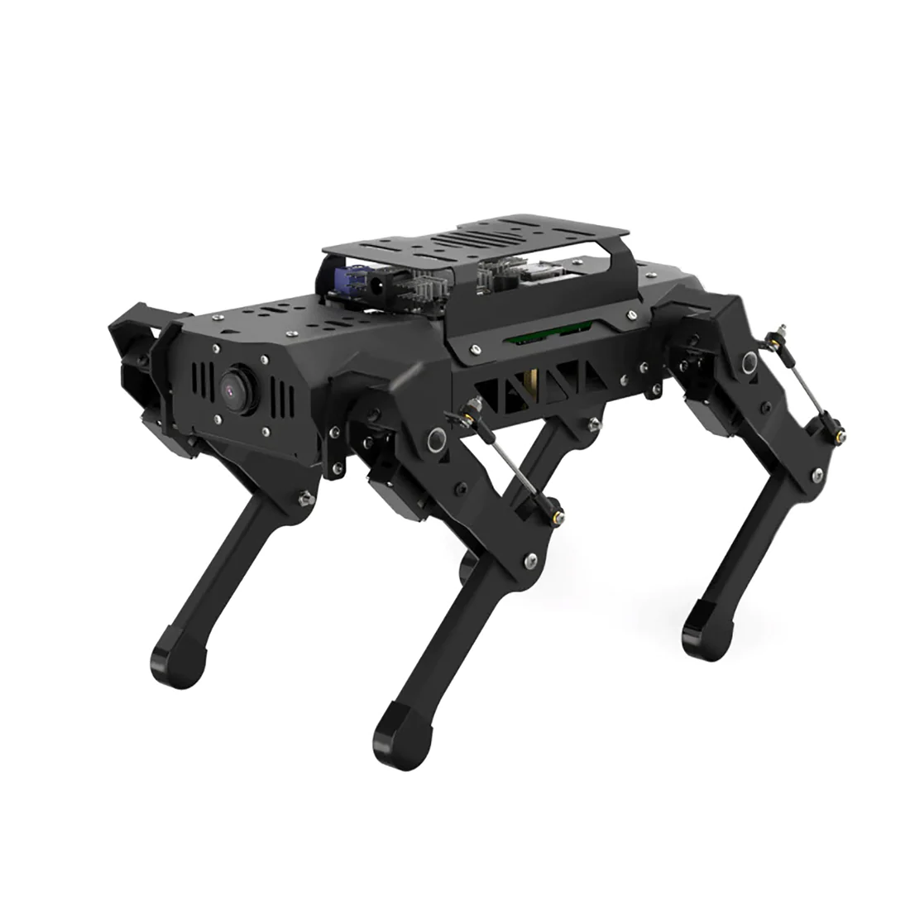

Submitted to

Prof. Ohn-bar

by

Team 2

Team Members

Bowen Ma [bma1024@bu.edu](mailto:email1@bu.edu)

Shun Zhang shunz[@bu.edu](mailto:email1@bu.edu)

Xiteng Yao xtyao[@bu.edu](mailto:email1@bu.edu)

Yichen Wang wyichen@bu.edu

Yihe Bi ybi[@bu.edu](mailto:email5@bu.edu)

:

Submitted: (Mar.24th)

#### **Autonomous Legged Robot**

#### **Table of Contents**

Autonomous Legged Robot 1

Table of Contents 2

**Executive Summary** **3**

**1. Introduction** **4**

**2. System Overview and Installation** **5**

1.1 Overview Block Diagram 5

1.2 User Interface 5

1.3 Physical description 6

1.4 Installation, setup, and support 7

**3** **Operation of the Project** **10**

2.1 Operating Mode 1: Normal Operation 10

2.2 Operating Mode 2: Abnormal Operations 10

2.3 Safety Issues 11

**4** **Technical Background** **12**

**5** **Cost Breakdown** **14**

**6** **Appendices** **16**

5.1 Appendix A - Specifications 16

5.2 Appendix B – Team Information 16

# 

# **Executive Summary**

According to the World Health Organization, at least 2.2 billion people globally have near or distance vision impairments (WHO 2022). Walking in unfamiliar environments can be challenging for these individuals. Traditional solutions include probing canes and specially-trained guide dogs, but both have limitations: neither can provide navigation to visually impaired people and guide dogs can be expensive. In public spaces such as hospitals, schools, and malls, direction signs are typically hung on the ceiling and do not provide touch or sound interaction. As a result, it can be difficult for visually impaired people to navigate to the correct location. To help them move around more easily, our autonomous legged robot, PuppyPi, acts as an indoor guide. It can lead users to specific locations, such as an office room or a specific aisle. Our legged robot can navigate through routes, avoid obstacles, and provide voice feedback about obstacles and location information along the way.

# **Introduction**

Sight is a crucial sense in everyday life. For individuals with visual impairments, even simple tasks can be incredibly challenging. Reduced mobility is among the most significant problems faced by visually impaired individuals. Researchers have explored various ways to improve mobility for these individuals, but each solution has drawbacks.

Traditional solutions like probing canes have been used for years, but they come with substantial limitations. Canes can inform users about nearby obstacles but are unable to convey additional information about the surroundings, such as signs, door numbers, or maps. Guide dogs, although intelligent and capable of guiding people, face similar issues. While guide dogs can remember some routes, their memory capacity is limited, and adapting to a new environment can take a long time. Consequently, neither solution offers comprehensive navigation capabilities. Furthermore, training guide dogs can be prohibitively expensive. Our project aims to address these limitations by developing a robotic guide dog.

PuppyPi, our autonomous-legged robot is an AI guide dog, providing visually-impaired users with timely information about obstacle positions for safer navigation. The robot's first function is to reach a predetermined destination using an audio-based user interface. It has the ability to understand the building's map based on lines on the floor and gather information about the building by scanning QR codes placed on the floor. Decoding each QR code provides information about the location, helping the robot dog decide where to go and guiding the user to the intended destination.

The robot's second primary function is obstacle detection and avoidance. We employ LiDAR and an OAK-D camera, along with machine learning models, to identify obstacles within a specific range, providing feedback about when and how to change direction or stop. For the legged robot itself, we concentrate on maneuvering around stationary obstacles like pillars before returning to its planned route. This innovative approach improves mobility for visually-impaired individuals by overcoming the shortcomings of traditional solutions. Due to the limited time and resources of our project, we mainly focused on the indoor navigation task for visually impaired people.

# **System Overview and Installation**

# ***2.1 Overview block diagram***

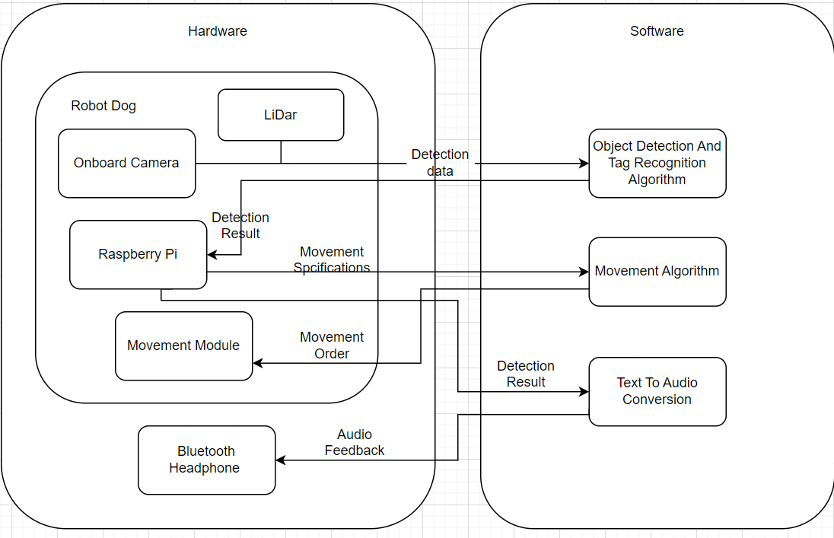

The block diagram above depicts a system consisting of two components: a robot dog and Bluetooth headphones. Four main modules on the robot dog and one Bluetooth headphone module are responsible for tasks such as line tracking, object avoidance, and QR code recognition. The detection modules, which include an onboard camera and LiDAR, serve as data inputs, and the detection data is transmitted to the Raspberry Pi module. The Raspberry Pi then generates commands for the movement module to finalize the movements of the robot dog.

## ***2.2 User Interface***

Once the connection with the VNC Viewer is successful, the Raspberry Pi desktop will be displayed as the screenshot shown below



The function and directory are listed below:

| Directory | Function |
| --- | --- |
| puppy_pi | All source codes of functions, programs, and modified modules |
| PuppyPi_PC_Software | Source code of PC software |
| hiwonder-toolbox | Wi-Fi management tool |



Functions can be called and tested upon open command line terminal with the icon:

All testable functions are stored under “puppy_pi/src” and should be accessed by entering:



In order to run an individual script, the format for running should be “**rosrun *type_of_function*  *function_name.py***”. For instance, when running the QR code recognition function, the command should be:



## ***2.3 Physical Description***

Provide a sketch of your project hardware (accurate and to scale, in 3-D or as a series of planar views), or photograph.



Figure 3.1: Photograph of the robot dog

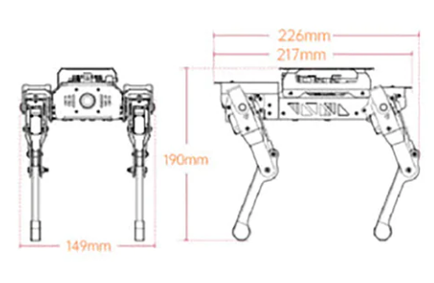

Figure 3.2 Front and side view of the robot dog with dimensions

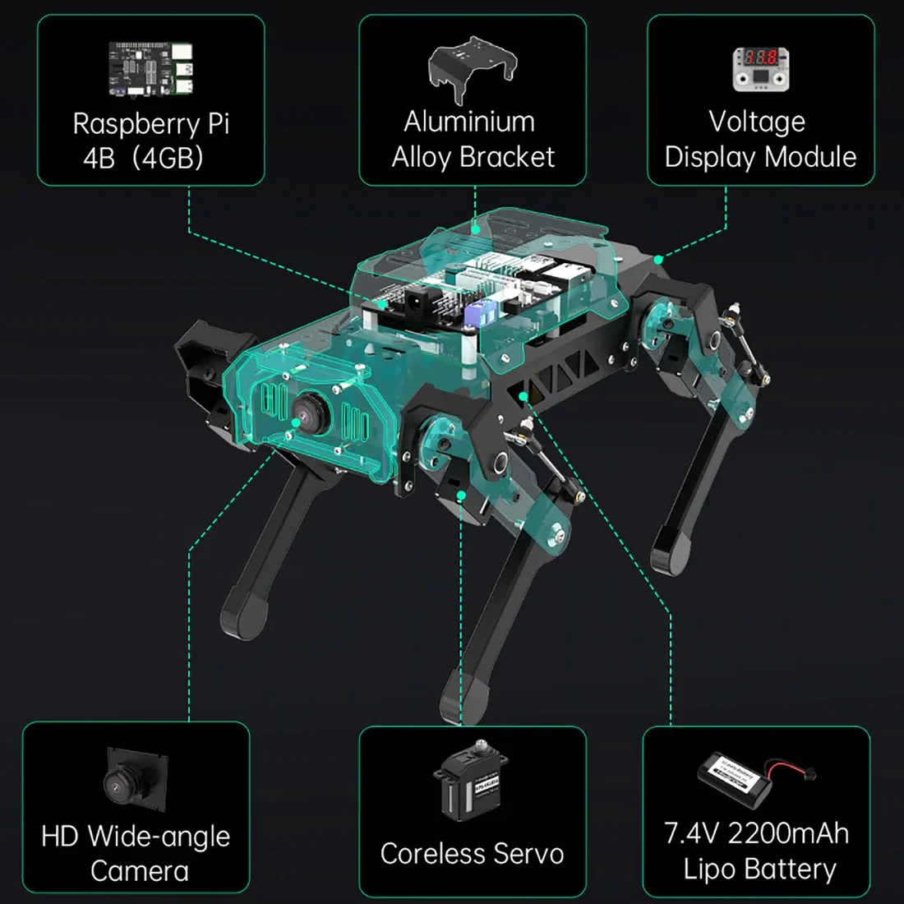

Figure 3.3: Specified components of the robot dog

## ***2.4 Installation, setup, and support***

**2.4.1 Hardware Requirements**

For remote connection and installation, a laptop or desktop computer with wireless network card supporting 5G frequency band is required.

**2.4.2 VNC Installation**

In our design, we use VNC, a graphic remote control software to control the Raspberry Pi installed on the robot dog directly from your computer through the hotspot created by Raspberry Pi.

1. For VNC installation, please visit the following Google Drive for installation: <https://drive.google.com/file/d/11sKy2Hfr73Ogibdv9UpjCGfhcvdci4lk/view?usp=share_link>
2. Follow the prompt of the VNC Viewer Setup. Proceed with the default settings.

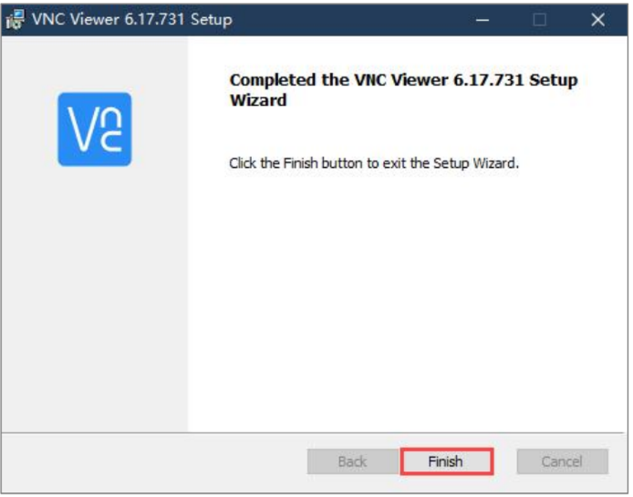

1. When the above prompt is shown, it marks a successful installation and you should be able to click the icon to open the VNC viewer.

**2.4.3 Boot Up the Robot Dog**

Flip the switch on the robot dog into the on position. The LED1 on the extension board of Raspberry Pi will light up and LED2 will flash continuously. When the robot dog finishes initialization, the buzzer will beep once, and the robot dog will return to initial posture signaling that the robot is ready for connection.

**2.4.4 Device Connection**

1. The default network mode for the robot is AP Direct Connection. After initialization, the Raspberry Pi should launch a Wifi hotspot with the naming format of “HW-xxxxxxxx” as shown in the screenshot below:  
   
2. After the installation of VNC Viewer, we can add the robot to the viewer by entering the default IP address of the Raspberry Pi: **192.168.149.1.**

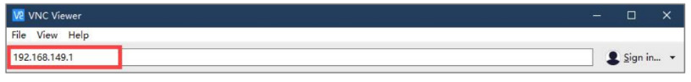

1. Then the VNC Viewer will prompt for authentication information, the Username is “**pi**” and the password is “**raspberry**”.

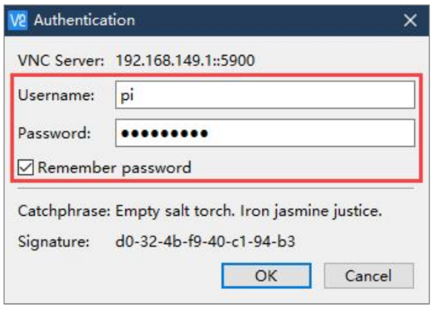

1. After authentication, the Desktop interface of the Raspberry Pi will be displayed. Ignore the pop-up warning message by clicking “**OK**”.

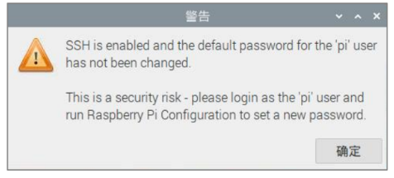

1. The User Interface and operations will be shown in Section ***2.2 User Interface***

# **3. Operation of the Project**

## ***3.1 Operating Mode 1: Normal Operation***

The normal operations are the interactions between the user and the robot and the robot with the surrounding environment, including:

1. The user will indicate the destination and the robot dog will get the information via a generated QR code.
2. The robot will track the line and follow it with voice feedback to the user.
3. The robot will recognize and avoid the obstacles on the line.
4. When facing a turning point, the robot will read the QR code, decide which way to go, and indicate the direction to the user.
5. When reaching the destination, the robot will recognize the destination QR code and indicate the information to the user (e.g. “reach point A”) . 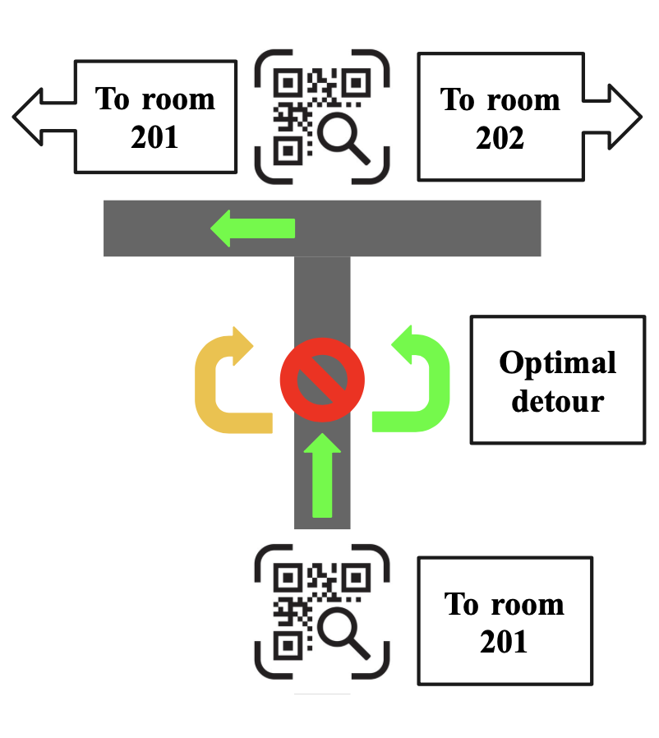
6. Additional function with OAK-D: the robot can perform different gestures (e.g. shaking hand, nodding, boxing) with respect to the hand gesture of the user, which will be detected by a hand-tracker model we get from an open resource with the OAK-D camera.

## ***3.2 Operating Mode 2: Abnormal Operations***

The abnormal operations include some technical issues that the robots might face:

1. Low Battery: Additional batteries grant the robot dog a battery life of around 40 minutes, but sometimes the voltage change can affect the performance of the robot especially when it drops lower than 7.2V.
2. No detection of obstacles: the TOF sensor sometimes can’t recognize the obstacle
3. The Bluetooth connection of the earphone might not be very stable if the distance is too far.

## ***3.3 Safety Issues***

Because this robot walks relatively slowly, most passersby can easily and safely avoid collision with the robot. However, crowded areas and pedestrians can damage the robot dog.

# **4. Technical Background**

*Robots:*

*Hardware:*

Powered by Raspberry Pi 4B 4GB, PuppyPi is an AI-vision quadruped robot. It is made of aluminum alloy and loaded with 8 powerful coreless servos. Linkage mechanism on its leg allows for flexible and diverse actions and enables it to walk, step up and down stairs, etc. It owns first-person vision for realizing more features, including target tracking, face detection, line following, auto climbing, and so on.

*Software:*

The robot is based on the ROS system, which allows the robot to do many things separately in different nodes. It also gives the dog signals when facing different cases, such as running the obstacle avoidance module while seeing obstacles in front of it or making a left turn while seeing QR codes.

*VNC Viewer:*

The VNC Viewer is a platform to modify code and control the Raspberry Pi directly from your computer through the hotspot created by Raspberry Pi. The VNC Viewer shows the image the robot dog sees and the printed information in the terminal.

*LiDAR:*

LiDAR is a remote sensing method that uses a laser to detect the position and speed of the target. It features high-ranging resolution, strong penetrability, excellent anti-interference ability and eminent anti-stealth ability. LiDAR is composed of a laser emitting system, scanning system, laser receiving system and signal processing system.

Firstly, the laser emitting system will send the detection signal (laser beam), and the scanning system takes charge of scanning the surrounding area to receive the related information. The laser receiving system will receive the laser reflected by the target object to generate a receiving signal. The signal system will process the receiving signal to get the features of the target, such as shape and physical properties (position, height and speed), then build the model. Our liDAR system will detect the obstacle in front of it and do obstacle avoidance automatically. The basic principle of obstacle avoidance is storing the angle that the robot turns, making the robot walk a little bit, checking whether the obstacle is bypassed, turning the angle back if the obstacle is bypassed, and seeking the line that it can follow on the floor to go back on the line.

*RGB camera:*

RGB camera produces the image in front of the robot dog and operates according to the image.

*Line following:*

RGB camera uses its mono camera and CVlibrary to first recognize the color on the floor. It then uses built-in functions in the CVlibrary to locate and sketch the contour of the line, calculate the middle point of the diagonal lines of that contour, and mark that as the center. It compare that center with the center of the image and controls the dog to turn right or left according to the difference.

*QR Code Recognition:*

Each tag has its own family which can be detected by RGB camera. Then the tag is numbered in the program and compared with the local library which contains information about the room number, floor, etc. The robot will follow the command according to the tag.

# **5. Cost Breakdown**

Consider your EC464 prototype to be the *alpha* version. The next unit made, according to your engineering specifications and design, would be the *beta* version. Later a manufacturing version or release-version would be made.

What would be the cost of your ***beta*** unit when it is created? This should assume market costs, i.e. no donations, no picking through the customer’s parts closet.

You can edit the table below to describe the project expenses for the beta version. It is not necessary to provide every detail about parts, labor, and services in your cost breakdown. Decide upon a level of aggregation of investment and group costs accordingly.

| Project Costs for Production of Beta Version (Next Unit after Prototype) | | | | |
| --- | --- | --- | --- | --- |
| Item | Quantity | Description | Unit Cost | Extended Cost |
| 1 Quadruped Robot Dog | 1 | Pre-assembled robot dog with 8 servos | 699 | 699 |
| 2 TOF Lidar | 1 | Lidar to be installed on robot dog | 99 | 99 |
| 3 Extra Battery | 2 | External Battery for more battery life | 20 | 40 |
| 4 Earphone | 1 | Ear-phone for voice interaction | 100 | 100 |
| 5 QR-Codes | 10-20 | QR code for marking locations | 0.5 | 5-10 |
| 6 Duct Tape | 10 | Duct tape for pre-set route | 25 | 25 |
| Beta Version-Total Cost | | | | 933 |

Budget Narrative

We chose a pre-assembled robot dog from Hiwonder because they have the parts needed in mass production, so the cost can be lower than making our own robot dog bodies, legs, and ankles. The TOF liDAR is for obstacle detection, and the cost can be lowered for wholesale price, which is about $70. Extra batteries are not necessary but highly recommended. Robot dog is functional without the extra battery, but only for about 15 minutes. We do need a Bluetooth earphone or speaker to receive voice commands and give voice feedback. This cost can be as high as $300 if premium quality headphones are used and can be as low as $20 if users want just the voice feedback. The estimated cost of $100 is the cost for a basic Bluetooth earphone that has both a microphone for input and a speaker for output. QR codes and duct tape are for location marking, and the quantity of those needed depends on the scale of the navigation area and the complexity of the location. Also, we wouldn’t use an OAK-D camera in the beta unit, which cost $199. We do have the software ready to use, and it is a bolt-on hardware installation that will provide more accurate object recognition and detection.

# **6. Appendices**

## ***Appendix A - Specifications***

| Requirements | Value, range, tolerance, units |
| --- | --- |
| Size | 289*149*190 (mm) (102 height if folded) |
| Weight | 720g (900g with add on modules) |
| Battery | 7.4V 2200mAh |
| Servo | HPS-0618sg * 8 |
| Lidar Module | 360 degree ToF |
| Connection | Bluetooth, USB, Wi-fi |

## ***Appendix B – Team Information***

Team 2 consists of Bowen Ma, Shun Zhang, Xiteng Yao, Yichang Wang, and Yihe Bi. All members are computer engineers. The legged robot is pre-built with most of the components, and we reprogram and make the robot to be suitable for visually impaired people. The work includes installing new hardware, implementing new interfaces, and other optimization for easier use. We do want to help everybody live an easier life without having to pay a lot of money or labor.

## ***Appendix C – Citation***

“Vision Impairment and Blindness.” *World Health Organization*, World Health Organization, https://www.who.int/news-room/fact-sheets/detail/blindness-and-visual-impairment.