**New Requirements for Digitizer**

**Yixin Geng**

**5-22-2012**

1. **Introduction**
   1. **Overview**

This documentation describes the proposed new features for Digitizer. Digitizer is the software used to capture and generate a 3D plotting file using Bumblebee 2 camera. The stakeholder uses the software to manufacture seat cushions for disable people. The previous version of digitizer only can generate a 3D plotting file for the seat.

* 1. **Key Stakeholder Needs**
* System shall capture and generate 3D plotting files for both back and seat cushions.
* System shall let operators to determine a cut line on the chair.
* System shall let operators to determine cut angles and positions.

1. **Requirement**
   1. **Use Characteristics**
      1. **Actors**
2. **Users:** the chair manufacturing people
3. **Camera:** Bumblebee 2 camera
4. **Computer:** system with Triclops software
   * 1. **Use case: capture and generate the 3D images for both seat and back**

**Description:**

The manufacturing people put the camera at some certain height and angle to capture the 3D images for both back and seat.

**Step 1:** Before capturing, operators will enter a value of bending angle (such as the 110 degree in the cross section figure below) into the computer for the chair. In the software, the following figure will not be shown. Only a dialog box will appear to enter the angle.

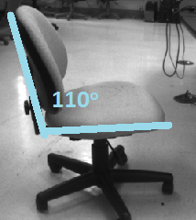

Figure 1

**Step 2:** Set the camera shooting the model chair at a certain height and angle. The following schematic diagram shows the scenario:

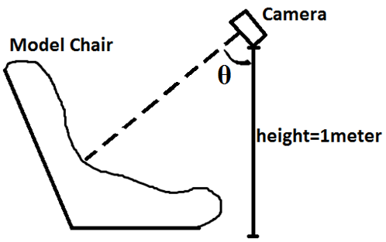

Figure 2

**Step 3:** Determine the cutting position for the cutting line (the blue line in the center of the red frame below in the figure).

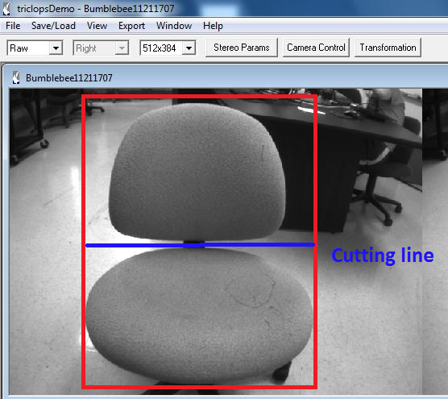

Figure 3

**Step 4:** export the 3D image in the milling format. Then the system will export the whole chair shape into two separate pieces which are back and seat. However, for the milling convenience, there will be some space between back part and seat part and each of these two parts will remain in the center of each image. The following sketches demonstrate the process:

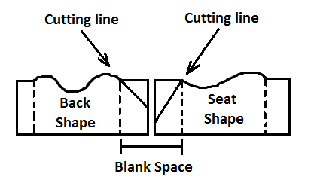

Figure 4

**Step 5: O**perators need to enter a cutting angle for the cutting line into a dialog box to determine another cutting angle. For example, if the angle user enters for seat shape is 30 degrees, and the total seat bending angle is 110 degree, then the cutting angle of the right one will be 180-110-30 = 40 degrees. Then after cutting, two pieces will fit together and form a 110 degrees angle.

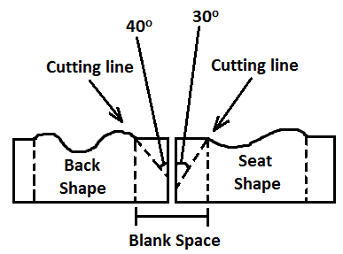

Figure 5

1. **Conclusion**

The report describes the new features for Digitizer. However there are still some technical details need to be specified. And also to fulfill these requirements will require a lot of work.

1. **Further Questions:**
   1. **Question 1:**

How do you want to determine the blank space between the two shapes in figure 5?