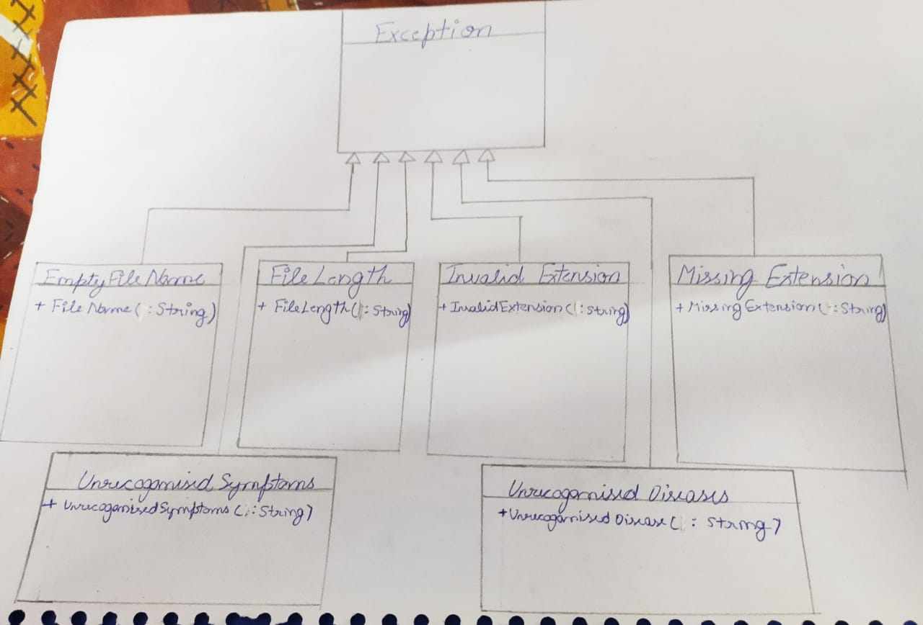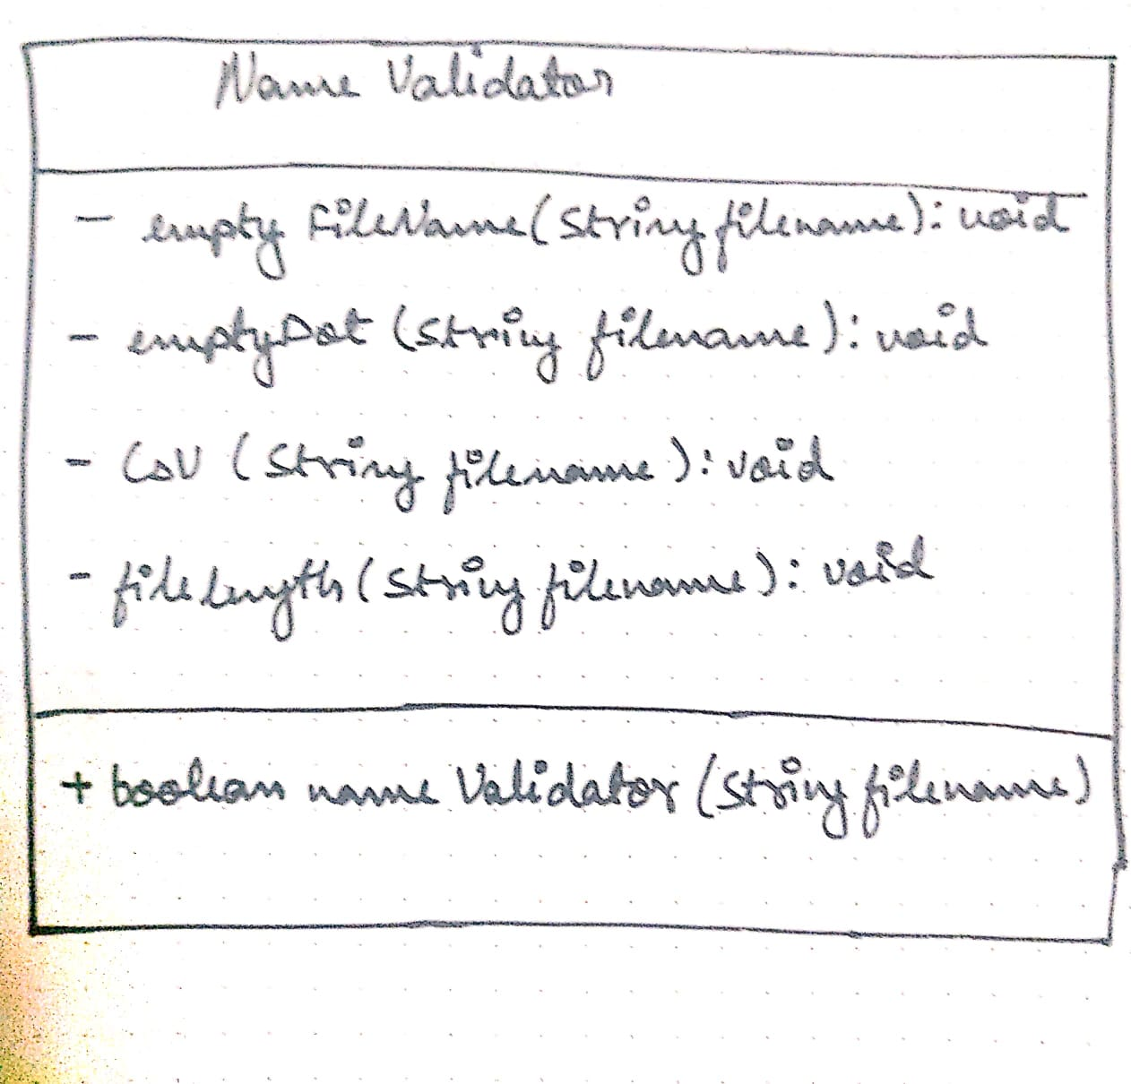

class mainDriver  
+main(String[]args):void  
  
  
  
 class MedicalDatabase  
-int id  
-String PatientName  
-ArrayList<String> symptoms;  
-ArrayList<String> disease;  
  
+set(int id , String PatientName):void  
+addSymptom(String Symptom) : void  
+diagnosis();ArrayList<String>