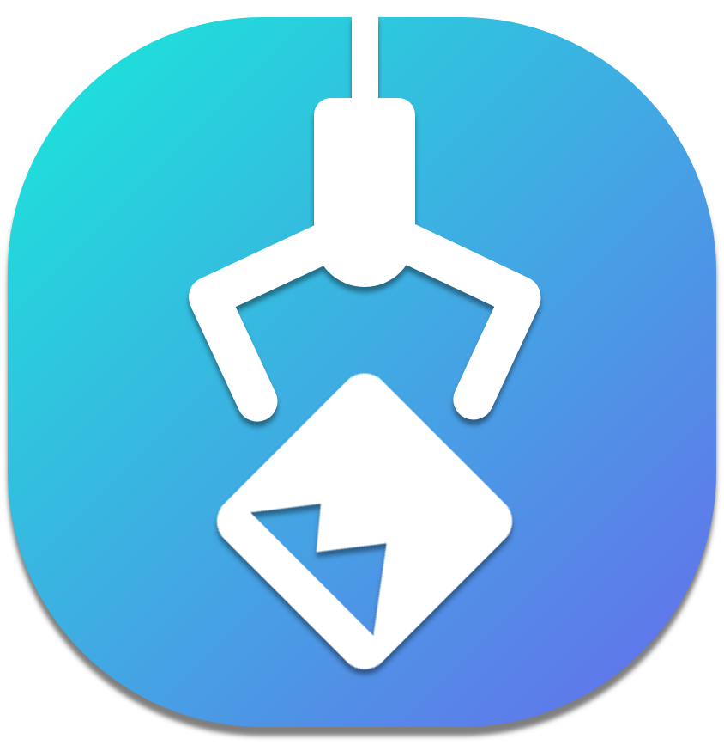

**Pick Pic**

**Documents for Users**

**2017 - 1 Human ICT Software Engineering | 2017.06.02**

|  |  |
| --- | --- |
| 20155652 | KangSoYeon |
| 20154019 | LeeYeWon |
| 20151722 | MyungSeKyo |
| 20152164 | LeeWonJun |
| 20151535 | ParkGunHoo |

Table of Contents

1. A description of project 3

2. How to obtain and install the software 3

2.1 Installing Server 3

2.1.1 set up python 3

2.1.2. set up node js 3

2.1.3. set up tesseract-ocr 3

2.1.4. set up modules to node js 3

2.2 Installing Client 3

3. How to run the software 4

4. A high-level description of the user view of software 4

Main Activity 4

Search Activity 4

Gallery Activity 5

5. How to use the software 5

Main Activity 6

Search Activity 6

Gallery Activity 6

6. How to report a bug 6

# A description of project

The goal of this application is by automatically tagging all images in your gallery, make easy to find the images you want.

Additionally tag will help you to manage the images in your gallery. This application is unique because by using the machine learning there are various options to search pictures. For example, by color, by text in image, and by the object in the picture.

This application is for the people who have difficulty in finding or managing there images.

# How to obtain and install the software

## 2.1 Installing Server

### 2.1.1 set up python

PickPic_Server use Tensorflow for Python, so you need to set up python and Tensorflow for python.

To set up python: https://www.python.org/

To set up Tensorflow: https://www.tensorflow.org/install/

### 2.1.2. set up node js

PickPic_Server is node js server, so you need to set up node js.

use https://nodejs.org/

### 2.1.3. set up tesseract-ocr

To extract text from image, so you need to set up tesseract-ocr.

sudo apt-get install tesseract-ocr

sudo apt-get install tesseract-ocr-eng

*if you want detect more language from image,then see "<https://ubuntu.flowconsult.at/linux/ocr-tesseract-text-recognition-ubuntu-14-04/>" and "<https://github.com/tesseract-ocr/langdata>"

*if you are not linux, then see "<https://github.com/tesseract-ocr/tesseract/wiki>")

### 2.1.4. set up modules to node js

PickPic_Server use variable modules for ndoe js, so you need to set up modules for nodejs.

npm install

## 2.2 Installing Client

Install android studio and run PickPic code(<https://github.com/PickPic/PickPic_Client>) or you can get PickPic.apk in github(<https://github.com/PickPic/PickPic_Client/tree/master>) and install your device.

# How to run the software

While we hope to have an executable as an .apk file in the future, currently the best working method to run our app is through the command like and an emulator from Android Studio.

with our PickPic code(<https://github.com/PickPic/PickPic_Client>)

**To run our application**

Way1. Install android studio and run PickPic code(<https://github.com/PickPic/PickPic_Client>) with an emulator from Android Studio.

Way2. Download PickPic.apk(<https://github.com/PickPic/PickPic_Client>) to your android phone, install the app and click it for download.

*Make sure that your Android version is higher than Android 4.0.3 (ICE_CREAM_SANDWICH_MR1).

**To run our server**

Enter “sudo node server.js” to execute server

# A high-level description of the user view of software

## Main Activity

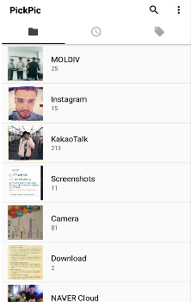 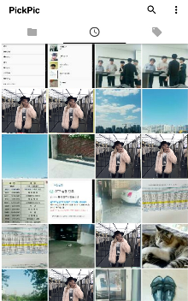 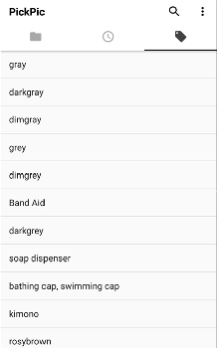

You will be able to see the pictures on your device by directory, by time and by tags on Main Screen. Press the Menu button in the upper right corner to make the settings.

## Search Activity

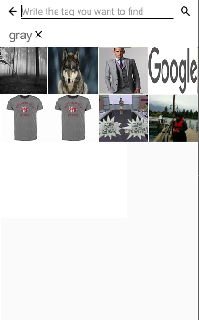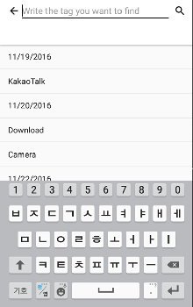 When you click the search button you can see the editable textview and below that there are recommended tag list.

You can see the searched grid view image and above them there are tags you searched.

## Gallery Activity

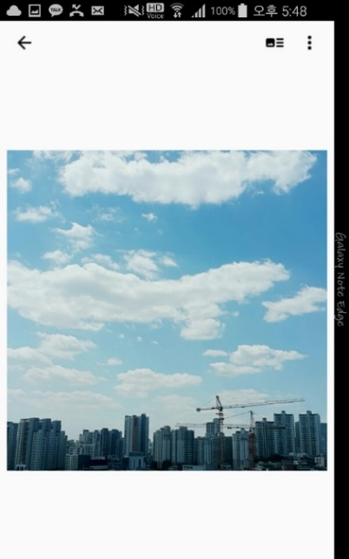 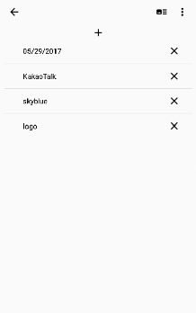

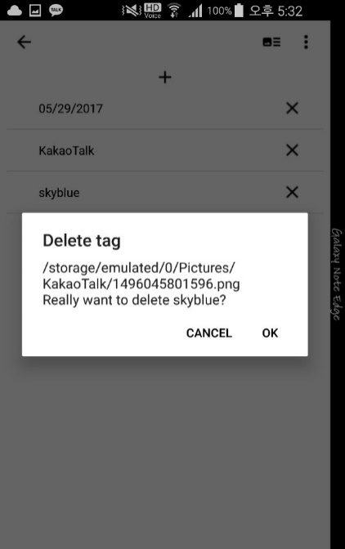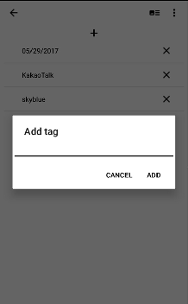

You can see full-screen image when you clicked thumbnail image at grid view. If you want to go back to grid view, click back button above. There are ‘share’, ‘rotate’ button in menu. When you click button, you can see the list of tags. You can add new tag you want by click add button. Also, you can delete the tag you don’t like by click delete button.

# How to use the software

## Main Activity

1. You will be able to see the pictures on your device by directory on Main Screen.
2. On the Main Screen, tap the Time tab and you will be able to see the pictures sorted by the latest pictures.
3. Pressing Tag tab will show the tags in your pictures sorted in order of tag frequency.
4. If you press the Menu button on the upper right, you will see 4 different menus. The menus are ‘Synchronize’, ’Delete all tags’, ’How to use’ and ’Service Center’.
5. ‘Synchronize’ will manually synchronize your pictures.
6. ‘Delete all tags’ will erase all tags in your pictures.
7. ‘How to use’ will show how to use this application.
8. ‘Service center’ will provide developers’ contacts and sites that you can give feedback to us.

## Search Activity

1. When you click the search button, you will be able to find the pictures you want by entering the tag you want to find.
2. Also, there are few tags that system recommend so you can search by clicking the tags recommended.
3. As you narrow down the tag range, you’ll be able to find the desired photo with multiple tags at the same time. The tags you searched are shown above of the screen.\
4. You can see the searched Image result in GridView.

## Gallery Activity

1. You can see full-screen image.
2. You can zoom in image if you want to see enlarged image.
3. If the image is rotated, you can rotate it again. Click menu button and choose rotate button.
4. When you want to share a found image, you can click share button at menu.
5. If you want to see tags that tagged on the image, click button.
6. When you want to add a tag that does not exist, click add button. Then, popup window asking you which tag you want to add is appear. You can see the added tag immediately.
7. There may be tags that you don’t like. Then, you can clicked delete button next to the tag you want to delete. A popup window asking if you really want to delete it will appear. You can delete tag and see that tag is disappeared immediately.

# How to report a bug

**To report a bug, go to this webpage:**

<https://goo.gl/forms/ZUELf9P6R0jT474G3>

You can freely submit your comments anonymously. Also, if you want to receive our feedback, you can write your email address and get feedback.