

**Pick Pic**

**2017 - 1 Human ICT Software Engineering | 2017.04.05**

|  |  |
| --- | --- |
| 20155652 | KangSoYeon |
| 20154019 | LeeYeWon |
| 20151722 | MyungSeKyo |
| 20152164 | LeeWonJun |
| 20151535 | ParkGunHoo |

Table of Contents

1.0 Product description 4

1.1 Background 4

1.2 Goal 4

1.3 Function 4

1.3.1 Normal Gallery 4

1.3.2 Automatically tag* image 4

1.3.3 Show category 4

1.3.4 Manually tag image 4

1.3.5 Word/Selective search to find images with tags* 5

*kinds of tag 5

2.0 Pick Pic Icon 5

3.0 UI Diagram 5

4.0 Use cases 6

4.1 Automatically tag image 6

4.1.1 Brief Description 6

4.1.2 Initial Step-By-Step Description 6

4.2 Show category 7

4.2.1 Brief Description 7

4.2.2 Initial Step-By-Step Description 7

4.3 Search image 7

4.3.1 Brief Description 7

4.3.2 Step-By-Step Description 7

5.0 Process description 8

5.1 Software toolset 8

5.1.1 Android Studio 8

5.1.2 Microsoft Computer Vision API 8

5.2 Group organization(roles) 8

5.3 Risk Summary 8

5.3.1 Synchronizing problem 8

5.3.2 Data management 8

5.4 Schedule / Timeline 9

6.0 Meeting reports 9

6.1 Talk about 9

6.2 Feedback 9

# Product description

## 1.1 Background

Today, smart phone memory is largely increased and there are many images on your gallery.

And also with the development of SNS, there are lots of chance to sharing images.

But you may have the experience that you were fail to find the image you want because there were too many images.

This application is for the people who have difficulty in finding or managing there images.

## 1.2 Goal

The goal of this application is by automatically tagging all images in your gallery, make easy to find the images you want. Additionally tag will help you to manage the images in your gallery.

It makes you finding the precious memory in your gallery and you will never going to lose your memory.

## 1.3 Function

### 1.3.1 Normal Gallery

Pick Pic provide a basic gallery function

### 1.3.2 Automatically tag* image

Pick Pic uses artificial intelligence technology to automatically add appropriate tags to photos.

### 1.3.3 Show category

Pick pic show three categories of image classification

1. By directory
2. By time
3. By tags*

### 1.3.4 Manually tag image

Apart from the way that artificial intelligence automatically adds tags, you can add your own tags to your images.

### 1.3.5 Word/Selective search to find images with tags*

You can find the images you want by searching the tags. When you do not remember the right tag, You can find the image by clicking on the tag recommended.

### *kinds of tag

1. color
2. action
3. person
4. text
5. And so on

# Pick Pic Icon



# UI Diagram

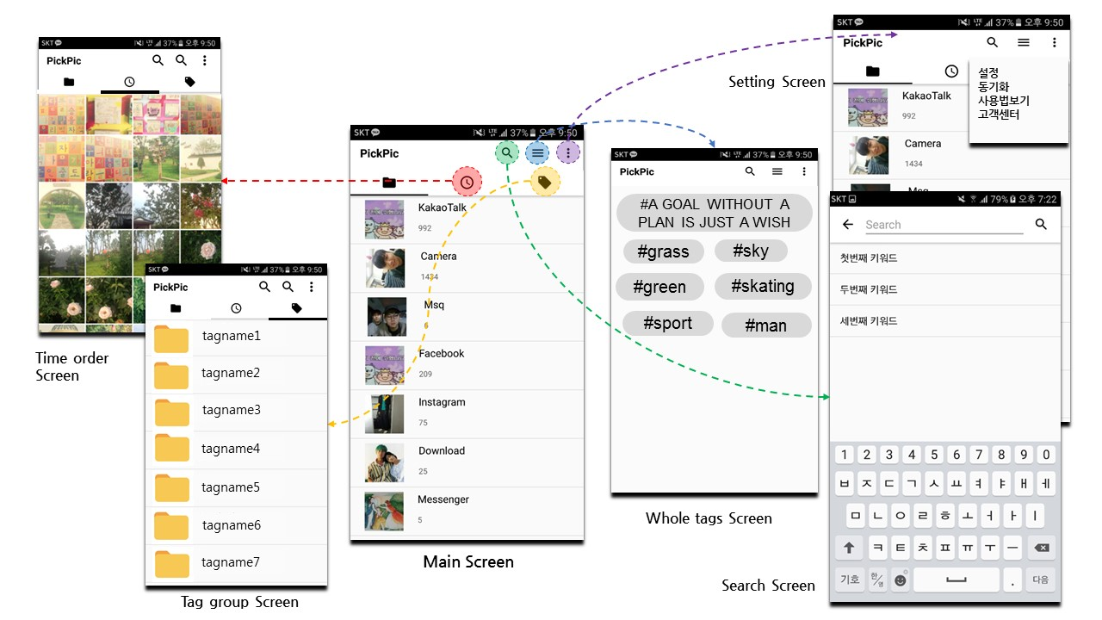

# Use cases

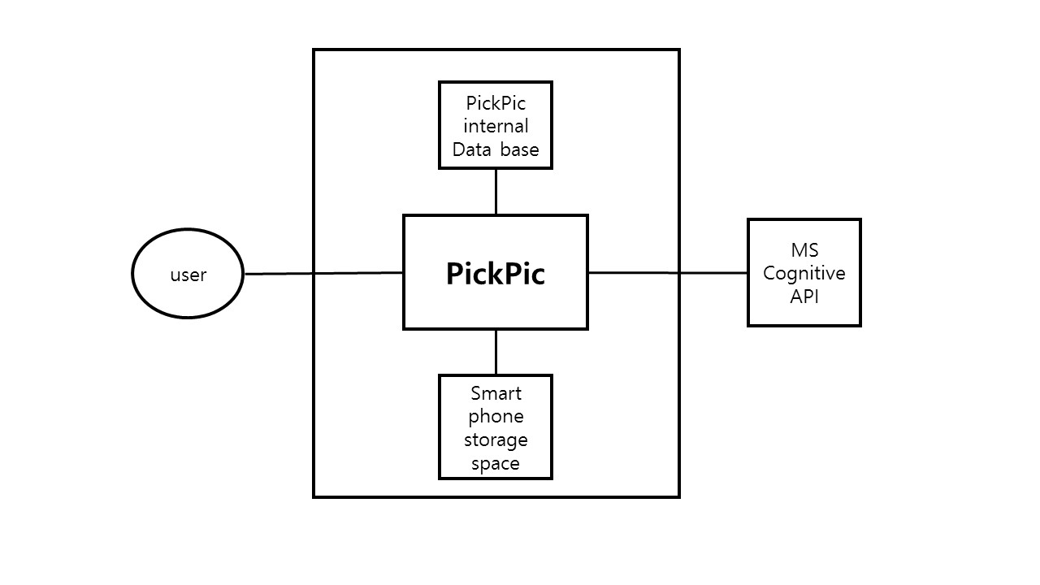

Figure System Environment

## 4.1 Automatically tag image

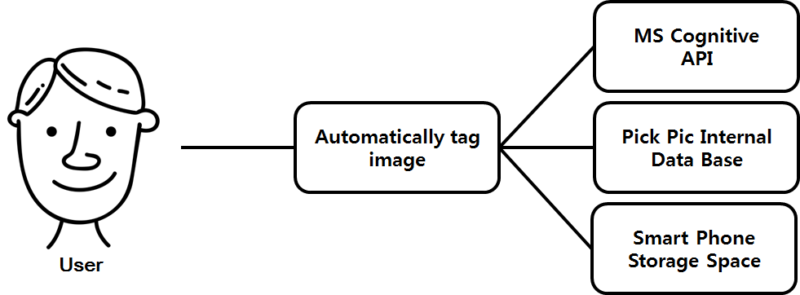

### 4.1.1 Brief Description

When the user kick the Pick Pic,the Pick Pic automatically analyze all photo in user’s smart phone and tag each untagged image.

### 4.1.2 Initial Step-By-Step Description

Before this use case can be initiated, the user has already kick the Pick Pic.

1. The system displays the loading scene to the user for a few seconds.
2. The system compare the images in smart phone storage space and the Pick Pic’s database.
3. The system request the untagged images to MS computer vision API.
4. The system save the return value of API for the form of tag in the Pick Pic’s database.

## 4.2 Show category

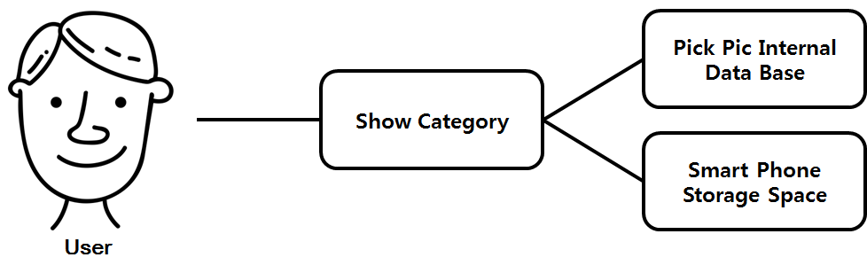

### 4.2.1 Brief Description

The user can view all images sorted in various ways.

### 4.2.2 Initial Step-By-Step Description

1. The user touch the tab or swipe the main screen to change the way of sorting image.
2. The system load the sorted image list from the Pick Pic’s database.
3. The system display the images sorted by selected way from smart phone storage space.

## 4.3 Search image

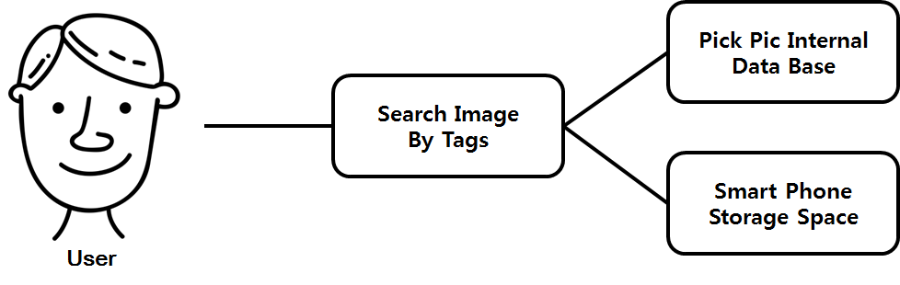

### 4.3.1 Brief Description

The user can search images by tags

### 4.3.2 Step-By-Step Description

1. The user click the searching button in the main scene.
2. The system display the search screen..
3. The user input a keyword in search bar.

(option : When user don’t know any keyword, the user touch selective search button in search screen. Then, the system display all tags that the user can search.)

1. The system find the all images ID that have the keyword tags from the Pick pic’s database.
2. The system display the images from smart phone storage space.

# Process description

## 5.1 Software toolset

### 5.1.1 Android Studio

Android Studio is the official Integrated Development Environment (IDE) for Android app development, based on IntelliJ IDEA . On top of IntelliJ's powerful code editor and developer tools, Android Studio offers even more features that enhance your productivity when building Android apps

### 5.1.2 Microsoft Computer Vision API

Extract rich information from images to categorize and process visual data and protect your users from unwanted content.

## 5.2 Group organization(roles)

**MyungSeoGyo** Backend(DB, API)

**LeeWonJun** DB, Backend(DB, API)

**LeeYeWon** Frontend

**KangSoYeon** Frontend

**ParkGunHoo** Frontend

## 5.3 Risk Summary

### 5.3.1 Synchronizing problem

This application require synchronizing in case of first install this and many new photos added. So little time should be taken

### 5.3.2 Data management

In synchronizing, some Data fee will occur.

So we recommend you to use Wi-Fi in that process

## 5.4 Schedule / Timeline

**April 30** Make a prototype of the application.

1. Save the tags returned from the API.
2. Complete searching function
3. Connect application and smart phone gallery

**May 22** Complete detail functions

1. Sorting images – by tags, by dates
2. Make application’s own gallery
3. Share function
4. Add tag directly by user
5. Make tutorial for user

**June 12** Complete final application

# 6.0 Meeting reports

We talked about our project index to our customer.

## 6.1 Talk about

1. Search : Tagging your photos and store, plus search
2. Show results of search by showing thumbnail
3. If the photo is clicked, open gallery
4. Sort by tag
5. Sort by day
6. 2nd tag : Show original file directory
7. Image zoom in zoom out

## 6.2 Feedback

1. Add share function to other SNS like Kakao Talk
2. Add tag directly by users
3. Make tutorial display