Perf_env

Ubuntu 16.04.6 LTS (GNU/Linux 4.4.0-157-generic x86_64)

lscpu

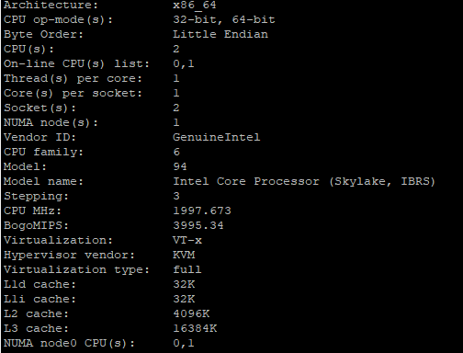

cat /proc/meminfo

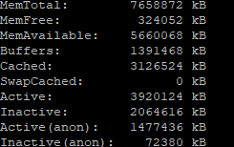

df -h –total

