Perf_env

Hardware

Ubuntu 16.04.6 LTS (GNU/Linux 4.4.0-157-generic x86_64)

ls**cpu**

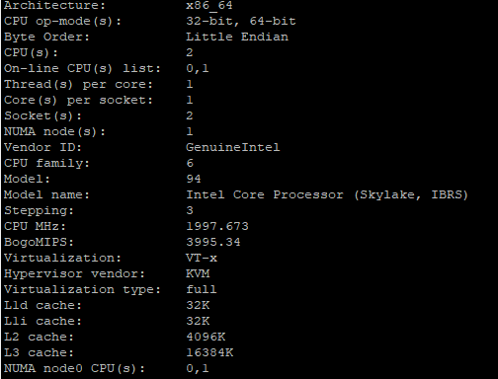

cat /proc/**mem**info

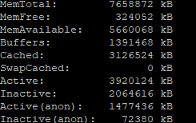

df -h –total (disk)

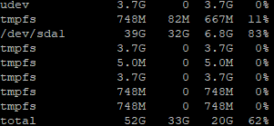

Architecture ?????

Prod_env

Hardware ?????

Architecture

