**Test report (16.02.2020 Task1)**

**1. Executive summary**

**1.1. Test purpose**

Create simple script to open Home page, open Contacts.

**1.2. Test status**

Test Passed

**1.3. Test summary**

Site works (checked with response assertions). Basic metrics are collected, and multiuser mode was enabled. Evaluating the results, we can say that system is able to cope with such load because scenario was easy for it (consist of 2 steps and 2 timers). CPU usage increase from 10 to 30% with random spike to 80%, mem usage was around 57% during test.

**2. Test objectives**

a) Check availability of the site from the load tool

b) Make sure the site is configured for multiuser mode

c) Setup basic metrics and make sure they can be collected

d) Setup ramp-up mode in the scenario

**3. Test configuration**

**3.1. Hardware configuration**

Environment: virtual machine

Operation System: Windows 10(64-bit)

RAM: 4GB

Processor: Intel Core i-7 6700. Use only to 1 CPU on environment

HDD memory size: 50GB

**3.2. Test configuration**

Prerequisites: Manually test site’s workability

Test configuration

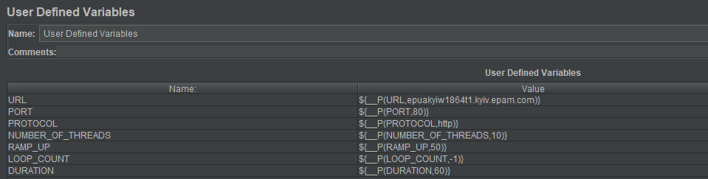

**4. Quality criteria**

Test meets all the requirements

**5. Test scenario**

**5.1. User Behavior and Workload**

In this test scenario we doesn`t emulate real behavior of user. It`s an initial test that`s check that system works.

**5.2. Scheme of scenario**

Open contact page

Open Home Page

**6. Test results**

Checking availability of the site from the load tool

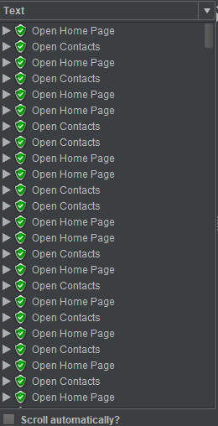

Setting up and collecting basic metrics

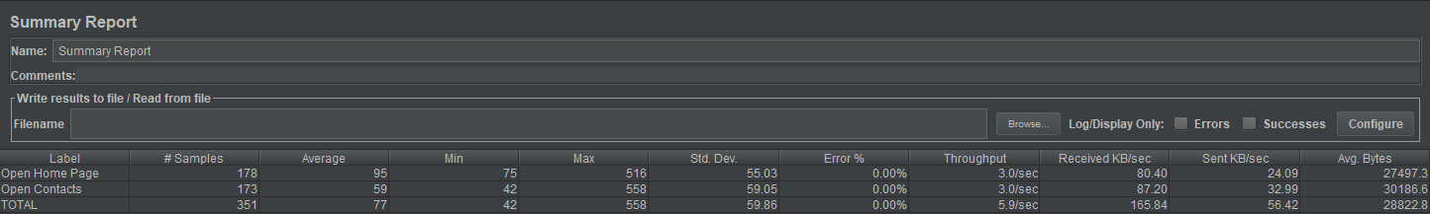

Active threads, hits, CPU load, transactions successful/failed

