**Test report (21.06.2020 Task 9)**

**Executive summary**

1. Test purpose

* Get an experience on durable/longevity/stability testing.
* Get an experience on load parameters definition for the long-time testing.
* Learning how to identify bottlenecks and possible issues for long-time running systems.

2. Test status

Test passed

3. Test summary

Before the test ‘low-load’ was defined based on the results from Task 7 and 1000 posts were generated.

Test was held without any critical errors and problems. Error rate is below 0.1% that means stable application and jmeter test behavior. Such case gives possibility to get valid results and calculate KPIs

**Test description**

1. Define low load based on the results from Task 7.
2. Perform long-time testing.
3. Gather all needed metrics.
4. Calculate KPI.
5. Try to identify any issues based on the results.
6. Prepare detailed report.

**Test configuration**

1. Hardware configuration

Environment: virtual machine

Operation System: Windows 10 (64-bit)

RAM: 4 GB

Processor: Intel Core i-7 6700, 1 core

HDD memory size: 50GB

2. Test configuration

Prerequisites:

1. Generated 1000 posts

**Quality criteria**

Test gives necessary and valid information about KPI (response time, CPU-RAM-Disk consuming, error rate)

**Test scenario**

1. User Behavior and Workload

Regular load was discovered from task 7 results and defined as 16 users (10% form capacity point + 2 editors + 2 admins). Ramp-up and shutdown time using only for Anonymous users, admins and editors appear instantly.

|  |  |  |  |  |  |
| --- | --- | --- | --- | --- | --- |
| **Test type** | **Duration, sec** | **Ramp-up, sec** | **Shutdown Time, sec** | **Number of users, Admin/Editor/Anonymous** | **Think time, sec** |
| Load test | 36000 | 6000 | 6000 | 2/2/12 | 3 |

2. Scheme of scenario

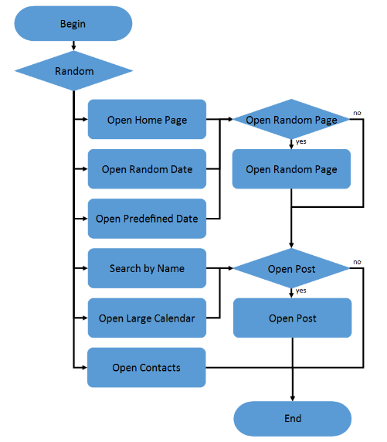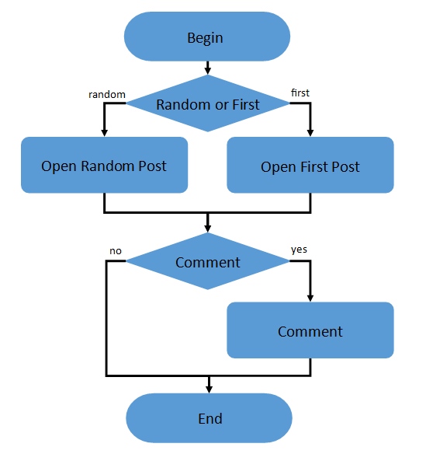

Anonymous script

Anonymous script conditions

|  |  |
| --- | --- |
| **Transaction** | **Probability** |
| open home page | 15% |
| open random date | 10% |
| open predefined date | 30% |
| search by name | 30% |
| open large calendar | 10% |
| open contacts | 5% |
| open random page | 50% |
| open post | 80% |
| open random post | 65% |
| open first post | 35% |
| Leave comment | 20% |

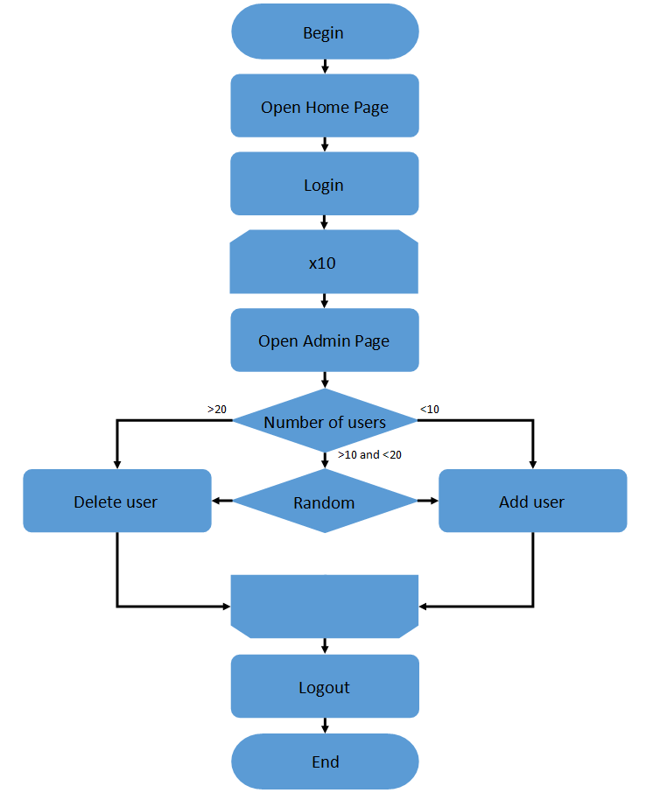 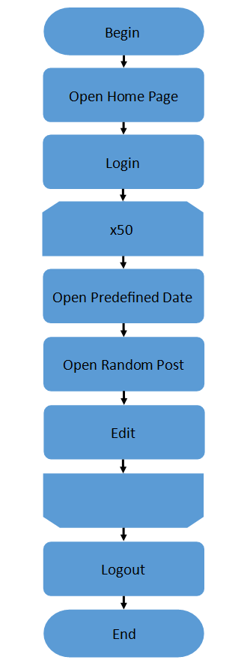

Admin script (left), Editor script (right)

**Test results**

**Low load test**

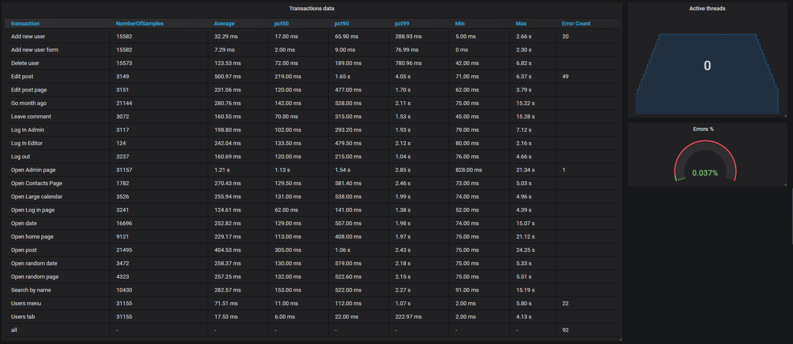

Transactions data

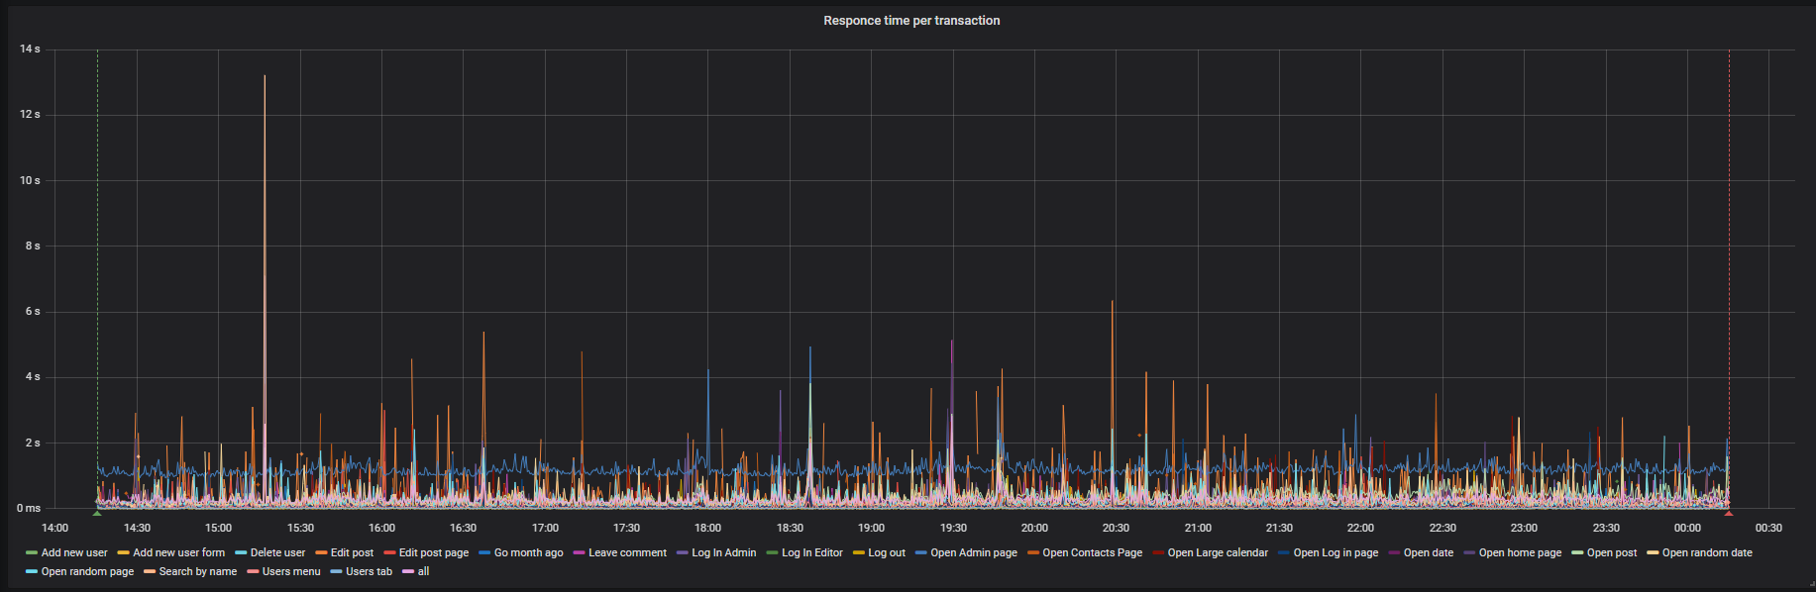

Average per transaction

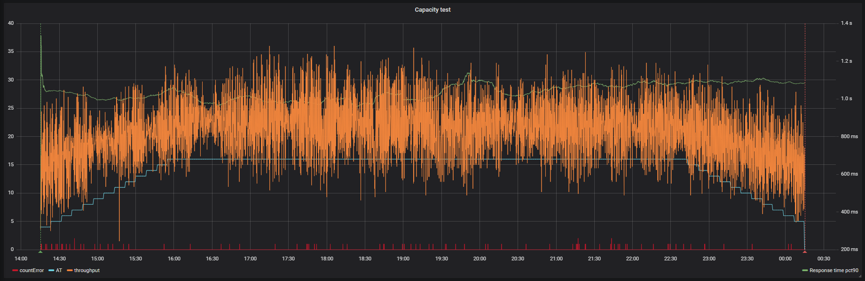

Active threads/errors/throughput

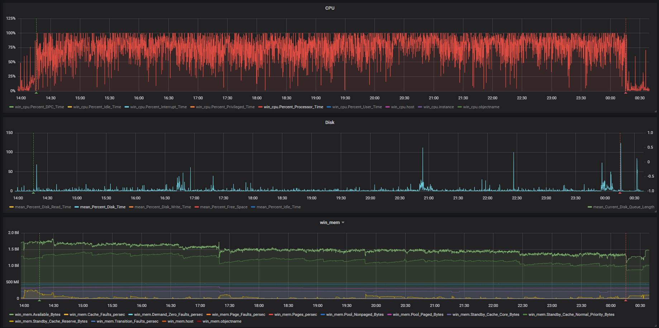

CPU/Disk load/ RAM

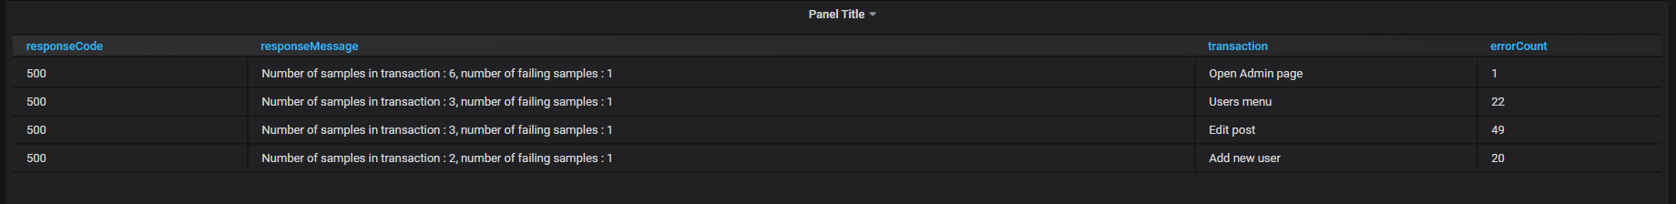

Errors details

|  |  |  |  |  |  |  |  |  |  |  |
| --- | --- | --- | --- | --- | --- | --- | --- | --- | --- | --- |
| Time interval, h-h | CPU load, % | Multiplier for CPU load | Disk load, % | RAM available, Gb | Error rate, % | Multi for error rate | Response time pct90, ms | Multiplier for Response time | Throughput, tps | Multiplier for throughput |
| 2-4 | 74 |  | 2 | 1.539 | 0.022 |  | 989 |  | 23 |  |
| 4-6 | 76 | 1.027027027 | 1 | 1.469 | 0.037 | 1.681818182 | 1031 | 1.042467 | 21 | 0.913043 |
| 6-8 | 80 | 1.052631579 | 2 | 1.445 | 0.04 | 1.081081081 | 1057 | 1.025218 | 22 | 1.047619 |

Results for different test’s time intervals

**Summary**

1. Hardware metrics

* CPU. CPU load increases each 2 hours by 2% during the test, but still within normal limits. Need to run endurance test to find out will CPU utilization have reached 100% after 100 hours test. Full CPU load may cause throughput and response time degradation.
* Disk. Disk load remained without any changes and does not consider any possible performance issues.
* RAM. RAM available bytes were slowly getting lower (from 1.767 gb to 1.369gb) by the end of the test. Need to run endurance test to find out will RAM available bytes run out after 40 hours test or it clears by itself.

1. Application metrics

* Response time. Response time was holding between 975ms from the start and 1.108 by the end of the test. It correlates with CPU utilization. In term of this test increasing does not look critical.
* Throughput. Throughput repeats active threads line by shape and does not look strange or unhealthy.
* Error rate. Error rate grows from 0.022 to 0.04. It correlates with CPU utilization. In term of this test increasing does not look critical.