|  |
| --- |
| EPAM Systems |
| <Mentoring program>  Performance Test Complex Report |

1. INTRODUCTION

This document describes performance testing activities, approaches, and results of testing BlogEngine v3.2 web application (blog platform).

1. OBJECTIVE

The main purpose of this document is to provide high-level vision on the application’s performance condition and on the way to test it.

1. TEST STRATEGY

# SCOPE

The scope of this performance testing stage contains such parts:

* Hardware part that runs BlogEngine
* CPU
* Disk
* RAM
* Software part (BlogEngine platform pages and functions)
* Home page
* Post page
* Contacts page
* Admin page
* Log-in page
* Editing posts
* Commenting posts
* Log-in and log-out procedure
* Creating and deleting users

Out of scope:

* client-side testing

# TEST APPROACH

To test our application was used such approach as defining number of users that application is able to handle and then using this number run different types of tests those will be described in the next part of this report.

# TEST TYPES

Here are present necessary types of testing those were used during performance testing stage:

* Smoke testing
* Capacity testing
* Load testing
* Stress testing
* Scalability testing
* Configuration testing
* Volume testing

# TEST DELIVERABLES

So far as this test activities were for education the deliverables are presented as test reports and in addition as links to GitHub with test scenarios (<https://github.com/Pickausaname/PTMT-2020-tasks>).

# ENVIROMENT

Hardware configuration:

* Environment is a virtual machine
* Operation System: Windows 10 (64-bit)
* RAM: 4 GB
* Processor: Intel Core i-7 6700. 1 core
* SSD memory size: 50GB

# TOOLS

During performance testing stage were used such tools as:

* Jmeter for load generation and test scenario scripting
* Grafana for visualization
* Telegraf – monitoring agent
* InfluxDB – database for metrics collection
* Github - Version Control System

# RESOURCES

Resources required: Junior Performance analyst, Performance analyst as a mentor.

# ENTRY & EXIT CRITERIA

**Entry Criteria** – Application should be functionally stable

**Exit Criteria** – All the features that are in scope must be tested against different performance testing approaches

# RISKS

* Any misprints in test configuration may lead to incorrect test results. It is critical for such test as stability because usually it lasts for 10+ hours.
* Any changes in application configurations may lead to request structure changes that involve test scripts overview.
* Application crashes may lead to unexpected and unusual problems which involve application reinstallation.
* Lack of tester’s experience mean possible mistakes in time estimation of testing processes and lead to falling behind the schedule.

1. TEST PLAN

# OBJECTIVE

The objective of performance testing within the framework of BlogEngine testing activities is to define main performance parameters of application to find out system strong and weak points such capacity, response time, efficiency of work with different amount of data and different configurations, bottlenecks. So far as BlogEngine is an end-product, testing activities just help to find out how application can be used, in which area, what is the limit. In case of serious performance issues is possible to connect with developers to help them improve the application, what indirectly profitable.

# SCOPE

Scope is to test application using common anonymous/admin/editor flows against different number of simultaneous users and different configuration. It concerns only server-side and client-side testing is out of scope.

# APPROACH

Using only one physical machine as load generator and virtual machine on it as a server for BlogEngine the tests were run.

# ENVIRONMENT

|  |  |  |  |  |  |
| --- | --- | --- | --- | --- | --- |
| Application Server(s) | | | | | |
| Resource | CPU | RAM | Disk Array | | Software configuration |
| Interface | Capacity |
| EPUAKYIW1864T1 | Intel Core i-7 6700. 1 core | 4gb | SATA | 50 Gb | OS: Windows 10 Enterprice  App. server: IIS version 10 |
| Measurement Station(s) | | | | | |
| Resource | CPU | RAM | Disk Array | | Software configuration |
| EPUAKYIW1864 | Intel Core i-7 6700 | 32Gb | SATA | 240G | OS: Windows 10 Enterprice |

# TEST SCENARIOS

* + Anonymous script
  + Admin script
  + Editor script

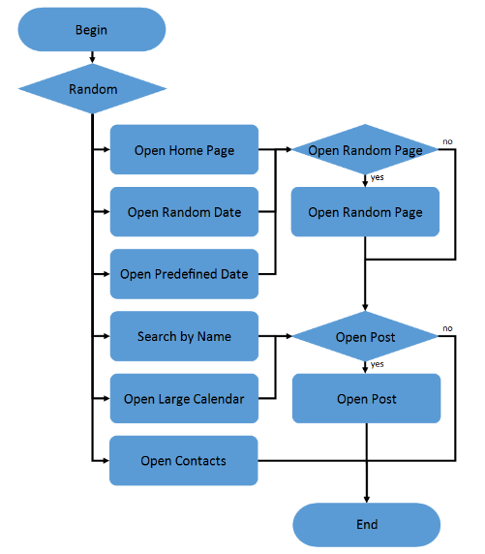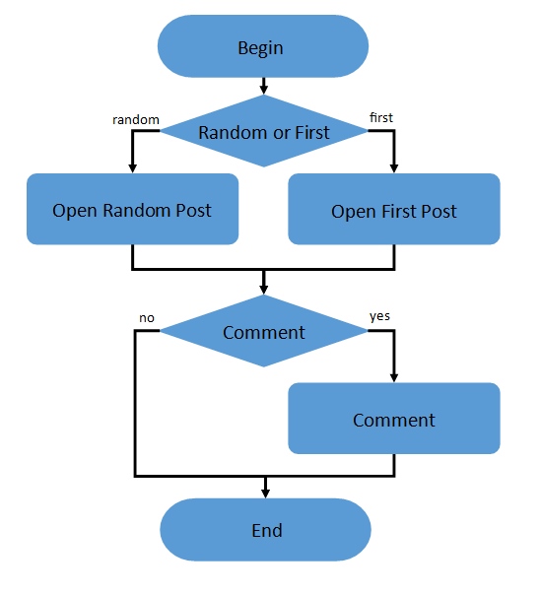

Anonymous script

Anonymous script conditions

|  |  |
| --- | --- |
| **Transaction** | **Probability** |
| open home page | 15% |
| open random date | 10% |
| open predefined date | 30% |
| search by name | 30% |
| open large calendar | 10% |
| open contacts | 5% |
| open random page | 50% |
| open post | 80% |
| open random post | 65% |
| open first post | 35% |
| Leave comment | 20% |

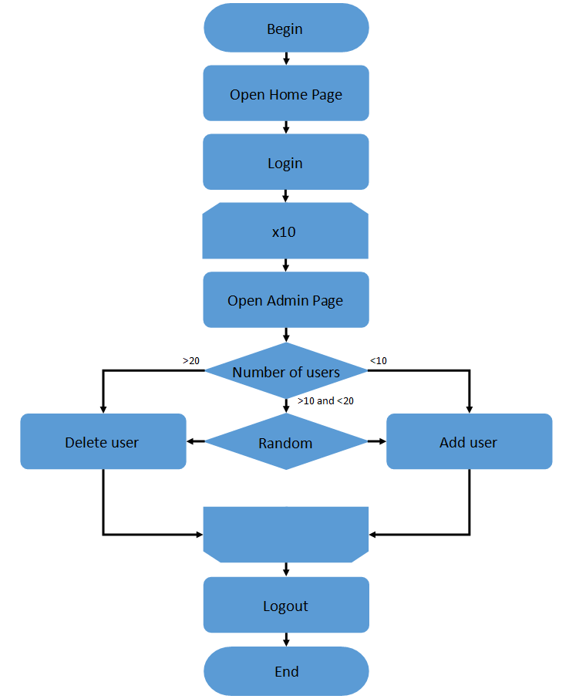 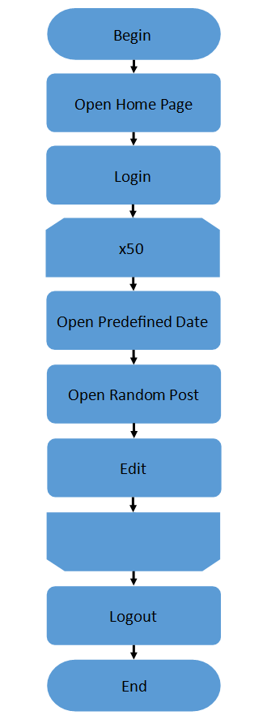

Admin script (left), Editor script (right)

# PERFORMANCE TEST METRICS

* + Response time, ms
  + Throughput, transactions per second
  + CPU utilization, %
  + Disk utilization, %
  + RAM utilization, %
  + Error rate, %

# TEST DELIVERABLES

So far as this test activities were for education the deliverables are presented as test reports and in addition as links to GitHub with test scenarios (<https://github.com/Pickausaname/PTMT-2020-tasks>).

# TEAM

|  |  |  |
| --- | --- | --- |
| **Name of employer** | **email** | **duties** |
| Rehina Lukianchenko | email@email.com | Mentor |
| Rehina Lukianchenko | email@email.com | Creating scripts, running tests, reporting |