**Test report (19.02.2020 Task2)**

**1. Executive summary**

**1.1. Test purpose**

Generate test data (posts) and measure execution time

**1.2. Test status**

Test Passed

**1.3. Test summary**

Data was generated and time was measured. Now we are able to estimate time for data generating. CPU usage looks like here is bottleneck, but it depends on test architecture. Using think Time simulation we can configure test in the most efficient way to create posts fast with low errors rate and average CPU usage less than 95%. 100 ms think time halves errors rate and almost doesn’t affect test (creation posts) time.

**2. Test objectives**

a) Get data generator

b) Script login procedure

c) Get experience of test data preparation

d) Get estimated time needed for data generation

**3. Test configuration**

**3.1. Hardware configuration**

Environment: virtual machine

Operation System: Windows 10(64-bit)

RAM: 4GB

Processor: Intel Core i-7 6700. Use only to 1 CPU on environment

HDD memory size: 50GB

**3.2. Test configuration**

Prerequisites: Manually test site’s workability

Test configuration

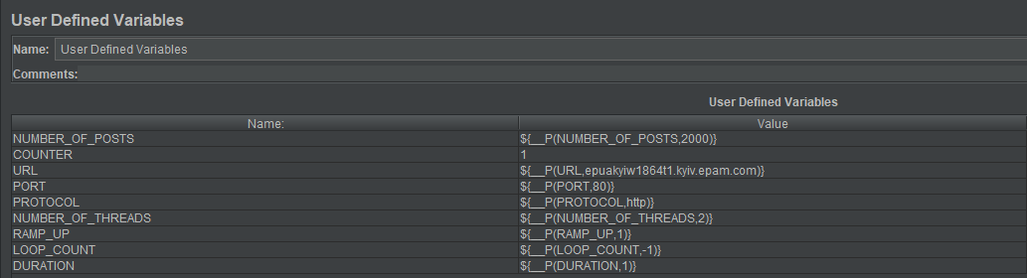

**4. Quality criteria**

Data generate

**5. Test scenario**

**5.1. User Behavior and Workload**

In this test scenario we doesn`t emulate real behavior of user. This test was created for fast data generation

**5.2. Scheme of scenario**

**6. Test results**

Generating 100 posts (20 sec)

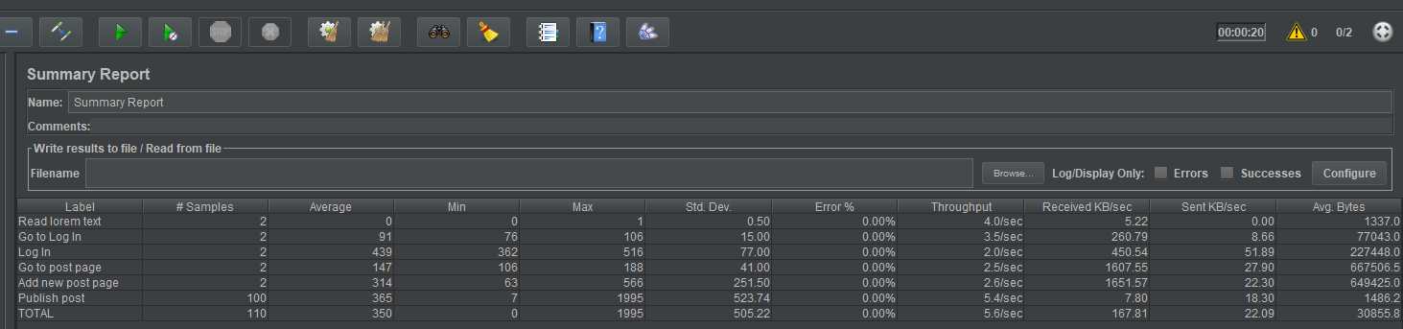

Active threads, hits, CPU load, transactions successful/failed

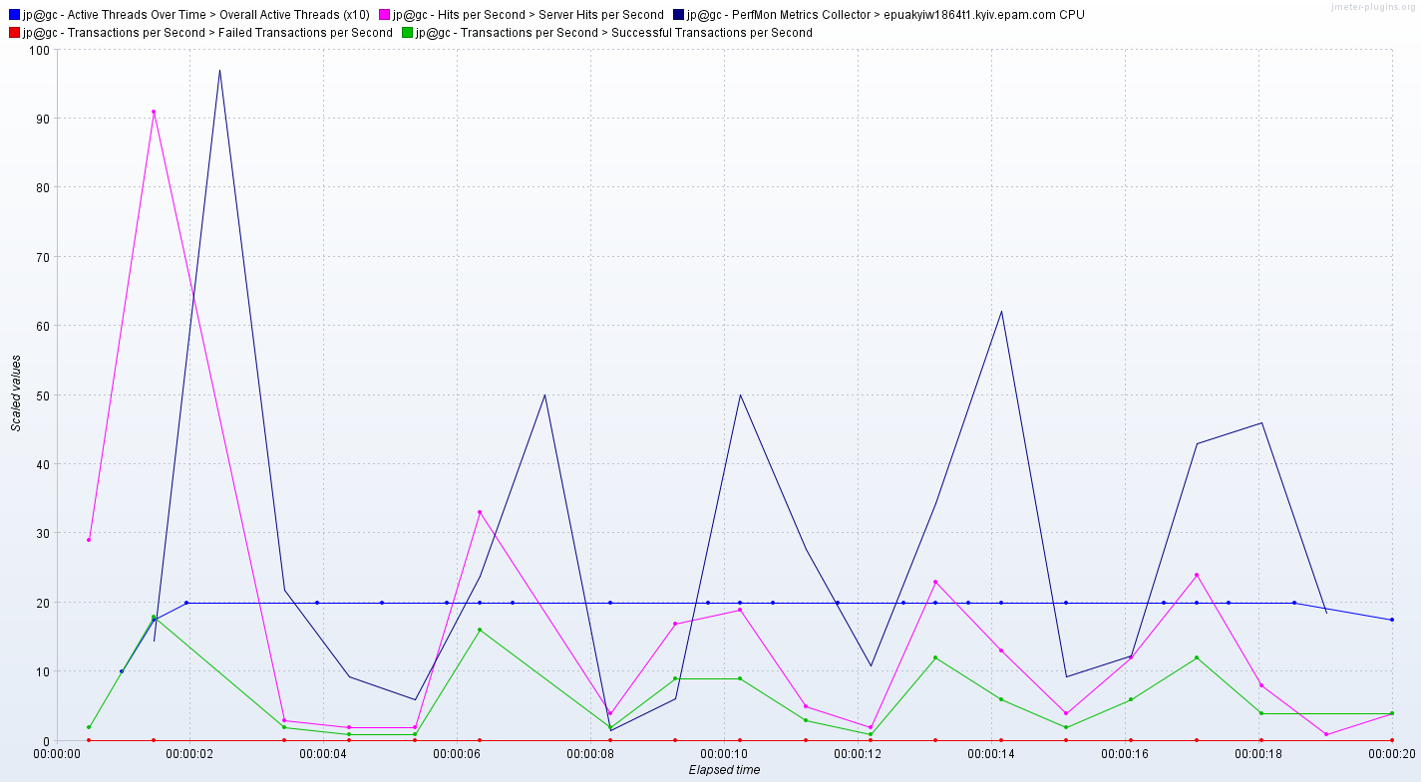

CPU, Disk, Mem

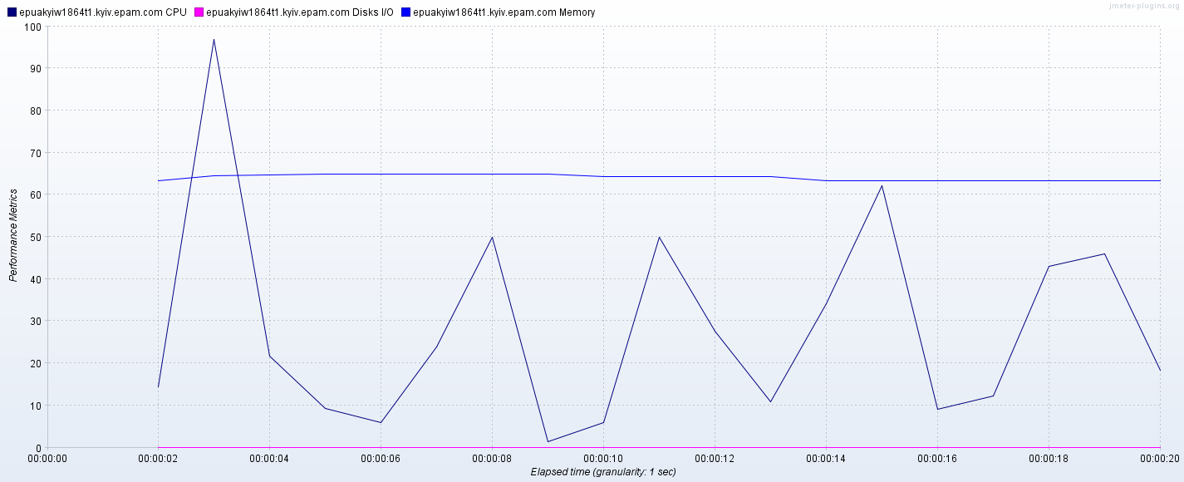

Generating 1000 posts (2 min 23 sec)

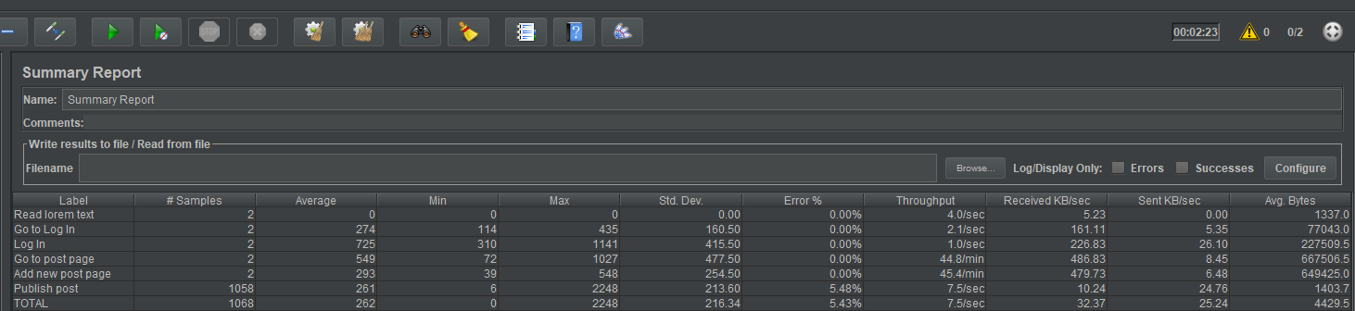

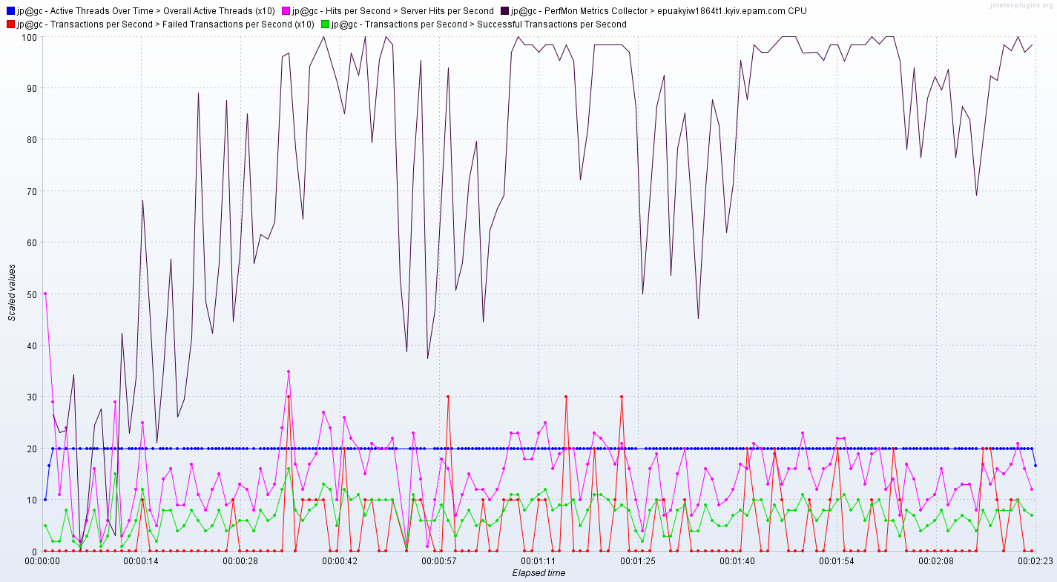

CPU, Disk, Mem

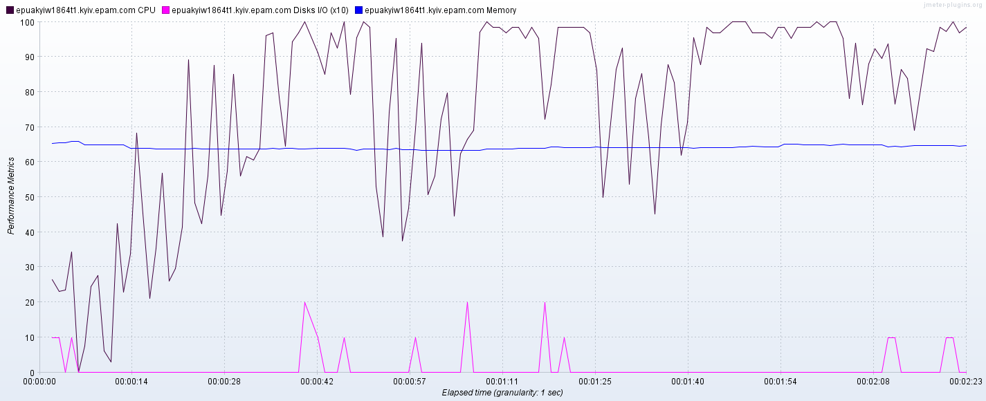

Generating 2000 posts (5 min 48 sec)

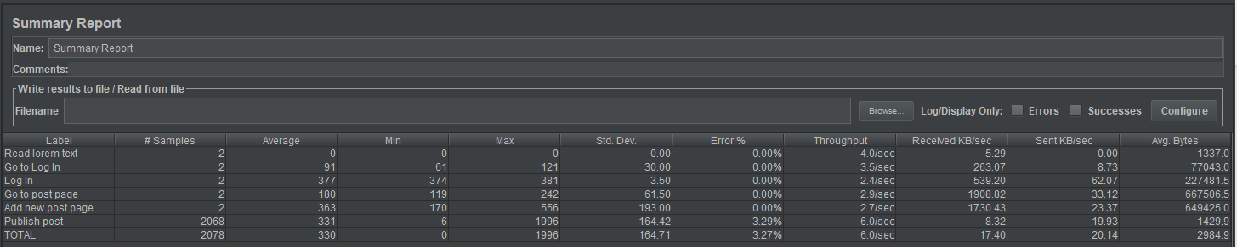

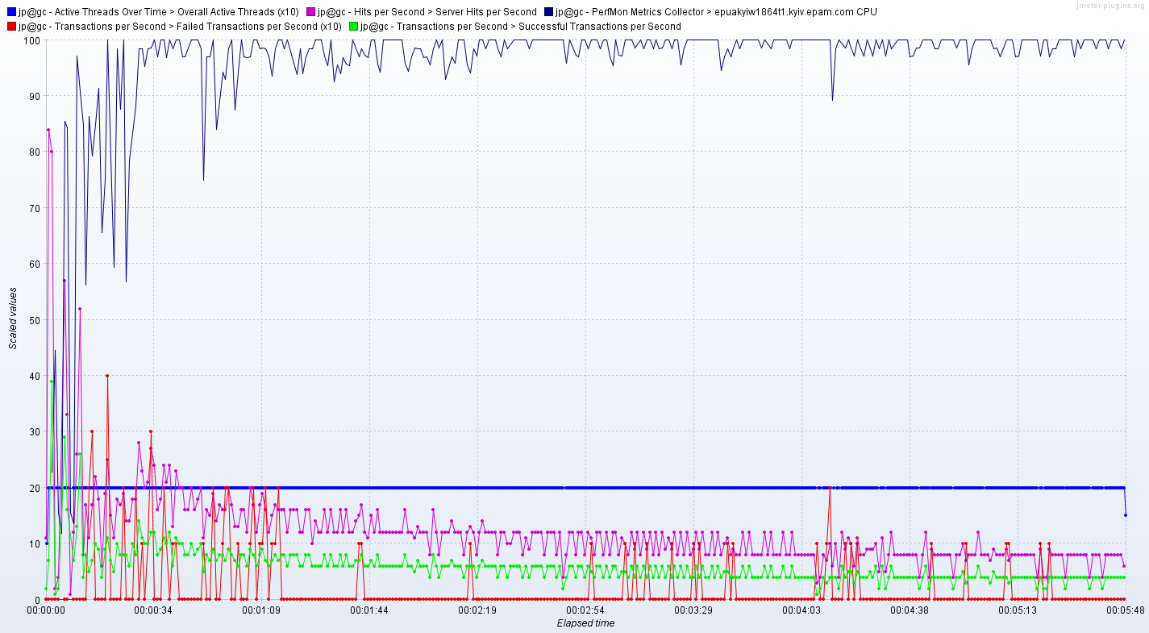

CPU, Disk, Mem

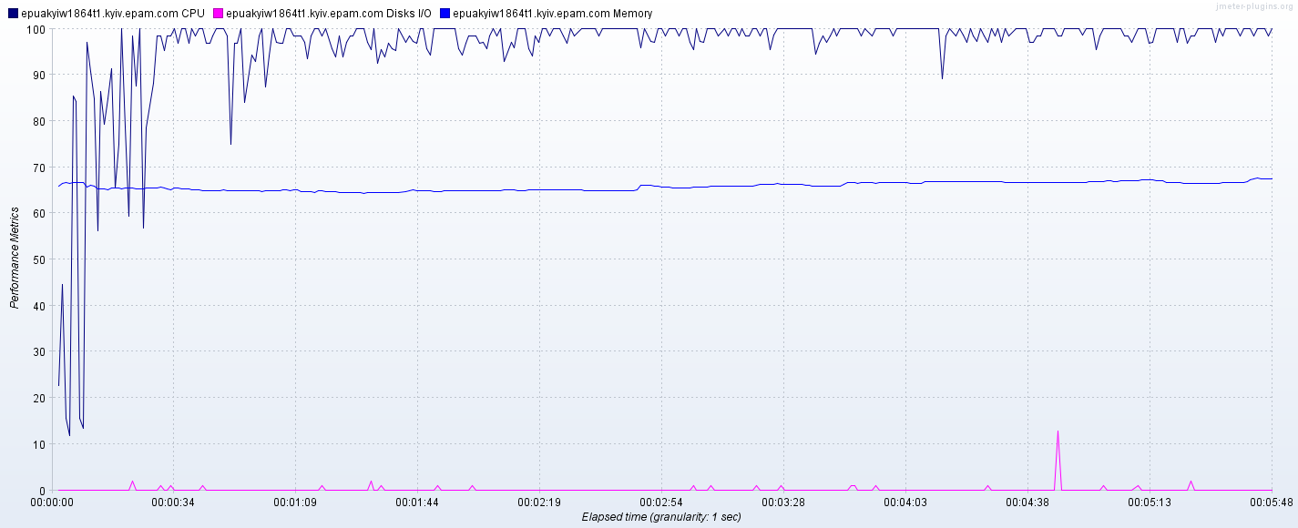

Generating 996 posts with total timers 2 sec in post operation (17 min 47 sec)

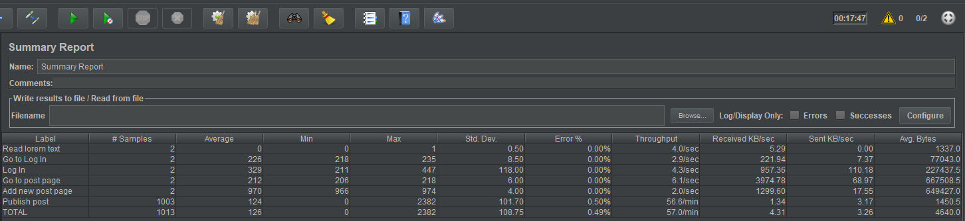

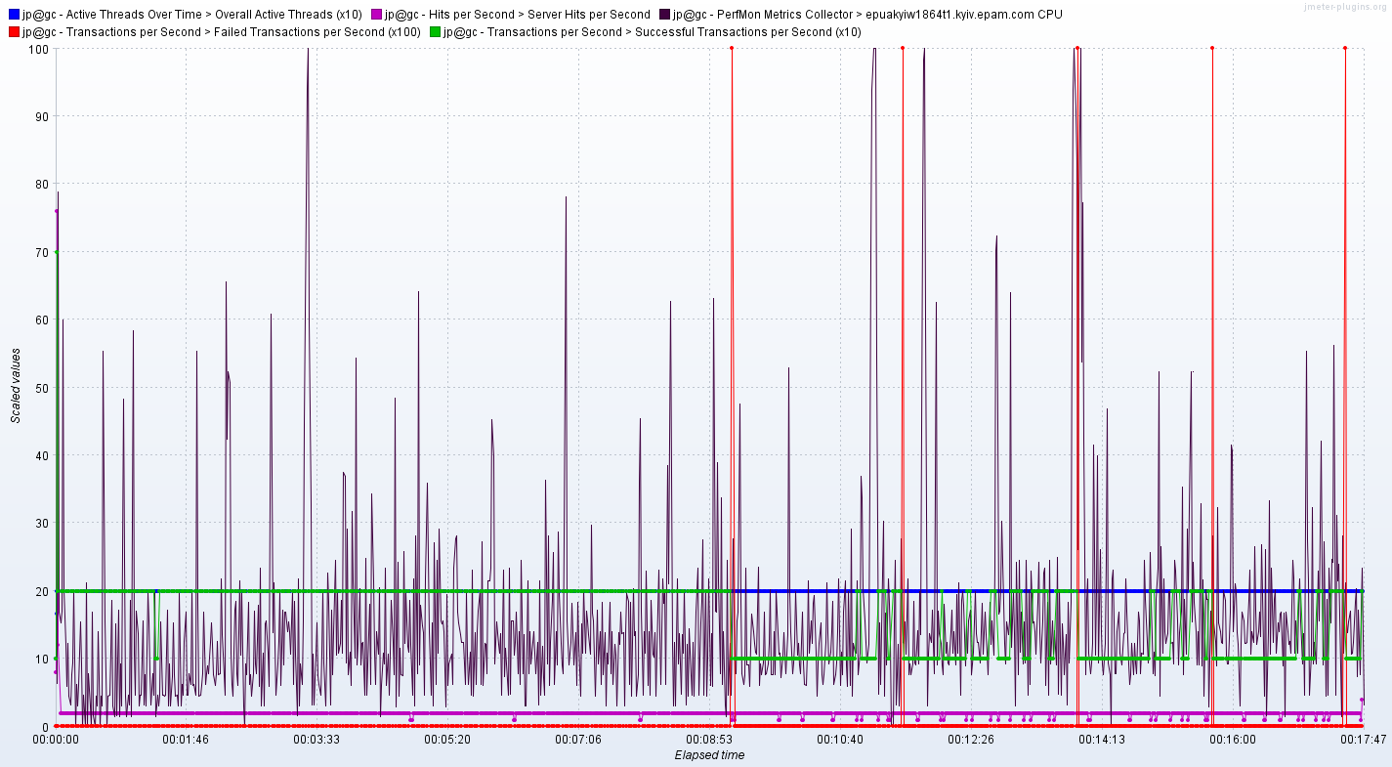

CPU, Disk, Mem

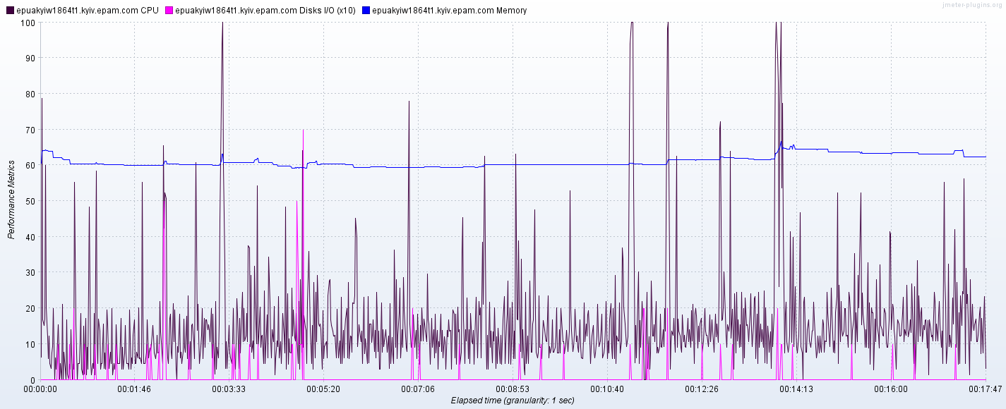

Generating 1004 posts with total timers 600ms sec in post operation (06 min 04 sec)

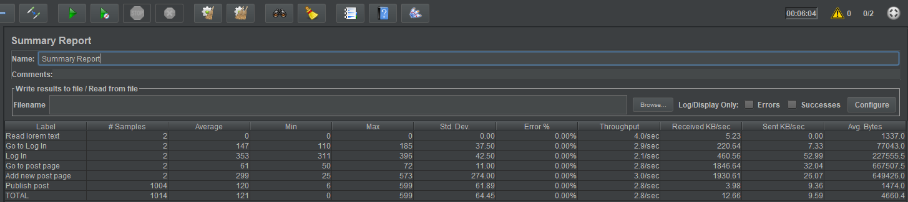

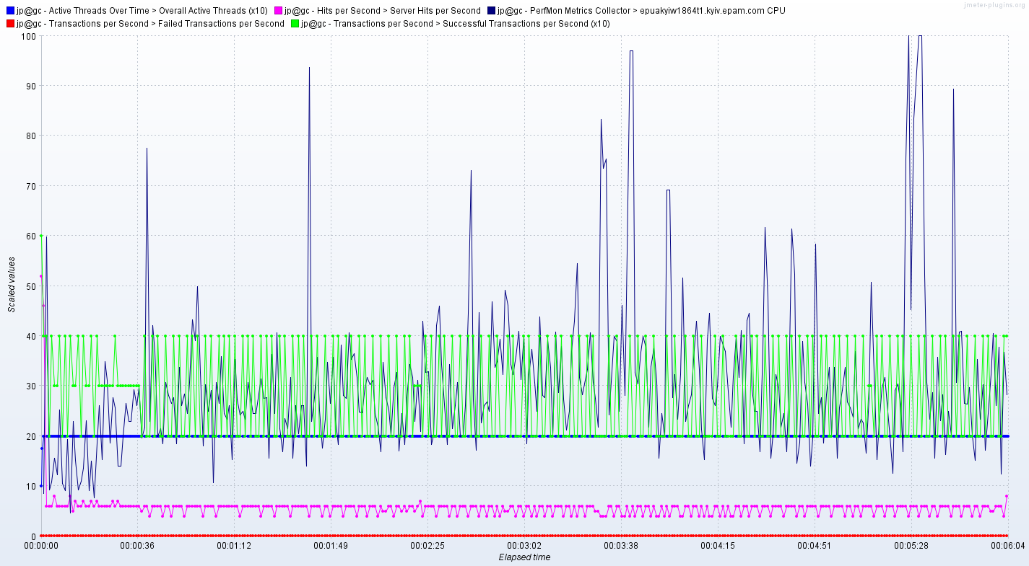

CPU, Disk, Mem

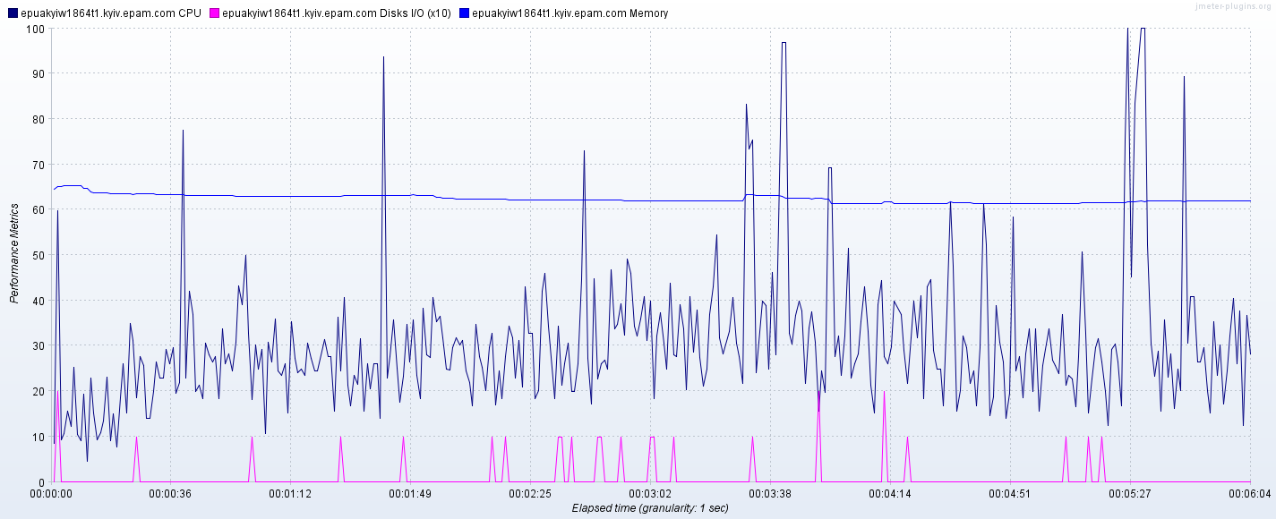

Generating 1000 posts with total timers 100ms sec in post operation (02 min 28 sec)

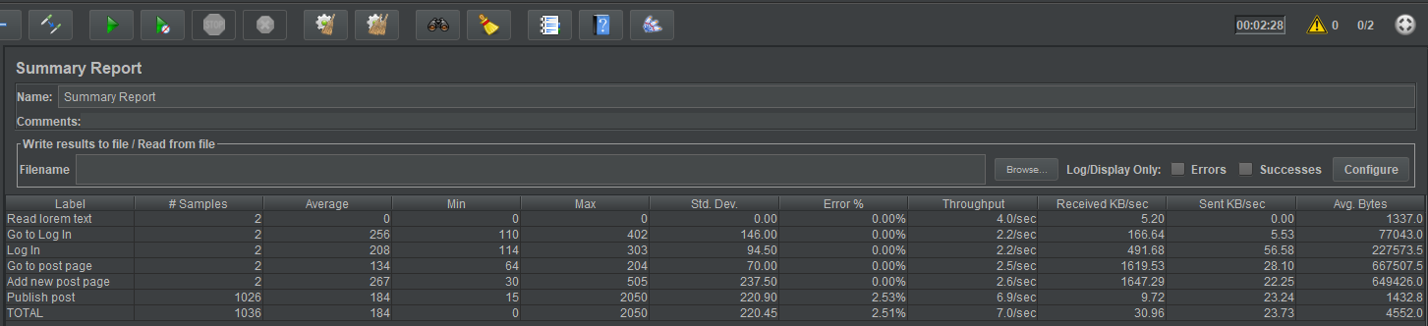

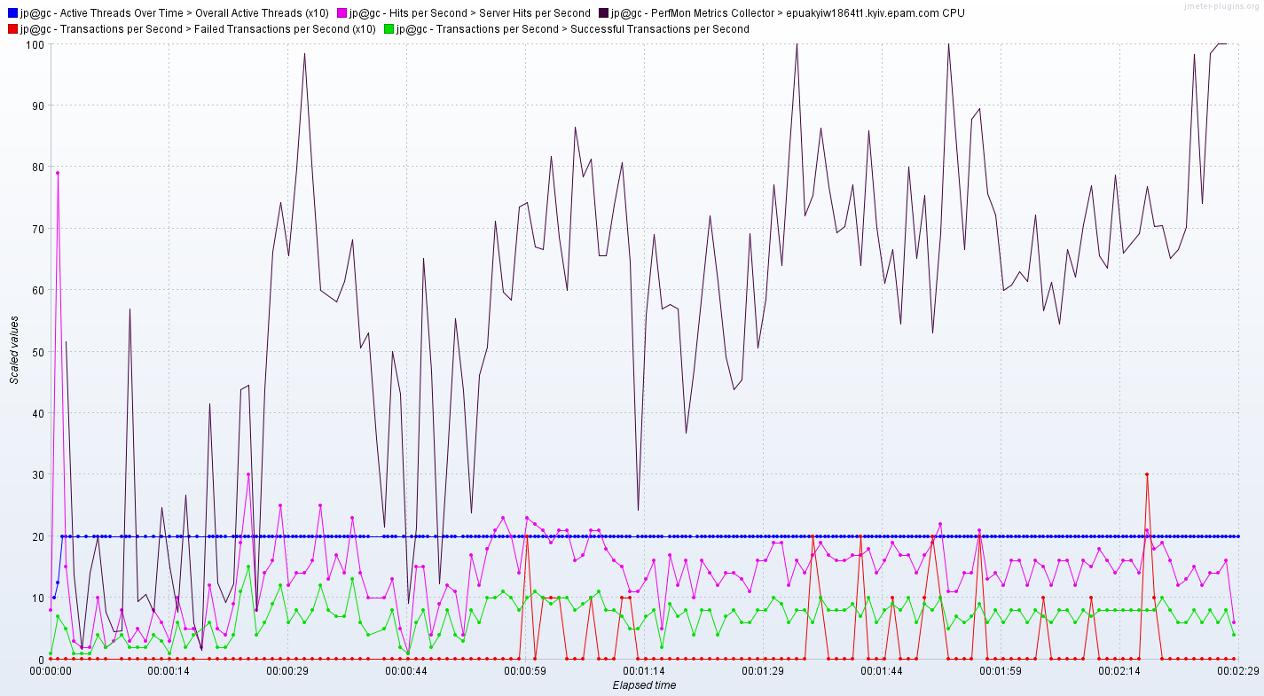

CPU, Disk, Mem

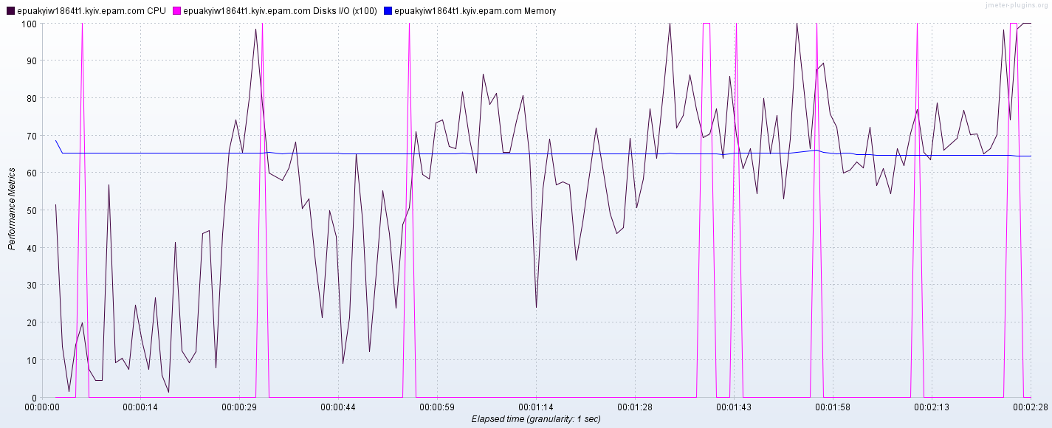

System recovery after generating 2000 posts (the end of test 13.46.10)

