**Test report (22.03.2020 Task 3)**

**Executive summary**

1. Test purpose

- Perform smoke testing

- Investigate how many users our application can handle.

2. Test status

Smoke test passed

Capacity test passed

3. Test summary

Before main capacity test we checked script workability and system availability with 1 user for 10 minutes. Next step was an executing capacity test to discover amount of users that site can handle. During test we found capacity and saturation points but in the same time with main pointer of saturation – application errors occur jmeter errors those make our test result isn’t so obvious.

**Test objectives**

a) Implement Anonymous user scenario

b) Perform Smoke testing.

c) Perform Capacity testing.

d) Document results.

**Test configuration**

1. Hardware configuration

Environment: virtual machine

Operation System: Windows 10(64-bit)

RAM: 4GB

Processor: Intel Core i-7 6700. Use only to 1 CPU on environment

HDD memory size: 50GB

2. Test configuration

Prerequisites: Generated 100 posts.

Test configuration:

Number of Threads(users): 300

Ramp-up period(seconds): 3570

Loop count: infinite

Duration(seconds): 3600

Delays: 1 sec after each logic transaction

**Quality criteria**

- Smoke test passed without any errors

- Capacity test shows us capacity and saturation point

**Test scenario**

1. User Behavior and Workload

In this test scenario we try to emulate real user behavior. That`s why we use timers and random access to transactions. Workload is 300 users with 3570 ramp-up and 3600 duration

2. Scheme of scenario

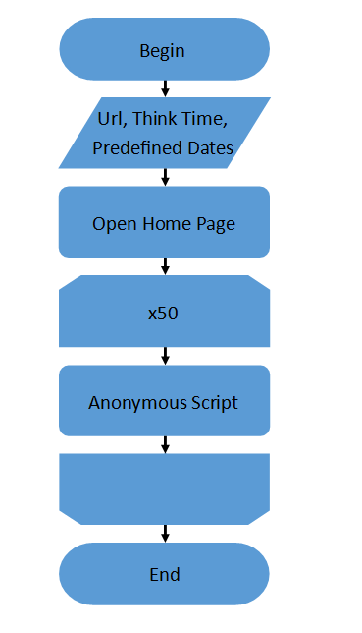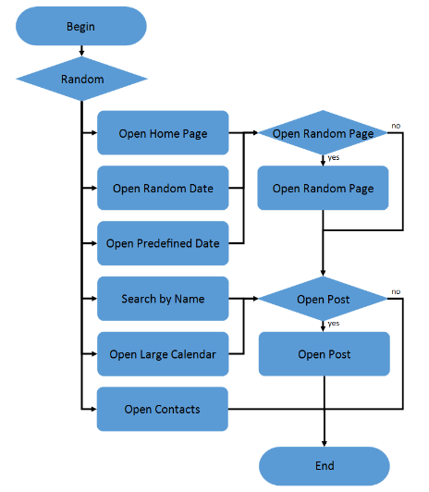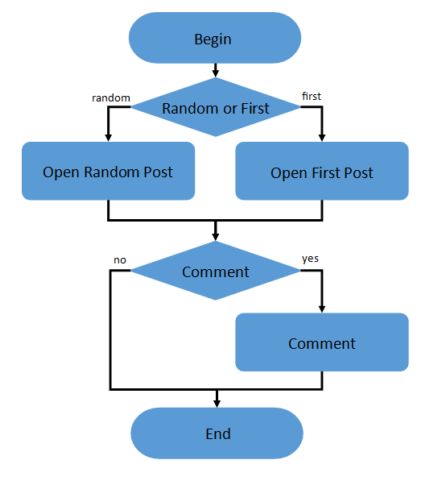

Main, Anonymous and Open post script

**Test results**

Smoke test (1 user 5min 0 errors):

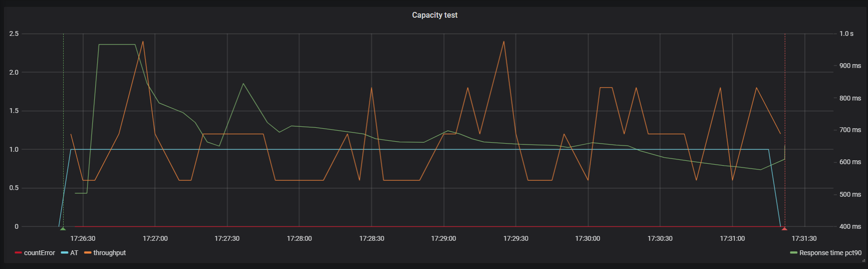

Active threads/errors/throughput

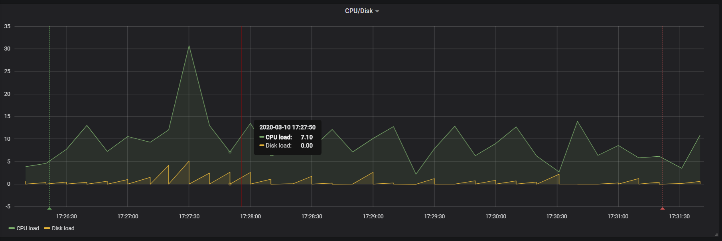

CPU/disk load

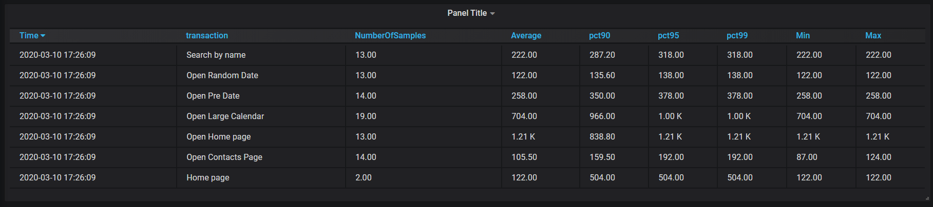

Transactions and response time

Capacity test (300 users, 3600 sec duration, 3570 rump-up):

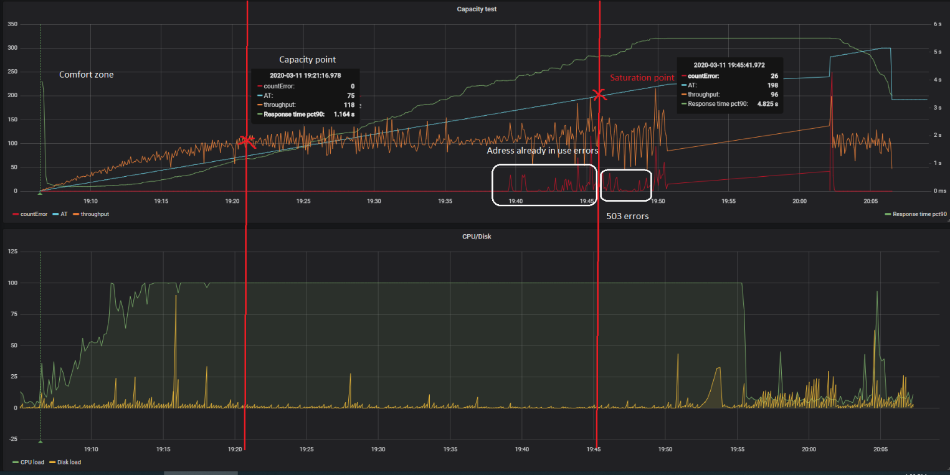

Active threads/errors/throughput

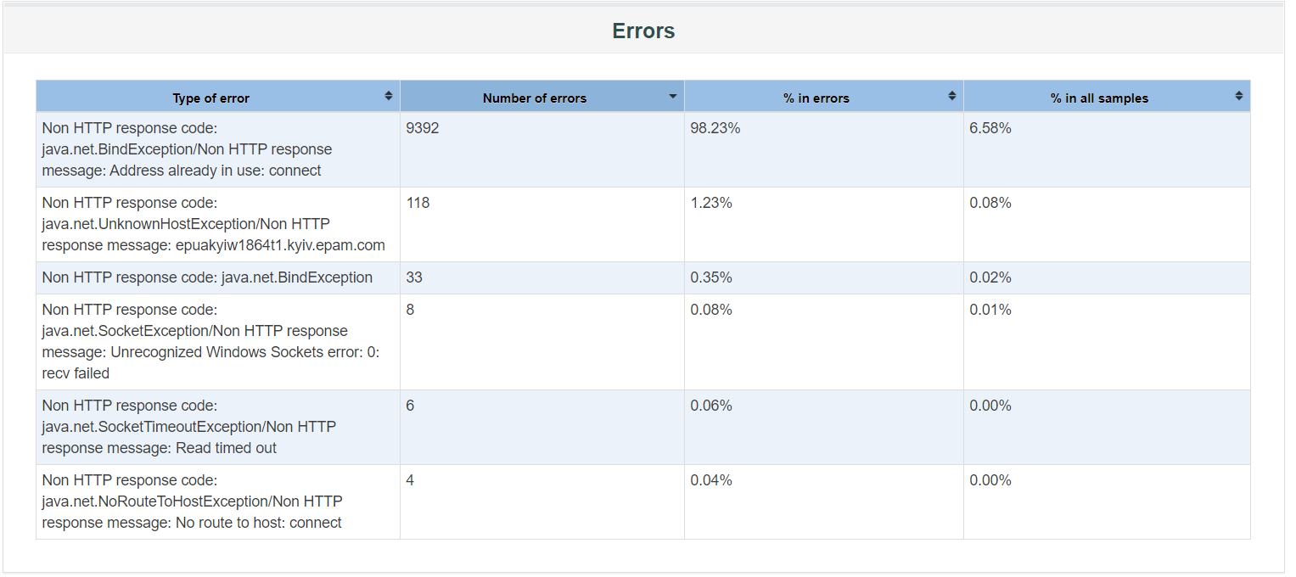

Errors description

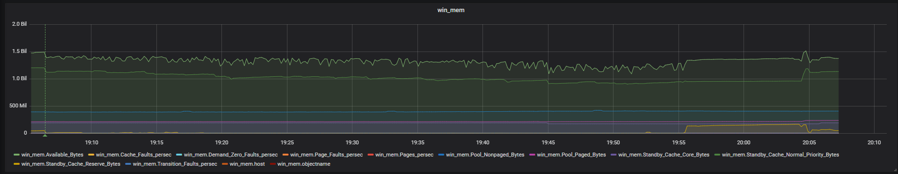

RAM load

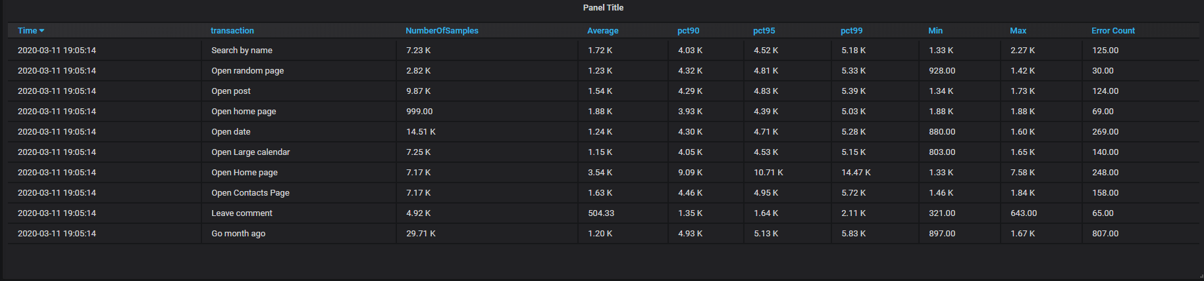

Transactions and response time

**Summary**

Main script implemented. Smoke and capacity tests are executed and results are documented. Capacity point: 75 users, Saturation point198 users