**Test report (29.03.2020 Task 4)**

**Executive summary**

1. Test purpose

- Perform smoke testing

- Perform load test and explore application behavior under 2 users load in admin area

2. Test status

Smoke test passed

Load test passed

3. Test summary

Before main capacity test we checked script workability and system availability with 2 user for 10 minutes. Smoke test held without any errors. Next step was an executing load test with the same number of users but much longer (1h). Only two errors with code 500 in module admin page appeared during load test that is 0.023% from total number of transactions so we consider this test as passed.

**Test objectives**

a) Implement Admin user scenario

b) Perform Smoke testing.

c) Perform Load testing.

d) Get base line on performance of particular admin’s actions.

e) Document results.

**Test configuration**

1. Hardware configuration

Environment: virtual machine

Operation System: Windows 10(64-bit)

RAM: 4GB

Processor: Intel Core i-7 6700. Use only to 1 CPU on environment

HDD memory size: 50GB

2. Test configuration

Prerequisites: none

**Quality criteria**

- Smoke test held without any errors

- Load test held with threshold of errors below 1%

**Test scenario**

1. User Behavior and Workload

In this test scenario we try to emulate real admin behavior. Number of users 2, duration 10 min for smoke and 1 h for load, ramp-up 1 sec for smoke and 100 sec for load.

2. Scheme of scenario

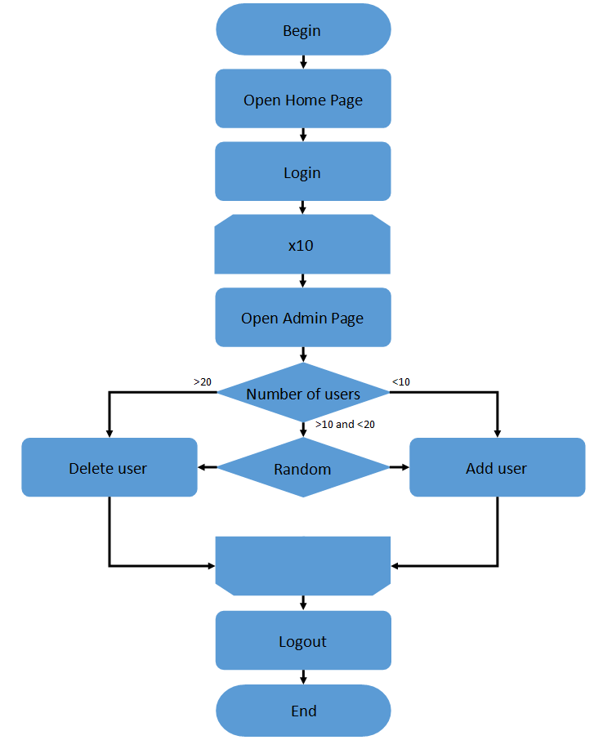

Admin script

**Test results**

Smoke test

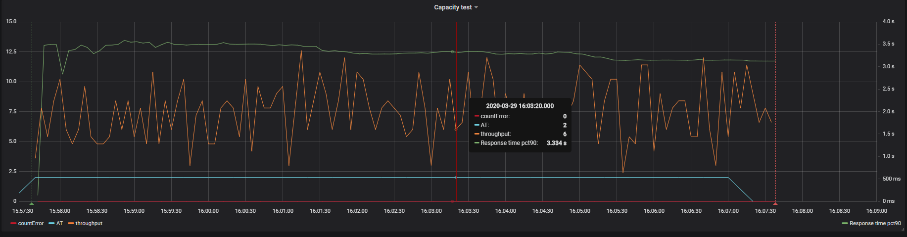

Active threads/errors/throughput

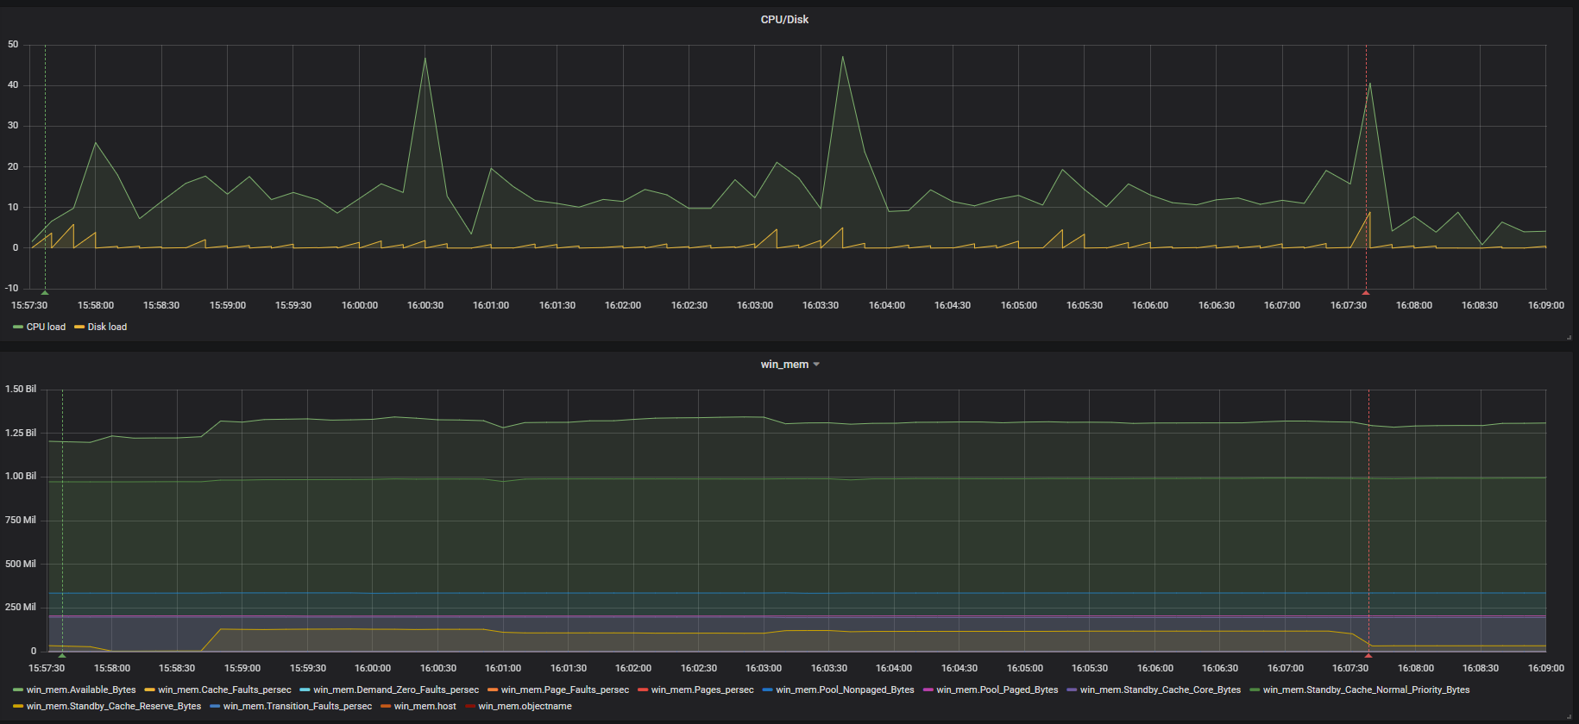

CPU/disk load/RAM

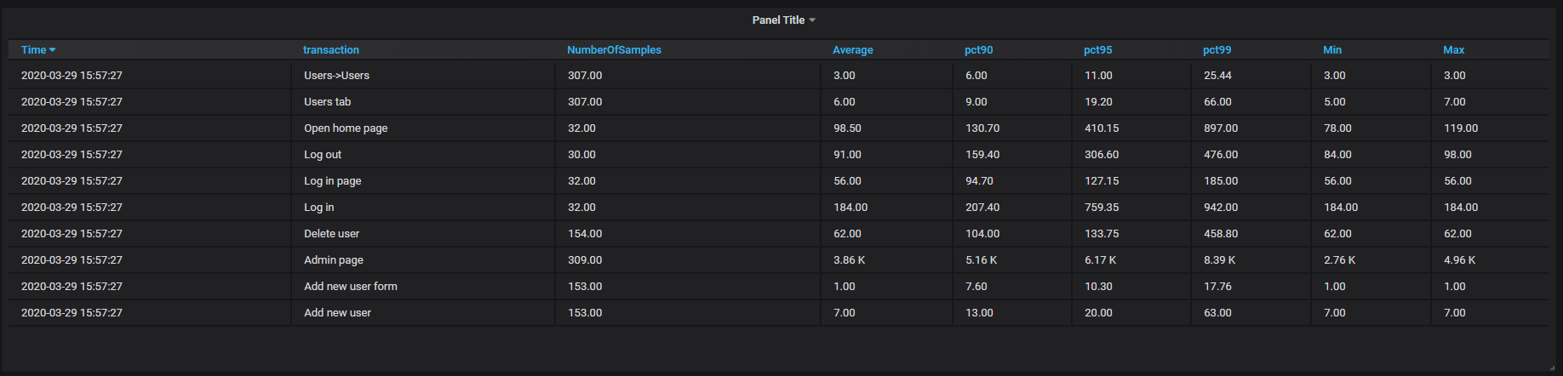

Transactions and response time

Load test

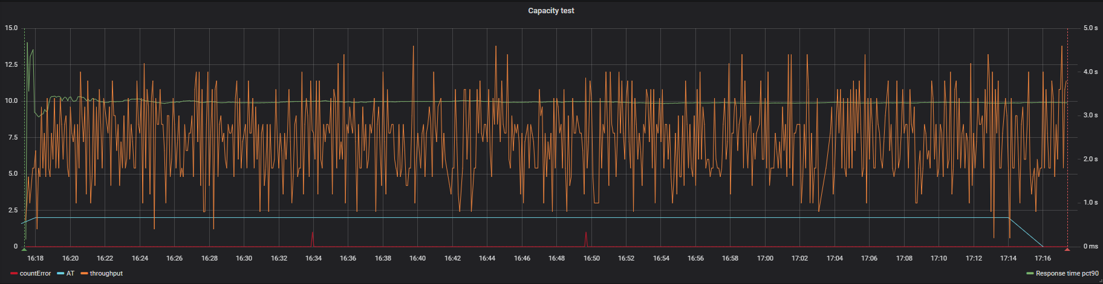

Active threads/errors/throughput

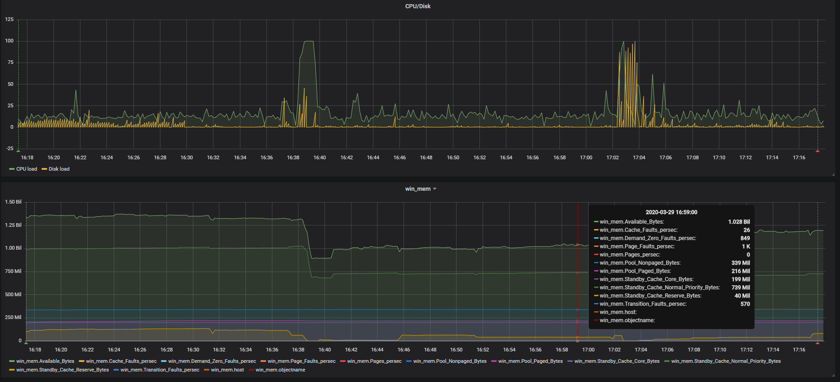

CPU/Disk load/ RAM

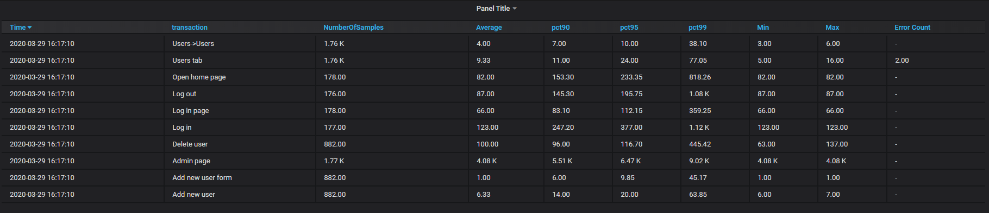

Transactions and response time



Errors

**Summary**

Smoke test passed successfully. Application under load test behave almost stably, excluding two CPU load spikes that didn’t influence response time and two random 500 errors. Admin page – the most time-consuming action in the flow (5 sec avg) against other actions those 1sec and less.