**Test report (03.04.2020 Task 5)**

**Executive summary**

1. Test purpose

- Design editor script and scenario

- Perform load test and explore application behavior under 2 users load in editor flow

2. Test status

Smoke test passed

Load test passed

3. Test summary

Before main load test we checked script workability and system availability with 1 user for 22 minutes. Smoke test held without any errors. Next step was an executing load test with the same number of users but much longer (1h). This test also was without errors, so we mark both of those as passes.

**Test objectives**

a) Implement Editor user scenario

b) Perform Smoke testing

c) Perform Load testing

d) Get base line on performance of particular editors’ regular actions

e) Document results

**Test configuration**

1. Hardware configuration

Environment: virtual machine

Operation System: Windows 10(64-bit)

RAM: 4GB

Processor: Intel Core i-7 6700. Use only to 1 CPU on environment

HDD memory size: 50GB

2. Test configuration

Prerequisites:

Created 2 Editors

Generated 100 posts

**Quality criteria**

- Smoke test held without any errors

- Load test held with threshold of errors below 1%

**Test scenario**

1. User Behavior and Workload

In this test scenario we try to emulate real editor behavior. Number of users 1, duration 22 min for smoke and 2 users 1 h for load, ramp-up 1 sec for smoke and 1 sec for load. Delay between transaction controllers 1 sec.

2. Scheme of scenario

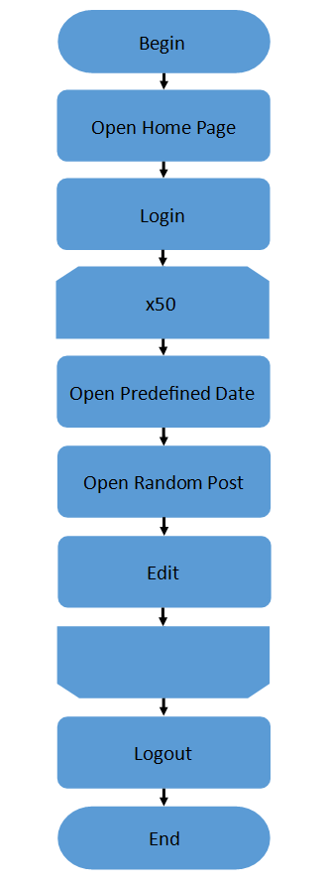

Editor script

**Test results**

Smoke test

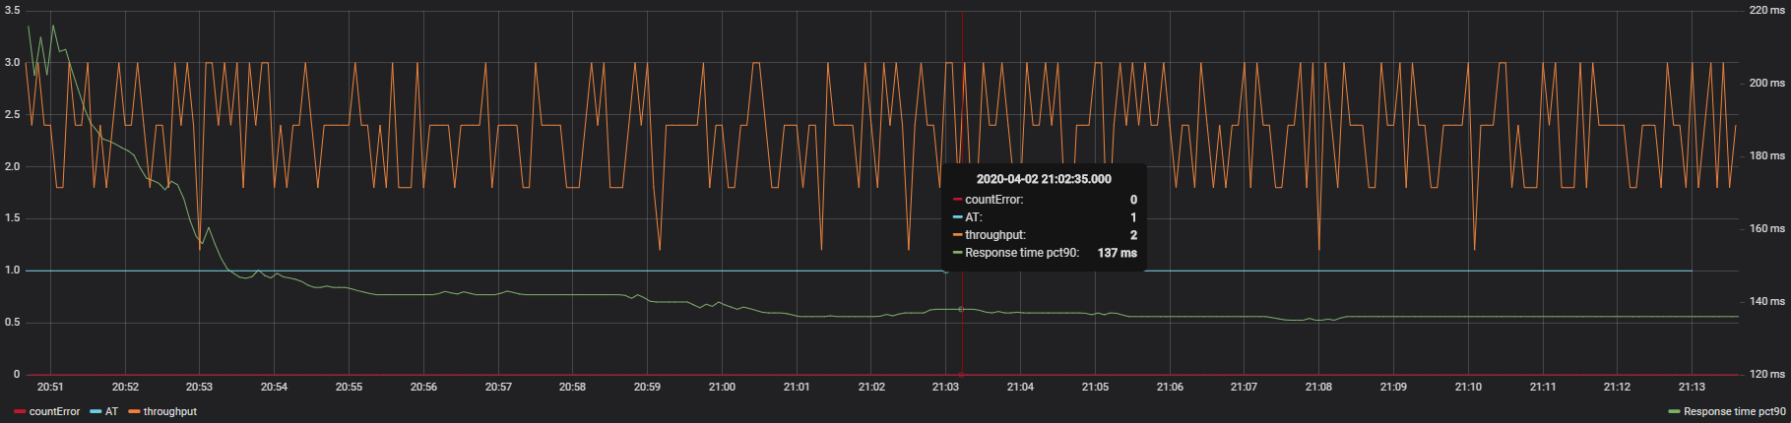

Active threads/errors/throughput

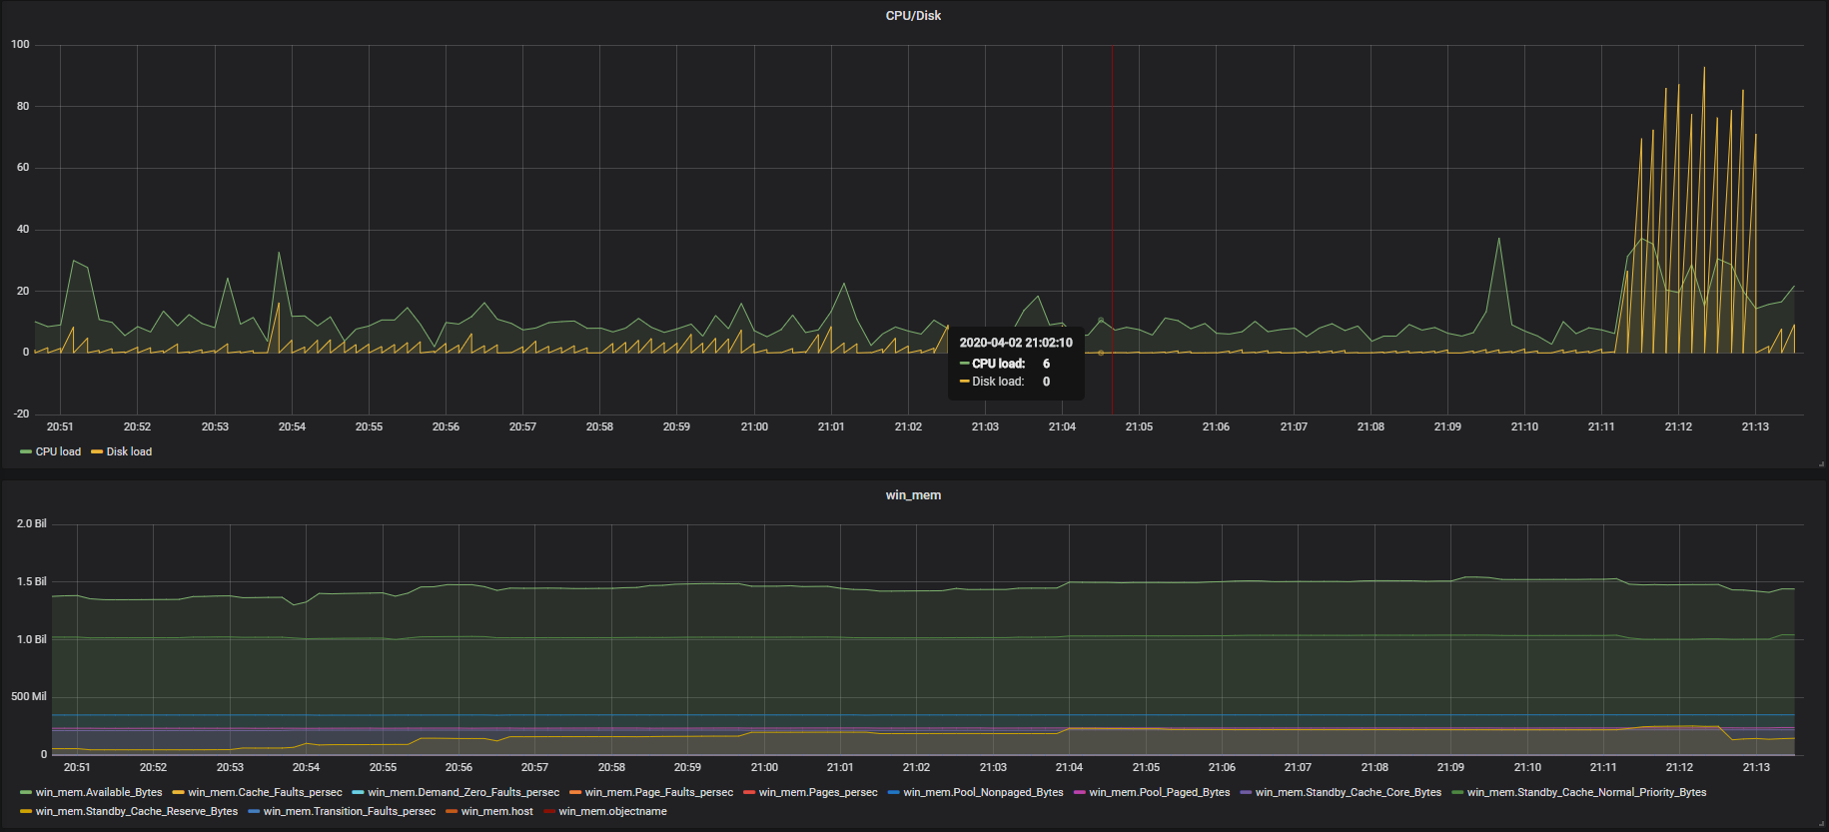

CPU/disk load/RAM

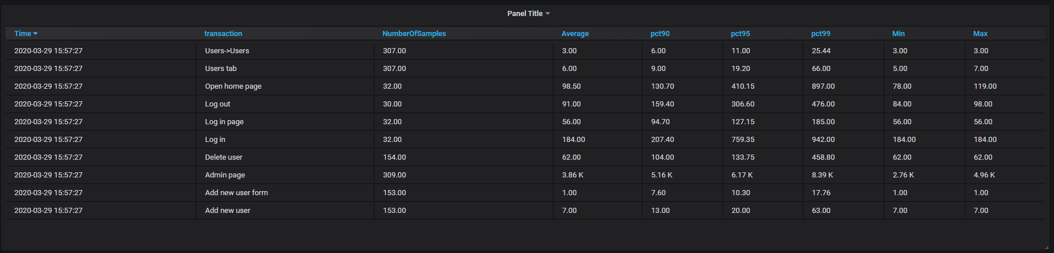

Transactions and response time

Load test

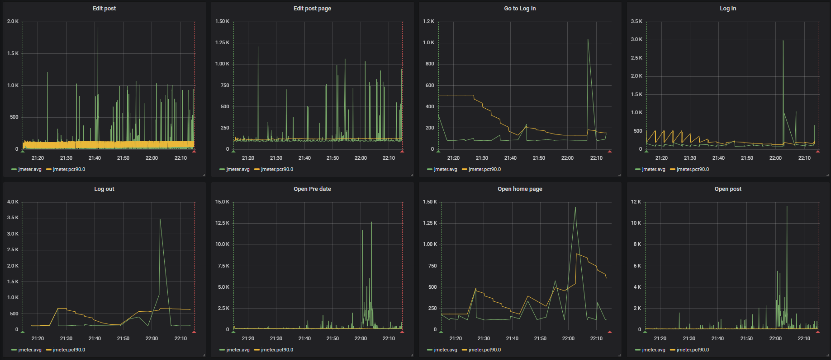

Response time 90pct yellow and avg green

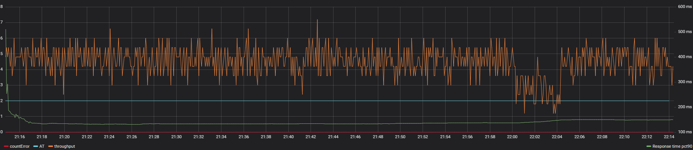

Active threads/errors/throughput

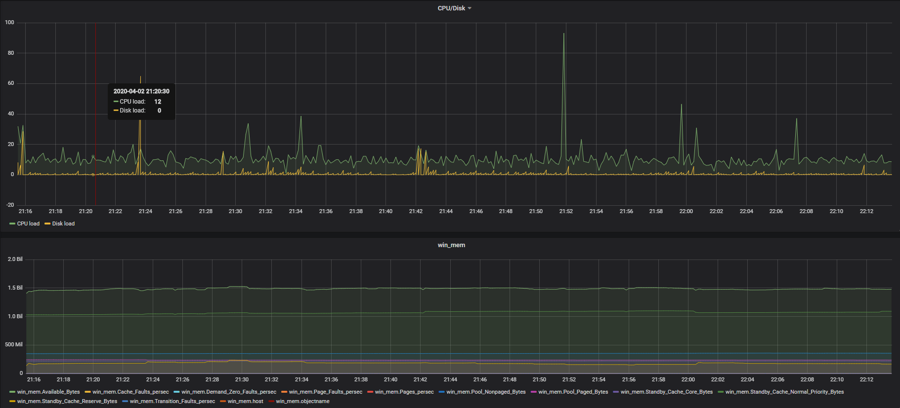

CPU/Disk load/ RAM

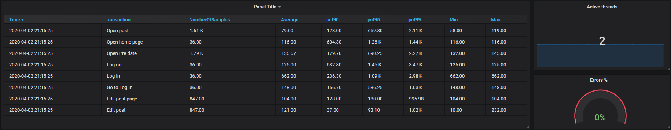

Transactions, response time, error rate, active users

**Summary**

Smoke test passed successfully. Application under load test behave almost stably, excluding one CPU spike that didn’t influence response time and throughput decrease that isn’t connected with CPU/disk/mem issues. Looks like we need to add network monitoring. The biggest average response time – edit post transaction 760ms, the biggest 99 percentile – 3,4 sec