**Test report (20.04.2020 Task 7)**

**Executive summary**

1. Test purpose

- Design combined script and scenario

- Get an experience of combined testing with different user roles

2. Test status

Smoke test passed

Capacity test passed

3. Test summary

Before capacity tests we checked script workability and system availability with 2 anonymous 2 editors and 2 admin users for 10 minutes. Smoke test held without any errors. Next step was executing capacity test for anonymous script during executing admin and editor scenarios. Capacity test showed capacity point and held with expected application and unexpected “java.net.BindException” type errors.

**Test objectives**

1. Prepare combined scenario which is to include the scripts:

* Task 4 (admin)
* Task 5 (editor)
* Task 6 (anonymous)

1. Perform Smoke testing
2. Perform Capacity testing
3. Document results

**Test configuration**

1. Hardware configuration

Environment: virtual machine

Operation System: Windows 10(64-bit)

RAM: 4GB

Processor: Intel Core i-7 6700. Use only to 1 CPU on environment

HDD memory size: 50GB

2. Test configuration

Prerequisites:

Generated 1000 posts

**Quality criteria**

- Smoke test held without any errors

- Capacity tests give ability to find out a capacity point

**Test scenario**

1. User Behavior and Workload

In this test scenario as usual was emulated real user behavior.

|  |  |  |  |  |
| --- | --- | --- | --- | --- |
| **Test type** | **Duration, sec** | **Ramp-up, sec** | **Number of users, Admin/Editor/Anonymous** | **Think time, sec** |
| Smoke test | 600 | 1 | 2/2/2 | 3 |
| Capacity test | 3600 | 3600 | 2/2/300 | 3 |

2. Scheme of scenario

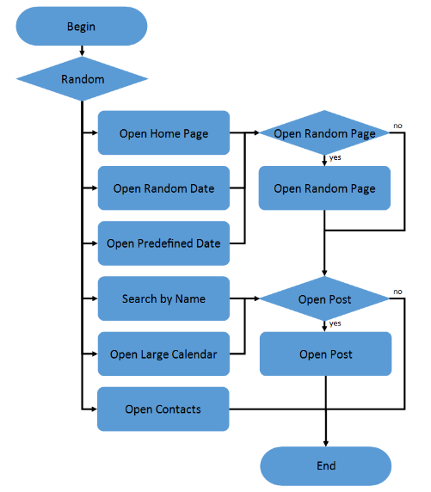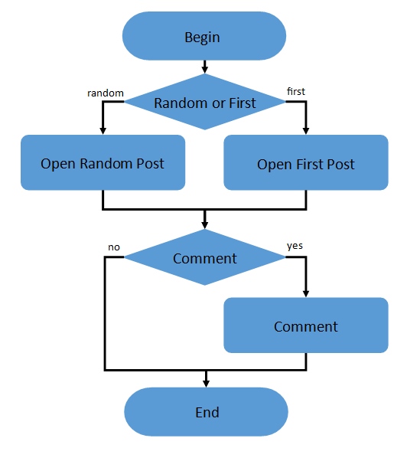

Anonymous script

Anonymous script conditions

|  |  |
| --- | --- |
| **Transaction** | **Probability** |
| open home page | 15% |
| open random date | 10% |
| open predefined date | 30% |
| search by name | 30% |
| open large calendar | 10% |
| open contacts | 5% |
| open random page | 50% |
| open post | 80% |
| open random post | 65% |
| open first post | 35% |
| Leave comment | 20% |

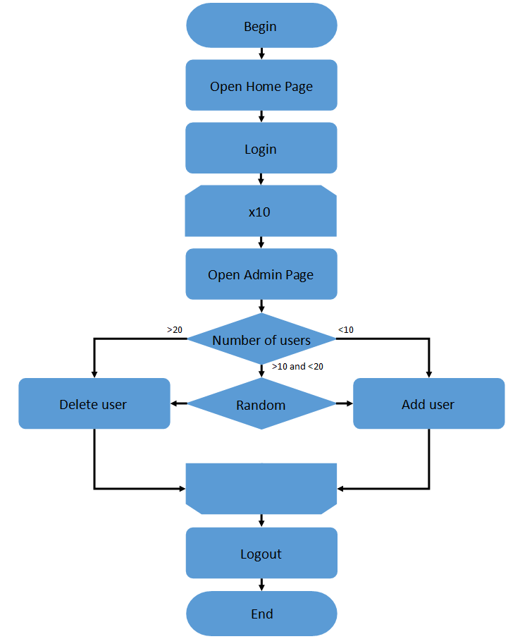 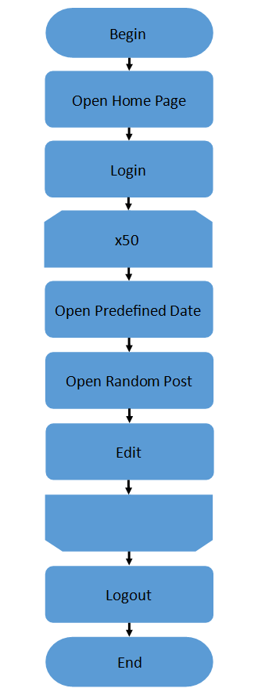

Admin script (left), Editor script (right)

**Test results**

Smoke test

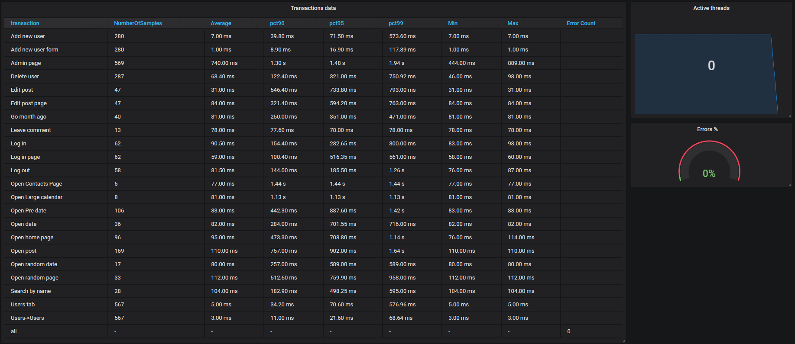

Transactions data

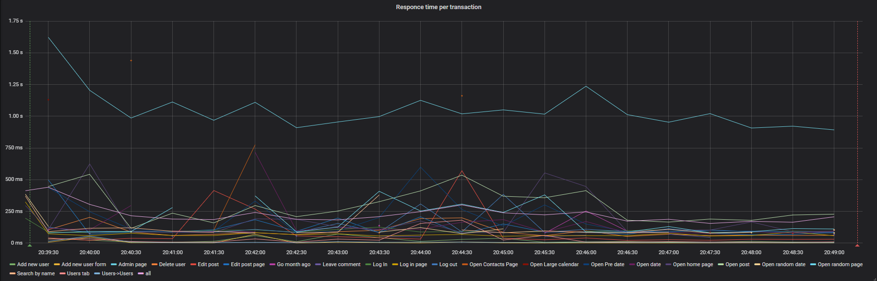

Response time per transaction

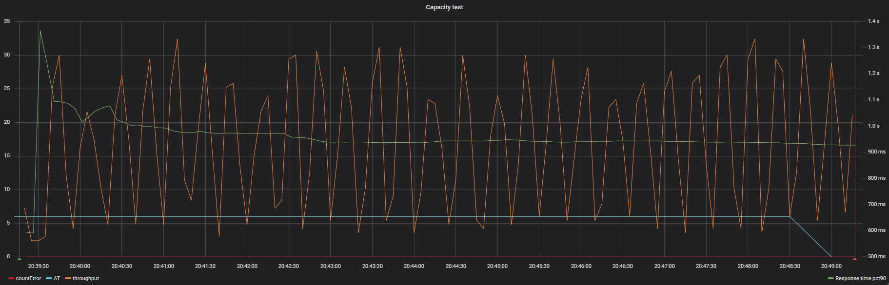

Active threads/errors/throughput

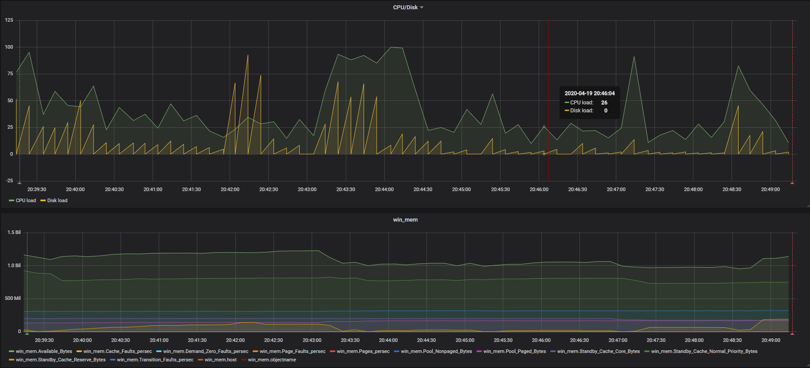

CPU/disk load/RAM

**Capacity test**

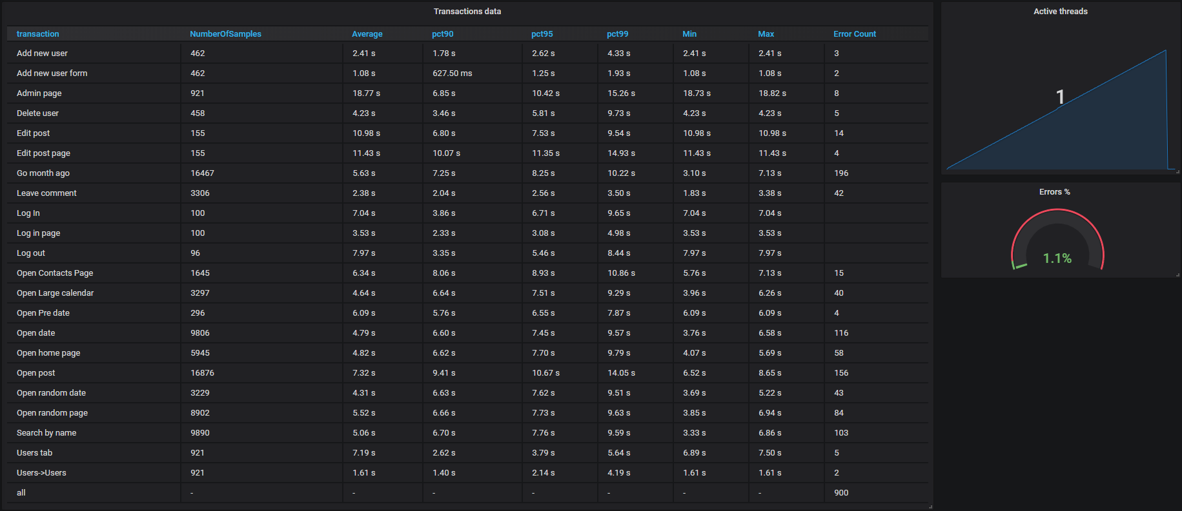

Transactions data

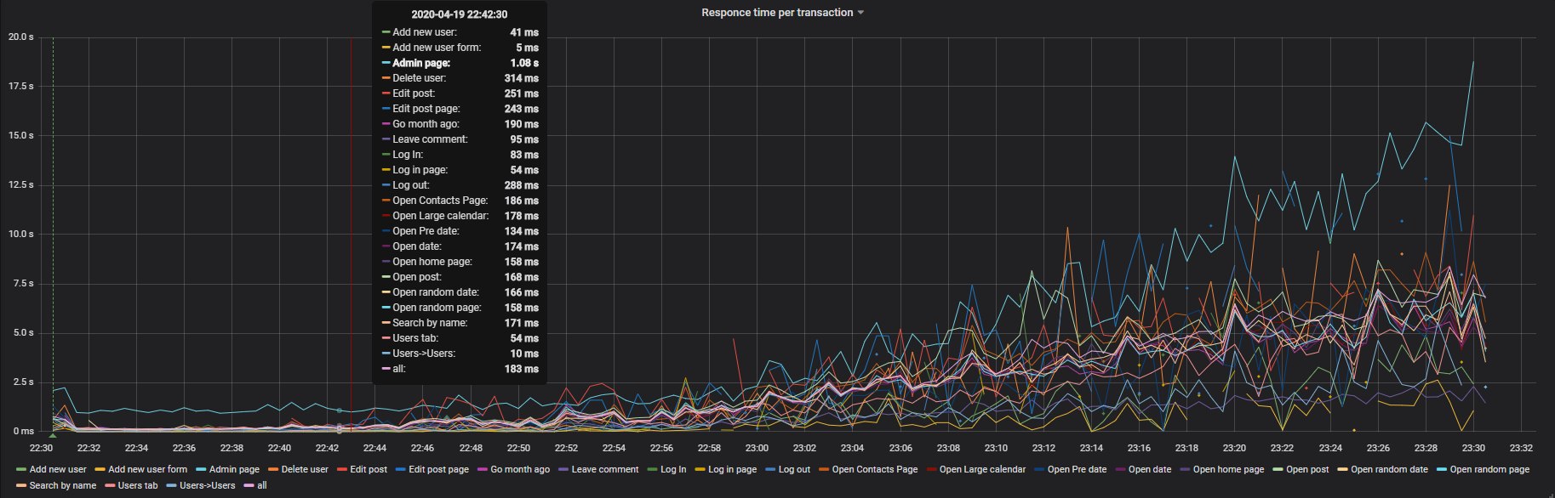

Average per transaction

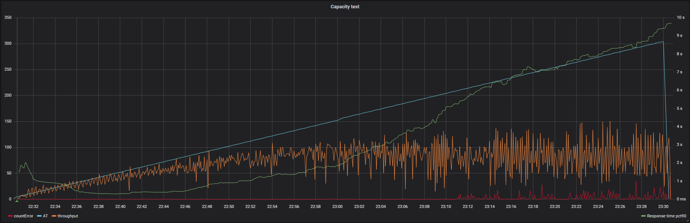

Active threads/errors/throughput. X-capacity point (142 users)

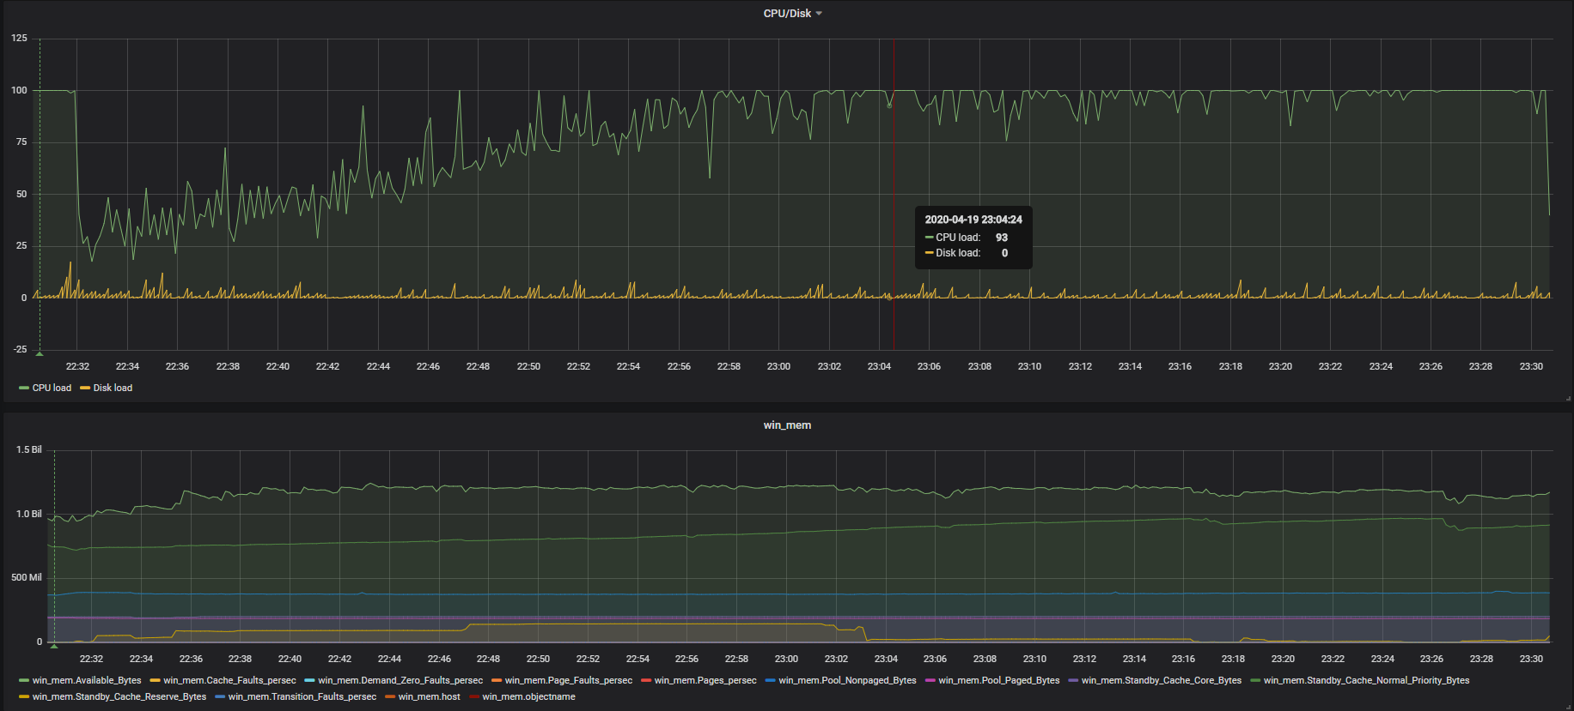

CPU/Disk load/ RAM

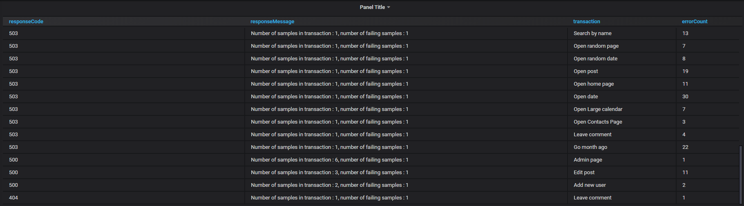

Errors details

The fastest transaction – Add new user form, less than 1.5 sec. The slowest - Admin page, getting closer to 20 sec.

**Summary**

|  |  |  |  |  |
| --- | --- | --- | --- | --- |
| Test | Capacity point, Users | Error rate % | Number of posts | Delay, sec |
| task 6 | 188 | 1.2 | 1000 | 3 |
| task 7 | 142 | 1.1 | 1000 | 3 |

Exploring the result of this test was found out that 2 users in admin mode and 2 users in editor mode approximately equivalent to 40 users in anonymous mode because such heavy actions as open Admin page, Delete user and Edit post are present in our test and probably cookie size for these logged in users makes some additional load on application.