3. 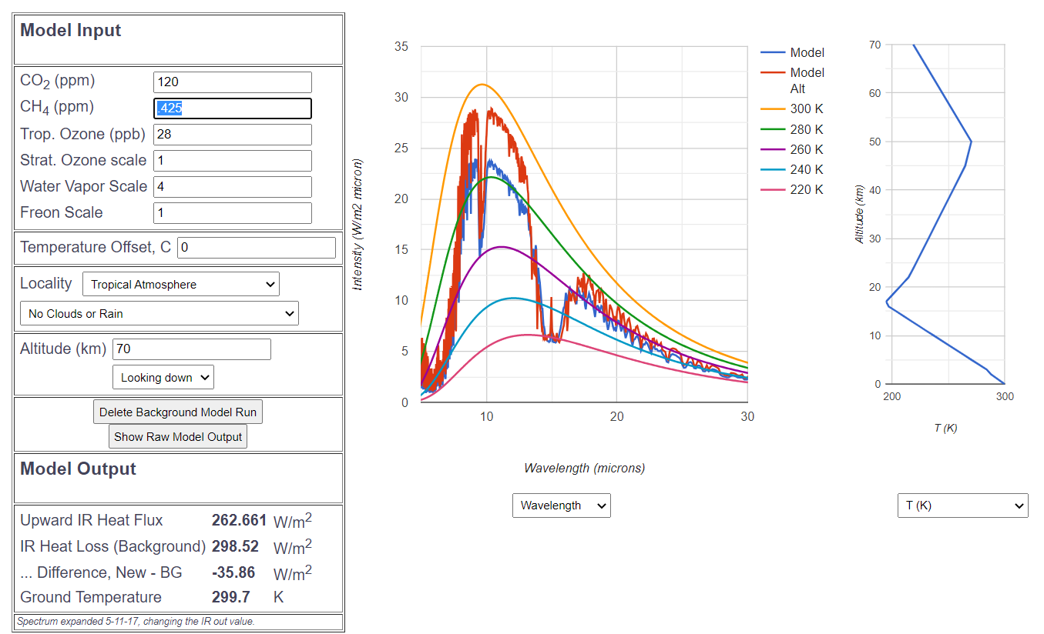

I reduced CO2 and CH4 ppm by a factor of 4 and increased the water vapor by the same factor, resulting in an overall decrease in IR intensity. This drop in intensity demonstrates that water vapor outweighs CO2 and CH4 in IR absorption and emissivity. H2O(g)’s broader absorptivity in the IR spectrum compared to selective absorption by CO2 and CH4 explains this phenomenon. More radiant energy refluxes back into the Earth due to the overall increase in absorptivity/emissivity and results in less upward IR heat flux as shown.