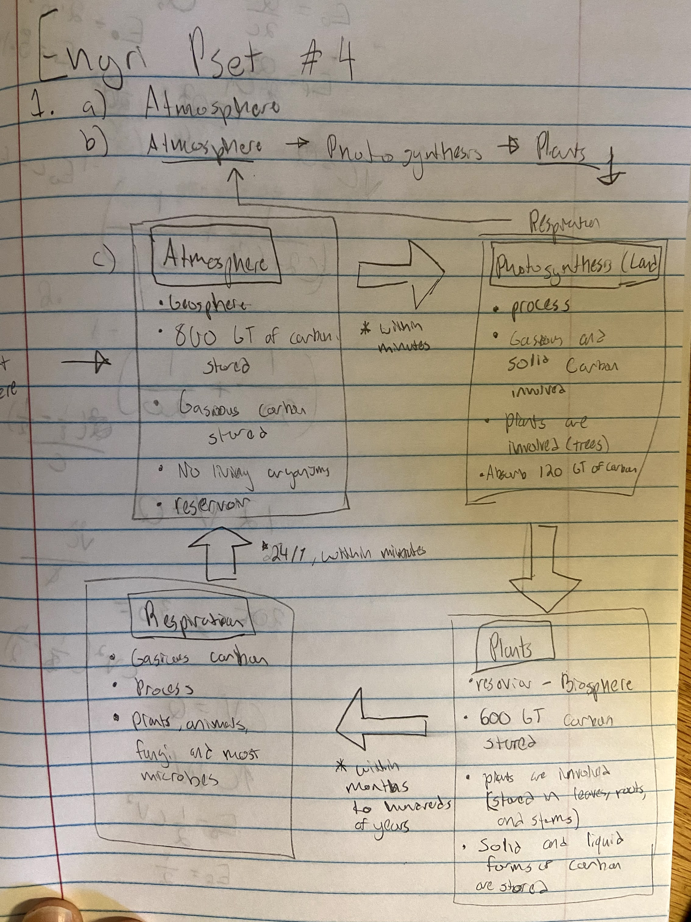

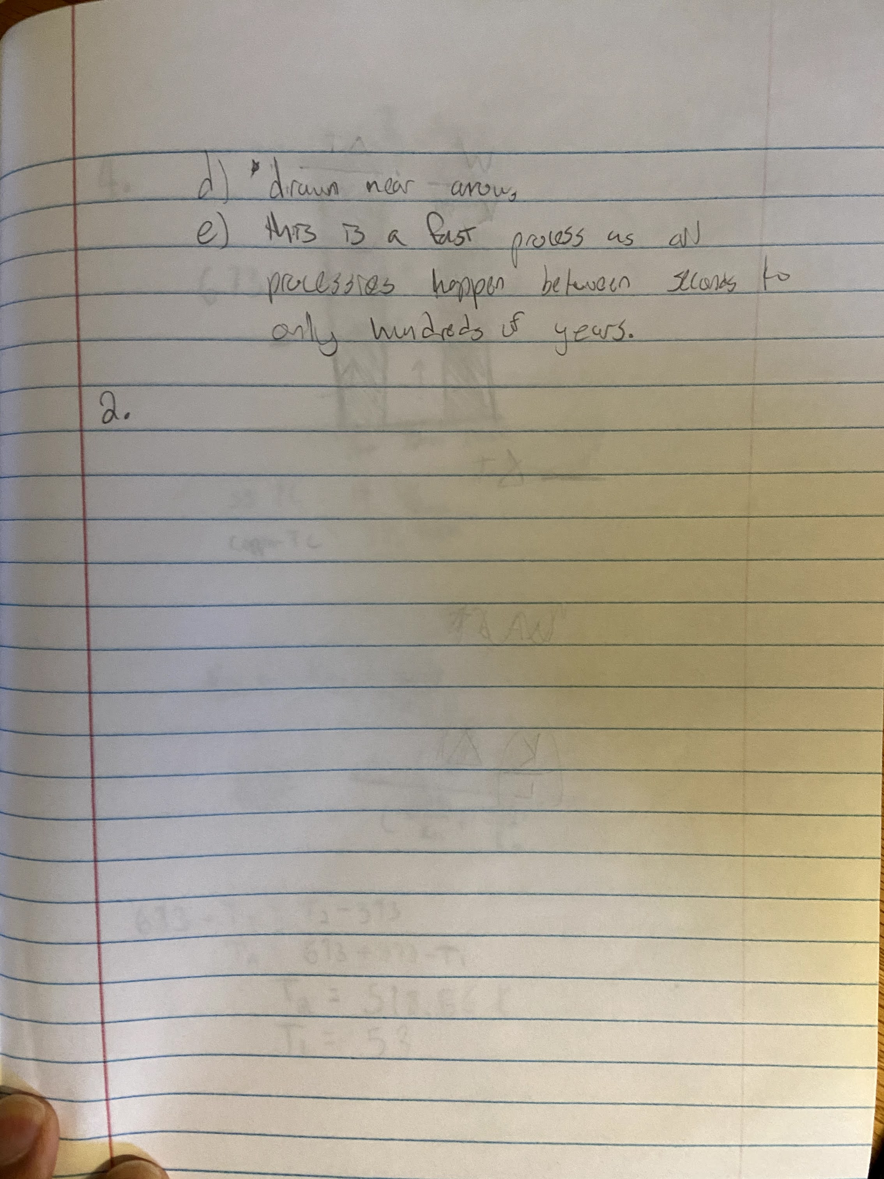

2. Agricultural activities are the greater responsible for nitrous oxide release than the energy sector because they have maintained a majority nitrous oxide output for the last 38 years whereas the energy sector has not reached more than 10 percent.

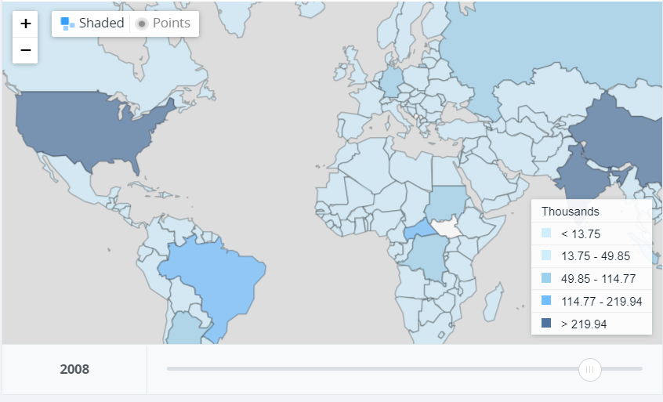





UAE increases their nitrous oxide output where in contrast the US is decreasing their output. However, the US’s nitrous oxide emission has been oscillating prior to the major downward trend. The UAE sees a gradual increase in production instead with no major oscillations.

1. Plants and animals need nitrogen to produce DNA, RNA, and proteins.
2. The most common way that nitrogen fixation occurs is when microbes convert N2 into ammonium. This microbial process is crucial to plants and animals because they can not directly use nitrogen gas for life processes.
3. Fertilizers add ammonium and fixed nitrogen directly to the soil.
4. One consequence of the human alteration of the N cycle is the increase of nitrogen in groundwater which can lead to cancer in humans. Another consequence is that excess nitrogen in water and soil can escape into the atmosphere as nitrous oxide, a harmful greenhouse gas.

3. a) iv. Eccentricity.

Aphelion only describes when the Earth is furthest from the sun. Precession is the change of axis orientation of the Earth not the orbit. Obliquity is the tilt of the Earth

b) ii. More extreme

This is because the tilt affects how much sunlight can melt ice. When the ice melts or reforms at a more dramatic rate, the seasons will be more extreme due to the changes of received energy flux emitted by the sun.

c) iii. The gravitational effects of the sun and moon

The moon and sun can apply a torque to the Earth changing its angular momentum, causing procession.

1. i. winter

Perihelion occurs on January 3rd which corresponds to winter in the Northern Hemisphere.

