Hybrid Neural Classification Model
For Network Intrusion Detection

Janou Milligan Zachary Kennedy
Department of Computer Science Department of Computer Science
Georgia State University Georgia State University
Atlanta, GA Atlanta, GA
Jmilligan4@student.gsu.edu zkennedy3@student.gsu.edu

Abstract—Given its recent developments and potential, artificial intelligence (AI) has come to play an important role in cyber security. For the same reasons, we have also seen an exponential rise in cyber-attacks in recent years. These developments and the need to keep up with rising civilian and national security threats have made mainly traditional defense methods insufficient. This explores the possibility of using AI and, through machine learning (ML), developing a model capable of accurately and efficiently identifying and dealing with potential cyber attacks
Keywords—cybersecurity, artificial intelligence, machine learning, neural network, intrusion detection system, network intrusion detection system

Introduction
Cybersecurity protects networks, devices, and data from unauthorized access or unlawful use [5]. Nowadays, the need for cybersecurity is rapidly growing as individuals, companies, and nations seek to maintain and ensure their information's confidentiality, integrity, and availability. In the past decade, the increase in reliance on data and technologies has only further increased the importance of cybersecurity in recent years. During the COVID-19 pandemic, the reliance on these technologies has significantly grown as the work-from-home mindset has established itself as the new norm [6]. As a result, recent studies have begun to show the correlation between these factors and the growing number of cyber-attacks [4]. In 2020, IBM estimated that the average cost of data breaches, as a result, reached US$3.86 million [4], further highlighting the issue on a corporate level.
On a national level, the confidentiality and integrity of the United States military information from its adversaries, among other things, is crucial to its national security [3]. This only highlights the issue on a national level. Considering these factors, it is clear that the coming years will significantly increase the need for new cyber defense methods.

Basic Concepts
Within this section, we will outline some basic knowledge of the concepts associated with this project.

Cyber Security
Within most literature, cybersecurity is generally defined as the application of security preventions to maintain data confidentiality, integrity, and availability [1]. Confidentiality, integrity, and availability are commonly referred to as the “Triad of Confidentiality, Integrity, and Availability” (CIA) within the field [1]. Confidentiality is a concept that refers to the ability/necessity to keep information available to only those intended [1][7]. Integrity is a concept that refers to the ability/necessity to prove that said information has not been tampered with [1][7]. Availability is a concept that refers to the ability/necessity to keep information readily available when people need to access it [1][7]

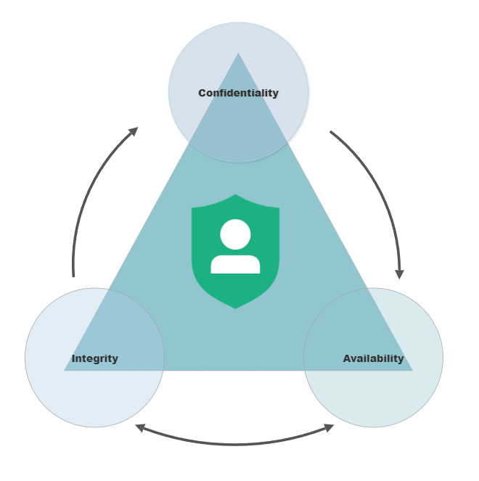
Fig 1. Visual representation of the C.I.A triad
The structure of the CIA triad is supported by the tools used to maintain each aspect of it. This includes implementing and using firewalls, intrusion detection systems (IDS), and honeypots. These are just among the few that can use to evaluate, manage, and protect the confidentiality, availability, and integrity of data within cyberspace.

Intrusion Detection Systems
The concept of IDSs was first proposed in 1980 by Jim Anderson [5][7], and since then, the idea has seen itself developed into products designed to fit the needs of network security [5]. These products are built from devices or software and monitor networks while searching for potentially harmful activities within a system. An IDS can report these activities, store them, and help to prevent them from being carried out if detected early enough.
However, as technology continues to develop rapidly, especially with advances in artificial intelligence (AI) and machine learning (ML), so are the methods used to break down one’s network security structure. As a result, current IDSs are growing inefficient. To remedy this, using AI, specifically through ML and deep learning techniques for IDSs, has become a topic among researchers. [5]
Recently, three main types of IDSs have become of particular interest for the application of AI and ML algorithms: Network Intrusion Detection Systems (NIDS), Network Node Intrusion Detection Systems (NNIDS), and Host Intrusion Detection Systems (HIDS).

Machine Learning
ML can be defined as “the science of getting computers to act without being explicitly programmed.”[2]. Essentially, the primary goal of ML is the creation of models that can forecast outcomes based on input values without specific instructions or code. ML algorithms can be classified into one of three groups, supervised learning, unsupervised learning, and reinforcement learning [2]. Supervised algorithms train a model on already labeled data or contextualized data. Furthermore, ML algorithms classified as supervised learning can be broken down into two groups, regression, and classification algorithms. Due to the nature of our problem, this project focuses on a model that utilizes supervised learning and classification algorithms.

Artificial Intelligence
AI is a field of study that focuses on developing ways to make computers or software think intelligently [13]. This is achieved through the development and application of algorithms and knowledge. In recent years, AI has begun to see applications in nearly all aspects of our lives and are heavily involved speech recognition, computer vision, robotics, games, natural language, and fuzzy logic to name a few [2].
Like ML, neural networks (NN) are a subcategory of AI that aim to simulate the way the human brain processes information through layers of neurons and pattern recognition. NNs can take on many forms and be applied to more complex problems

Proposed method
For this project, we explore the possibility of using a neural network combined with popular machine learning algorithms to create a hybrid neural classification model for identifying attacks based on network packet features. The model will be trained on the NSL-KDD dataset, a revised version of the popular KDD’99 dataset. The data will go through the standard cycle associated with training a machine learning model: data analysis, preprocessing, training, and optimization. This entire cycle is broken down further below.
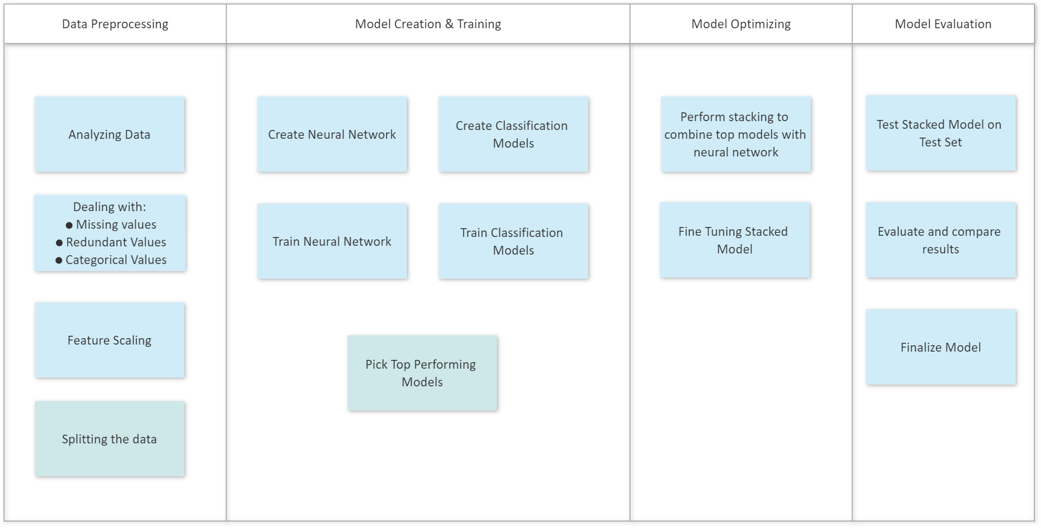
Fig 2. Visual breakdown of the planned process
While doing this, we also explore the idea of using low-code solutions for model creation and implementation to speed up the entire process. For this purpose, we have opted to use the PyCaret library. With the PyCaret library, we can easily create, fit, and evaluate classification models based on popular classification algorithms and select the best-performing ones to stack onto our neural network. By doing this, we can use those models' strengths to bolster our neural network's efficiency, thus creating our hybrid neural classification model.

Process And Results

Dataset and Data Analysis
The model itself is trained and tested on the NSL-KDD dataset. This dataset is a revision of the KDD Cup 1999 data set [10]. The KDD Cup dataset is widely used as a benchmark for NIDS [10]. However, the original dataset comes with several deficiencies, including redundant records in training sets, duplicate records in test sets, and exceedingly large amounts of data in the training and test sets. The NSL-KDD dataset addresses some of these issues to make results obtained from using the KDD dataset more consistent and comparable [10][12].
 | Original Records | Distinct Records | Reduction Rate
Attacks | 3,925,650 | 262,178 | 93.7%
Normal | 972,781 | 812,814 | 16.4%
Total | 4,898,431 | 1,074,992 | 78.05%

 | Original Records | Distinct Records | Reduction Rate
Attacks | 250,436 | 29,378 | 88.26
Normal | 60,591 | 47,911 | 20.92%
Total | 311,027 | 77,289 | 75.15%
TABLE I. Comparison between the KDD’99 (top) and NSL-KDD datasets (bottom)
The entire NSL-KDD dataset is divided into smaller datasets for training and testing. The datasets used in this project are the KDDTrain+ datasets. The training set consists of 22 attack labels and one normal label. These labels will be the target label for the model.
Fig 4. Label distribution in the KDDTrain+ dataset
KDDTrain+ | Total | Normal | Attack
KDDTrain+ | 125973 | 67343 | DOS | Probe | R2L | U2R
KDDTrain+ | 125973 | 67343 | 45927 | 11656 | 995 | 52

Data Preprocessing
Because of the revisions made in the NSL-KDD dataset, a portion of the work that would be done in this phase is removed. As seen in the figure below, there are no missing or duplicate values to take care of. However, the categorical values must be dealt with.

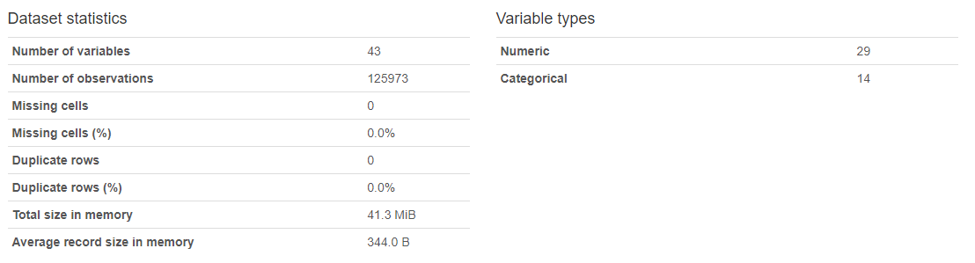
Fig 5. Statistical representation of the KDDTrain+ dataset
Out of the fourteen categorical variables, only four must be dealt with by encoding: protocol_type, service, flag, and label..
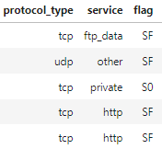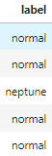
Fig 6. Sample of categorical strings in the KDDTrain+ dataset
For protocol_type, service, and flag, we immediately use dummy encoding to transform the values into binary values that the model can read. For label, we first categorize each attack type into a single group, labeled “Attack,” and leave normal. Afterward, we proceed to encode those values into binary ones.

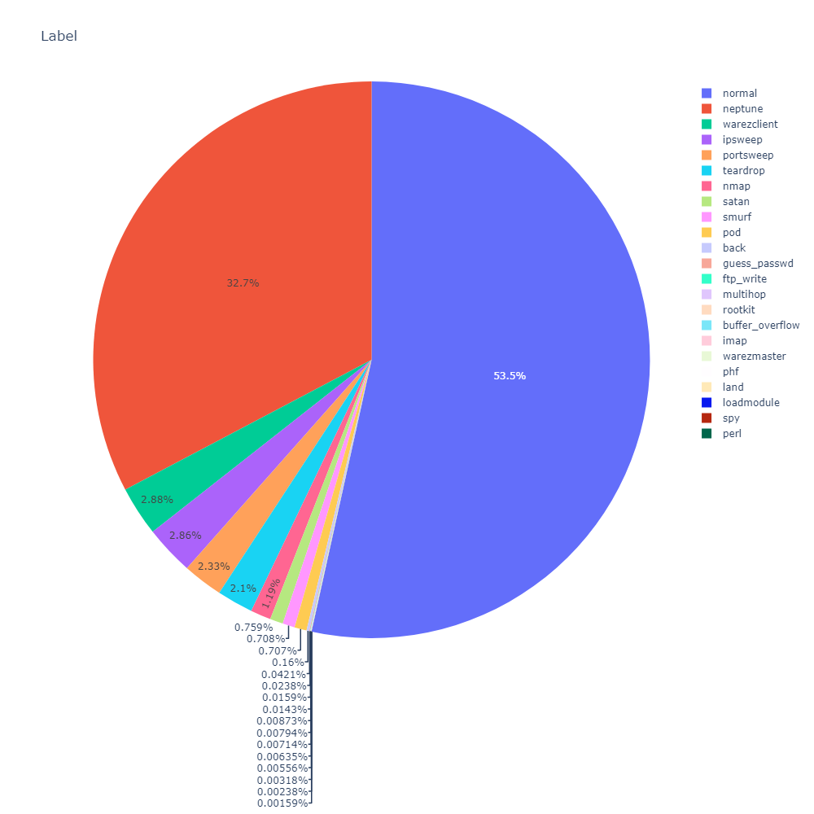
Fig 7. Distribution of attack labels before categorization
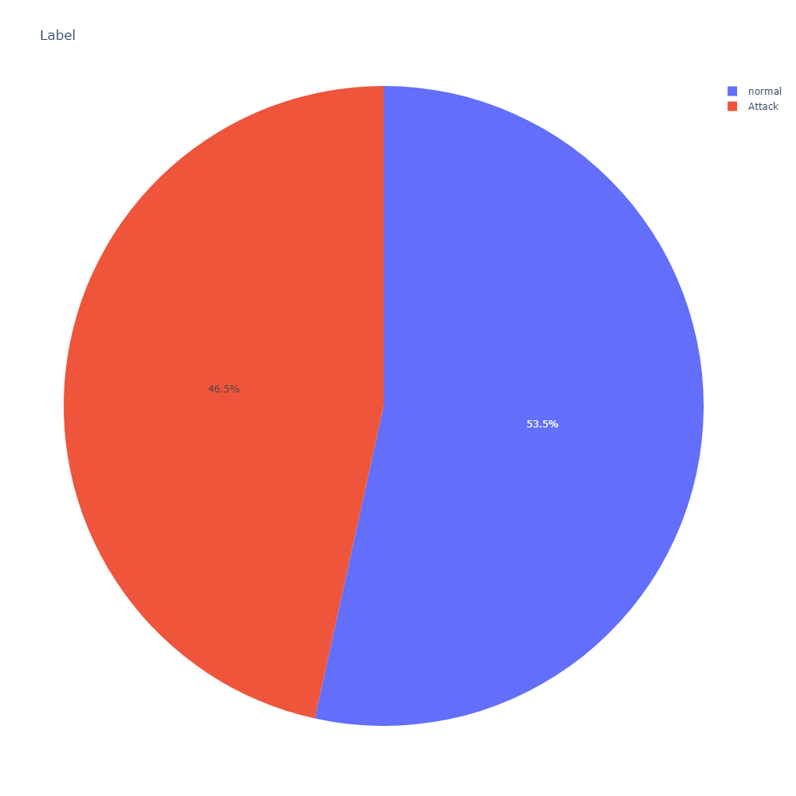
Fig 8. Distribution of attack levels after categorization
After categorizing the data and encoding them, we finish by splitting the training set into both training and test sets for model fitting

Model Creation & selection
For our model, we explore the idea of using a low-code approach for model creation, comparison, and optimization, which is one of the main focuses of this project. To achieve this, we used the PyCaret library, which offers a low-code solution for creating classification and regression models, optimizing them, and gathering the results. The second focus is creating a neural network combined with classification algorithms to create a model capable of competing with other models solely based on said algorithms.
We first created a simple neural network with three layers: the input layer, the hidden layer, and the output layer. The network alone is incompatible with PyCaret, so after instantiating the network, we use a data frame transformer to pass the data into PyCaret. Afterward, we set up and trained the model on the training set and got the following results.
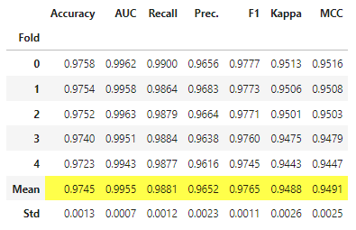
Fig 9. Initial results for the neural network on the data set
Afterward, we train multiple classification models on the same dataset. We then get the following results and compare them against each other.
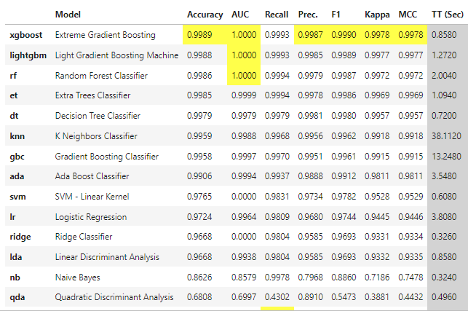
Fig 10. Comparison of classification models on the dataset
We select the top three performing models as candidates for optimizing our neural network through stacking and creating separate models for each. These values will be the baseline for comparing the initial neural network and the final network classification model.
Finally, we have our completed neural classification model after stacking all of our models. The pipeline for the model is illustrated in the figure below.
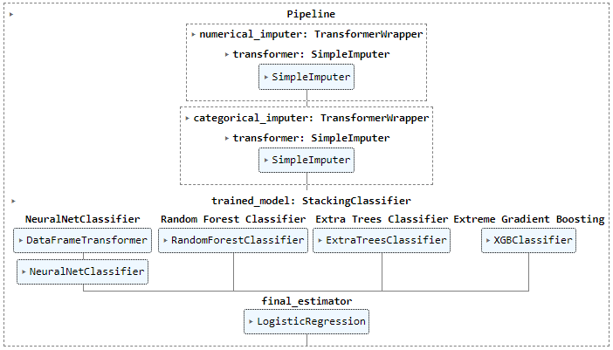 Fig 11. Pipeline of the final model

Final Results
After model creation, we can evaluate the final model’s performance.

Fig 12. Final results
There are several metrics to consider here when comparing our final model to the baselines. We focus on evaluating our model's precision, recall, accuracy, and F1 scores. All these scores are based on true positive (TP), true negative (TN), false positive (FP), and false negative (FN) values. The area under the curve (AUC) is also a good metric for evaluation, but as seen in the initial results, the models used all had the same AUC.
Precision measures performance by comparing the number of TPs with predicted positive values.
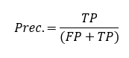
Recall measures performance by comparing TPs with the actual amount of positive values.
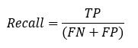
Accuracy the ratio of TP and TN to all positive and negative observations.
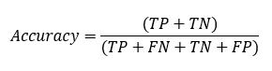
F1 represents the harmonic mean of the precision and recall score.
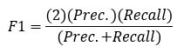
Based on these metrics, we see that our model is comparable to, or even slightly outperforms, the top classification models and our initial neural network.

Conclusions
As the reliance on technology and data within our society continues to increase, so does the threat to data security on all levels. As these threats continue to advance and become more sophisticated, we must explore new solutions that can be applied to intrusion detection technologies. With the advances in artificial intelligence and machine learning techniques, as well as neural networks and deep learning, many new proposals have been made.
Though numerous proposals have been made to apply artificial intelligence, neural networks, and machine learning techniques for the benefit of IDSs, few offer a low-code result utilizing various classification algorithms on top of a neural network. Comparing our model with other proposals, along with the methods taken to develop our model, our proposal shows great potential in cybersecurity and the development of IDSs.

References
[1] A. Okutan and C. Eyupoglu, “A review on Artificial Intelligence and Cyber Security,” 2021 6th International Conference on Computer Science and Engineering (UBMK), 2021.
[2] O. Yavanoglu and M. Aydos, “A review on cyber security datasets for machine learning algorithms,” 2017 IEEE International Conference on Big Data (Big Data), 2017.
[3] Demertzis, Konstantinos & Liadis, Lazaros. (2014). Hybrid Artificial Intelligence System for Cyber Security.
Sep-2020.[Online].Available: https://impact.economist.com/perspectives/sites/default/files/report_ai_cybersecurity_sept_2021.pdf.
[4] M. Pattera, K. Andreasson, M. Gold, A. Simms, and N. W. C. Design, “Balancing innovation, execution and risk artificial ... - economist impact,” impact.economist.com, Sep-2020. [Online]. Available: https://impact.economist.com/perspectives/sites/default/files/report_ai_cybersecurity_sept_2021.pdf.
[5] DUA, Sumeet; DU, Xian. Data mining and machine learning in cybersecurity. CRC press, 2016.
[6] J. Ahmed and Q. Tushar, “Covid-19 pandemic: A new era of cyber security threat and holistic approach to overcome,” 2020 IEEE Asia-Pacific Conference on Computer Science and Data Engineering (CSDE), 2020.
[7] J. V. Ham, “Toward a better understanding of ‘cybersecurity,’” Digital Threats: Research and Practice, vol. 2, no. 3, pp. 1–3, 2021.
[8] Anderson JP. Computer Security Threat Monitoring and Surveillance. Fort Washington, PA: James P Anderson Co; 1980.
[9] Ahmad, Z, Shahid Khan, A, Wai Shiang, C, Abdullah, J, Ahmad, F. Network intrusion detection system: A systematic study of machine learning and deep learning approaches. Trans Emerging Tel Tech. 2021; 32:e4150. https://doi.org/10.1002/ett.4150
[10] X. Zhang and K. Dongseong, “Network intrusion detection using generative Adversarial Networks.” [Online]. Available: https://ir.canterbury.ac.nz/bitstream/handle/10092/100016/Zhang%2C%20Xiran_Master%27s%20Thesis.pdf?sequence=1.
[11] Kdd.ics.uci.edu. (2018). KDD Cup 1999 Data. [online] Available at: http://kdd.ics.uci.edu/databases/kddcup99/kddcup99.html.
[12] “NSL-KDD Dataset,” University of New Brunswick est.1785. [Online]. Available: https://www.unb.ca/cic/datasets/nsl.html.
[13] J. N. Welukar and G. P. Bajoria, “Artificial Intelligence in cyber security - A Review,” International Journal of Scientific Research in Science and Technology, pp. 488–491, 2021.

