**INFO 6205**

**Program Structures & Algorithms**

Assignment 5

Screen Shots

Test Case

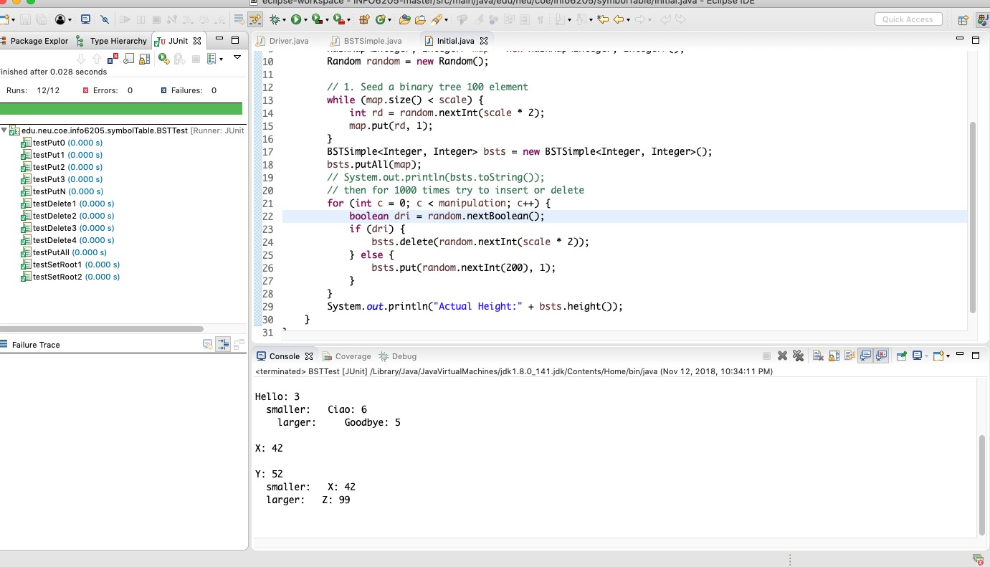

Program output

