# **Assignment: CRUD in MongoDB**

1. Verify Load

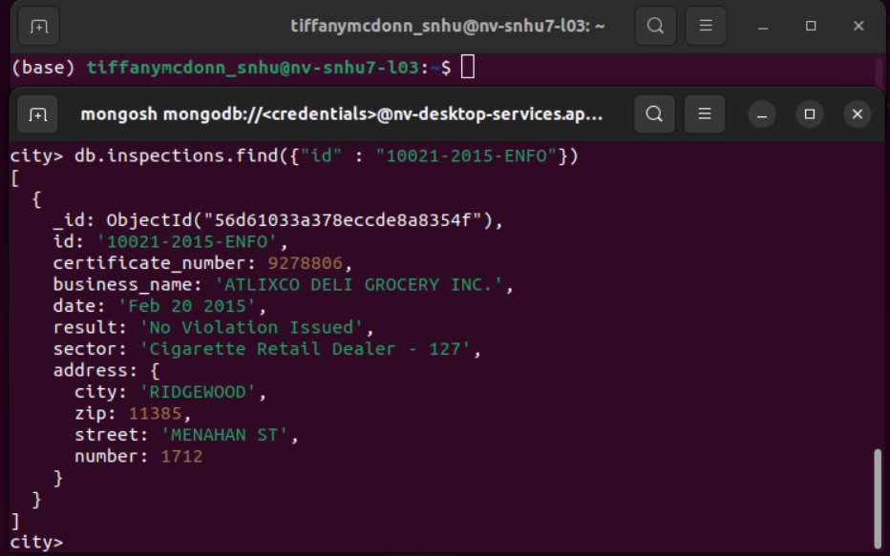

2. Insert a Document

3. **MongoDB queries**

**a.** distinct list of inspection “sector”

b. The list contains 87

c. Both AUSTIN 2012 and ACME Explosives date types are strings.

d. 13823 results for Violation Issued

4. Update the Document

5. Update all documents with key-value Rosedale to 76114

6. Remove the first document

