Swinging the Bucket: A Colored Water Balloon Fight for Teenagers

Water balloon toss is a thrilling and entertaining game that brings laughter, excitement, and camaraderie to any outdoor gathering. In this exhilarating activity, participants form teams of two and engage in a friendly competition to see who can successfully toss a water balloon back and forth without breaking it. The game typically begins with pairs of players standing a short distance apart, each holding one end of a water balloon-filled balloon. As the game progresses, players take turns tossing the balloon to their partner, gradually increasing the distance between them with each successful catch. The objective is to keep the balloon intact for as long as possible, with the last remaining team declared the winner.

This one is more fun to play at the beach, but your backyard is also a good option.

1. Add a few drops of food color of your choice to the water while filling the balloons. (Using different colors is more fun)
2. Fill a small bucket up to the brim with the colored balloons.
3. Tie the bucket to a long rope.
4. Then, dangle it in a way that one player will have to stand under it, firmly holding one side of the rope so as not to spill the bucket on his/her oChildren get easily bored and drained out in the lazy, long days of summer. Make these dull days exciting by arranging any of these water balloon games. You may add your variations too.wn head.
5. Make the other kids throw water balloons at the player standing under the bucket for 1 minute (use a stopwatch)
6. The moment the first player loses grip on the rope, he/she will get smeared by the colored balloons. One who withstands till the end emerges victorious

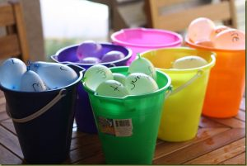https://royalbaloo.com/wp-content/uploads/2012/05/IMG_6144_thumb.jpg

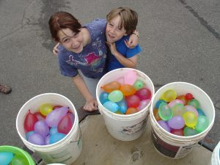https://www.gamesandcelebrations.com/wp-content/uploads/2017/03/Water-Balloon-Fight-Games-300x225.jpg

Src video: [Easiest Way to Tie Your Water Balloon (youtube.com)](https://www.youtube.com/watch?v=r-43-u9i8Qk)

**Redlight, Greenlight**



https://cdn2.momjunction.com/wp-content/uploads/static-content/noimage-med.jpg.webp

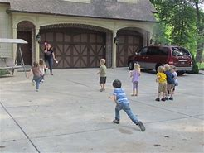

https://handsonaswegrow.com/wp-content/uploads/2012/06/Mothers-Day-caterpillar-1761-250x250.jpg

Red Light, Green Light is a classic and exhilarating children's game that combines elements of speed, strategy, and suspense. In this engaging activity, one player assumes the role of the "stoplight" while the other participants line up at a designated starting point. When the stoplight faces away and shouts "green light," players are free to move forward towards the finish line. However, as soon as the stoplight turns around and shouts "red light," players must freeze in place to avoid being caught moving. The stoplight continues to alternate between calling out "green light" and "red light," with players attempting to reach the finish line without getting caught moving. The game is filled with tension and excitement as players strive to advance while remaining vigilant for the sudden command to freeze. With its simple yet thrilling gameplay, Red Light, Green Light captivates players of all ages and provides hours of entertainment and laughter at any gathering or event.

Similar to the statue game, redlight and greenlight can be enjoyed by everyone.

**How To Play:**

* Select one player to be the traffic light or traffic cop.
* All the other players have to scatter around.
* When the traffic light says ‘redlight’, players must freeze and stay still.
* And when the traffic light says ’greenlight’, players must start moving, running and jumping around.
* Any player who fails to follow the instructions of the traffic light is eliminated.

Src video: [Red Light, Green Light (youtube.com)](https://www.youtube.com/watch?v=4vPep4MB_8A)

**Wheelbarrow Race**

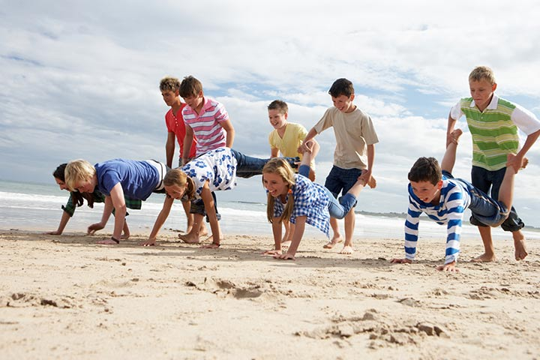

https://encrypted-tbn1.gstatic.com/images?q=tbn:ANd9GcTf_fVqUjpwsulioRFmahzk95Z1UbDymyi1NkS00OcERnhsdnXA

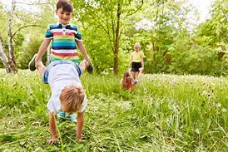

<https://encrypted-tbn3.gstatic.com/images?q=tbn:ANd9GcSKYnxmpyLQISjwn8NtbywiO_KiZj_gJt9Sa1ugEwruY1IGrY21>

The Wheelbarrow Race is an exciting and entertaining outdoor game that challenges participants' coordination, teamwork, and speed. In this lively activity, teams of two players work together to navigate a course while one teammate assumes the role of the "wheelbarrow" and the other acts as the "pusher." The "wheelbarrow" teammate positions themselves on their hands, with their legs lifted off the ground, while the "pusher" teammate holds onto their ankles and guides them forward by lifting and pushing the "wheelbarrow" along the course.

**One of the very popular outdoor picnic games for children is the wheelbarrow race.** So find a smooth and comfortable place to play this game.

**How To Play:**

* Divide the players into teams of two.
* One among the two is the driver and the other is a wheelbarrow.
* Set a start and finish line.
* The driver holds the ankles of the wheelbarrow, and the player who is the wheelbarrow walks on their hands.
* The team which reaches the finish line first wins.

Src video: [#24SEVEN - Wheelbarrow Race (youtube.com)](https://www.youtube.com/watch?v=TBED8E-zq1c)

**I Spy**

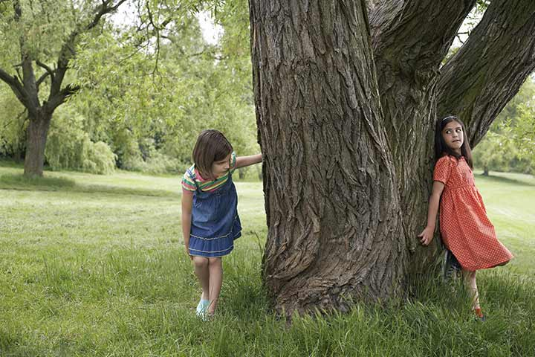

https://encrypted-tbn3.gstatic.com/images?q=tbn:ANd9GcTYJLNo85904iDdLhz6UCB63I1uwG_JLRSVOaaJwDfuBhxqqo65

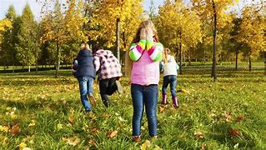

https://encrypted-tbn2.gstatic.com/images?q=tbn:ANd9GcQ2UYDVzxCmJcjwikLXK9ZDeptNvPUf6gx_3PcGY-p0asnf8jL4

"I Spy" is a delightful game that challenges players to observe their surroundings keenly and use their imagination to guess hidden objects based on clues provided by the "spy." With its simple yet engaging gameplay, "I Spy" fosters creativity, critical thinking, and social interaction, making it a beloved pastime for people of all ages.

Games like hide and seek can be enjoyed by [kids of all ages](https://www.momjunction.com/articles/computer-games-for-kids_00778104/) and grown-ups too. **The best part of this picnic game is that you need no supplies.**

**How To Play:**

* Choose one player to be the spy, who has to count till 10 while keeping the eyes closed.
* Every other player has to find a spot to hide before the spy finishes counting.
* Spy has to scout the entire location and find each hiding player.

Src video: [How to Play Hide & Seek (youtube.com)](https://www.youtube.com/watch?v=OQZ8FNiQxG0)

**Group Massage**

**Group Massage is a relaxing activity where participants take turns giving and receiving massages in a circle or small groups. It promotes bonding, stress relief, and physical well-being as individuals share the soothing benefits of massage with each other. With its calming atmosphere and positive energy, Group Massage is a favorite among friends, families, and colleagues looking to unwind and connect in a meaningful way.**

Number of players: For this outdoor team building activity, all members of the team need to participate to enhance teamwork, with a minimum of 2 players returning.

Location/terrain: The game should be played outdoors in a cool and breezy environment.

How to play: Team members form a circle and stand in a line behind one another, placing their hands on the shoulders of the person in front of them. The game master gives commands for all members to perform actions such as massaging each other's shoulders and gently tapping each other's backs.

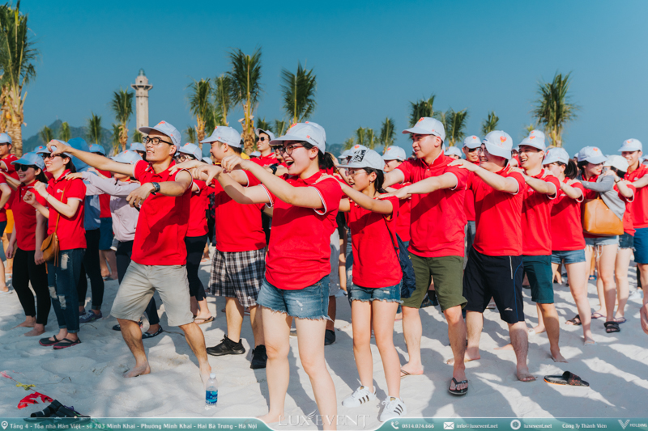

https://luxevent.net/wp-content/uploads/2023/04/tro-choi-team-building-ngoai-troi-1.jpg

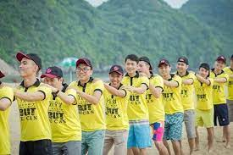

https://vietlinkevent.vn/wp-content/uploads/2022/08/cac-tro-choi-team-building-don-gian.jpeg

Src video: [[ Đào tạo MC Sự kiện ] HƯỚNG DẪN KHỞI ĐỘNG - ĐẤM BÓP TEAMBUIDING | MC VĂN MINH (youtube.com)](https://www.youtube.com/watch?v=hs7Bo70oDb4)

**"Capture the Flag"**

**Capture the Flag is an action-packed outdoor game where two teams compete to capture each other's flag while defending their own. Players strategize, run, and hide to outsmart their opponents, making it a thrilling and engaging experience for all participants.**

• Equipment used: 10 flags.

• How to play:

Players are divided into two teams, each standing on one side. Behind each team, there are 5 flags arranged horizontally. You must run past the enemy's defensive line to the flag area to capture the enemy's flag.

If you get tagged while chasing, you become a prisoner. However, if you manage to reach the flag area, you can choose to take a flag back or release all prisoners from your team. The team that brings back all 10 flags wins.

• Rules: Players must not run before the signal from the program leader.

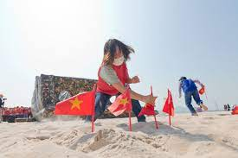

https://encrypted-tbn2.gstatic.com/images?q=tbn:ANd9GcQrAb3gwt8ukGu50dF452n2D2E-Cr7y0N1zaSoSFcO93fajyktP

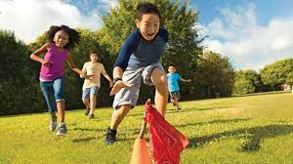

https://cdn.shopify.com/s/files/1/0037/3925/4899/files/New_Project_17.jpg?v=1700503457

Src video: [How To Play Capture The Flag? (youtube.com)](https://www.youtube.com/watch?v=AwQKf5Mn5Zc)