**Possession**

**Game Design Document**

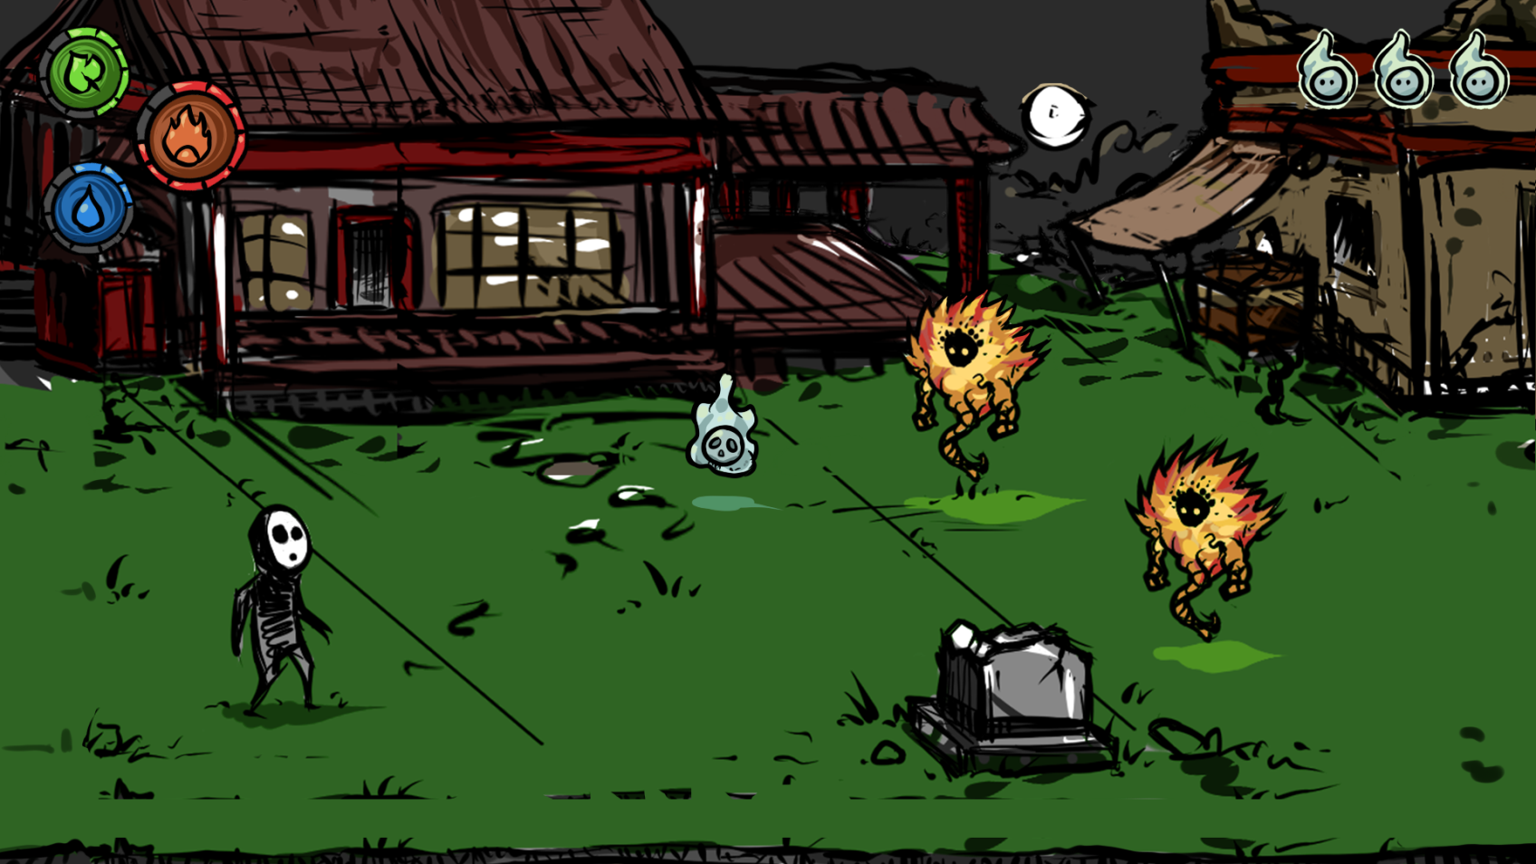You are a soul trying to get through a middle age Asian themed village with the help of three elements, fire, wood and water.

A mock-up of the game’s play area.  
Here you can see the HUD as well as the player, a lost soul and two fire enemies.

Contents

1. General Game Overview 3

2. States & Modes 3

3. Graphical User Interface 4

4. Avatar 5

5. Controls 7

7. Non-player Characters/Enemies 8

The End Game Boss 10

8. Resources 10

Elemental Points 10

Lost souls 10

Karma 11

9. Game Environment 11

10. Critical Points 11

11. Story 11

12. Level Design – Intro 12

12.1 Battles 13

13. MDA 13

## General Game Overview

You are a soul trying to get through a middle-aged Asian themed village with the help of three elements; fire, wood and water. Depending on your choices in-game you are either the one to conquer the village or save it from evil.

## States & Modes

When starting the game there will be a start screen of group 12’s logo. You can see a flowchart of our states and modes below this paragraph. When the start screen has faded away, the start menu will be shown on the screen. The game’s main menu’s interface has four options to choose between; Play, Options, How to Play and Quit. If you choose to press quit the game is closed down. When how to play is pressed a screen explaining how you play the game and the game controls show up. If you press options you can adjust the game’s master volume, effect volume and background sounds volume, and you are also given a fullscreen option.  
By pressing play you start the game. The in-game’s interface consists of the GUI with the elemental points, an indicator of which element is selected and lost souls-counter as well as the play area. On the title screen of this document you can see a mock-up of the game screen. The elemental points are shown in the upper right corner as well as the indicator of the selected element, and the lost souls counter is shown in the upper left corner.

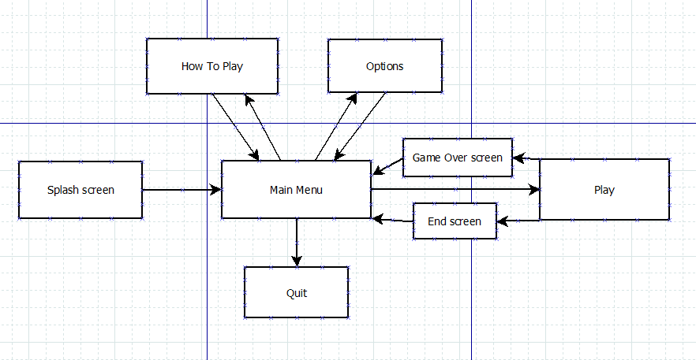

When the game ends, either by losing or winning, you will return to the main menu. However, there will be three different game over screens. If the player loses the game, there will be a screen telling the player that she lost the game. When the player wins the game, depending on what karma she has received during the game, she will either be shown a screen showing the evil version of the player character where she is the conqueror of the village, or if her karma is positive she will be shown the nice version of the player character where she is the village’s hero. The karma system is further explained in the resources section below.

## Graphical User Interface

An example of the game’s GUI can be seen on this document’s first page. On the mock-up of the game screen you can see the elemental points in the upper right corner as well as the counter of lost souls in the top right.

The elemental points are divided in the three types of elements; fire, water and wood. To indicate what element is currently used, the current element will be bigger and in the middle of the other elements. The icons will tell you what the elements are. Then, there are the elemental points’ bars around the icons. The coloured ones are points that the player currently has, and the grey elemental points are to show the maximum amount of points that can be had, which is ten. When you have a certain amount of elemental points, you will receive a power up. In the updated version of the GUI, there will be indicators of when a power up will be received. The indicators are small swirls that emerge from the bar, and they can be seen in the picture below. More information about the power ups can be found in the Player section. The lost souls counter is seen on the upper left corner. They are visually represented by icons of lost souls.

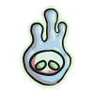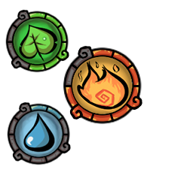

The elemental points and lost soul icons for the GUI.

When the player switches between elements, the indicator will be updated to show what the currently used element is. The elemental points will be updated when elemental points are lost or obtained. The player loses elemental points when hit and can obtain elemental points from either sacrificing/releasing lost souls or when encountering an altar. When a lost soul is picked up by the player, it will be added to the counter, and when a lost soul is used the counter will decrease. Elemental points, altars and lost souls are all further explained in the Resources paragraph.

The non-diegetic type of GUI is used in the game, because of the vital information that has to be visible for the player at all times. To know what element you are using or what element to switch into is important when fighting enemies, so that the player effectively can use the element that does more damage on the enemy and avoid using the element that will give the enemy advantage, doing more damage on the player when she is hit by the enemy or it’s projectile.

The elemental points are vital because they represent the health of the player, they show when a power up is received and they also show what elements can be used. The grey/empty elemental points are visible so that the player knows how the maximum amount of elemental points that can be held, so that she does not feel cheated when she sacrifices/releases lost souls and is not given the correct amount of elemental points because the maximum is reached.

The lost souls are important for the player to know that there is lost souls that can be used. They will also be able to tell the maximum amount of lost souls that can be held, since the player cannot pick up more lost souls when the maximum of five lost souls are carried.

## Avatar

The abilities that this avatar has are to switch between the three elements possessed and to shoot projectiles of the currently chosen element type. The avatar is placed in the center of the screen and is able to move in four directions, up, down, left and right. The restrained mobility of the avatar is that she can’t leave the foreground.

The health of the avatar is represented by the elemental points (more information about them in resources). When all elemental points are lost in all element types the avatar dies, a game over screen will be shown and you will return to the start menu.

The element system, the damage the character makes and/or takes, can be found in Elements in the Rules section, as it all depends on the current element of the avatar and the element of the enemy. The player has two types of power ups that are available in all elemental types. The first power up is given when seven elemental points are had in an element, then the player will receive double shot. Then the player shoots, there will be two projectiles shot instead of one. The projectiles will be shot in a 15 degree angle. When the maximum amount of elemental points are had in an element, which are ten points, the final power up will be given to the player.

The final power up is triple shot, where the player will shoot one horizontal projectile and two diagonal projectiles which are shot in the same angle as the double shot’s projectiles. When the player loses elemental points and is below the required amount for a power up, the power up is lost.

The controls are of the avatar are the WASD keys to move, the Q-key to sacrifice a lost soul, E to release a lost soul, R to switch elements and space bar to shoot.

The player’s avatar is visually represented by a human-shaped, mask-wearing soul that has a shadow-like body with fading legs. Eight different animations of the avatar are required; walk, idle, getting hit, death, attack/shoot, switching element, first encounter with a lost soul and spawn.

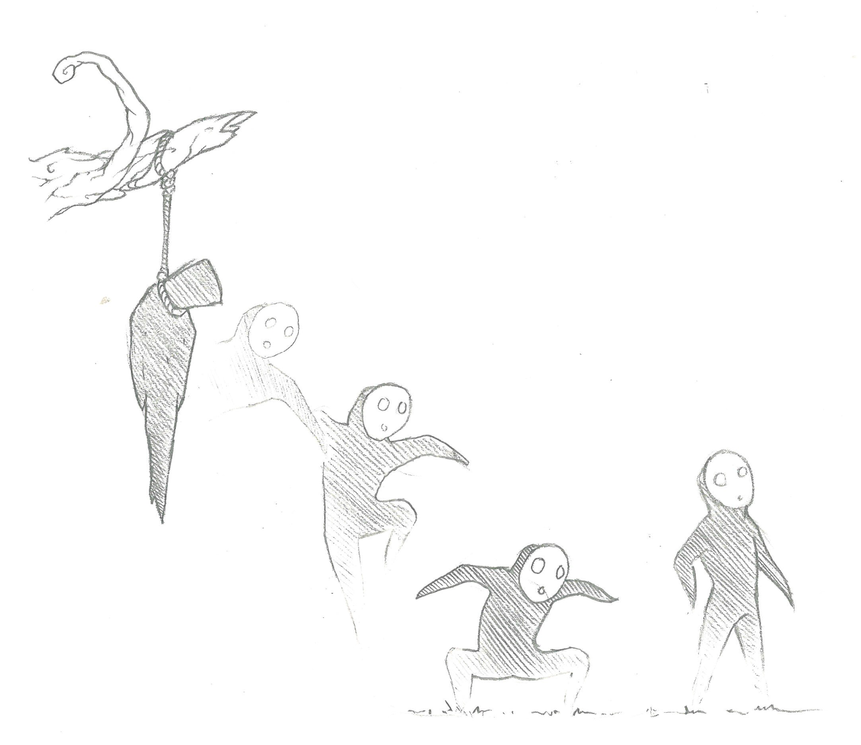Moving the character will result in the walk animation being shown and the sound of footsteps being played, and when no input is given or the avatar is not hit by anything, the avatar will be idle. When the avatar is hit by either an enemy or an enemy projectile, the avatar will switch into the hit animation and a sound will be played. An attack animation and a sound will be played when the player shoots, and sounds will be played when the player picks up or uses a lost soul. The spawn animation will only be shown in the beginning of the level. There is a dark silhouette which looks like a body hanging from the branch of a tree, and the character is seen jumping out of the silhouette. You can see a sketch of the player's spawn below. When the spawn animation is done the player will be able to control the character. The death animation will be played when the player loses the game. The body of the character will fade away and the mask will drop with a sound playing when it hits the ground.

A sketch of the player in the beginning of the game.

## Controls

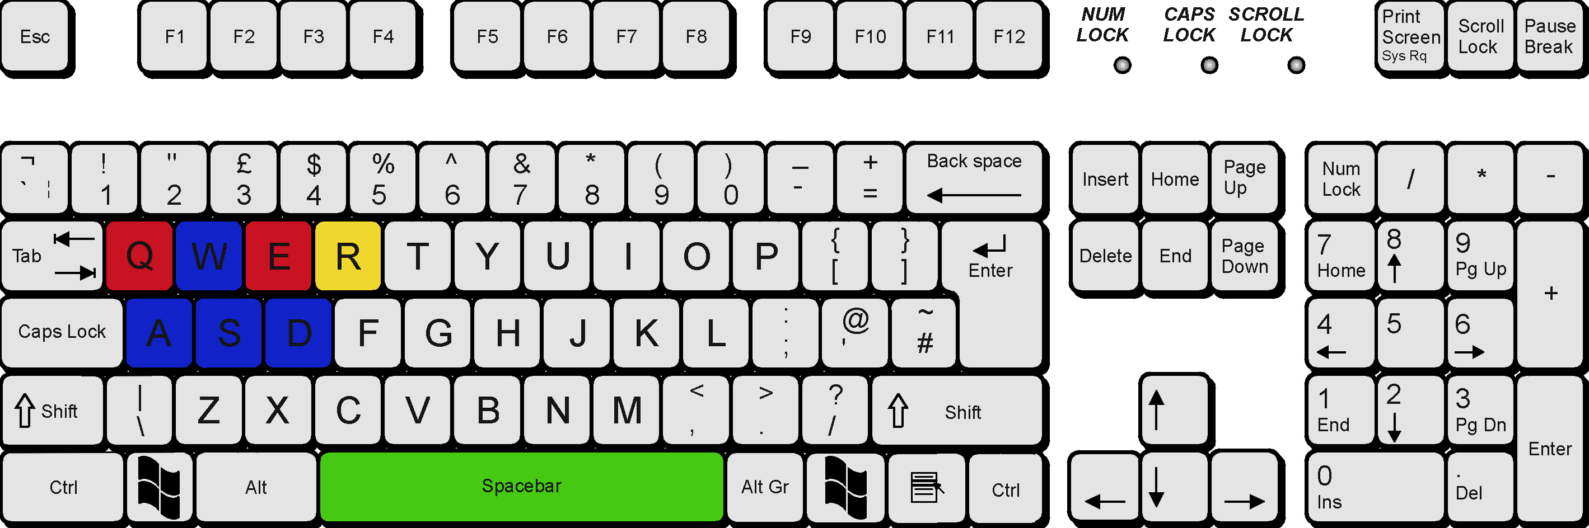These are the game's controls when played on a PC:

The avatar of the player can be moved with the blue keys, the W-key moves the avatar upwards, A left, S down and D right. The yellow R-key is to switch between elements. The red keys, Q and E, are to either sacrifice lost souls (Q) or release lost souls (E). The green space bar button allows the player to shoot projectiles.

To navigate in the menu you use the blue keys to go up or down in the list of options and to choose an option you press spacebar. In the options of the game, the volume meter can be changed by pressing the A and D keys.

## Non-player Characters/Enemies

### The Elemental Enemies

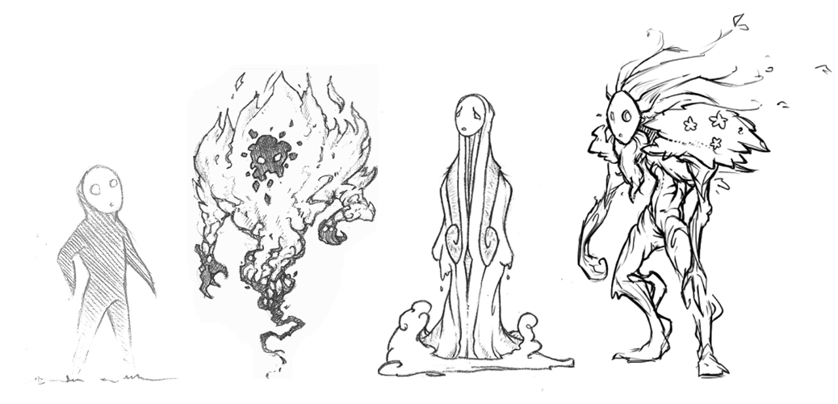The three main enemies are made of water, fire or wood. These enemies appear in waves, spawning outside of the screen. They all attack the player on sight and they have the same restrained mobility as the player, they can't leave the foreground. The elemental enemies are not smart, but they will follow and try to kill the player until they or the player is defeated. To kill the enemies you have to shoot them until they lose all their health, which is five health points.

Thumbnails of the player and the three elemental enemies – fire, water and wood.

What differentiate the elemental enemies from one another are their attacks, their attack range, their visual representations and strengths/weaknesses.

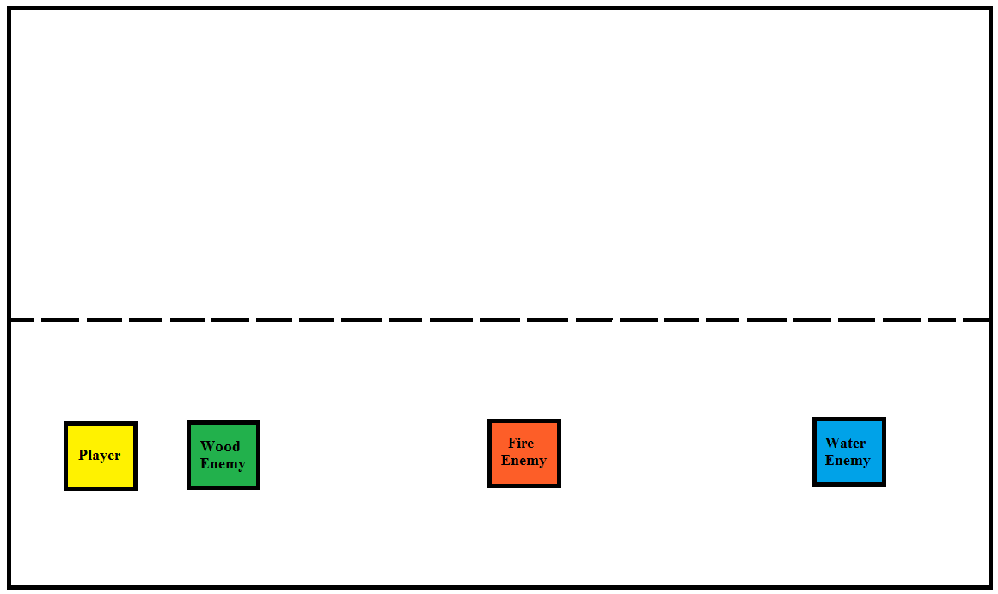

Here you can see the approximate range of the three enemies in comparison with the game screen. The yellow square is the player, the green square the wood enemy, red/orange the fire enemy and blue the water enemy. The dotted line represents the end of the foreground. The water enemy's attack range is long; they can attack the player even if she is on the other half of the screen. The fire enemy's attack range is medium and the wood enemy's is short.

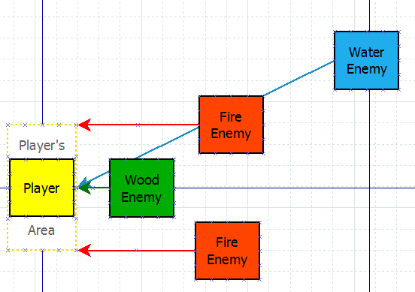

In the picture above you can see how the three elemental types of enemies will attack the player.

The wood enemy does not shoot projectiles. The wood enemy comes within a short range from the player and then it uses melee attacks to hit her center.

The fire enemies often come in groups and will target a point a little above or underneath the center of the player. These points will be within the hitbox of the player. When they are in mid-range from the player, they will fire projectiles in a horizontal line.

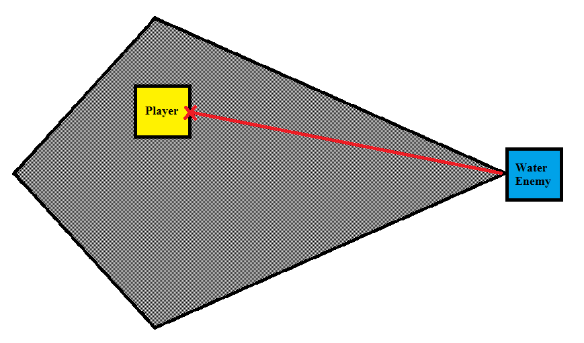The water enemy can shoot diagonal projectiles. The water enemy has an invisible polygonal area (seen in the picture below), and if the player enters this area the water enemy will start shooting at the player.

All elemental enemies have five health points. The enemies lose health by getting hit by the player's projectiles. How much damage the enemy does and how much damage it takes depends on the elements. You can read about the elements system in the Rules section under the title Elements.

The required animations for each enemy are idle, move, attack/shoot, getting hit and a death animation. All enemies have different visual representations that match their elemental type. The projectiles that the enemies shoot are depending on the elemental type as well. The fire enemy's projectile is a fire ball and the water enemy's projectile is a round water ball. The wood enemy does not have any projectiles as it uses melee attacks. The enemy will play sounds when they are attacking, when they are hit by the player's projectiles and when defeated.

### The End Game Boss

The end game boss is able to use all three elements. Just like the elemental enemies, the boss has the same restrained mobility as the player and is not able to leave the foreground. The boss will switch between the three elements which all have different attacks.

When the player is at the end of the level, the boss will appear. The boss has 50 health points, and she does and takes the same damage as the player and elemental enemies, which can be found in Elements in the Rules section.

The fire attack of the boss will have a medium range, just like our fire enemies. The attack will be several projectiles moving towards the player in a formation that is possible to avoid.

The water attack water attack will have a long range; the boss can hit the player even if she’s on the other side of the play area. Like the water enemies, the boss is able to shoot water projectiles in a diagonal angle.

The wood attack will have a short range. When attacking while using the wood element the boss will use melee attacks.

In the first half of the boss fight, the boss will randomly switch between the elements every five seconds to attack the player. However, when she has lost half of her health her speed will increase and she will check the player’s currently chosen element and then switch into the same element or the stronger element every second.

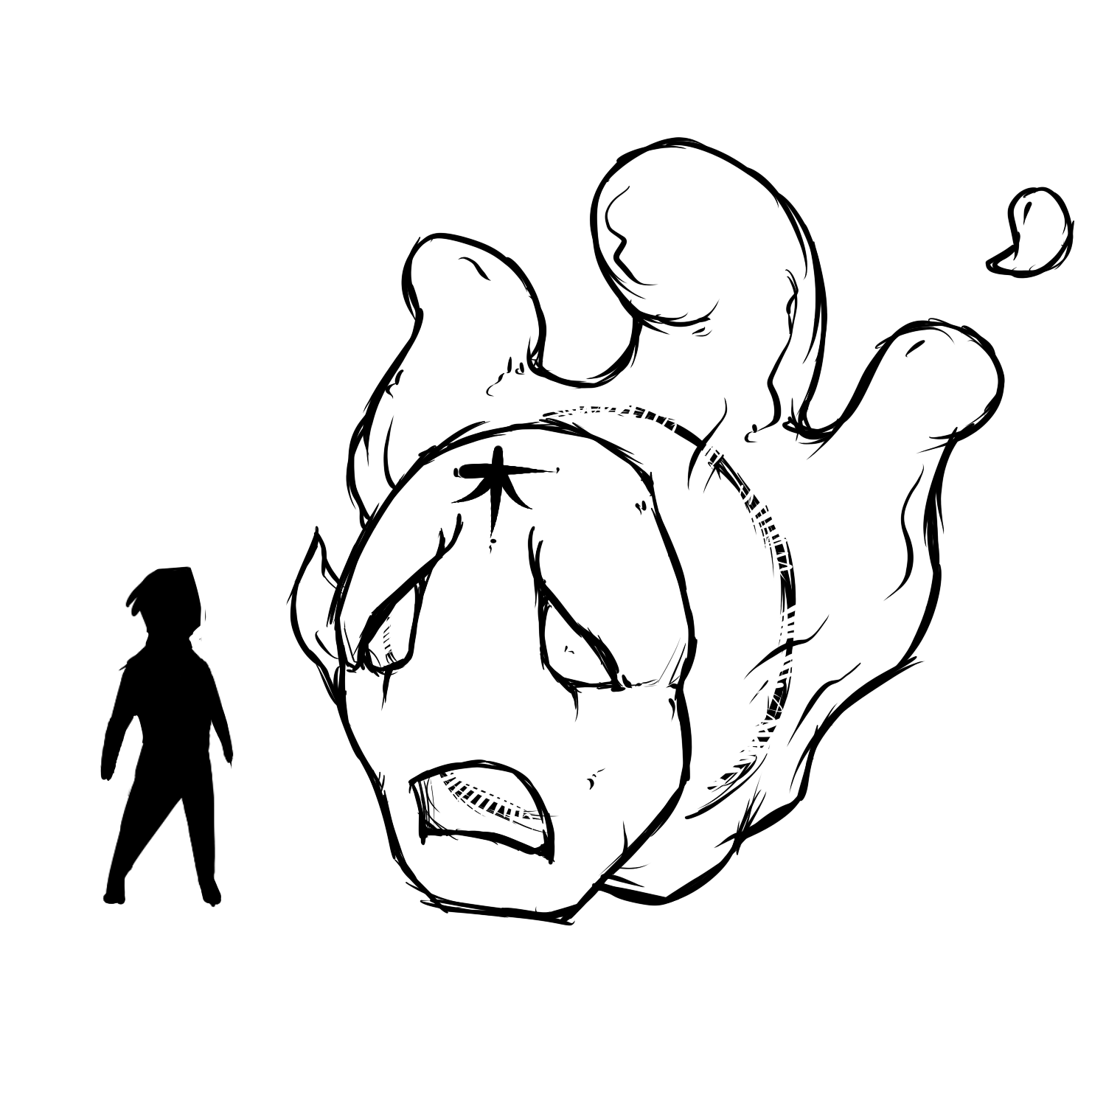

The end game boss’ size in comparison with the player.

The visual representation of the boss will be somewhat like a lost soul but wearing a mask like the player. In the first half of the boss fight, when switching between elements her colour will change, as well as her projectiles and her attacks. When half of her health is lost, she will turn yellow and stay that colour for the rest of the fight and her facial expression will also change, making her look angrier than before. Her attack and projectiles will stay the same as before. When losing health, her facial expressions will gradually change. The boss’ required animations are; spawn/introduction, idle, move, attack/shoot, getting hit and death animation. The idle, move, attack/shoot and getting hit animations should be available in all three colours and with all different facial expressions.

## Resources

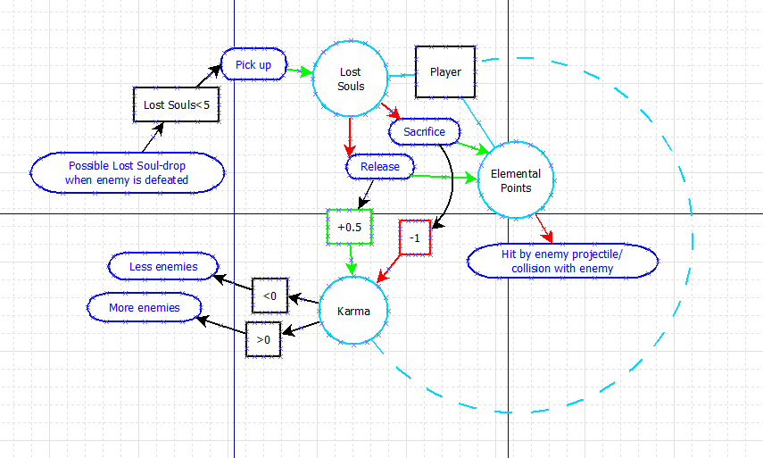The resources of the game are the elemental points, lost souls and karma.

### Elemental Points

The elemental points work as both health and power-up system. The player is given one point of each element in the beginning of the level and the maximum amount of elemental points for each element that the player can have is ten. The points can be obtained by either sacrificing/releasing lost souls. When enough points are collected the player will gain power-ups that are described in the Avatar section.

You lose elemental points when hit by either an enemy or an enemy projectile. When you run out of points in an element you can no longer use that element, and if you lose all points in all elements you lose the game and you are returned to the start menu.

If you’re out of points in an element you can go to altars placed across the map and be given one point of the empty element. If two elements are empty when you encounter the altar you will get one point in each of those elements. When an altar has been used you have to wait 10 seconds before being able to use it again. The altars’ purpose is to give the player the possibility to use the elements that they have lost and they do not have any lost souls to use.

### Lost souls

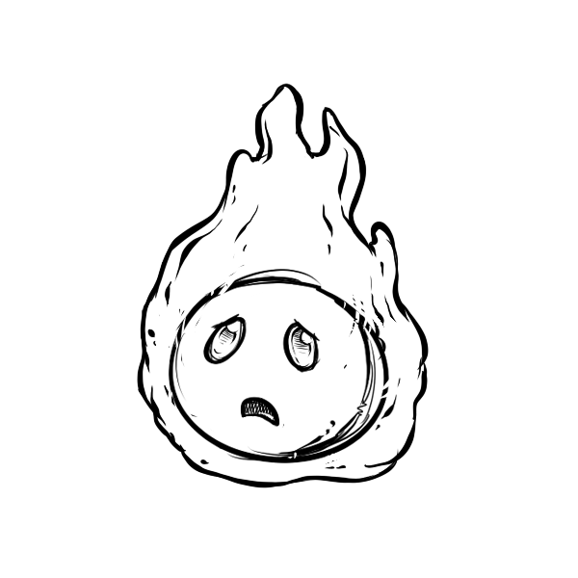There is a 30% chance that a lost soul will be dropped by defeated enemies. When a lost soul is picked up, you can either press the Q-key to sacrifice the soul, giving you three elemental points on the currently chosen element and one point each to the other elements, or the E-key to free the soul, giving you one point to each element. This choice will affect your karma, sacrificing gives you bad karma and freeing gives you good karma, which then affects the game’s ending.

A sketch of a lost soul. Its scale can be seen in the mock up on the first page.

When a lost soul is used it will cease to exist. The lost souls only require an idle animation and an icon for the counter in the HUD. There will be audial feedback when a lost soul is picked up and when they are sacrificed/released. When sacrificed, there will be a sound of bones breaking, and when released there will be a sound of the lost soul flying away.

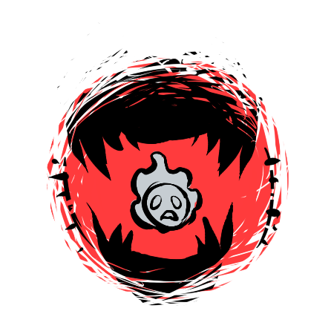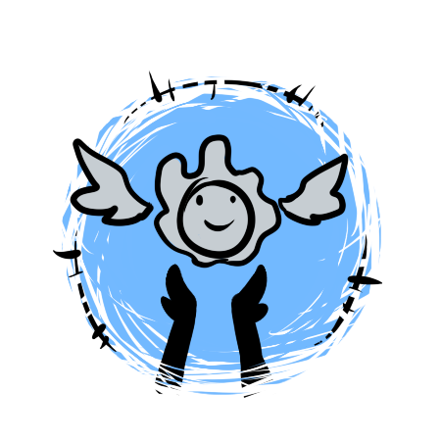

The player is given one lost soul in the beginning of the map for the purpose of showing the player the system of lost souls. When picking up the first lost soul, the controls of sacrificing and releasing lost souls are shown with pictures shown above them. The picture above the sacrifice key will be a red glow and lost soul with big sharp teeth shown above and underneath it, implying that the lost soul will be eaten when this key is pressed. The picture above the release key has a light blue glow and shows a lost soul floating away from a pair of open hands, implying that the lost soul is set free.

### Karma

The karma system depends on what choices the player makes in the game. When a lost soul is sacrificed you get worse karma, and when the lost soul is released you get better karma. The karma system can change the difficulty of the game. If your karma is bad/negative, there will be more spawning enemies making the game more difficult to play, and if your karma is good/positive there will be fewer enemies.

Depending on your karma you can get either the bad or good ending when winning the game.

The player’s karma is never revealed to the player, except for what ending the player is shown and the sky’s colour. If the player’s karma is positive, the sky will have more of a blue colour, and if it is negative it will be more red.

To prevent the karma from being neutral, the choice of sacrificing a lost soul will give more bad karma than what the choice of releasing a lost soul gives you good karma.

## Level Design

The environment of the game is mystical, dark and melancholic. The level has a middle-age Asian theme, with a background with buildings of Asian architecture. Together with the dark and grey-toned colours, the Asian theme creates the mystical and dark feeling for the player. The village is in ruins and the player is alone with the enemies. There is depressing music at a low volume playing in the background and there are also sounds of the waling wind and the player’s footsteps.

### Intro

This is the intro of our game’s level.  
The player spawns with 0 elemental points and sees a lost soul. It is the only thing on the map and it is shown with a pulsating glow and float in the middle of the map. If the player ignores it and try to walk past it she will be stopped by a wall of fire that you can see if you walk past the lost soul. When the player pick up the lost soul a bubble appears and shows what you can do with it it. If you sacrifice it you get three elemental points in the element that you currently are possessing (water by default) and one elemental point each in the other two. Or if she free the lost soul and let it go to the next life the player get one point in each element.

It will be made clear what an evil action is and what is a good action. The evil choice button will be surrounded by red colour, have an evil picture on it and you see the text “Sacrifice the soul to gain three elemental points in the element you are possessing and one in the other two”. The good choice button will be surrounded by a yellow or green colour and have a “good” picture on it and have the text “Help the soul go to the next life and you gain one point in each element”.

After the player have chosen she gains the elemental points and the part of the HUD where elemental point tree show change. The player learns were she can see how many elemental points she has.

The element you are currently possessing is shown with that part of the elemental point tree is lit up a little. For example if the player has water the water elemental point tree is lit up. The player sees that that you can probably change that and discover it by testing the other buttons. During that process the player also learns how to shoot. She tries to shoot the fire wall and change what element she is possessing until she hit the wall with water and it disappears. The player learns water is good against fire.

The player continues to walk and a fire enemy appears and starts attacking the player. The player knows that she should shoot water on fire so she shoots it and kill it in one shot. The enemy has three points of health and a super effective attack do three points of damage. If she shoots it with wood it will do one point of damage as fire is strong against wood. If she shoots the enemy with fire it will do two points of damage. If the player get hit she loses an elemental point in the element she is currently possessing.

The player continues and a wood enemy appears. The same thing as with the fire enemy happens but fire does three points of damage, wood do two points of damage and water does one point of damage.

The same thing happens again but it is a water enemy this time. Wood does three points of damage, water do two points of damage and wood does one point of damage.

Then the player continues and this time she gets confronted by three enemies, one of each element. So she has to change between what element she is possessing to do the most effective damage to each of the enemies. One of the enemies drops a lost soul. The player walk up to the soul but this time there is no bubble, the player simple pick it up when she touch it and it get put in a jar that is shown in the HUD. If the players try to use one of the buttons she have learned does sacrificing or freeing the lost soul the same thing happens as before and the lost souls disappear from the HUD, it is consumed. If there is more than one lost soul in the jar only one disappears per button press.

The player continue and see an altar, the first one is shown with a pulsating glow around it. The altar has the same picture on it as the evil choice button. If the player goes up to it a bubble appears and shows that if you sacrifice a lost soul close to an altar you make a minion that helps you attack the enemies. If the player has a lost soul she can test it.

### Battles

Battle #13 fire types  
One wood wall behind them

Battle #2  
3 wood types  
One water wall behind them

Battle #33 water types

Battle #4  
4 wood  
2 fire  
2 water

Battle #5  
4 water  
4 fire  
One water wall behind them  
One altar

Battle #6  
4 fire  
3 wood  
1 water

Battle #7  
5 water  
2 wood

Battle #8  
4 fire  
5 wood  
One fire wall behind them  
One altar

Battle #9  
6 fire  
3 water

BOSS BATTLE!

## Rules

To win the game you have to defeat the end game boss. You lose the game if you lose all elemental points in all elements. You lose points by being hit by either the enemies/boss or their projectiles.

When the game is over, the player will be shown one of the end screens and then return to the game menu.

When the boss is defeated and the game is won, the end screen shown to the player will depend on what karma she has. If the karma is positive, the end screen will show the player's avatar rebuilding the village with the help of happy looking lost souls. If the karma is negative however, the end screen will show the player's avatar standing in a triumphant pose on top of a pile of elemental enemies and in the background you can see the village in an even worse state than before.

### Elements

There are three elements; fire, water and wood. These elements are part of an intransitivity cycle. An example of this relation is rock paper scissors. Fire is strong against wood, wood against water and water against wood. Here is a table depicting the relation:

|  |  |  |  |
| --- | --- | --- | --- |
| **Attacking Element →** | Fire | Water | Wood |
| Fire | 100% | **150%** | 50% |
| Water | 50% | 100% | **150%** |
| Wood | **150%** | 50% | 100% |

When the player is damaged, the amount of damage taken depends on the player’s currently chosen element as well as the enemy or enemy projectile’s elemental type. When hit by the superior element 3 points are lost, when hit by the same element 2 points are lost and when hit by the inferior element one point is lost. This system is the same for both the player and the enemies, but the player’s elemental points are instead the enemy’s health points.

For example, if the player’s currently chosen element is fire, if she’s hit by something of the water type she loses 3 elemental points, if she is hit by the fire type she loses 2 elemental points and if she is hit by wood she loses one elemental point.

## Story

*Throughout the game there will be a story. It will be told to the player by narrative boxes seen in the upper right corner of the player’s screen. The player will be told what happened to the village and why it is in ruins. It will however not tell the player who is the destroyer, since that will be revealed in the ending depending on your karma. The story is to make the player unsure if she is the protagonist or the antagonist of the game.*

## MDA

*The aesthetic goals of the game are to make the player feel lonely/melancholy and also make her feel conflicted with a moral choice. The melancholy feeling will be achieved with the help of visual and audial effects. Furthermore, the Asian style of the aesthetics influences our art process and music as well some coding decision. The moral choice however will be supported by the dynamics of the game, which is to sacrifice or free lost souls. The mechanics of the game are; move, shoot, sacrificing/freeing lost souls and switch elements.*