**Possession**

**Game Design Document**

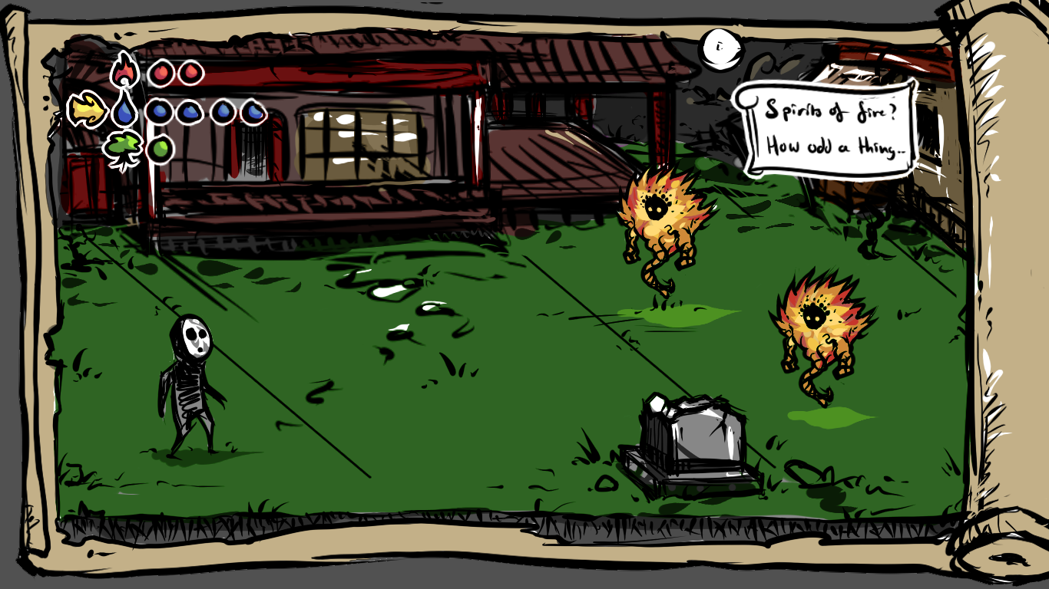You are a soul trying to get through a middle age Asian themed village with the help of three elements, fire, wood and water.

A mock-up of the game’s play area.

Contents

1. General Game Overview 3

2. General Gameplay 3

3. Play Mechanics 3

4. Player Characters 4

5. Non-player Characters (N.P.C’s) 4

6. Player Resources 5

7. Game Environment 6

8. Critical Points 6

9. Story 6

10. Level Design 6

10.1 Battle 7

11. MDA 7

## General Game Overview

You are a soul trying to get through a middle-aged Asian themed village with the help of three elements; fire, wood and water. Depending on your choices in-game you are either the one to conquer the village or save it from evil.

## General Gameplay

The enemies are made of one of three elements; fire, wood, water. The player also uses these elements for her attacks. The elements are in a rock-paper-scissors system, fire>wood, wood>water, water>fire. The player attacks the enemies with their counterpart element to do more damage. Elemental points are lost when the player is hit. If you have less than one elemental point you cannot use that element. Altars are placed across the map and can be used to give you one elemental point of the element that is out of points. When the player runs out of all elemental points in all elements, she loses.

Some enemies drop lost souls when killed. You can use the lost souls to either sacrifice them for a power-up or free them and get a significant smaller power-up. This choice affects your karma, and depending on what way you go, evil or good the ending will be different. The sound and visual effects will give the player feedback on what is more evil, sacrificing the lost soul, and what is more good, freeing the soul.

If the team has enough time they will include the minions-function. When you sacrifice a lost soul and one elemental point by an altar you can make a minion that will follow you and it will assist you by doing attacks that will slow the enemies down.

The player’s objective is to run and shoot the enemies and then defeat the end boss, thus winning the game.

Getting attacked by enemies results in a loss of elemental points and if all elements’ points are lost, you lose.

The on-screen information of the game are the amount of elemental points and a counter of the collected lost souls.

## Play Mechanics

The actions of the player is to move, shoot, pick up lost souls, sacrifice or free the lost souls and get elemental power-up points. You use the joystick to move, button A to shoot, button B to switch between elements and button C/D to sacrifice/free lost souls. On PC the controls are the arrow keys to move, space bar to shoot, E to switch elements and Q/W to interact with lost souls.

The game’s main menu’s interface has four options to choose between. The options available are “Play”, “Options”, “How to play” and “Quit”. If you choose to press quit the game is closed down. When how to play is pressed a screen explaining how you play the game and the game controls show up. If you press options you can adjust the game’s master volume, effect volume and music volume.  
By pressing play you start the game. The in-game’s interface consists of the GUI with the elemental points and lost souls-counter as well as the play area.

## Player Characters

The player is visually represented by a human-shaped mask wearing soul that has a shadow-like body with fading legs. The character is controlled with a joypad and 4 buttons. Button B allows you to switch between the three element types that the character possesses, fire, water and wood. To attack you press A and a projectile made of which ever elemental power you have currently chosen will be shot. When a lost soul is picked up, you can choose to either sacrifice it pressing the C button or free it using the D button.

The players speed is 1. The elements of the player can be updated by sacrificing or releasing lost souls. If your element is upgraded to a high enough level it gets more powerful. This will give you power-ups such as split shots or piercing projectiles.

You get an upgrade in an element when you have 3 element points in that element.

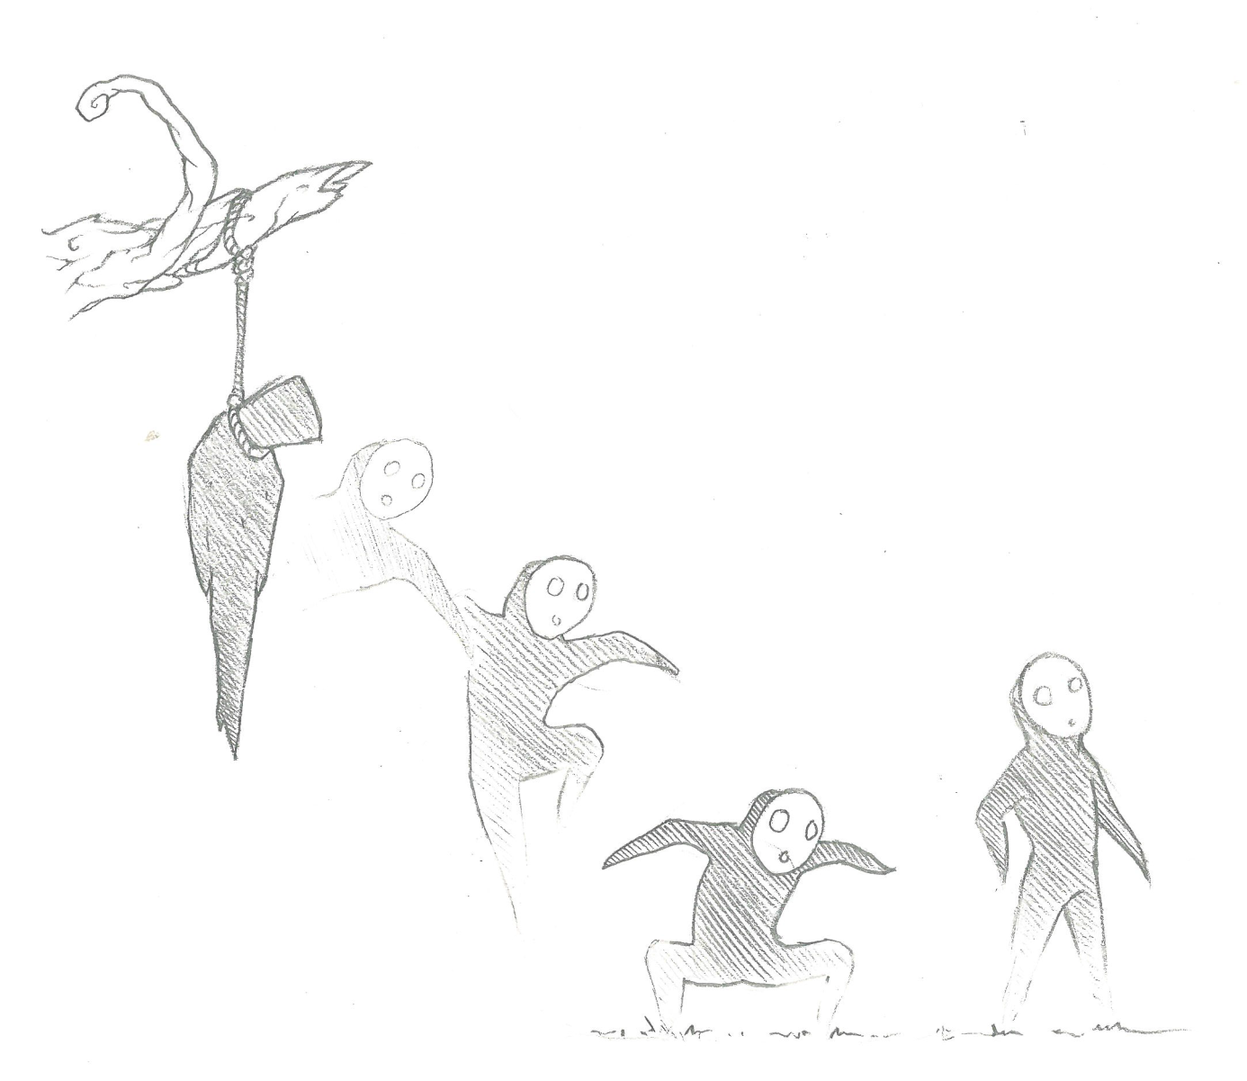To interact with the other characters, which is enemies, you shoot them and dodge their attacks. You can't interact with the minions, except for the making of them when sacrificing the lost souls. When all elemental points of all elements are lost, the character dies. The player is in placed in the center of the screen and requires seven different animations; walk, idle, getting hit, death, attack/shoot, changing element power and spawn. The animations of the player's projectiles are also required. If minions are included in the game, the player will also need an animation when spawning minions.

A sketch of the player in the beginning of the game.

## Non-player Characters (N.P.C’s)

The NPC's in the game mostly consists of enemies. The three main enemies are made of water, fire or wood. These enemies appear in waves, spawning outside of the screen. They all attack the player on sight and they can only shoot horizontally. The speed of the enemies is all the same, which is the same speed as the player has. The enemies have the same restrained mobility as the player, they can't leave the foreground. The elemental enemies are not smart, but they will follow and try to kill the player until they or the player is defeated. To kill the enemies you have to shoot them until they lose all their health, which is three health points. The required animations for each enemy are idle, move, attack/shoot, getting hit and a death animation. The animations of each enemy's projectile are also required. All enemies have different visual representations that match their elemental type. The projectiles that the enemies shoot are depending on the elemental type as well.

What differentiates the elemental enemies from one another are their attack range and strengths/weaknesses. The water enemy's attack range is long; they can attack the player even if she is on the other half of the screen. The fire enemy's attack range is medium and the wood enemy's is short.

The elements are in a rock-paper-scissors system. For example, if water enemy hits the player it will make more damage if the chosen element is fire and less damage if wood is chosen. The system is; fire>wood, wood>water, water>fire.

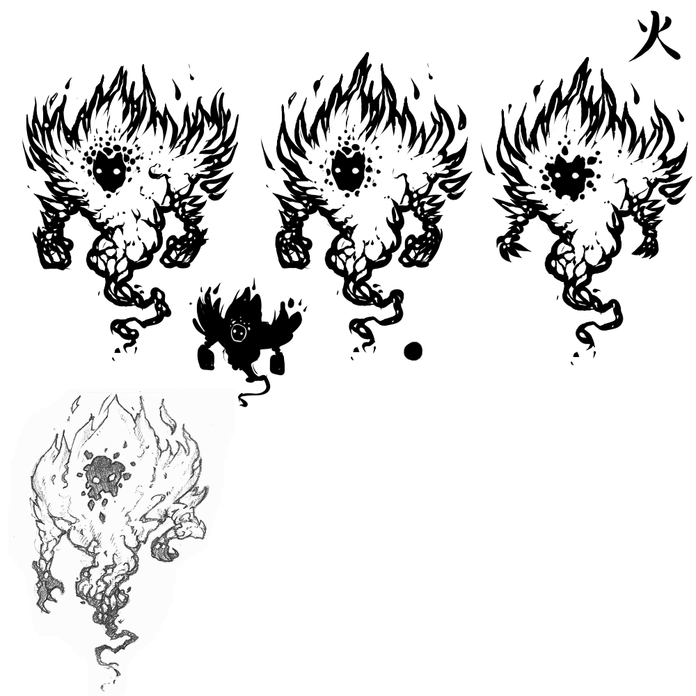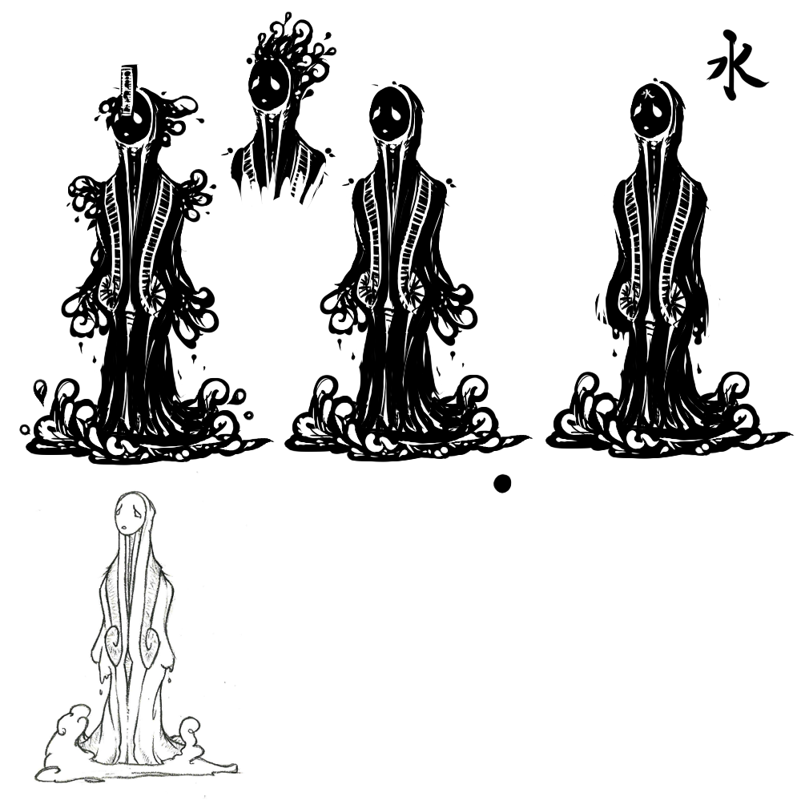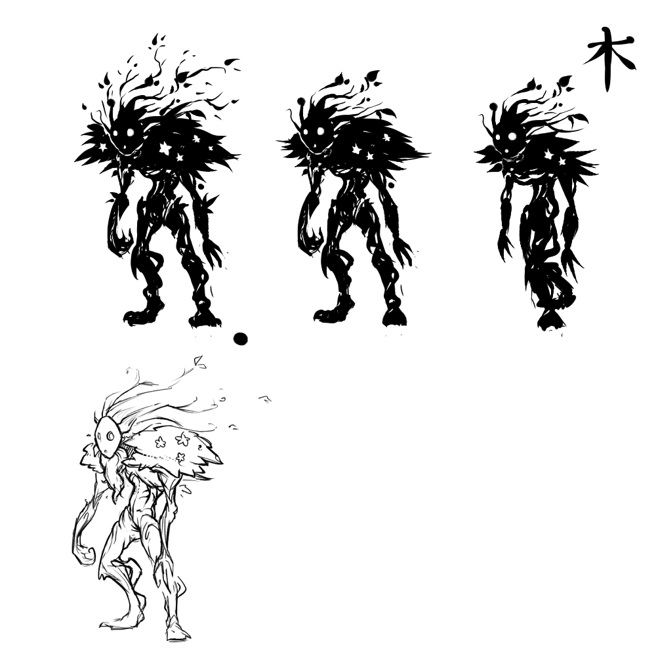

Thumbnails of the three elemental enemies – fire, water and wood.

The end game boss is made of all elements. When attacking the range depends on what type of element the attack is; water has a long range, fire medium and wood short. Just like the elemental enemies, the boss will start attacking the player on sight, and it also has the same speed and restrained mobility as the others. The boss is semi-smart; it will use the same or most effective elemental attack depending on what elemental type the player is using. When the player switches between elements, the boss will switch into the stronger element five seconds later. It is not weak against any element and its attack strengths are according to the elemental system. The boss is defeated when all its 50 health points are lost. When the player reaches the end of the level, the boss will have an intro where is appears in front of the player. The required animations of the boss are six; spawn, move, idle, shoot (water/wood/fire), getting hit and death. The projectiles that the boss shoots require animation as well.

The minions are also part of the NPC's. These will however only be part of the game if the team has enough time to include them. They are not very high priority as they do not add much to the gameplay. To create a minion you have to go to an altar and sacrifice a lost soul and one elemental point. The minion will appear next to the player and it will follow you as you go through the level. Visually, the minion will be chained to the player, making it seem as if it's been forcefully enslaved. This implies that the player has made an evil choice sacrificing the lost souls to be one's slave. Now and then the minions will attack the enemies, slowing them down for several seconds. When hit the minion will lose health, and when all three health points are lost the minion will disappear. The minion requires four animations; spawn, idle, attack and death.

## Player Resources

The player's resources are the elemental points, lost souls, karma and minions.

The elemental points work as both health and power-up system. The player is given one point of each element in the beginning of the level. The points can be obtained by either sacrificing/freeing lost souls or if you’re out of points in a certain element you can go to altars placed across the map and be given one point of that element. When enough points are collected the player will gain power-ups such as split shots or piercing projectiles when attacking with that element. You lose elemental points when hit, and if all elemental points in all elements are lost then you lose the game. The animations/sprites that the elemental points require are the ones in the HUD; one for each element, the current amount of points and which element is currently chosen.

Lost souls are sometimes dropped by enemies and can sometimes be found in hidden areas. The player is given one lost soul in the beginning of the map for the purpose of showing the player the system of lost souls. You either press button C to sacrifice the soul, giving you three elemental points on the currently chosen element and one point each to the other elements(if not a minion by an altar), or button D to free the soul, giving you one point to each element. This choice will affect your karma, sacrificing giving you bad karma and freeing giving you good karma, which then affects the game’s ending. When a lost soul is used it will cease to exist. The animations that the lost souls require are; dropped, idle and pickup. An animation when meeting the first lost soul is also required. In the HUD there is a lost soul counter that also requires animations/sprites. Depending on how the lost souls are used (sacrifice/free), the player will be given both visual and audial feedback.

The karma system depends on what choices the player makes in the game. When a lost soul is sacrificed you worse karma, and when the lost soul is freed you get better karma. Depending on your karma you can get either the bad or good ending when winning the game. The player’s karma is never revealed to the player, except for what ending the player is shown.

The minions can also be seen as a kind of resource, as they require one soul and one elemental point that will be taken of the current chosen element. When you the soul and elemental point is sacrificed you will gain one minion, and when the minion is hit you lose one minion. See the paragraph about minions in NPC’s to read more about them.

## Game Environment

The environment of the game is mystical, dark and melancholy. The level has a middle-age Asian theme, with a background with buildings of Asian architecture. Together with the dark and grey-toned colours, the Asian theme creates the mystical and dark feeling that the game is to give. The village is in ruins and the player is alone with the enemies. There is depressing music at a low volume playing in the background and there are also sounds of the whaling wind and the player’s footsteps.

## Critical Points

At the end of the game after defeating the boss you will see the end animation which will be different depending on your karma, if you are evil or good. The player sacrifice lost souls to get a power-up and become more evil. The player frees the lost souls to get a significant lesser power-up and become more good.

This the high point because you get to see the result of the choices you have made during the game. See if you are the conqueror of the village or if you are its hero.

## Story

Throughout the game there will be a story. It will be told to the player by narrative boxes seen in the upper right corner of the player’s screen. The player will be told what happened to the village and why it is in ruins. It will however not tell the player who is the destroyer, since that will be revealed in the ending depending on your karma. The story is to make the player unsure if she is the protagonist or the antagonist of the game.

## Level Design – Intro

This is the intro of our game’s level.  
The player spawns with 0 elemental points and sees a lost soul. It is the only thing on the map and it is shown with a pulsating glow and float in the middle of the map. If the player ignores it and try to walk past it she will be stopped by a wall of fire that you can see if you walk past the lost soul. When the player pick up the lost soul a bubble appears and shows what you can do with it it. If you sacrifice it you get three elemental points in the element that you currently are possessing (water by default) and one elemental point each in the other two. Or if she free the lost soul and let it go to the next life the player get one point in each element.

It will be made clear what an evil action is and what is a good action. The evil choice button will be surrounded by red colour, have an evil picture on it and you see the text “Sacrifice the soul to gain three elemental points in the element you are possessing and one in the other two”. The good choice button will be surrounded by a yellow or green colour and have a “good” picture on it and have the text “Help the soul go to the next life and you gain one point in each element”.

After the player have chosen she gains the elemental points and the part of the HUD where elemental point tree show change. The player learns were she can see how many elemental points she has.

The element you are currently possessing is shown with that part of the elemental point tree is lit up a little. For example if the player has water the water elemental point tree is lit up. The player sees that that you can probably change that and discover it by testing the other buttons. During that process the player also learns how to shoot. She tries to shoot the fire wall and change what element she is possessing until she hit the wall with water and it disappears. The player learns water is good against fire.

The player continues to walk and a fire enemy appears and starts attacking the player. The player knows that she should shoot water on fire so she shoots it and kill it in one shot. The enemy has three points of health and a super effective attack do three points of damage. If she shoots it with wood it will do one point of damage as fire is strong against wood. If she shoots the enemy with fire it will do two points of damage. If the player get hit she loses an elemental point in the element she is currently possessing.

The player continues and a wood enemy appears. The same thing as with the fire enemy happens but fire does three points of damage, wood do two points of damage and water does one point of damage.

The same thing happens again but it is a water enemy this time. Wood does three points of damage, water do two points of damage and wood does one point of damage.

Then the player continues and this time she gets confronted by three enemies, one of each element. So she has to change between what element she is possessing to do the most effective damage to each of the enemies. One of the enemies drops a lost soul. The player walk up to the soul but this time there is no bubble, the player simple pick it up when she touch it and it get put in a jar that is shown in the HUD. If the players try to use one of the buttons she have learned does sacrificing or freeing the lost soul the same thing happens as before and the lost souls disappear from the HUD, it is consumed. If there is more than one lost soul in the jar only one disappears per button press.

The player continue and see an altar, the first one is shown with a pulsating glow around it. The altar has the same picture on it as the evil choice button. If the player goes up to it a bubble appears and shows that if you sacrifice a lost soul close to an altar you make a minion that helps you attack the enemies. If the player has a lost soul she can test it.

### Battles

Battle #13 fire types  
One wood wall behind them

Battle #2  
3 wood types  
One water wall behind them

Battle #33 water types

Battle #4  
4 wood  
2 fire  
2 water

Battle #5  
4 water  
4 fire  
One water wall behind them  
One altar

Battle #6  
4 fire  
3 wood  
1 water

Battle #7  
5 water  
2 wood

Battle #8  
4 fire  
5 wood  
One fire wall behind them  
One altar

Battle #9  
6 fire  
3 water

BOSS BATTLE!

## MDA

The aesthetic goals of the game are to make the player feel lonely/melancholy and also make her feel conflicted with a moral choice. The melancholy feeling will be achieved with the help of visual and audial effects. Furthermore, the Asian style of the aesthetics influences our art process and music as well some coding decision. The moral choice however will be supported by the dynamics of the game, which is to sacrifice or free lost souls. The mechanics of the game are; move, shoot, sacrificing/freeing lost souls and switch elements.