From Udacity

Program: Data Analysis and Visualization with Power BI

**SSBC Project**

In this project, you will create a data model and report in Power BI for Seven Sages Brewery combining information from across the company. Your data model will enable the company's CFO to quickly review and analyse which beers are selling well and which are generating the highest profitability.

By the end, you will have applied the key concepts from this course to combine and centralise previously scattered data, solving a common problem faced by many companies. More importantly, you will have a solid foundation to build on when you need to respond to more complex information visualisation requests, advanced DAX requirements or larger data models. Regardless of the size of the data models, as you progress professionally, the basic principles will remain the same.

When you complete this task, tab 1 of your report will look like this:

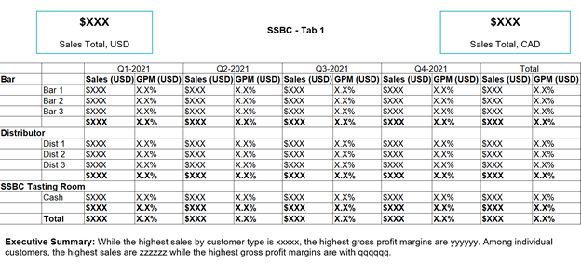

... and tab 2 will look like this:

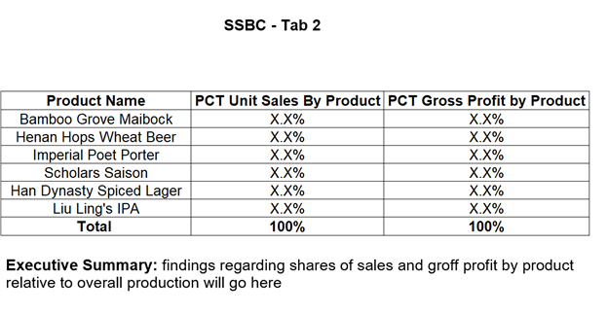

Main steps

These are the main steps you need to follow. We will discuss each of these steps in more detail on the following pages.

1. Download the files. Download the source files provided by SSBC and familiarise yourself with them.
2. Sketch the data model. Sketch an outline of the data model you intend to create.
3. Use Get Data. Use Get Data to load the source material data into Power BI.
4. Structure, combine, and clean the data. Clean and format the data so that it works well in the data model.
5. Create your date table. Create a date table to support time intelligence.
6. Create a relationship between the tables. Create a relationship from each dimension to the relevant data in the fact table.
7. Write the measures. To satisfy the CFO's requirements, we will need to write six measures to calculate sales, cost of sales and gross profit margin in two different currencies.
8. Create a report. Develop a basic visual report to show your results.

The steps for this project follow exactly the same flow as we have been seeing throughout this course:

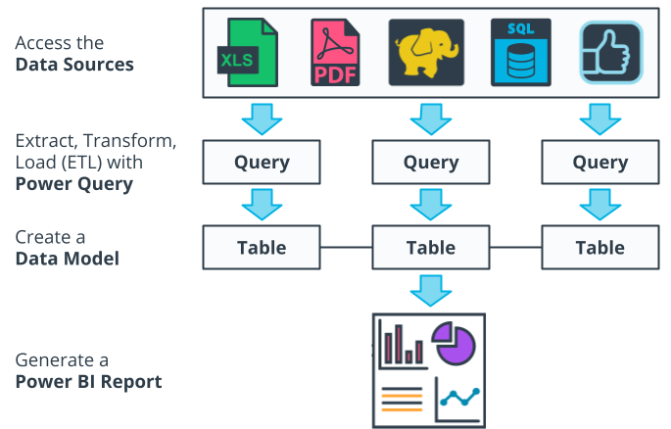

**Rubric**

**Getting and transforming data in Power Query**

The data model diagram shows a single fact table and four separate dimensions, three of which come from currency, customer and product origin.

Typos and obvious errors that could hinder the functionality of the data model/report have been removed.

The final matrix shows only three customer types for "Bar", "Distributor" and "SSBC Tasting Room".

The date table includes the following standard fields:

* Continuous calendar dates.
* Month name, month number, calendar years, fiscal periods, fiscal years and quarters.
* Fiscal periods, fiscal years, and fiscal quarters.

**Build Relationships**

There is a one-to-many relationship between each dimension table (on side one) and the fact table (on side many). In the PBIX file, all arrows point to the fact table.

The information layer includes two tabs.

The first tab has:

* Two card displays
* A matrix
* A text box that includes a summary of the main findings.

In the first tab, the totals are as follows:

* Total sales in USD: US$167.57k
* Total sales in CAD: US$224.21k
* Gross profit margin in USD (annual total): 14.7%.

Each value is reflected using the appropriate format and is clearly labelled. Time periods use fiscal quarters rather than calendar quarters.◂▸

◂▸The second tab presents a simple table with two columns showing the percentage of sales and the percentage of gross profit generated by each beer produced at SSBC. These add up to 100%.