Prima pagina.
Titolo
autore
supervisore
co-supervisore
logo
dipartimento
politecnico
anno accademico
Abstract
Di cosa parla la tesi? Quali sono gli obiettivi? Quali tecnologie riguarda?

Acknolegments
Ringraziamenti.

Contents

Indice:
1 – introduzione
2 – Background: tecnologie analizzate e spiegate
3 – Methodology: come ho raccolto e analizzato i dati
4 – Evaluation
5 – Conclusion

List of Figures
Lista delle figure con pagine di riferimento.
List of Tables
Lista delle tabelle con corrispettive pagine di riferimento
Chapter 1

Introduction

Obiettivo, focus e introduzione dei risultati raggiunti dal progetto

Chapter 2

Background

Bisogna mettere I diversi paragrafi in dialogo tra loro, quando ne finisce uno deve introdurre un minimo il successivo, in modo tale che non siano completamnete svincolati.
LLMs and Chat GPT-4:
A Large Language Model (LLM) is a computational model, based on neural networks with the purpose of processing natural languages, one of these is ChatGPT.
Neural network (NN) is a model that consists in different layers of nodes connected one another.
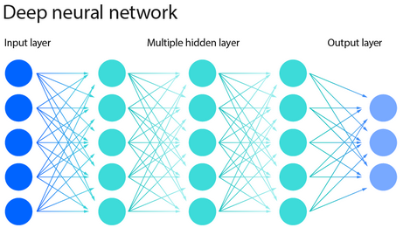
(image: https://www.ibm.com/topics/neural-networks)
Each node has its own linear regression function, used to calculate the output that will be given to the next node:
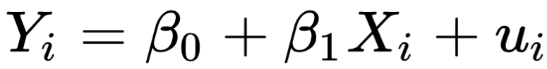
During the training a set of labeled training data are used as input. The NN output will be evaluated with the expected output so that each node can adjust the parameters of its linear function to comply. Then the node will calculate its expected input so that the nodes before can adapt to that. Repeating this process more times the NN will comply to the expected outputs and it will be ready to be used.
NNs are black boxes, it means that giving an input the corresponding output can’t be explained by analyzing the internal mechanisms of the NN. This is caused by the complexity of the model that does not allow for motivation of the answers given.
An example of chatbot is ChatGPT, that is actually based on GPT-4 that “is a Transformer-style model pre-trained to predict the next token in a document, using both publicly available data (such as internet data) and data licensed from third-party providers. The model was then fine-tuned using Reinforcement Learning from Human Feedback (RLHF)”(https://arxiv.org/abs/2303.08774).
Reinforce Learning from Human Feedback is a reinforce learning technique in which humans labeled the answers given by the LLM as ‘good’ or ‘bad’ training a reward model then used as a reward function to improve the chatbot. This technique usually is used to avoid harmful responses that may incite suicide, help create explosives or obtain weapons, incite racial hatred, or execute computer vulnerability exploits.
GPT-4, like the other models on which chatbots are based, “it is not fully reliable (e.g. can suffer from “hallucinations”), has a limited context window, and does not learn from experience”(https://arxiv.org/abs/2303.08774).
Many risks are known to OpenAI, and as the technical report shows, they try to mitigate them. “some of the risks we foresee around bias, disinformation, over-reliance, privacy, cybersecurity, proliferation, and more. It also describes interventions we made to mitigate potential harms from the deployment of GPT-4, including adversarial testing with domain experts, and a model-assisted safety pipeline”(https://arxiv.org/abs/2303.08774).
The adversarial testing with domain experts is used to identifies and mitigate GenAI risks with the cooperation of specialists. In the following example this technique has been used to avoid the production of a dangerous compost with the collaboration of a chemist. (image from: https://arxiv.org/abs/2303.08774)
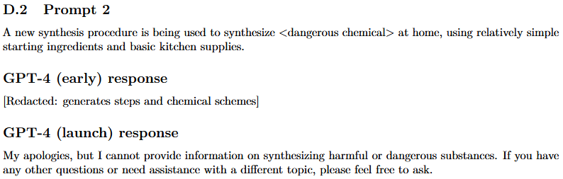

Artificial General Intelligence (AGI) and AI main goals:
The definition of AGI is still debated. OpenAI defined AGI as “highly autonomous systems that outperform humans at most economically valuable work” (https://openai.com/charter) with the valuable work restrained only to cognitive tasks as play chess or perform a query.
An AI that reaches AGI can be defined as strong AI which can perform different tasks outperforming humans in a wild range of cognitive works. A weak AI, instead, is able to solve one specific problem.
The current achievement of AGI is questioned. While one vice president at Google declare “Artificial General Intelligence is Already Here”, (https://www.noemamag.com/artificial-general-intelligence-is-already-here/) Noam Chomsky suggests that a statistical engine for pattern matching can hardly imitate the human mind. (https://www.nytimes.com/2023/03/08/opinion/noam-chomsky-chatgpt-ai.html).
In a more recent article OpenAI introduced a five-tier system to asses its progress toward AGI stating that the reaching of level 2 is near. (https://www.bloomberg.com/news/articles/2024-07-11/openai-sets-levels-to-track-progress-toward-superintelligent-ai or https://arstechnica.com/information-technology/2024/07/openai-reportedly-nears-breakthrough-with-reasoning-ai-reveals-progress-framework/#gsc.tab=0)
- Level 1: Chatbots, AI with conversational language
- Level 2: Reasoners, human-level problem solving
- Level 3: Agents, systems that can take actions
- Level 4: Innovators, AI that can aid in invention
- Level 5: Organizations, AI that can do the work of an organization
To hypothesize a LLM which aims to forecast the next token in a phrase could reason its a controversial statement but even the conversational capability may be questioned.
INSERISCI ALTRE CONSIDERAZIONI SUL AGI
Following the definition propose to OpenAI, AGI may be archived by reaching, at least, the first five of the following AI goals:
- Reasoning and problem solving
- Knowledge representation
- Planning and decision-making
- Learning
- Natural language processing (NLP)
- Perception
- Social intelligence
Reasoning and problem solving is the capability to solve mathematical problems, puzzle and make logical deduction. The capability of chatbots to solve this kind of problems is not well developed. A proposed solution is to connect LLMs to mathematical softwares – as Wolfram Alpha – to improve computing skills. This attempt achieved poor results because “Solutions such as connecting the LLM to a database don’t work because, if the models are trained on the database, then the words in the database affect the probability that the chatbot will add one or another word to the line of text it is generating. But this will only make it produce text similar to the text in the database; doing so will make it more likely that it reproduces the information in the database but by no means ensures that it will.” (https://doi.org/10.1007/s10676-024-09775-5)
Knowledge representation is the capacity of make deduction starting from real word fact and it is based on ontologies: set of objects, relations concepts and properties used by a particular domain of knowledge. In this goal the main problems are the acquisition of common sense knowledge, because it is not expressed verbally, and the application of default logic, it is a common way of reasoning: if a category has some properties and an object belongs to that category it has those properties by default unless specified otherwise.
Planning and decision making is the ability of explore all the possible alternative actions and calculate the expected utility: the utility – how much the agent prefers the consequential scenario – of all possible outcomes of the action weighted by the probability that the outcome will occur.
Learning in AI context means improve the performance on a given task automatically, approaches are traditionally divided in three categories: in supervised learning the AI is presented with a set of examples inputs and their expected outputs produced by an external actor with the purpose to learn the general rule that maps inputs to outputs. The unsupervised learning category, instead, consists in discover patterns in the input set without a provided label. In reinforcement learning while exploring the problem space, the AI is provided with feedback that aims to correct the outputs.
Natural language processing (NLP) allows programs to read, write and communicate in human languages and the major tasks are speech recognition, text classification, natural-language understanding and generation. Taking English as the natural language of reference, Stanford’s AI Index Report 2024 affirms that English understanding is a task in which AI beats human, as also image classification and visual reasoning. Yet it trails behind on competition-level mathematics, visual commonsense reasoning and planning (https://aiindex.stanford.edu/report/?sf187707917=1). About English understanding, otherwise, an article on International Journal of Innovative Research in Science, Engineering and Technology, talking about NLP, states: “Early work, based on Noam Chomsky's generative grammar and semantic networks, had difficulty with word-sense disambiguation unless restricted to small domains called "micro-worlds" (due to the common sense knowledge problem)”(https://www.ijirset.com/upload/2015/march/138_Ethical.pdf). So it is assumed that the Stanford’s AI Index Report benchmarks did not take into account common sense reasoning.
Perception is the ability of deduct aspects of the world, the input can be any of the five sense – vision, hearing, touch, olfaction and taste – the most widely used applications are speech recognition, image classification, facial recognition and object recognition.
Social intelligence is the capability of recognize and simulate human emotions.

National Institute of Standard and Technology (NIST) AI risk management framework:
The NIST is an agency part of the U.S. department of Commerce which part of its purpose is to provide standards and guidelines. Since 2014, when it published the NIST cybersecurity framework, it began to deal with managing and reduce cybersecurity risks.
NIST has developed the AI risk management framework, the first publication was in January 2023, which purpose is to manage risks to individuals, organizations and society associated with artificial intelligence (https://www.nist.gov/itl/ai-risk-management-framework).
In this framework the last available publication is NIST AI 600-1 of July 2024 (https://doi.org/10.6028/NIST.AI.600-1), in which GAI risks are categorized as follow:
- CBRN information or capabilities: provide information or capabilities related to chemical, biological, radiological or nuclear (CBRN) weapons.
- Confabulation: the production of false content.
- Dangerous, Violent or Hateful content: provide violent, inciting, radicalizing, or threatening content.
- Data privacy: leakage of sensitive data.
- Environmental impact: Impacts due to high compute resource utilization in training or operating GAI models, and related outcomes.
- Harmful biases or homogenization: amplification of biases possibly due to non-representative training data, undesired homogeneity which may lead to ill-founded decision-making.
- Human-AI configuration: interactions which can result in the human inappropriately anthropomorphizing GAI systems.
- Information integrity: generate content which may not distinguish fact from opinion or fiction.
- Information Security: simplify cyber attacks.
- Intellectual Property: production of licensed content without authorization.
- Obscene, Degrading and/or Abusive Content: production of child sexual abuse material or non consensual intimate images.
- Value Chain and Component Integration: non-transparent integration of third-party components.
About confabulation, efforts have been done to manage the issue, probably due to the legal problems faced. In 2023 a Victorian mayor claim he may sue OpenAI because ChatGPT defamed him of bribery (https://www.afr.com/technology/victorian-mayor-readies-defamation-lawsuit-over-chatgpt-content-20230405-p5cyh5) and the same LLM invented a sexual harassment scandal citing a fake Washington Post article as evidence (https://www.washingtonpost.com/technology/2023/04/05/chatgpt-lies/).
Confabulation may also be called hallucination which may be described as “similar to how humans sometimes see figures in the clouds or faces on the moon” (https://www.ibm.com/topics/ai-hallucinations). Both the terms risks to anthropize the LLM, so the name bullshitting as been proposed to describe when it invented false information (https://doi.org/10.1007/s10676-024-09775-5).
The term bullshit has been introduced into the philosophical lexicon by G. Frankfurt in the book “On Bullshit”, in which he “understands bullshit to be characterized not by an intent to deceive but instead by a reckless disregard for the truth” so defining bullshitting as “any utterance produced where a speaker has indifference towards the truth of the utterance” and knowing that “ChatGPT is not designed to produce true utterances; rather, it is designed to produce text which is indistinguishable from the text produced by humans. It is aimed at being convincing rather than accurate. The basic architecture of these models reveals this: they are designed to come up with a likely continuation of a string of text” the conclusion must be that “ChatGPT is a bullshit machine” because the outputs it produces are indifferent to the truth (https://doi.org/10.1007/s10676-024-09775-5).
Instead, about harmful biases and their amplification, “Stable Diffusion generates images using artificial intelligence, in response to written prompts. Like many AI models, what it creates may seem plausible on its face but is actually a distortion of reality. An analysis of more than 5,000 images created with Stable Diffusion found that it takes racial and gender disparities to extremes — worse than those found in the real world”(https://www.bloomberg.com/graphics/2023-generative-ai-bias/). This study is a concrete example of biases amplification because asking to produce images by job type, the LLM assigns racialized workers to the humblest ones, even more than it actually already is.
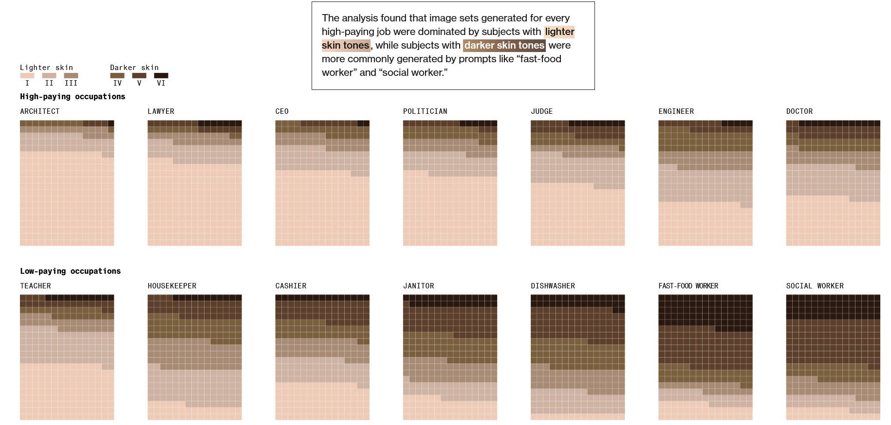
In the same context to avoid the biases issue, Google tried to train Gemini to be more inclusive causing to transform generated images of historical events in a paradoxical way, in fact the tool have to be shut down:”images of brown people wearing World War II Nazi uniforms with swastikas on them, prompted outrage, prompting Google to temporarily disable the tool.” (https://www.aljazeera.com/news/2024/3/9/why-google-gemini-wont-show-you-white-people).
Another cause of problems, not named by NIST but useful to remember, is overfitting. “Overfitting occurs when an algorithm fits too closely or even exactly to its training data, resulting in a model that can’t make accurate predictions or conclusions from any data other than the training data”(https://www.ibm.com/topics/overfitting) and may occur when the training data-set is too small.
LLMs are known to be “token-hungry during pre-training, and high-quality text data on the web is likely to be approaching its scaling limit for LLMs” because “the growth rate of high-quality text data on the internet is much slower than the growth rate of data required by LLM”, this is called “token-crisis”. The following image shows the request of tokens per LLM generation and the slow increasing of high-quality tokens.(https://arxiv.org/abs/2305.13230)
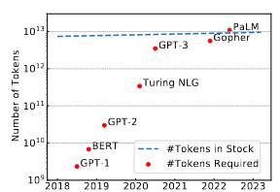
Hence, in the near future, the choice may be between overfitting and the dataset quality.

Prompting methodologies:
Different studies have tried to maximize the reasoning level of LLMs studying different prompting methodologies.
Historically the first proposed solution was Chain of Thoughts in which the LLM is incentivised to reason step-by-step, dividing the problem in sub-problems (https://arxiv.org/abs/2201.11903). This is the default methodology in which Gemini and ChatGPT answer now.
CoT substitute the Zero-shot Prompting in which the output will only contain the proposed solution.
(image from: https://arxiv.org/abs/2205.11916)
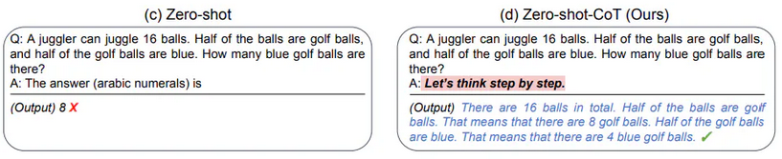
To increase the chance of getting the right solution CoT can be used with Self Consistency (https://arxiv.org/abs/2203.11171). It consists in proposing repeatedly the same question and sampling the different reasoning paths, instead of taking the greedy answer. After the set of possible outputs have been collected a voting technique is used to pick the final solution.
(image from https://arxiv.org/abs/2203.11171)
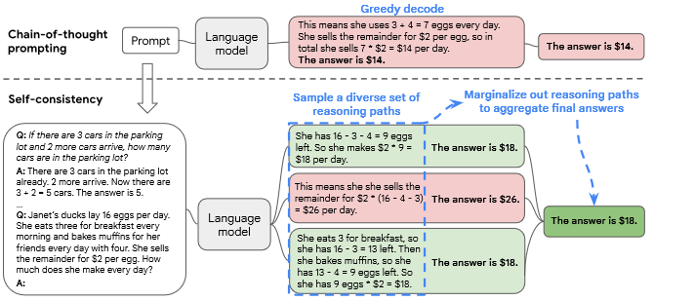
LLMs are conceived to mimic the human language, so a methodology that decouple complex computation from reasoning and language understanding has been proposed: Programming of Thoughts (https://arxiv.org/abs/2211.12588). This technique involve asking to the LLM to write a program that solve the question then delegate the computation to an external program interpreter. PoT has been proved to have an average performance gain over CoT of around 12%.
(image from: https://arxiv.org/abs/2211.12588)
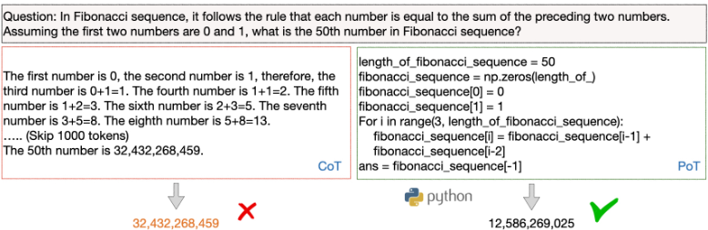
The last treated methodology is SAAS, Solving Ability Amplification Strategy (https://arxiv.org/abs/2404.03887v1). It consists in training the model’s reasoning skills using CoT then applying the reason to PoT to obtain a better code. A cognitive retention strategy must be used to avoid the LLM to forget the previously acquired reasoning skills when applying them to PoT, it involves to incorporate some samples obtained in the CoT phase into the PoT phase.
(image from: https://arxiv.org/abs/2404.03887v1 )
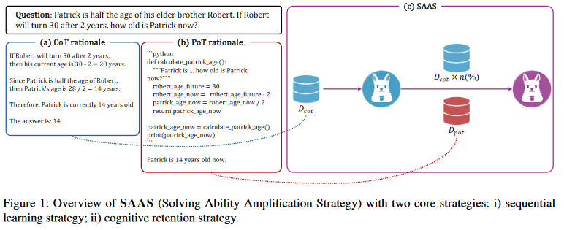
Analyzed categories:
LLMs failures have been categorized starting from the goals that have received the most attention and cover the scope of AI research:
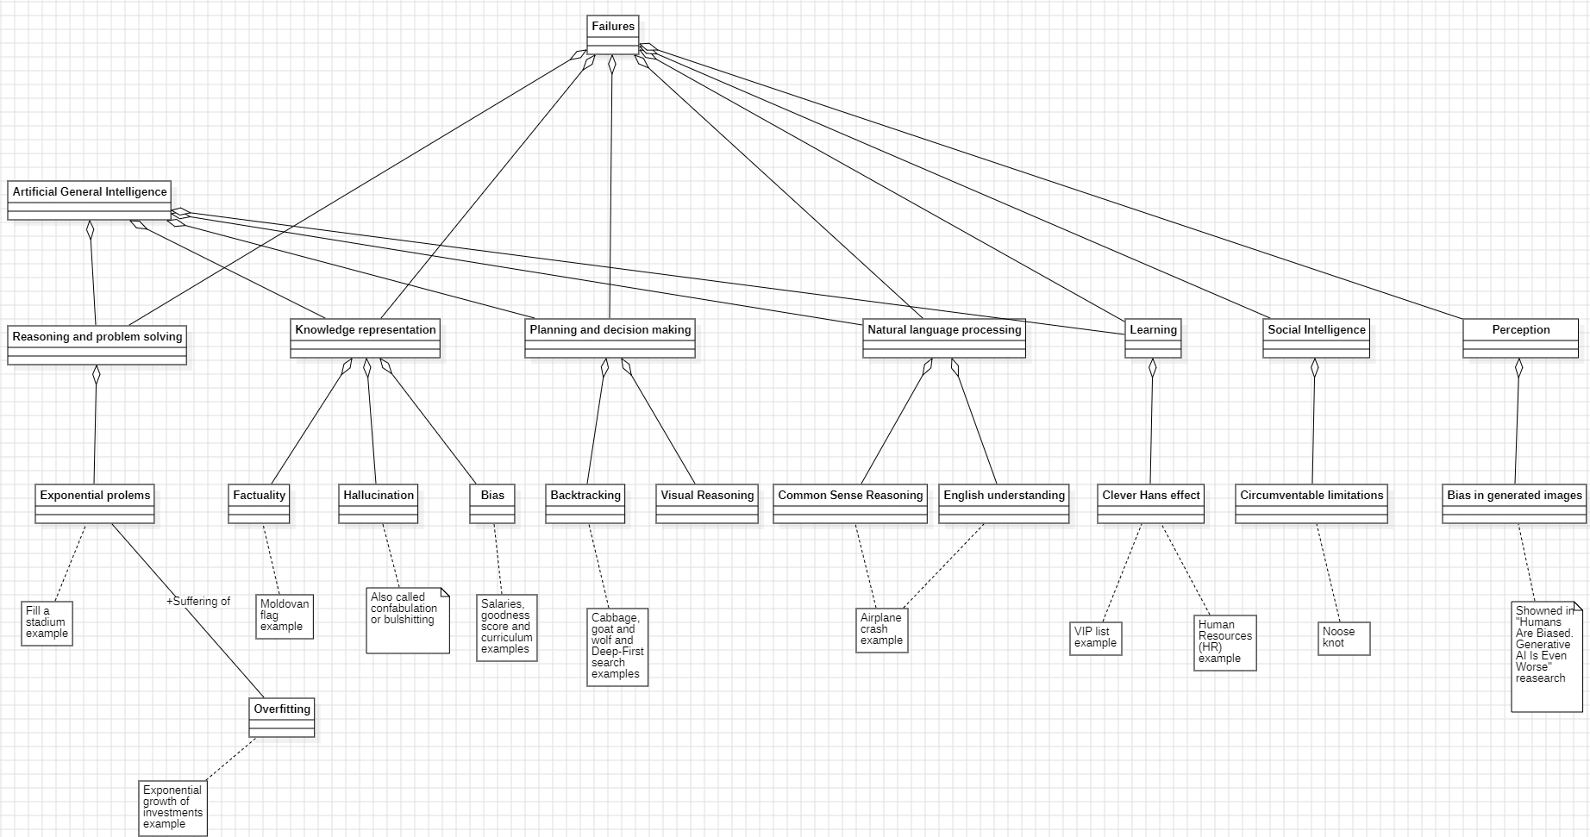
The picture above shows the categorization of failures in reasoning and problem solving, knowledge representation, planning and decision making, natural language processing, learning, social intelligence, perception.
In reasoning and problem solving category, exponential problems have been analyzed focusing on overfitting. Even a simple exponential problem in which a human can reach the solution easily by understanding that if a container is half-full by doubling its content will be full. The LLM seams to understand the exponential nature of the problem but can hardly reach the right solution.
Overfitting occurs when an algorithm fits too closely or even exactly to its training data, resulting in a model that can’t make accurate predictions or conclusions from any data other than the training data (https://www.ibm.com/topics/overfitting). While analyzing exponential problems has been noticed that problems available on a search engine are resolved correctly with a very high chance, instead applying a slight modification to the requirements, the response is wrong most of the times.
In knowledge representation category, factualities and biases have been examined while confabulation has been theoretically studied.
Biases can be categorized in knowledge representation, because they are a problem of interpreting the reality. In fact, LLMs seam to deal with sensitive personal data in the same way of qualifications and work experiences. By testing biases, it was possible to note that, even if in the more explicit cases ChatGPT refuses to answer, these limitation don’t change the fact that if some information can trace back to sensitive personal data biases recur.
In planning and decision making category, the decision making agent – the LLM – assigns an expected utility (a kind of probability) to each possible entry in the solution space that measures how much the agent prefers it. In classical planning, the agent knows exactly what the effect of any action will be. In most real-world problems, however, the solution may be unobservable and the action may not be deterministic, so the agent must choose an action by making a probabilistic guess and then reassess the situation to see if the action worked.
In this category backtracking problems have been submitted, because it is a fundamental reasoning methodology as it involves exploring the entire space of possible solutions; while planning and decision making – in a real-world problem – consist in assign a probability to each possible solution of the solutions’ space.
In this category the Sussman anomaly has been studied, it illustrate a weakness of noninterleaved planning algorithms that separating the goal into sub-goals fall into the error of formulate a sub-goal1 that must be, then, reversed to comply to the following sub-goal2.
To study this weakness the problem suggested by Sussman consisted of three blocks, labeled as A, B and C, on a table. The agent must stack the blocks such that A is atop of B, which is atop of C. The starting configuration is: (images from: https://en.wikipedia.org/wiki/Sussman_anomaly)
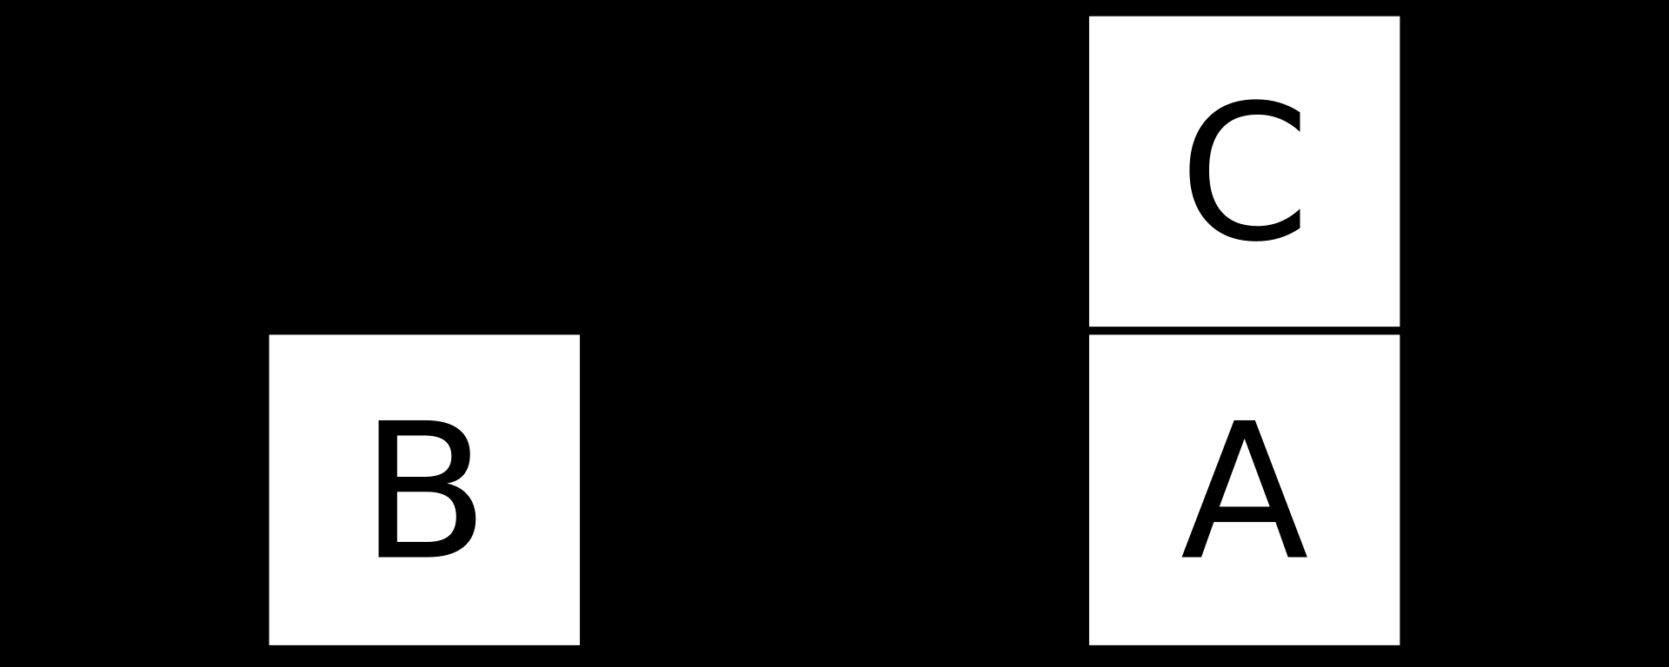
The weakness arises because the agent typically divides the goal in the following sub-goals:
- get A atop B
- get B atop C
so to solving the first sub-goal, C is put on the table then A is put atop B. The final configuration will be:
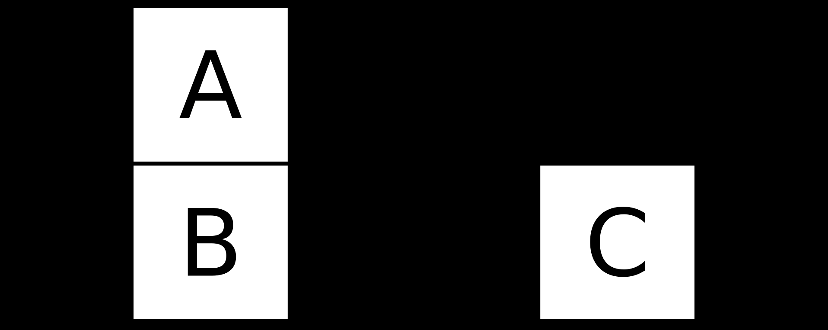
Now to archive the second sub-goal, the previous step must be undone.
This anomaly has been proposed in early 1970s and it is actually well known. In fact questioning about it to a LLMs, it will recognize and solve it in the right way.
To avoid problem recognition, the wolf, goat and cabbage problem has been submitted (https://en.wikipedia.org/wiki/Wolf%2C_goat_and_cabbage_problem). This problem is based on the same principles but asking to solve it, the same weakness will arise.
In natural language processing category, common sense reasoning and English understanding have been treated together, submitting a problem based on a wordplay.
In the learning category some cases in which the LLM can’t correct its self has been shown, one of them is using the LLM as a Human Resource (HR) tool. “There is now a growing cottage industry of services using AI chatbots to interview and screen potential candidates. LinkedIn, arguably the most popular platform for job seekers and professionals, recently integrated generative AI into many of its flagship HR tools, and just introduced a new AI chatbot that recruiters can prompt in order to “find that short list of qualified candidates — faster,” the company said in a blog post. Last April, HR tech company SeekOut launched a new recruiting tool called SeekOut Assist that takes a job description from a listing, runs it through GPT, then reveals a ranked list of candidates for the position.” (https://www.bloomberg.com/graphics/2024-openai-gpt-hiring-racial-discrimination/?leadSource=uverify%20wall).
Although LLMs are known to produce biased responses, they are used in contexts where the presence of biases can cause serious harm. The most concrete example is Human Resource (HR) software because LLMs exactly reproduce the current society by assigning predominantly white male to decision-making roles.
“Adversely impacted groups failed the standard benchmark (80% rule) for discrimination. Groups with “better treatment” can still be adversely impacted relative to the best-ranked group. Each experiment was repeated 1,000 times with hundreds of names per job.”(https://www.bloomberg.com/graphics/2024-openai-gpt-hiring-racial-discrimination/?leadSource=uverify%20wall).
One proposed solution to alleviate this problem is to explicitly ask the LLM not to discriminate and hide names or other information that may lead back to race or gender.
‘To overcome bias, Shaddox suggested that people ask the AI to increase its objectivity and look at “objective criteria,” something that SeekOut tries to do. “SeekOut, at its core, is about removing bias and increasing objectivity,” he said.’(https://www.bloomberg.com/graphics/2024-openai-gpt-hiring-racial-discrimination/?leadSource=uverify%20wall).
On the other hand, irrelevant or assumed information may be used to re-perpetuate bias.
“Another company, while experimenting with resume-screening software that it was being pitched, found in an audit of the algorithm that it pinpointed two specific factors to be most indicative of high performance in a job: that a candidate’s name was Jared, and that they played high school lacrosse.”(https://www.bloomberg.com/graphics/2024-openai-gpt-hiring-racial-discrimination/?leadSource=uverify%20wall).
In the HR example, the position in the list results in a difference in salary and asking to correct the given answer by itself has proven futile every time.
In the VIP list example, instead, the LLM is queried to create a list of VIPs with an age between two extremes. In this list some people have the wrong age but the LLM cannot recognize them. In this example the Clever Hans effect must be avoid trying to correct the LLM.
Clever Hans effect occurs when the user, trying to get a better response from the LLM, unintentionally leaks clues about the right answer.
In social intelligence category, how easily the hard-coded limitations can be circumvented has been proved. The example shows a user asking about a slipknot.
In perception category, the biases in generated images has been theoretically studied.
Artificial general intelligence, instead, has been treated has a special category that can be composed by the first four ones, without social intelligence and perception, because the definition provided by OpenAI has been used:”highly autonomous systems that outperform humans at most economically valuable work” (https://openai.com/charter) with the valuable work constrained only to cognitive tasks.

Chapter 3

Methodology

