Submission 1: Garance A-R

The mockup, personas and timesheet have all been uploaded to github.

# Mockup:

When Creating a tournament the user will have the option between choosing to create a tournament using the advanced ui or the basic ui to switch they need to press the view advance/basic tournament button.

When selecting a game a user can select from games in the dropdown or add their own custom one.

If a user selects view tournament bracket examples they will be shown the brackets for each available format (example in 3rd image).

The advanced creation allows for more detail such as entering the commentator, rule sets and venue accessibilities (these could be implemented as tags which could then be used as part of the search parameters when looking up tournaments).

The mockup was made in figma.

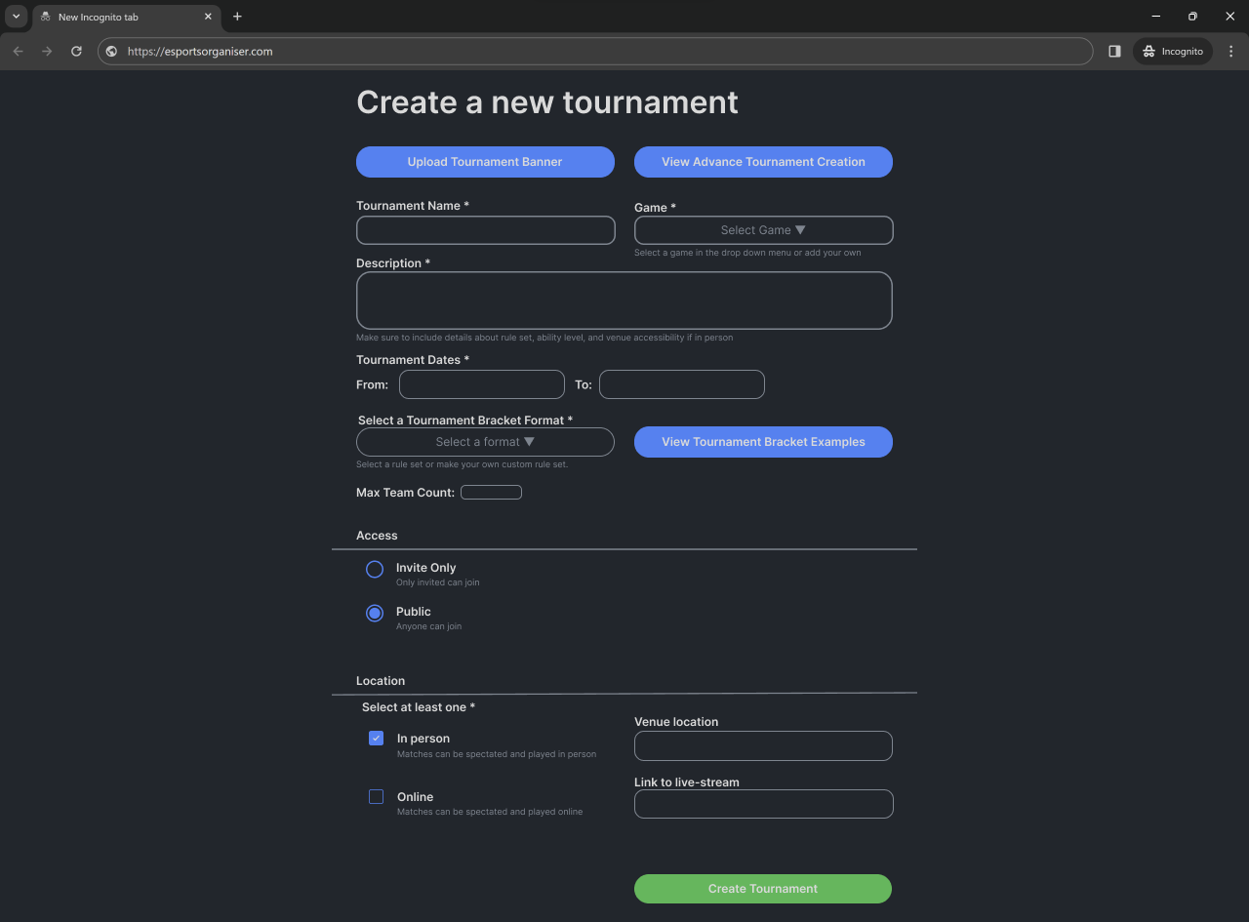

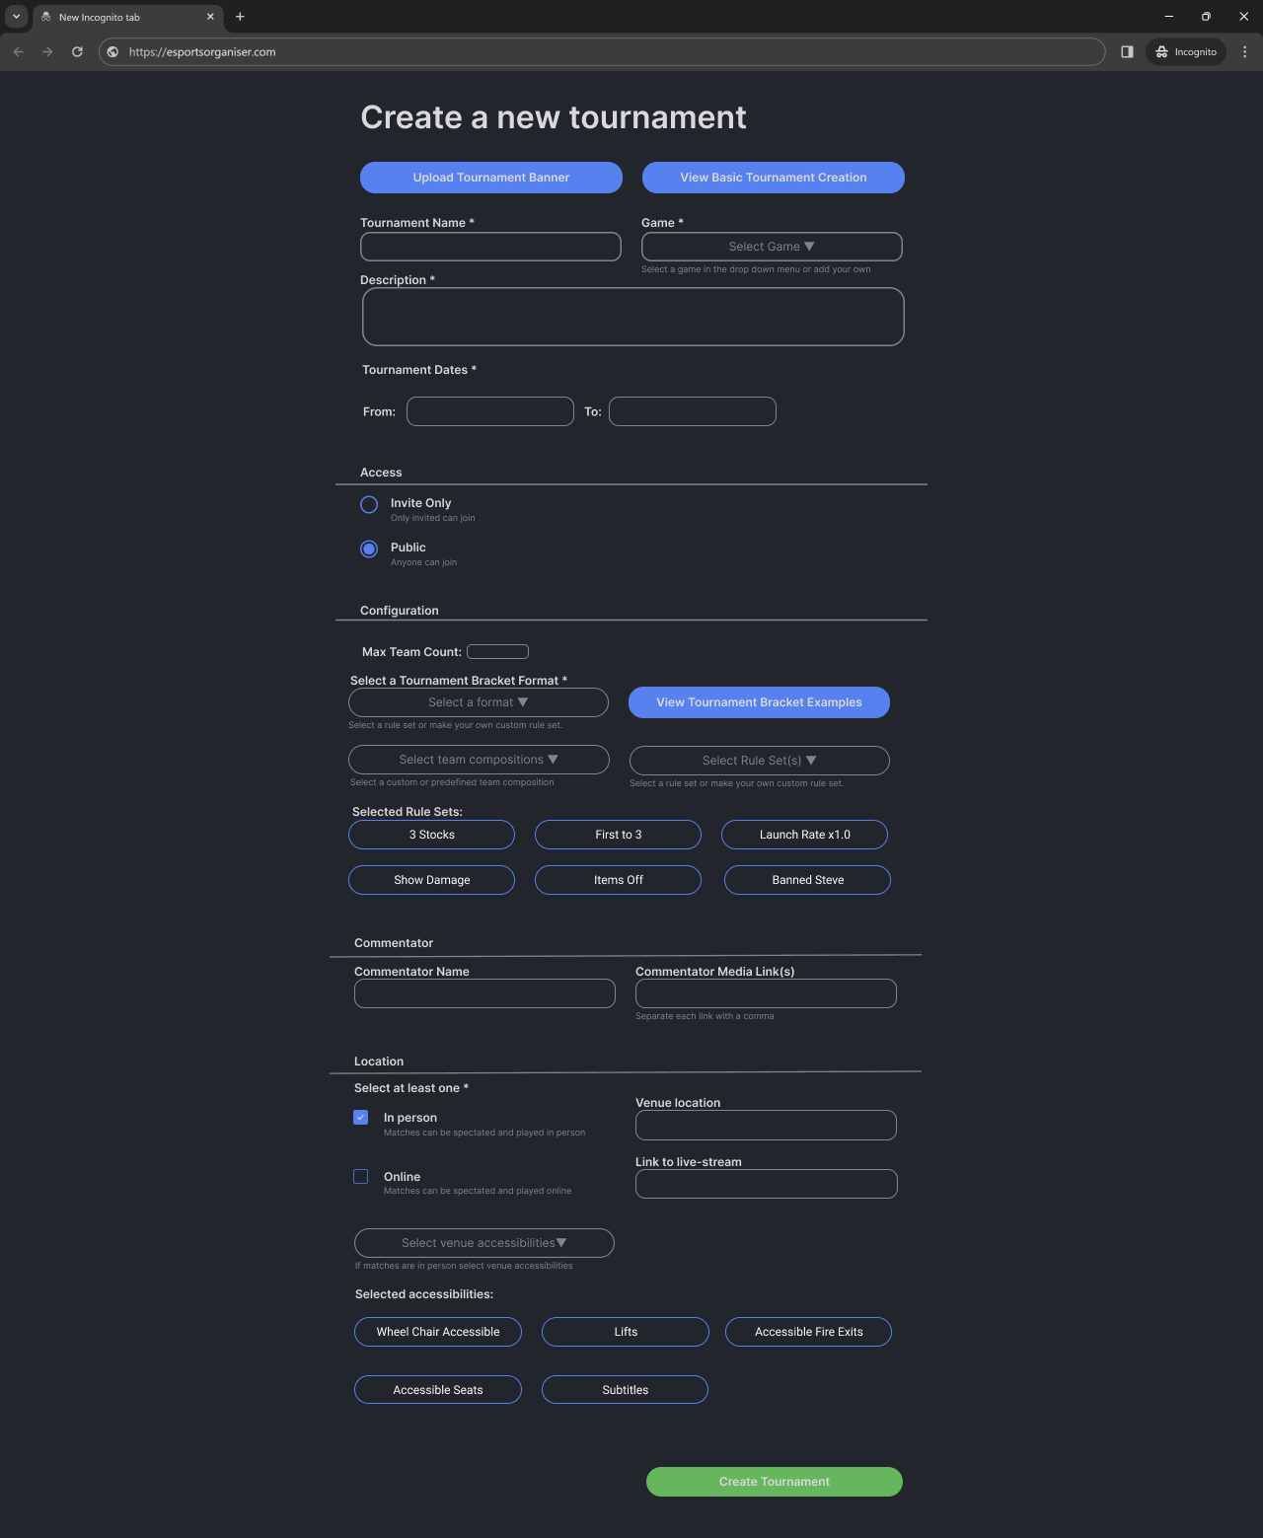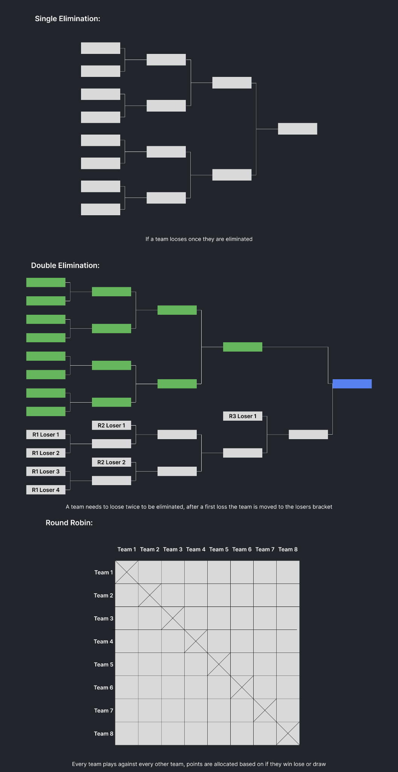

# Persona:

## Substitute:

This persona represents the substitute player, who will use the features: view player info/stats, individual match info, join team, filter lookup, and sort lookup.

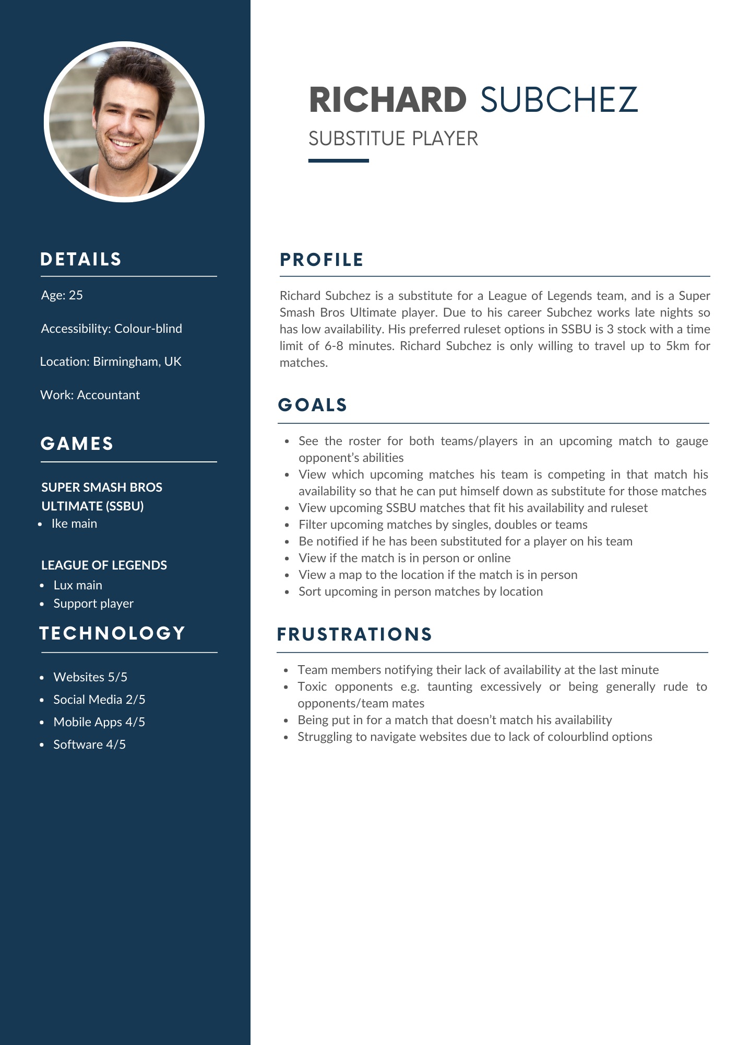

## Coach:

This persona represents the coach, who will use the features: view player info/stats, individual match info, spectate matches, lookup team, and search for tournaments.

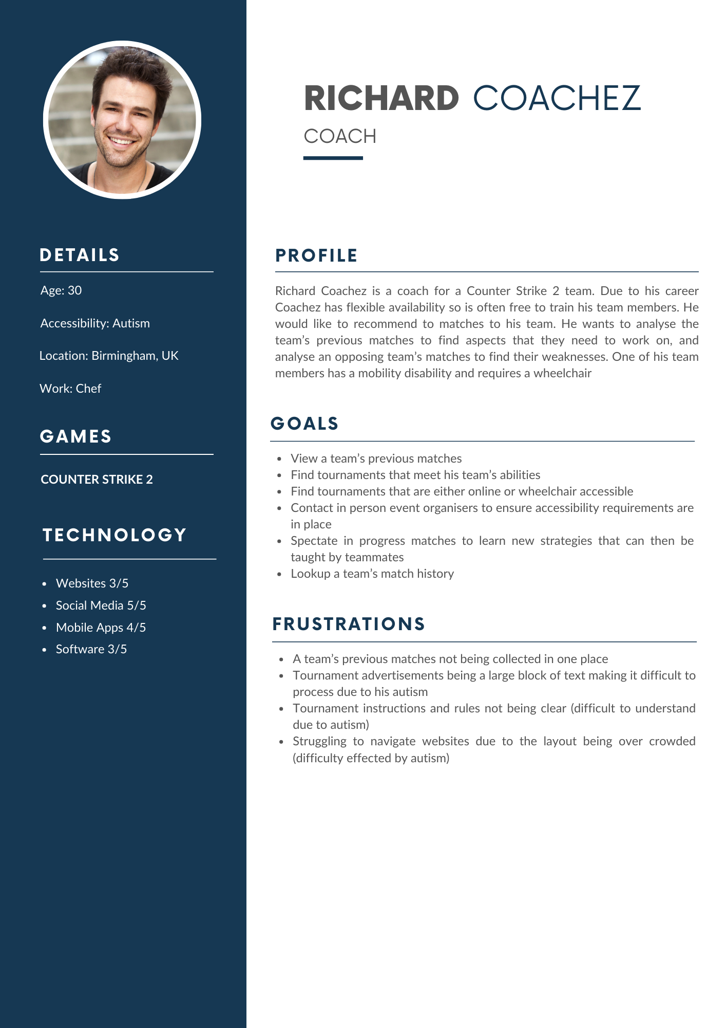

# Git Commit and SSH:

SSH key added to GitLab

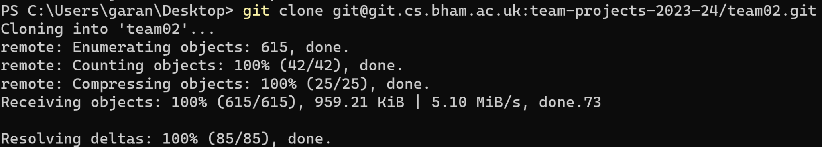

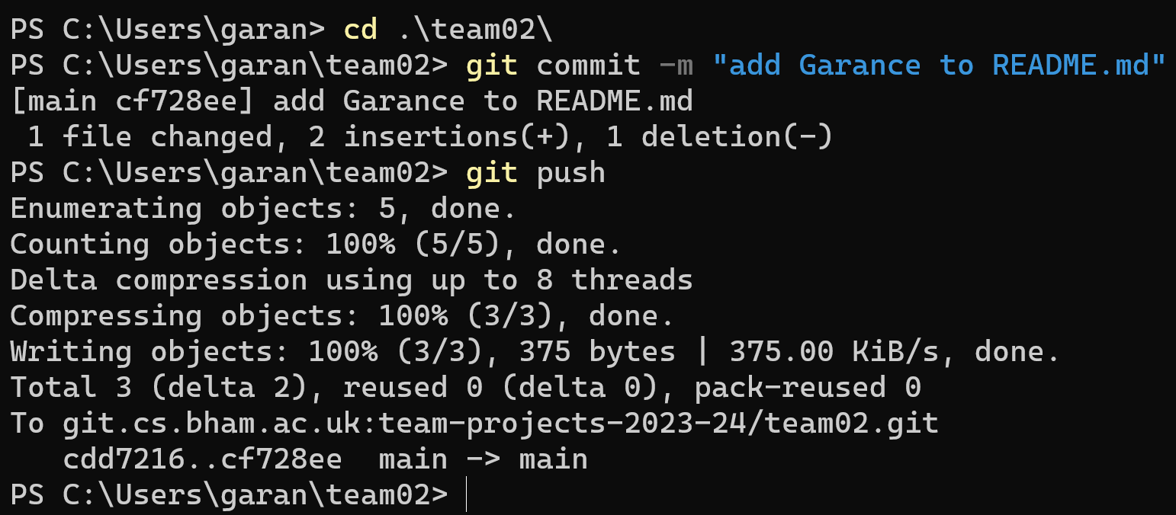

Added name to the README.md file and committed the change, required SSH key to pull and commit through terminal

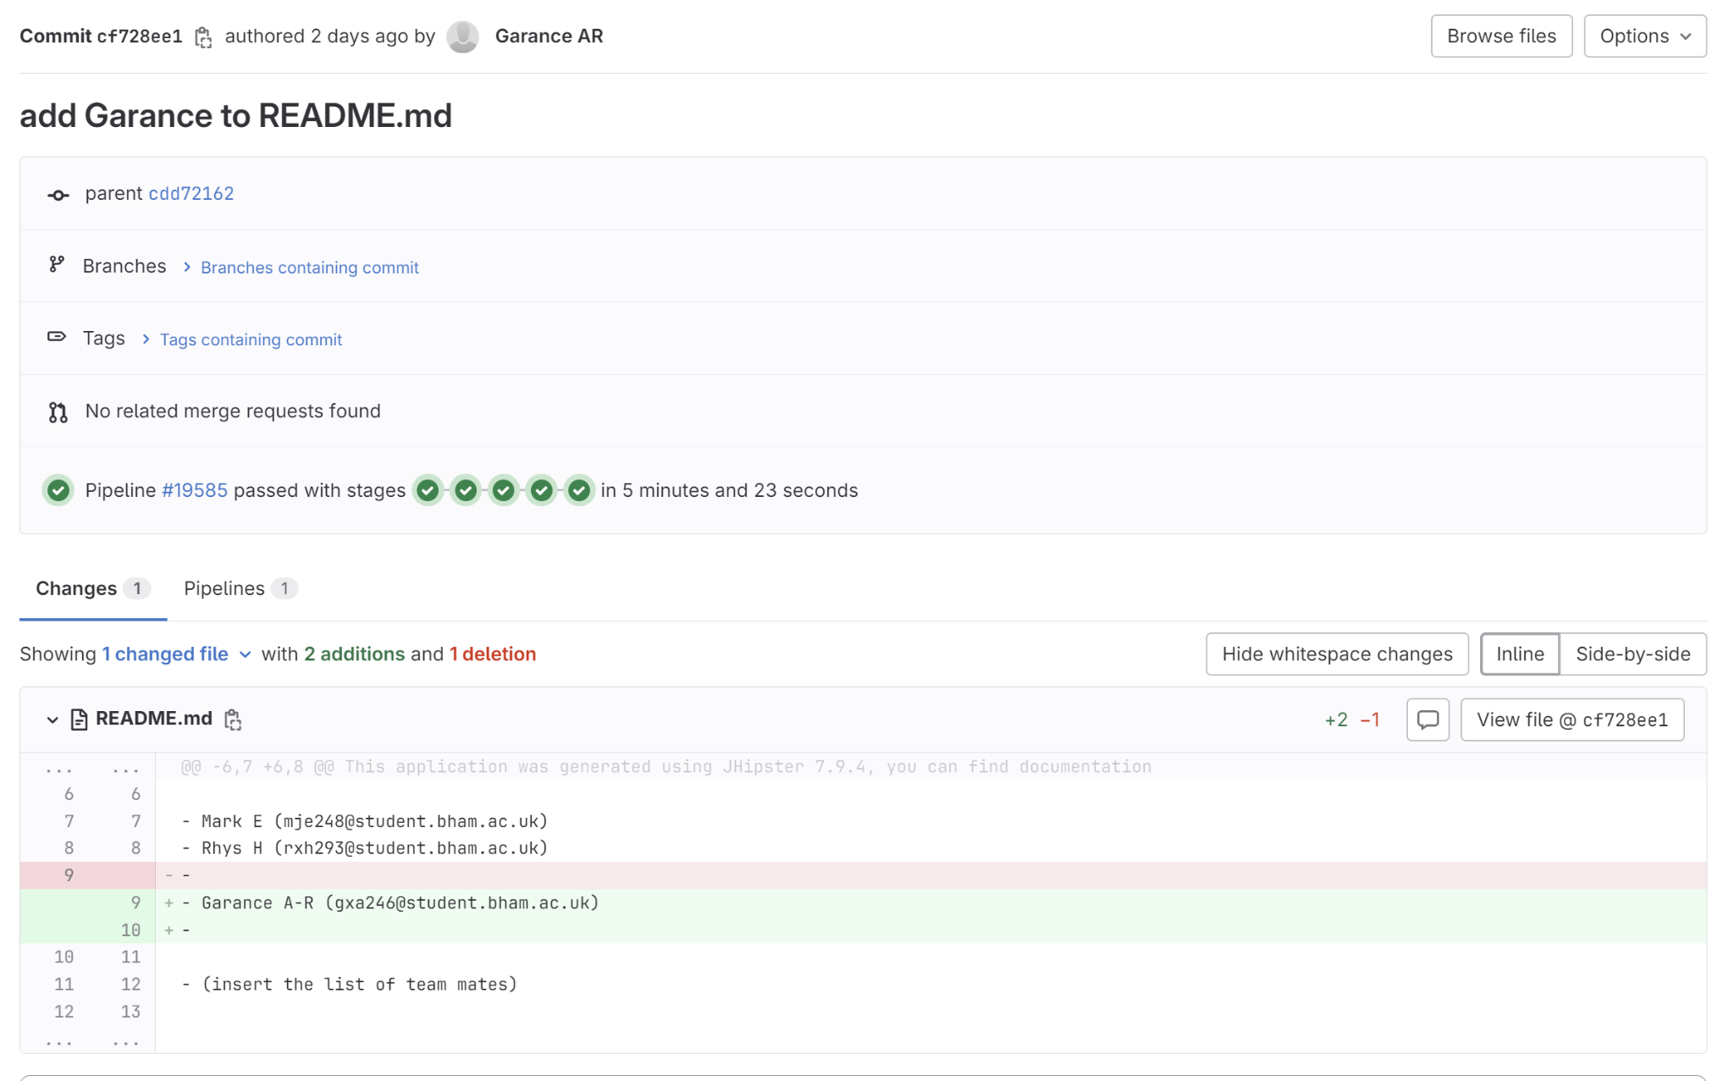

Git commit shown on GitLab

# Timesheet:

