# Mock-up:

This mock-up is for the Match pages for each match in a tournament. This page will initially be blank until a user submits a score for the match. Once a score has been submitted, it will then display the submitted scores for all users to see.

Submitting a score requires the user to input the following for each game in the match:

* Map name
* A replay code for the match (if the game has support for replays)
* A link to a recorded match replay / livestream (if match has been recorded)
* The Score for the game
* Select the players from each team that played in the game (if game is a team game)

The mock-up was originally drafted in Word and then remade in Figma.

The mock-up is made assuming that each team is made up of 8 players and the game played is 5v5.

The white circles represent a profile picture for each team and for each player.

Page before any scores have been submitted

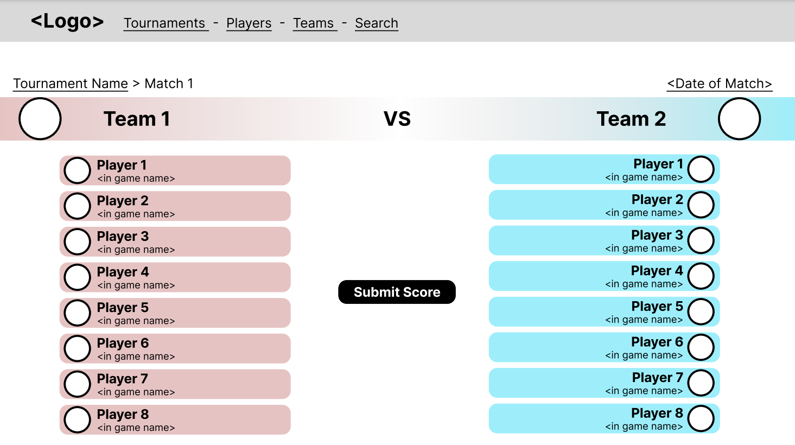

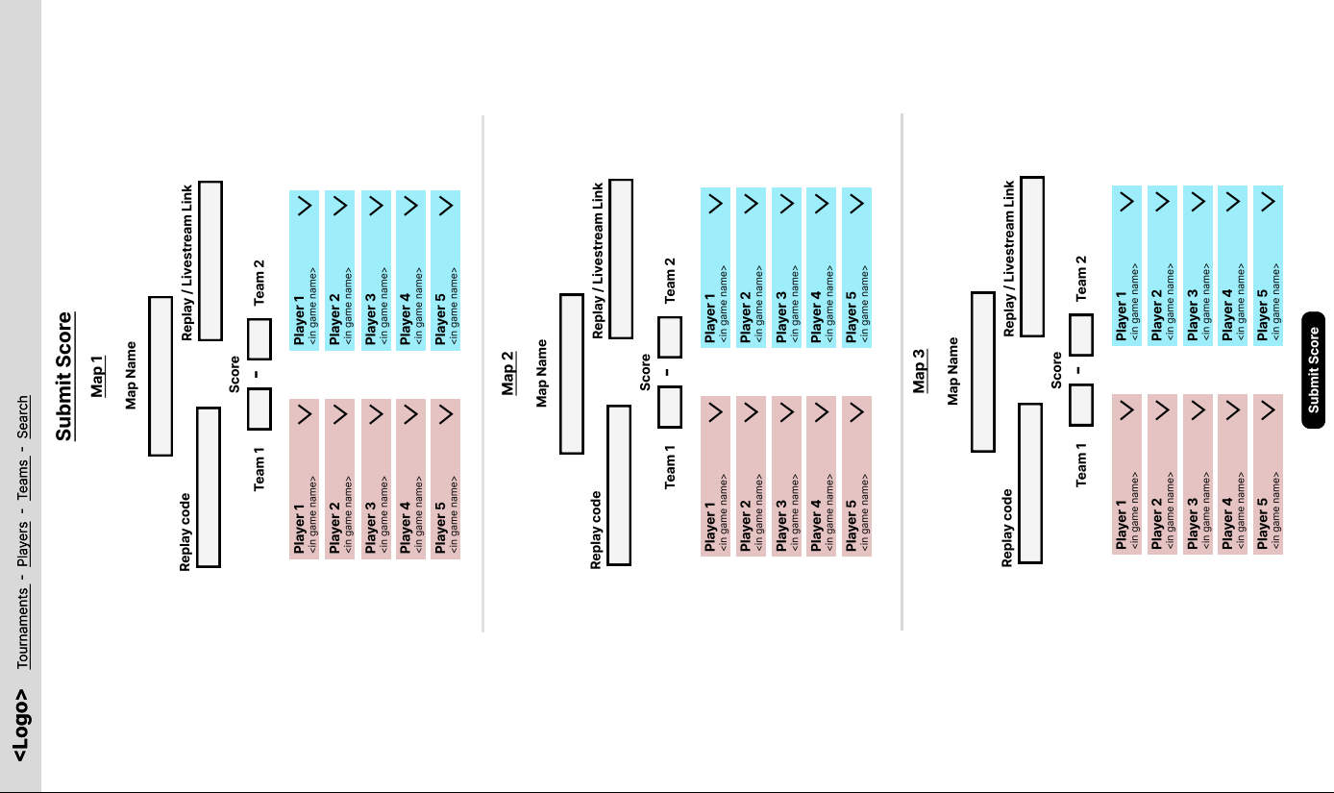

Page for the User to submit match scores

Map Name, Replay code, Replay / Livestream Link, and Score are given by keyboard input.

Players are picked from a dropdown of players on their team.

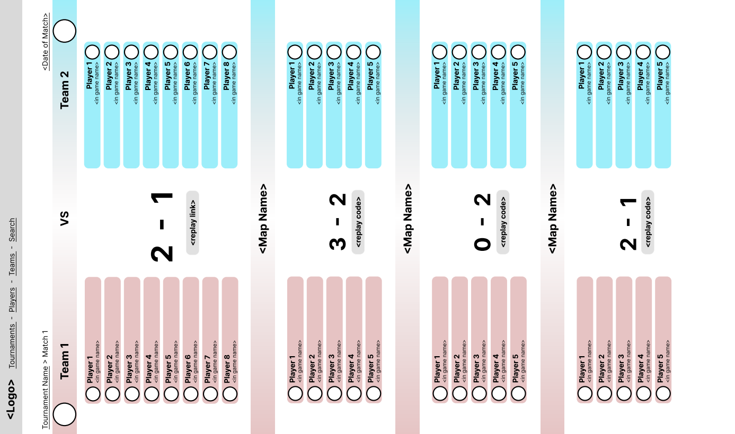

Page after scores have been submitted

# Persona:

This persona represents a player that is part of a University E-sports team. They will use the page to view information about past and upcoming games that they are playing. They will also be able to view the matches of other teams to learn more about them and spectate other tournaments, so that they can improve at the game.

Created using Canva.

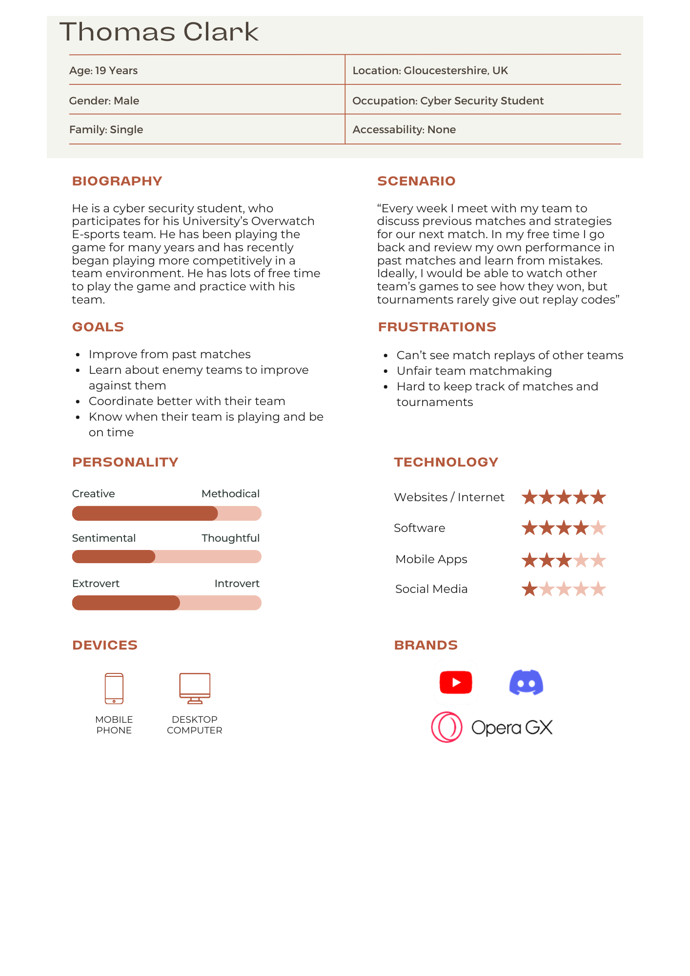

# Git Commit:

Done using the Git Bash terminal, using ssh keys, added my timesheet for S1 (TimesheetS1.xls) to the team02 repository.

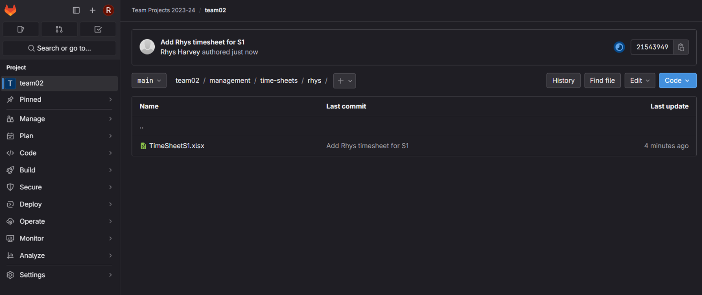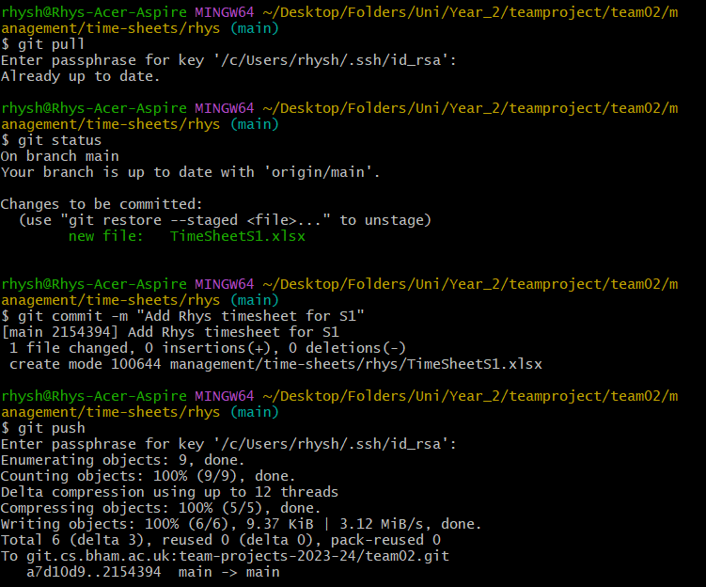

# Time Sheet:

My timesheet has been made available on the team02 repository (as shown above) for my team to see.

