

UNIVERSITY OF SCIENCE AND TECHNOLOGY OF HANOI

System Architecture
SongSong Project

By
Nguyễn Duy Anh Tùng - 2540107
Nguyễn Xuân Vinh - 2540027
M1 - Data Science

Hanoi, 2026

I/ SYSTEM MANUAL

Environment Setup
The system is implemented in Java and requires the Java Development Kit (JDK). Install JDK (version 8 or higher) and verify the installation:
java -version
javac -version
Set the JAVA_HOME environment variable and add %JAVA_HOME%/bin to the system PATH. The IP address used by the system must correspond to the machine running the Directory server. It can be obtained using:
ipconfig
If all components run on the same machine, localhost can be used instead.

Compilation
All source files must be compiled before running the system:
javac -d out src\common\*.java src\directory\*.java src\daemon\*.java src\download\*.java

Running the Directory Server
The Directory component maintains the list of available files and the clients hosting them.
Start the Directory server:
java -cp out directory.Directory

Running Daemon Clients
Each client that shares files runs a Daemon process. The Daemon registers its shared files in the Directory and serves file fragments through TCP sockets.
Example:
java -cp out daemon.Daemon 5000 shared1
java -cp out daemon.Daemon 5001 shared2
..
Where 5000,5001 are the Daemon port and shared1, shared2 is the folder containing shared files

Running the Download Client
To download a file, run:
java -cp out download.Download <filename>
The Download component requests the list of available sources from the Directory and downloads file fragments in parallel from multiple clients.

II/ ENHANCEMENTS AND EVALUATION

Enhancements

Failure and disconnection handling
In the DownloadWorker.run() method, the connection to the source client is created using a TCP socket. If the connection fails, an exception is caught and the worker thread marks the download as failed.
In this situation, the connection fails, the worker thread ends, and the fragment is not downloaded.
This behavior can be observed in the terminal output during the experiments, where messages indicate whether a fragment was successfully downloaded or if a source failed.
Example:
Fragment start-end downloaded from host:port
Source failed: host:port
Fragment start-end not downloaded
These logs allow us to detect whether disconnections occurred during the download.

Dynamic adaptation
- Detect and integrate newly available clients:
When a Daemon starts, it automatically registers its files in the Directory using the registerFile() method in DirectoryServiceImpl.java.
Example:
movie.mp4 → 10.0.6.16:5000
movie.mp4 → 10.0.6.156:5001
This mechanism allows the Directory to automatically integrate newly available clients that provide the same file.
- Detect and take into account disconnected clients:
When a client requests the list of sources for a file, the Directory verifies whether each registered client is still alive.
If a client is no longer reachable, it is removed from the list of available sources.
This behavior is implemented in DirectoryServiceImpl.java, where disconnected clients are detected and removed from the directory.
- Optimize source selection:
To distribute downloads across multiple clients, the Directory randomizes the order of available sources. This is also implemented in DirectoryServiceImpl.java.
As a result, the order of sources may differ between requests.

Example:
Request 1 → [A B C]
Request 2 → [C A B]
Request 3 → [B C A]
This strategy helps distribute download requests across clients instead of always selecting the same source first.

Data Compression
In addition to the original media file (.mp4), experiments were also performed using a compressed version of the file (.zip).
This allows us to evaluate the effect of file compression on download performance.
The results of these experiments are presented in the Evaluation section below.

Evaluations
To evaluate the system, several experiments were conducted using the same test file across different numbers of sources. The file used for testing is a video file (MP4) with a duration of 4 minutes 51 seconds and a size of 18.7 MB (19,677,087 bytes). A ZIP version of the same file was also used to observe the potential effect of data compression.
For each configuration, the file was downloaded from 1, 2, and 3 sources, and the experiment was repeated three times. The execution time of each run was recorded in milliseconds.

MP4 Download Performance
The graph shows the download time of the MP4 file for three independent runs. The results indicate that increasing the number of sources generally reduces the download time. This behavior demonstrates the benefit of splitting the file into fragments and downloading them in parallel from multiple clients.
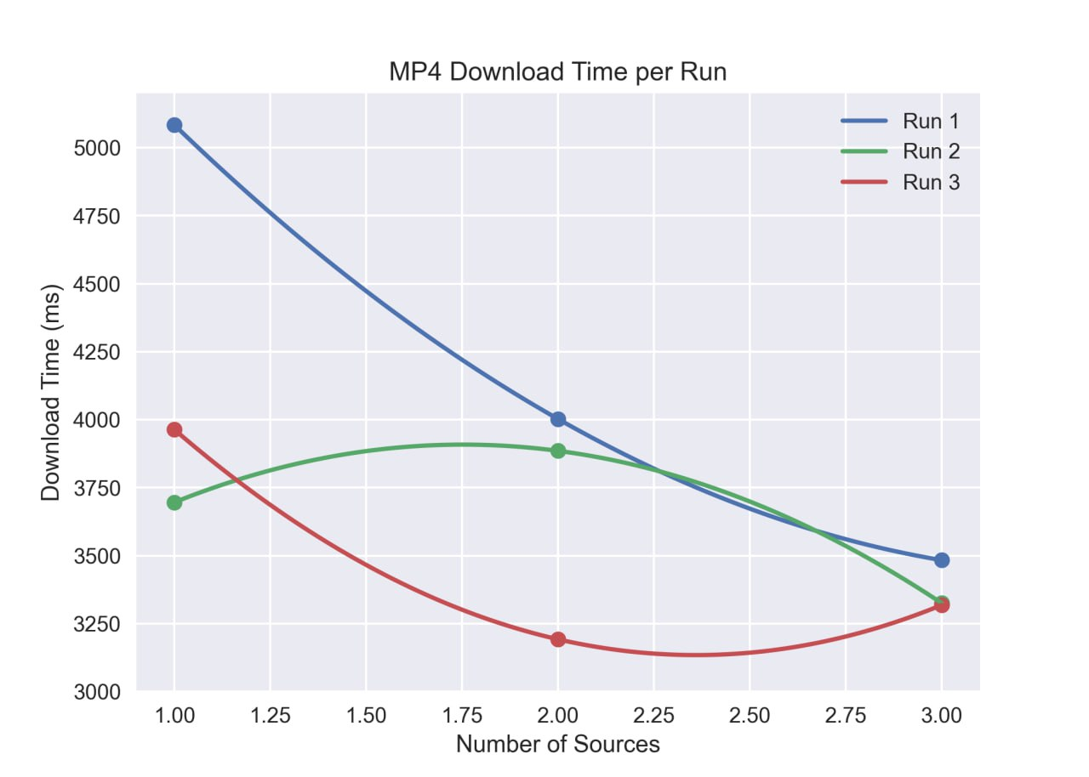

ZIP Download Performance
The graph presents the download time of the compressed ZIP file for the same experiment setup. Similar trends can be observed, although variations between runs may occur due to network fluctuations and processing overhead.
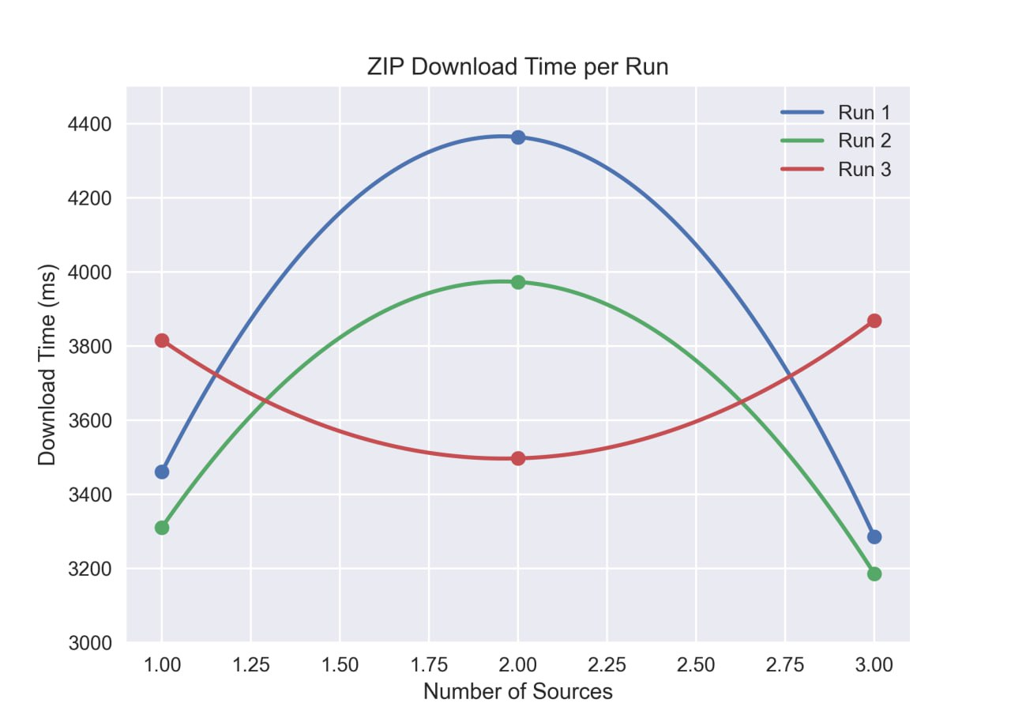

Average Performance and Speedup
To better understand the overall trend, the average download time across the three runs was computed. The first graph compares the average download time for MP4 and ZIP downloads as the number of sources increases.
Additionally, the speedup metric was calculated as the ratio between the execution time with one source and the execution time with multiple sources. The speedup graph illustrates the performance improvement achieved by parallel downloading.
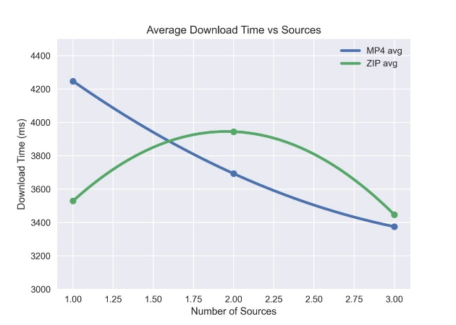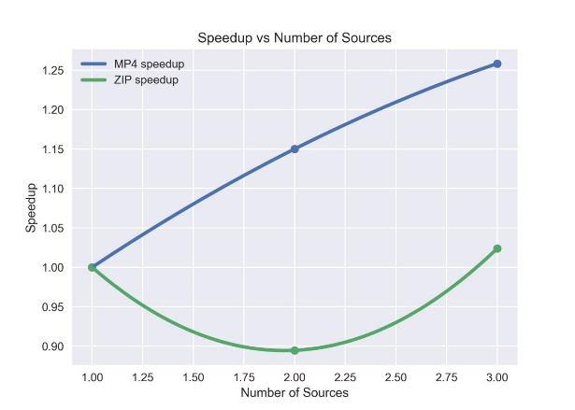
Note: Some preliminary tests were also conducted with larger files and slower network conditions. However, these experiments required significantly more execution time and computational resources. Due to time limitations and the fact that the implementation was still being refined, the results of those tests were not systematically recorded.

III/ CONCLUSION
This project implemented a distributed file downloading system that allows a client to retrieve file fragments from multiple sources in parallel. Several enhancements were introduced, including improved failure handling, dynamic adaptation to available sources, and optional data compression.
Experimental results show that increasing the number of sources generally reduces download time, demonstrating the effectiveness of parallel downloading. The speedup analysis also confirms that the system benefits from distributing the workload across multiple clients.
Overall, the implemented system successfully demonstrates the core principles of distributed file transfer and provides a foundation for further improvements and scalability experiments.

