Input Signal Conditioner (ISC) Circuit Design

David Pierce Walker-Howell

October 27, 2020

**1 Description**

The Input Signal Conditioner (ISC) is an amplifier and low-pass filter circuit responsible for conditioning the raw microphone signal from a dynamic microphone to be sampled by an Analog-to-Digital Converter (ADC). The circuit comprises of a DC biasing network, non-inverting amplifier, and a 2nd Order Butterworth active low-pass filter (LPF). Presented is the circuit design and specifications to signal the raw microphone signal to be sampled by the Cirrus Logic Inc. CS5343-CZZ Sigma-Delta ADC.

**2 Design**

**2.1 Sallen-Key Low Pass Filter Design**

A lowpass filter is designed to condition the frequency response of the microphone prior to sampling of the ADC. Typically, a lowpass filter is used as an anti-aliasing filter for the ADC to ensure no frequency components greater than the Nyquist frequency (Fs / 2) are sampled (which would result in signal aliasing). However, since the design uses a Sigma-Delta ADC with a digital internal anti-aliasing filter, the filter designed for this board is not specifically targeted for anti-aliasing. The lowpass filter design for the Input Signal Conditioner is primarily to cutoff frequencies outside the expected vocal range of a singer. Thus, the cutoff frequency is set to 15KHz, which is a common cutoff frequency estimate for most dynamic microphones. In this design, a Butterwork Sallen-Key lowpass filter is chosen for a **variety of reasons** [Discuss those here].

There are two critical parameters to consider for selecting an Op-amp for the Sallen-Key LPF: 1) Gain Bandwidth Product (GBWP), 2) Slew Rate. The closed-loop bandwidth of the amplifier must be at least 100 times greater than the passband (or cutoff) frequency of the filter. Thus, the minimum GBWP is calculated as

The Slew Rate is related to the internal circuitry of the Op-amp and determines how fast the output voltage or current can change. Ideally, the slew rate, measured in volts per microseconds, should be relatively high. The minimum slew rate is calculated based on the cutoff frequency and peak-to-peak output voltage of the amplifier. The minimum slew rate is calculated as

Based on the Op-amp requirements, the Microchip MCP6271 rail-to-rail, single-supply Op-amp is chosen.

|  |  |  |
| --- | --- | --- |
| **Specification** | **Designator** | **Value** |
| Filter Type | N/A | Butterworth |
| Configuration | N/A | Sallen-Key |
| Order | N | 2 |
| Passband Frequency | Fc | 15KHz |
| DC Gain | A | 1 V/V |
| Min. GBWP | GBWP_MIN | 1.5MHz |
| Min. Slew Rate | SR_MIN | 0.09 V / (us) |

The design of the lowpass Sallen-Key filter was generated by the Microchip FilterLab® software. The software provides the 1% tolerance resistance and capacitance values to obtain a realistic, implementable filter design.

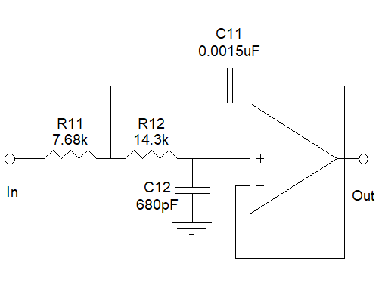

Figure 1- Sallen-Key, Butterworth, LPF generated by Microchip FilterLab design software (Fc=15KHz).

The designed filter was the simulated in LTSpice with the corresponding MCP6271 Op-amp spice parameters.

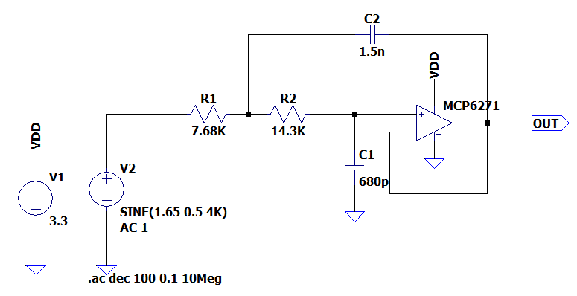

Figure 2 - LTSpice simulation schematic of LPF.

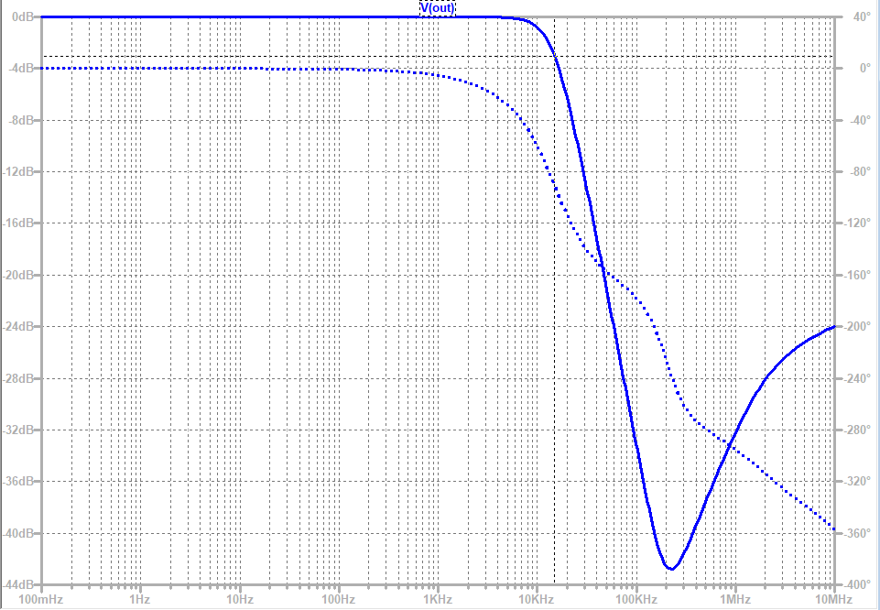

Figure 3- LTSpice simulated LPF frequency response.

Figure 3 shows the expected magnitude and phase response of the filter. Analyzing the magnitude response shows flat 0dB gain for the passband frequencies and -20dB per decade attenuation after the passband. The expected frequency range of the microphone signal will maintain most of the energy from approximately 50Hz to 2KHz. In this frequency range, it is observed there is a nearly constant group delay (linear phase) as desired.

**2.2 Amplifier Design**

The raw signal from the microphone is a small signal in the order of tens of millivolts. From initial measurements of a PDMIC58 Pyle Moving Coil Dynamic Handheld Microphone, the maximum raw signal at singing volume is approximately 100mV. This raw signal needs to be amplified and biased for sampling by the ADC.

The ADC chosen is the Cirrus Logic Inc. CS5343-CZZ Sigma-Delta ADC, which provides 24-bit conversion and an internal digital anti-aliasing filter. The datasheet for the device provides suggested analog input signal conditioning. The source impedance (impedance seen from the ADC) should be less than or equal to 2.5KΩ to achieve optimal THD+N performance. The magnitude of the incoming signal to the ADC needs to be less than or equal to the full-scale input voltage of the device. With the ADC operating at 3.3V, the full-scale input voltage range is defined as

.

It is important to note the analog input pins of the ADC expects zero DC bias. Thus, the voltage at the input shall be within . The desired gain of the amplifier is calculated as

Since the entirety of the design (all PCBs) are powered from a single supply voltage of 3.3V, the analog signal propagating through the Op-amp based amplifier and filter needs to be DC biased to be in the range 0V – 3.3V. Therefore, the input signal of the microphone is DC biased at .

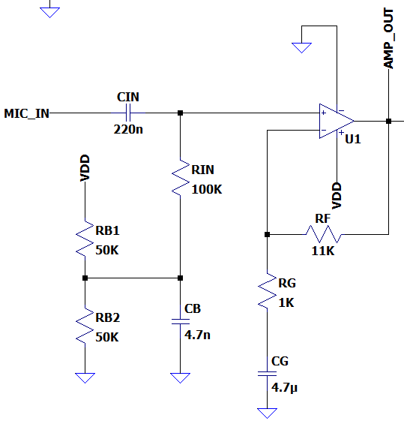

Figure - Input signal conditioner amplifier

The non-inverting amplifier configuration shown in Figure 4 applies the 1.65V DC bias and amplifies the analog components of the microphone signal by 21.6dB. The input capacitor removes any DC components from the raw microphone signal. The DC biasing network composed of applies the 1.65V DC bias and acts as a high-pass filter with respect to the microphone input, but a low-pass filter with respect to the input used to set the DC bias value. The primary reason for the addition of is to filter out any analog noise from the power supply of . Ideally, should come from a low-noise voltage regulator and therefore not be of concern. However, if is noisy and not well regulated, the capacitor will filter out any analog frequencies. The AC analysis of the biasing network (with respect to the microphone input) is analyzed to show the frequency response to the incoming microphone signal. A high-pass filter with cutoff-frequency in the tens of volts range is desired since vocal signal are nominally above 80Hz. The network with respect to the microphone input gives the transfer function

.

.

The feedback network of the amplifier, composed of , provides the high passband gain of . The capacitor ensures only analog signal components are amplified, and the DC bias signal component is not amplified. The closed-loop transfer function is given as

The total frequency response of the amplifier is given as

The magnitude frequency response of , with component values shown in Figure 4 , is shown in Figure 5. The cutoff frequency of the amplifier is approximately 35Hz.

Figure - Total Frequency response of amplifier

**2.3 Combining the Amplifier and Filter**

The amplifier and Sallen-key low pass filter are cascaded in series to complete the analog input signal conditioning of the microphone signal for sampling by the ADC. The final design is simulated and verified in LTSpice. It is important to note that the output of the Input Signal Conditioner is at the output of the Sallen-Key lowpass filter. Thus the Input Signal Conditioner does not perform the final step of removing the 1.65V DC bias before feeding into the ADC. This required step is done on the external board hosting the ADC. Therefore, the output of the Input Signal Conditioner is an amplified and low pass filtered version of the microphone signal with 1.65V DC bias.

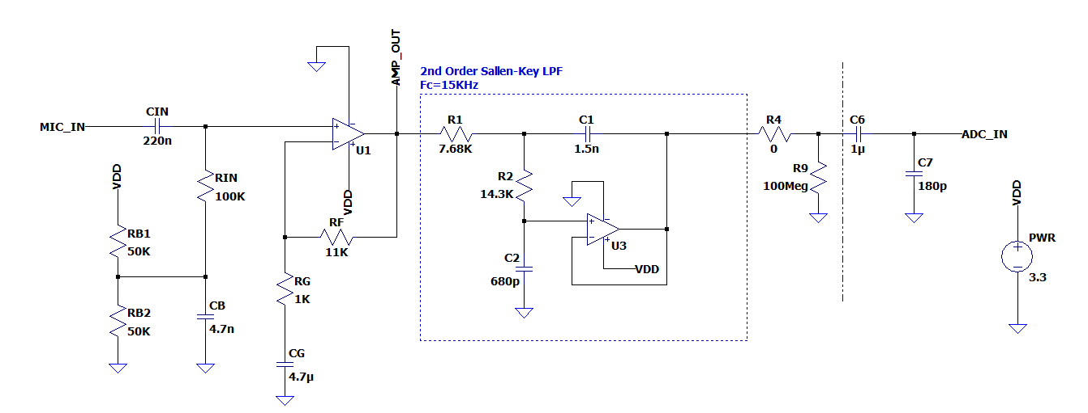

Figure - Input signal conditioner (Amplifier + LPF) LTSpice schematic.

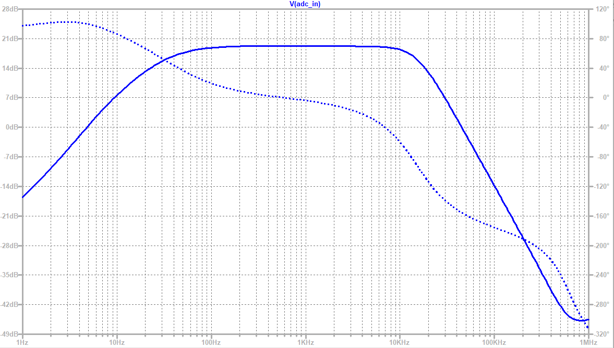

Figure - Frequency response (AC analysis) of Input Signal Conditioner.

Figure 7 is the simulated (expected) frequency response of the Input Signal Conditioner board design. Table 1 summarizes the specifications of the design.

|  |  |  |
| --- | --- | --- |
| **Specification** | **Designator** | **Value (Typ.)** |
| Low Freq. Cutoff | Fcl | 35Hz |
| High Freq. Cutoff | Fch | 15KHz |
| Passband Gain | A | 21dB |
| Output DC bias | VDC | 1.65V |

Table - Input Signal Conditioner Specifications

**Prototype**

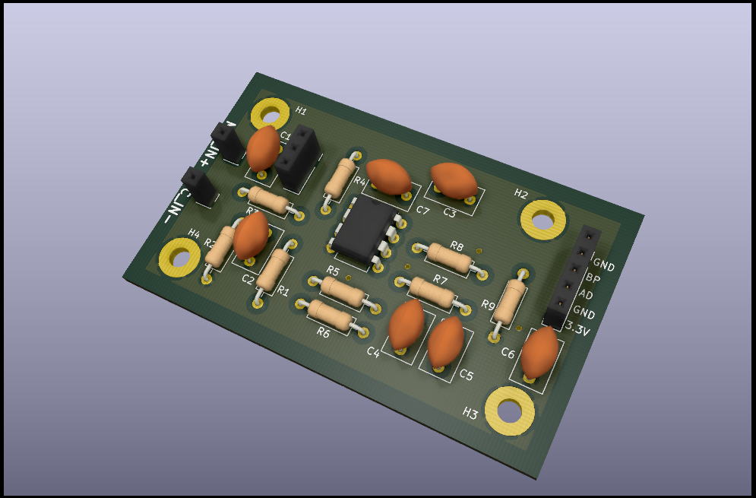

Figure - PCB design of ISC using KiCad.

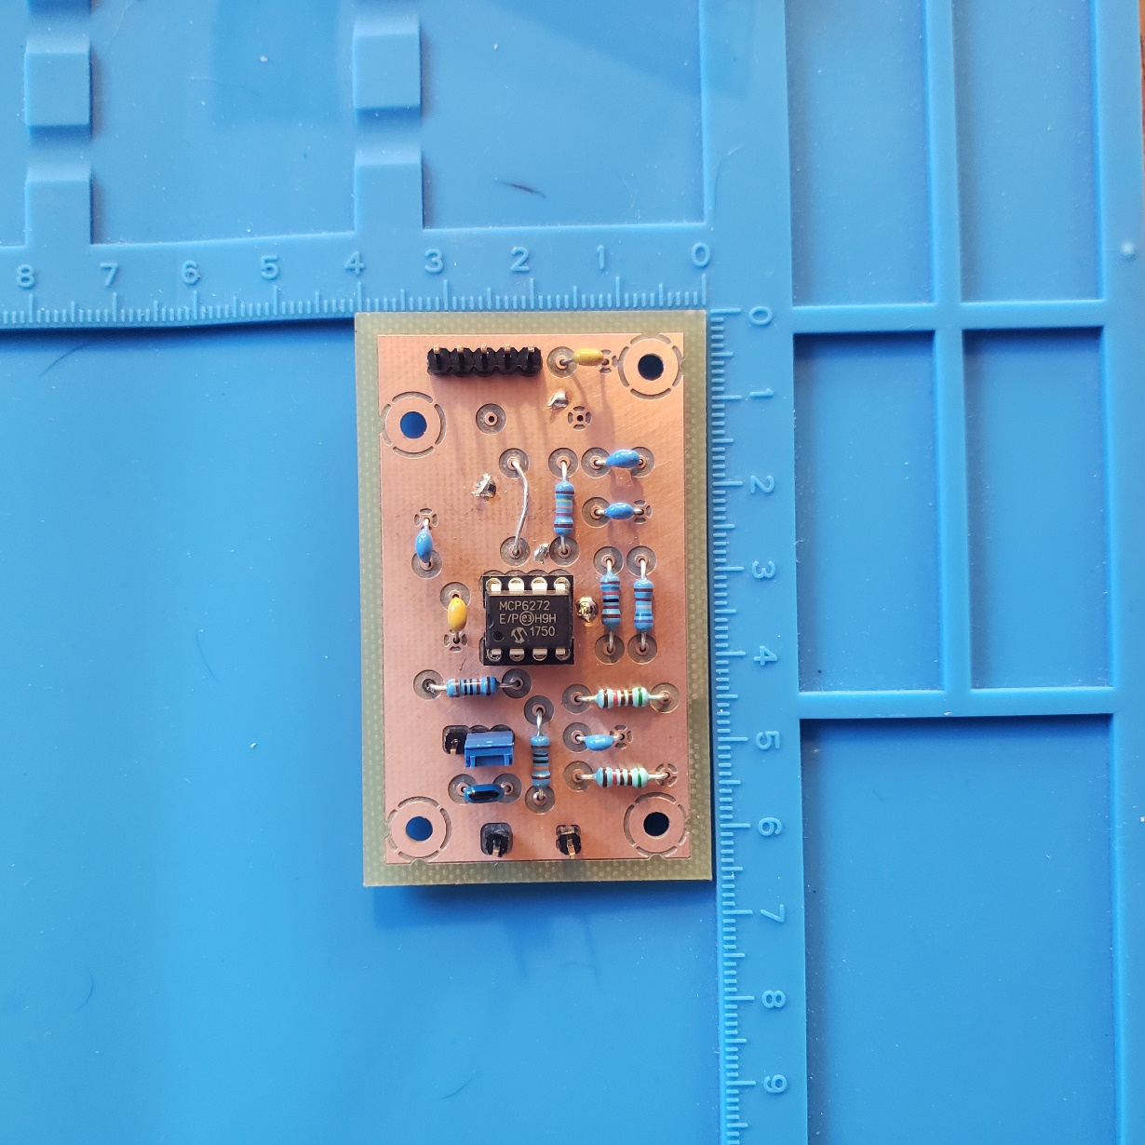

Figure - Milled and Assembled prototype of the ISC.

**Validations**

|  |  |  |  |
| --- | --- | --- | --- |
| **Specification** | **Designator** | **Value (Typ.)** | **Specification Met** |
| Low Freq. Cutoff | Fcl | 35Hz | YES |
| High Freq. Cutoff | Fch | 15KHz | YES |
| Passband Gain | A | 21.6 dB | YES – 21.6 dB |
| Output DC bias | VDC | 1.65V | YES |

Validations of the ISC were performed using a function generator for the input signal and an oscilloscope for measuring the output signal. The input signal is a 25mV amplitude sine wave with 0V DC bias. The frequency of the signal was varied to validate the frequency response of the circuit. The input signal matches the approximate expected microphone signal in amplitude.

The oscilloscope plots below present the AC coupled input and output signals of the ISC. The input signal on the ISC is measured at 20mV / div and the output signal is measured at 200 mV / div.



Figure - 100Hz sine wave input (Yellow). The output signal (Blue) has an amplitude of 520mV. The gain at 100Hz is thus A=10.4 V/V.



Figure - 440Hz sine wave input (Yellow). The output signal (Blue) has an amplitude of 610mV. The gain at 440Hz is thus A=12.2V/V.



Figure -1KHz sine wave input (Yellow). The output signal (Blue) has an amplitude of 600mV. The gain at 1KHz is thus A=12.0V/V.



Figure - 15KHz sine wave input (Yellow). The output signal (Blue) has an amplitude of 450mV. The gain at 15KHz is thus A=9V/V. 15KHz is the desired -3dB cutoff for this filter circuit, thus that figure is approximately met with a measured -2.5dB attenuation at 15KHz.



Figure - 20KHz sine wave input (Yellow). The output signal (Blue) has an amplitude of 300mV. The gain at 20KHz is thus A=6.0V/V.



Figure - 40KHz sine wave input (Yellow). The output signal (Blue) has an amplitude of 110mV. The gain at 40KHz is thus A=2.2V/V.

**Citations**

ADN003 “Select the Right Operational Amplifier for your Filtering Circuits”, Bonnie C. Baker, Microchip Technology Inc.