**Auto Grow**

Documentation

Index

1. Arduino
   1. Board Schematic
   2. Code
2. Python Server
3. Web Application
4. Mobile Application

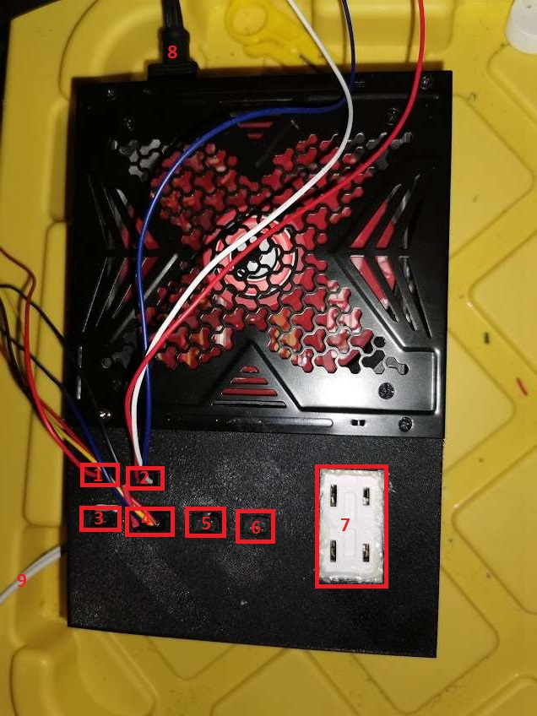Arduino Schematic

Port #1 – Two pin 12v power

Port #2 – Three pin 5v data to D3 (Temperature And Humidity Sensor)

Port #3 – Two pin 12v on relay D1 (Water Pump)

Port #5 – Three pin 5v data pin null

Port #6 – Three pin 12v data pin D4 (Null)

Port #7 – Wall plug on relay D7

Port #8 – PSU power in

Port #9 – Wall power in for Port #7

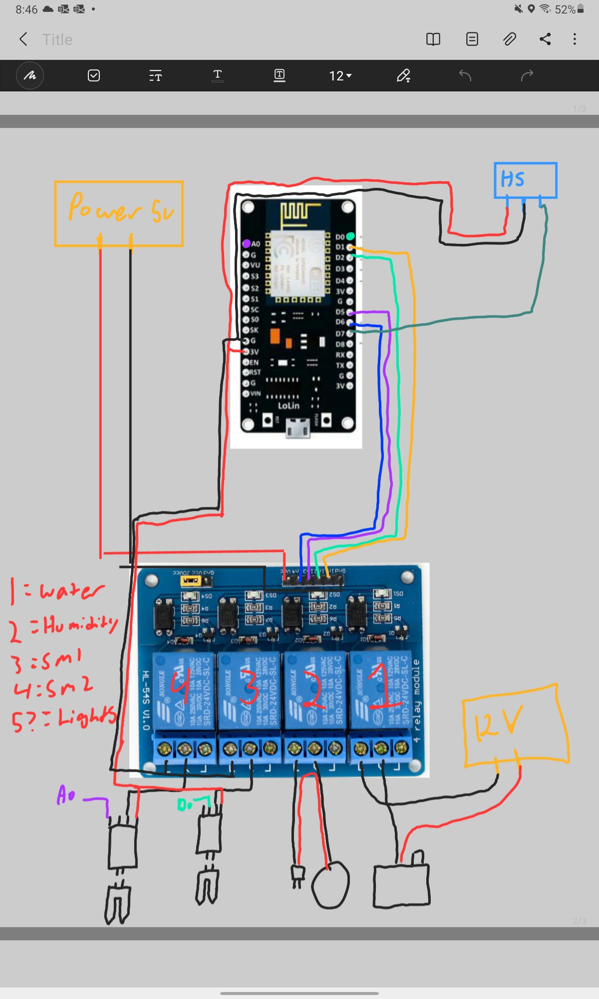

Arduino Code

|  |  |
| --- | --- |
| Class Summary | |
| File | Description |
| Driver.py |  |
| Connector.py | Manages the connection between the NodeMCU to get sensor data for processing |
| SensorController.py |  |

|  |  |  |
| --- | --- | --- |
| Function Summary | | |
| Controller.py | def getDataLine() |  |
| def getTemperature() |  |
| def getHumidity() |  |
| def getHumidStatus() |  |
| def getWaterPumpStatus() |  |
| def getSMsensorStatus() |  |
| def getSml() |  |
| def getSmr() |  |
| SensorController.py | def regulateHumidity(humidity, temperature) | Assesses the humidity of the grow space to control the humidifier |
| def soilMoistureOn() | Call url of NodeMCU to power on the soil moisture sensors for data logging and assessment for the server. |
| def soilMoistureOff() | Call url of NodeMCU to power off the soil moisture sensors after assessment. |
|  |  |