

CSE326: Software Formal Specifications

**Mini Project 1**

**Submitted by:**

Pierre Adel 17p6070

Shehab Alaa 17p3032

**Submitted to:**

Dr. Islam El Maddah

Faculty of engineering

Ain shams university

Nov 2020

Contents

1.0 Introduction 3

2.0 Design 3

2.1 Classes 3

2.2 Objects 4

2.3 Associations 4

2.4 Constraints 4

2.5 Pre and Post conditions 5

2.6 Violations and Satisfactions 6

# Introduction

In this project we define an online Shop model in which a user can browse products and can manage his cart by adding or removing the products and then place and order, while an admin can also manage available products and approve or reject order.

# Design

## 2.1 Classes

We will have 5 classes, namely: Person class, User class, Admin class, Product class and order class

Person class is never directly instantiated however it acts a template for the user class and the admin class which both inherit the Person class.

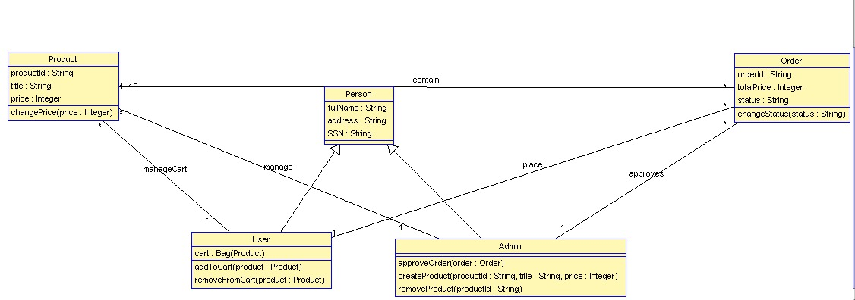

## 2.2 Objects

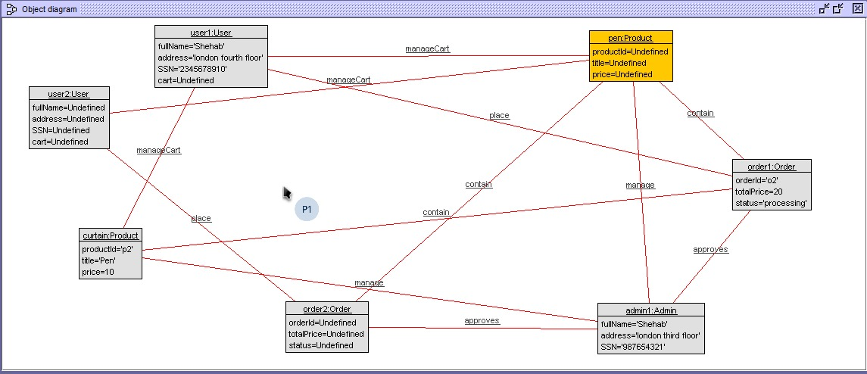

## 2.3 Associations

* Admin **manage** Product.
* Admin **approve** Order
* User **place** orders.
* User **manageCart** his/her cart.
* Order **contain** Product

.

## 2.4 Constraints

1. An order can never have more than 10 products and must at least have 1 product.
2. User cannot have an empty address
3. User Cannot have more than 10 products in their cart
4. User Cannot make more than one order
5. System must have only one admin
6. Number of users must be more than one and has no limit
7. Product price must be more than 1
8. A user can not remove products from his/her cart if is empty.
9. A user can only remove a product from his/her if it exists
10. Admin cannot add more than one product with the same id
11. The total price of an order must be at least 1.
12. An order must contain at least one product.

## 2.5 Pre and Post conditions

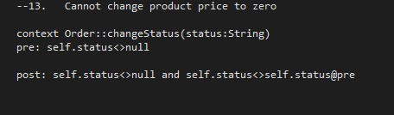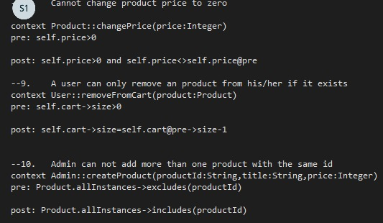

## 2.6 Violations and Satisfactions

